Name: Taneeshq Cholekar Date:14/06/2025

**Assignment-5**

**Docker and Kubernetes:The container masterclass**

**(url:** [**https://hub.docker.com/repository/docker/tanc2002/simple-webapp/general**](https://hub.docker.com/repository/docker/tanc2002/simple-webapp/general)**)**

**Problem Statement:**

Deploy Containers Using Kubectl, use Kubectl to create and launch Deployments, Replication Controllers and expose them via Services without writing yaml definitions. Deploy A Containerized Web Application On Kubernetes.

1) Package your app into a Docker image

2) Run the container locally on your machine (optional)

3) Upload the image to a registry

4) Create a container cluster

5) Deploy your app to the cluster

6) Expose your app to the Internet

7) Scale up your deployment

8) Deploy a new version of your app

**Methodology:**

**Step 1:** Created a simple webapp using node and express js to be deployed and ran it locally.

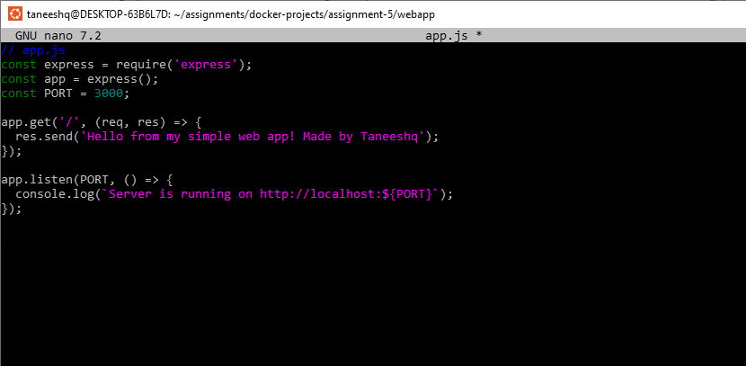

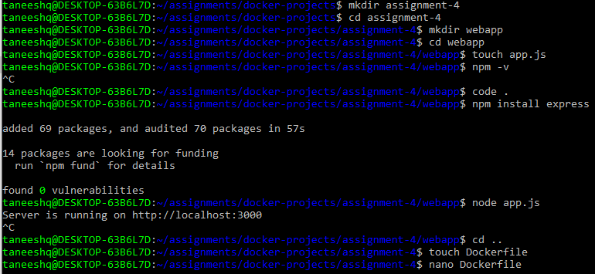

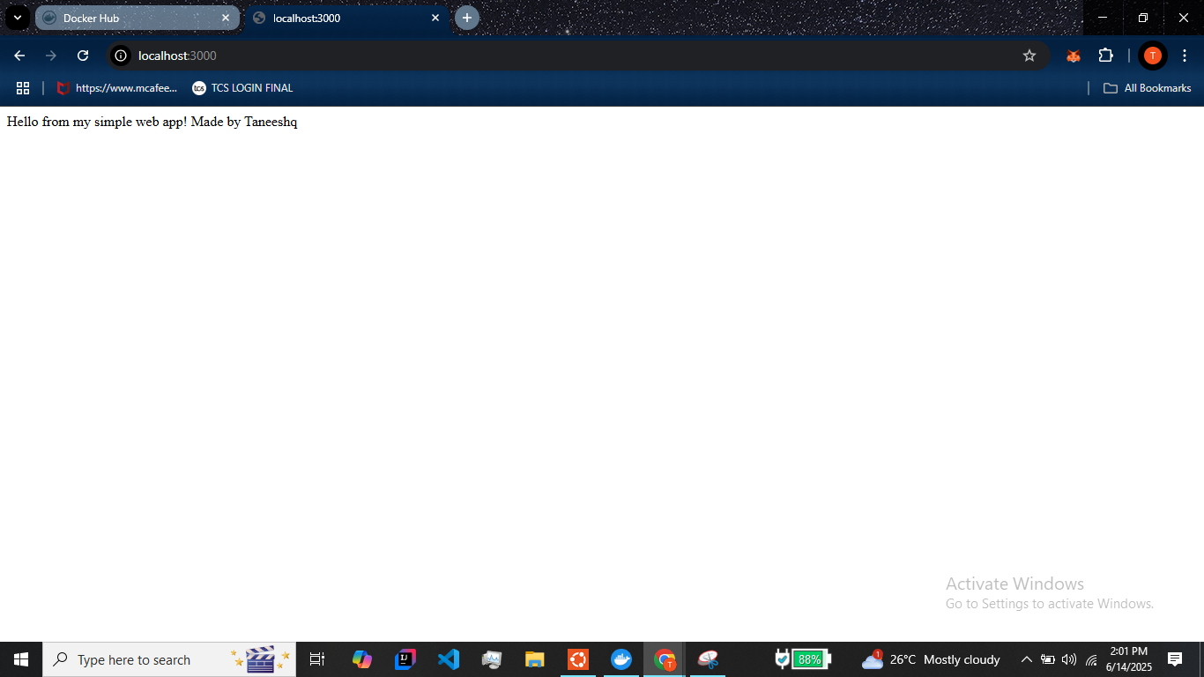

**Step 2:** Create a dockerfile to package the app.

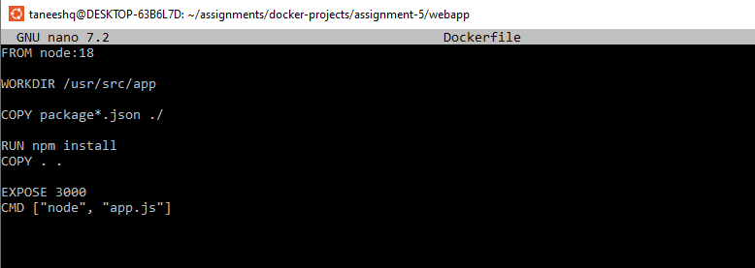

**Step 3:** Build the image and run the container to verify the image

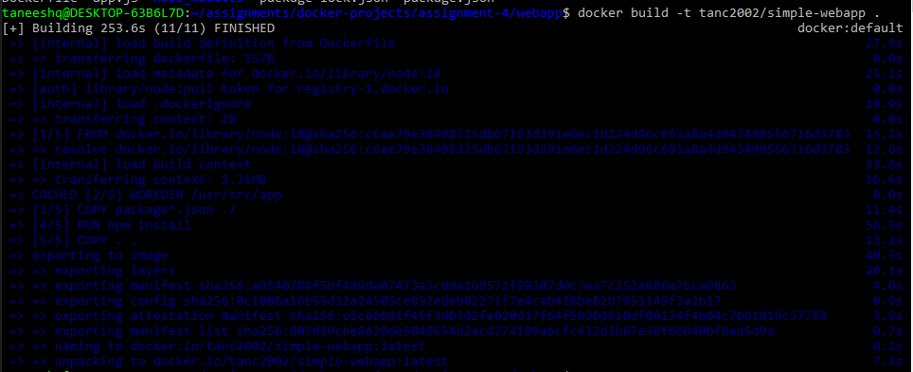

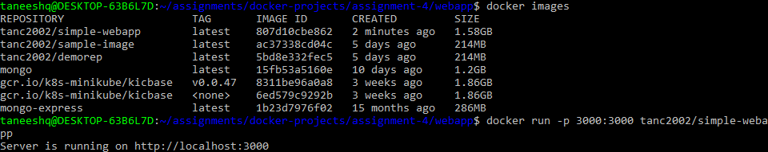

**Step 4:** Push the image to dockerhub repository so it can be later used in minikube.

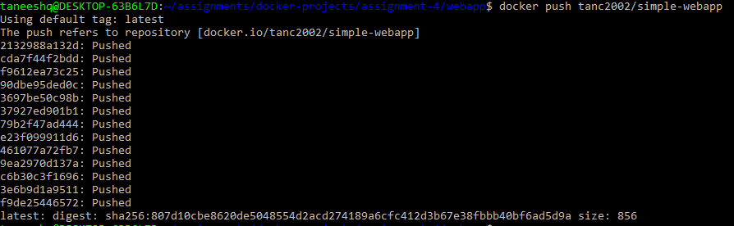

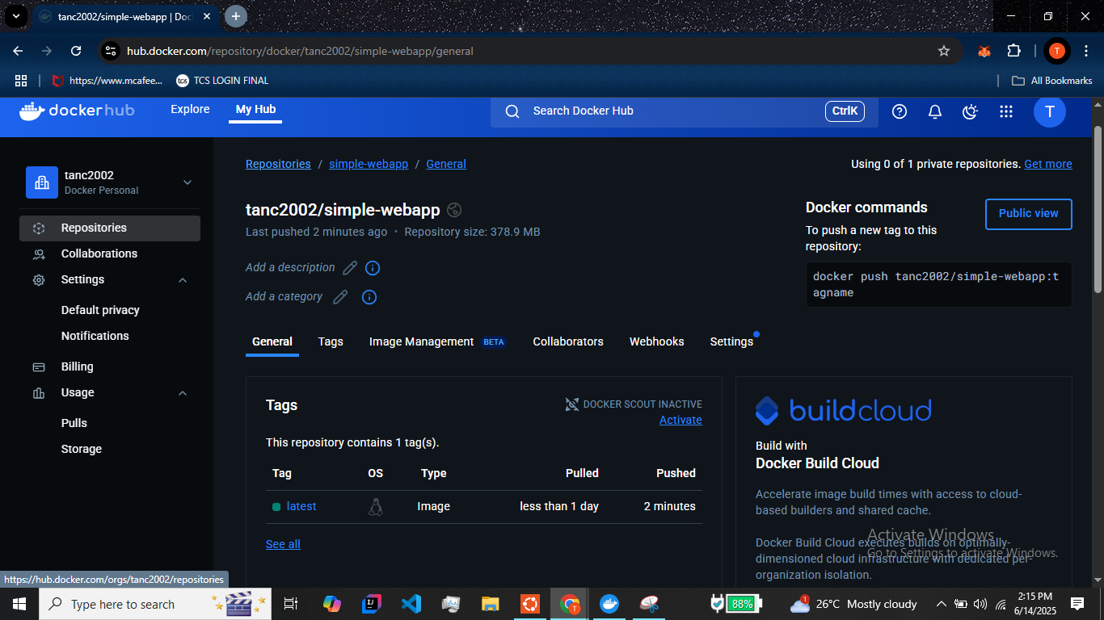

**Step 5:** Start the minikube cluster and create a deployment using the previously pushed image.

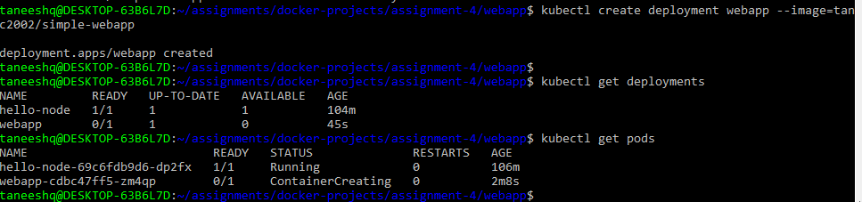

**Step 6:** Create a service from the deployment by exposing it on port 3000.

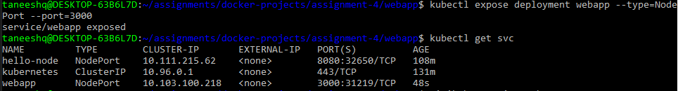

**Step 7:** Access the service using minikube. Check the url provided by minikube by pasting it in browser.

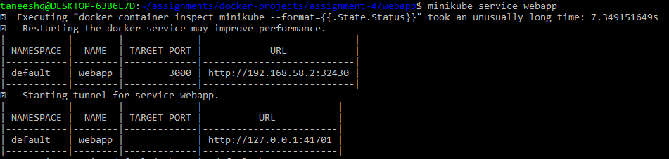

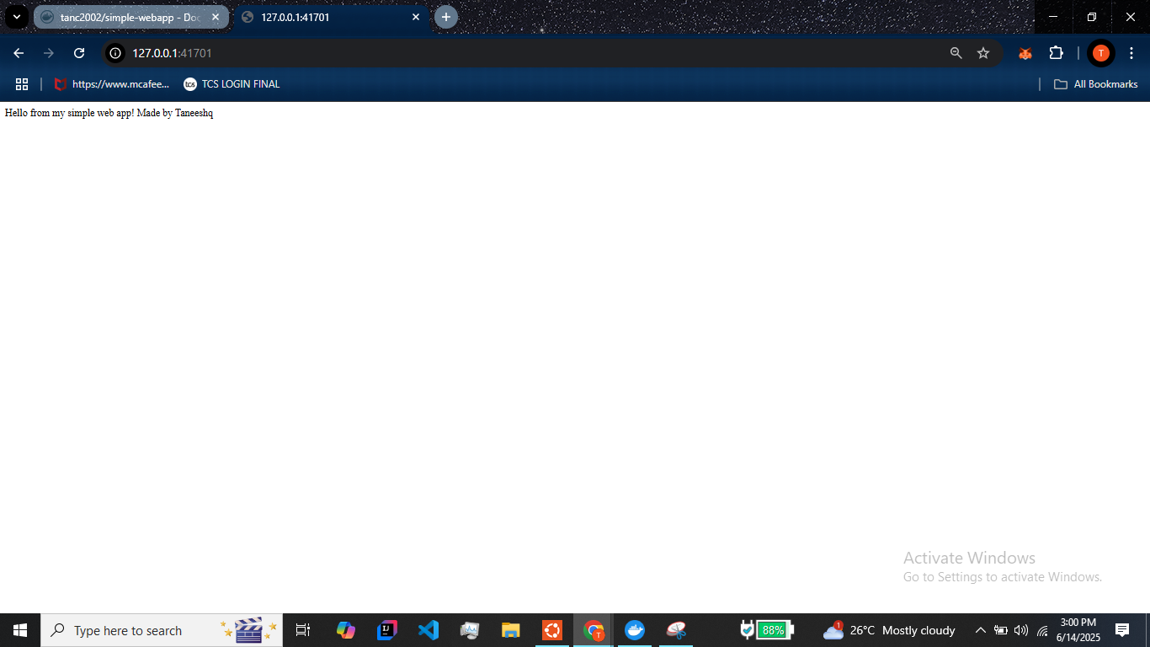

**Step 8:** Scale up the deployment by adding pods. Here I scaled it up to 3 pods.

**kubectl scale deployment webapp --replicas=3**

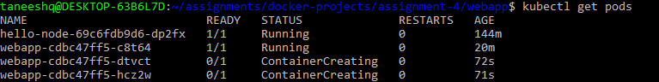

**Step 9:** Make minute changes in the webapp and push a new image to dockerhub. I just added a tag “v2”. Use the new image to create deployment.

