Name: Taneeshq Cholekar Date:15/06/2025

Assignment-6

Docker and Kubernetes: The container masterclass

**Problem Statement:**

Scale and Update Deployments, update the number of instances a deployment from 1 to 10, make sure to you need a running deployment as you did in the previous assignments. Perform also a rolling upgrade of your application to a new container image, update your deployment to use the v2 image

**Methodology:**

I had created a docker image in “Assignment-5” and it was a simple webapp developed using nodejs and expressjs. The image was already uploaded onto dockerhub hence the same image will be deployed in this assignment.

**Step 1:** Start minikube cluster

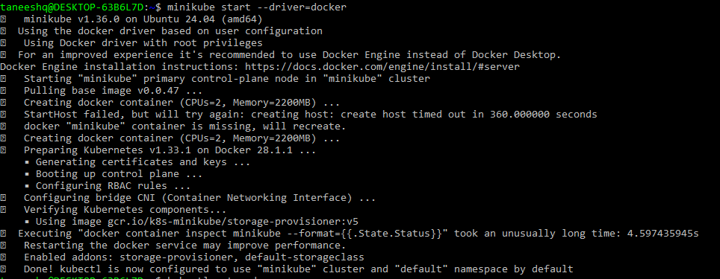

**Step 2:** Create a deployment for webapp using the latest image.

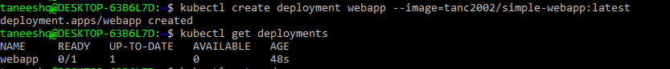

**Step 3:** Expose the deployment on port 3000 to run the application. Verify the url given by minikube and browser url.

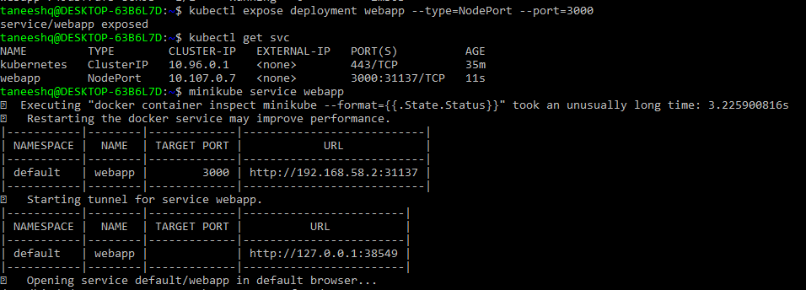

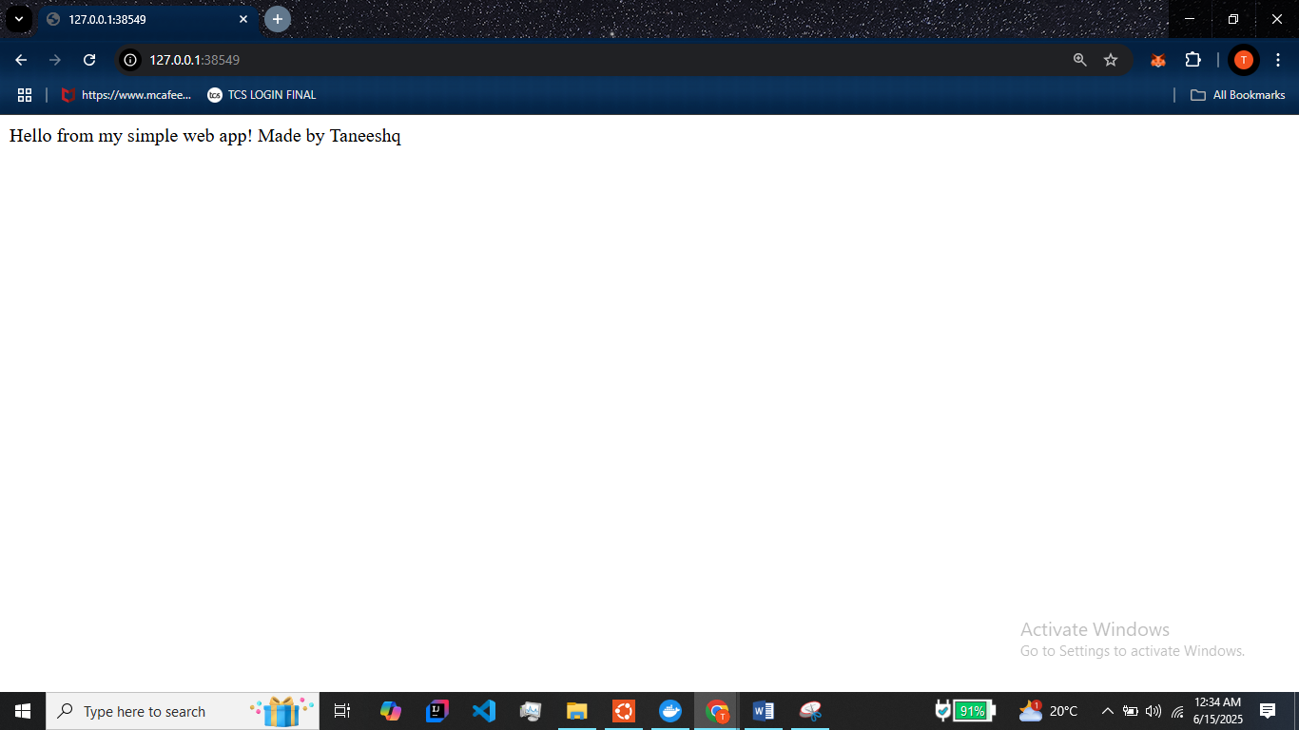

**Step 5:** Perform a rolling upgrade by using the tag “v2” along with the image. (Note version v2 is existing in the repository).

Check the rollout status then run the minikube service to view the output of new image. Also verify in browser.

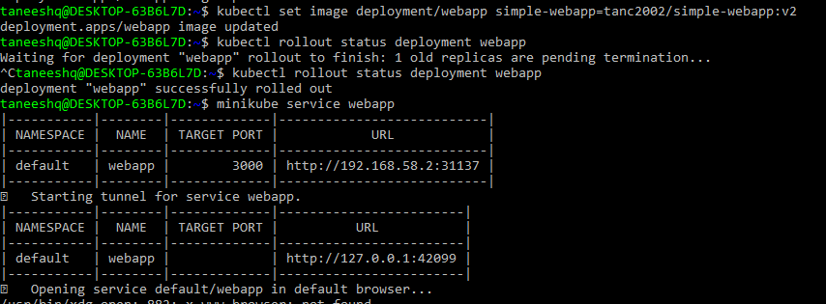

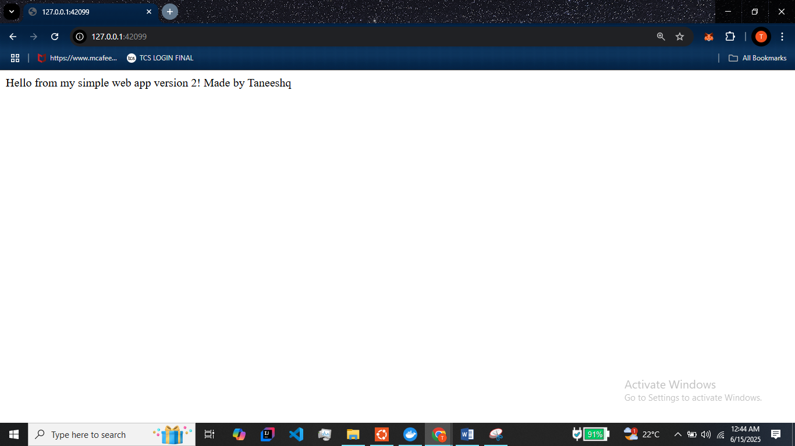

**Step 6:** Create 10 replicas of the deployment and view their status.

