Name:Taneeshq Cholekar Date:16/06/2025

Assignment-7

Docker and Kubernetes:The container masterclass

**Problem Statement:**

Deploy a microservice using Apache Zookeeper, instead of doing manually. using kubectl, create a template of a K8s manifest for each K8s resource that you need for your application. The template should refer to parameters (e.g. image name, deployment name, port number, etc.). Those parameters should substitute with provided values during the deployment.

**Methodology:**

**Step 1:** Create the required files and directories. I have an env file, a deploy.sh script and a zookeeper-deployment.yaml along with zookeeper-service.yaml.

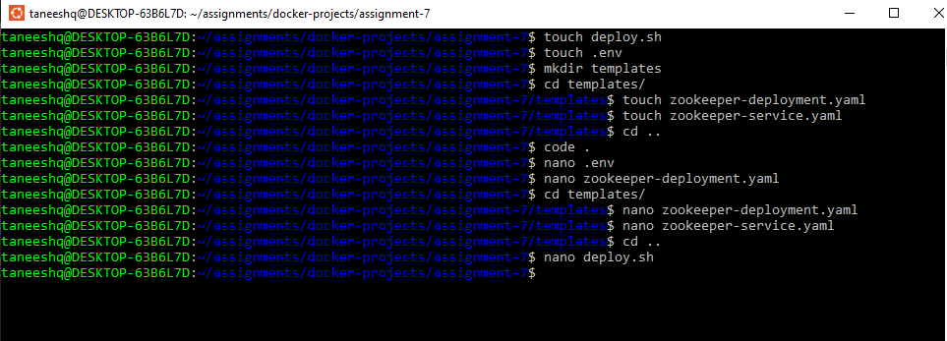

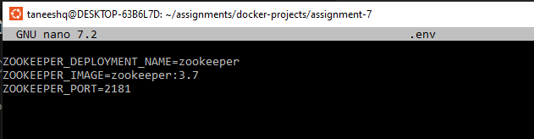

**Step 2:** Write the deployment instructions.

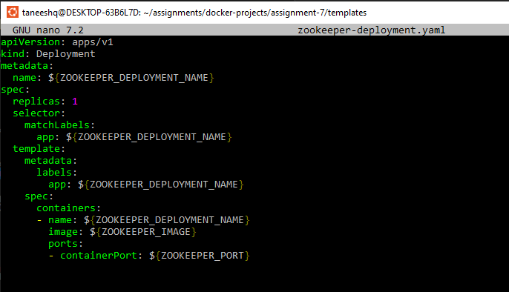

**Step 3:** Write the service instructions.

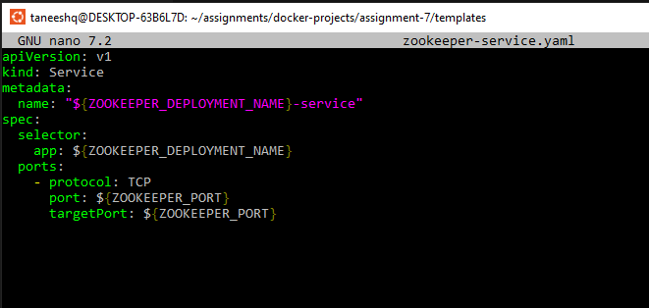

**Step 4:** Finally I wrote the script for deploying the microservice and made it executable by

**“chmod +x deploy.sh”**

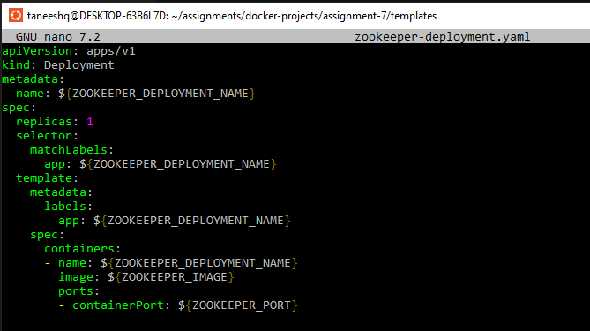

**Step 5:** To create the deployment and service I executed the deploy.sh script.

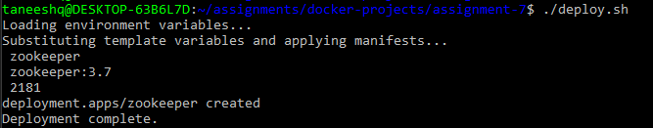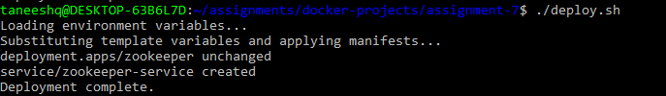

**Step 6:** To see the final output and verify the deployments and services I listed them.

