Name: Taneeshq Cholekar Date:31/05/2025

Assignment-1

Git and Github Crash course

(github url: <https://github.com/Taneeshq2002/git-projects.git> )

**1)** **Create the project for git which performs the operations like add, commit, push & pull.**

The following steps were executed to achieve the objective:

**1) Create a directory git-projects and a subdirectory assignment-1 and initialize a git repository. Also create 2 files “file1” and “file2” .**

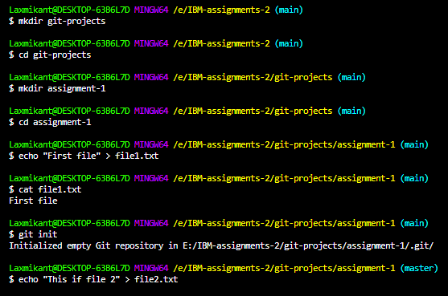

**2) Add the files to staging area using “git add .” and commit using “git commit –m “ ” ”.**

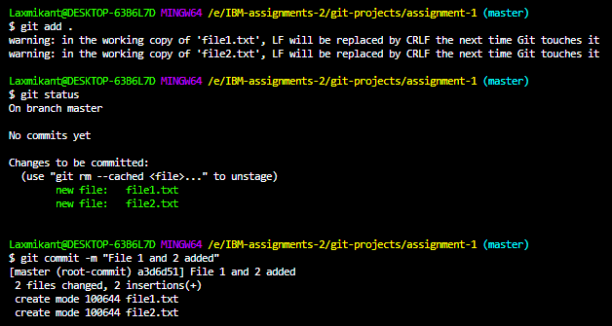

**3) To perform push and pull I created a remote repository on github named “git-projects”, added it as origin in the local repository using and pushed the files from local repository to the remote repository.**

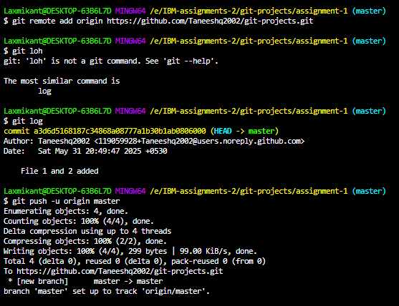

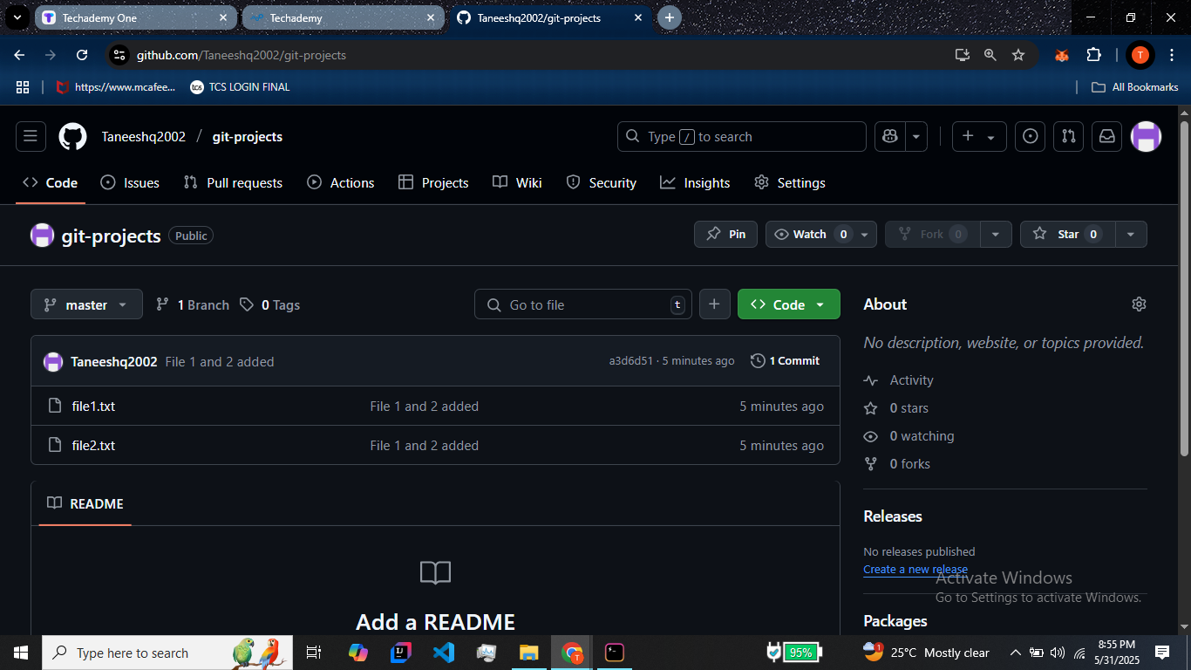

**4) To demonstrate pull command usage. I created a file “file3” in remote repository and updated the local repository.**

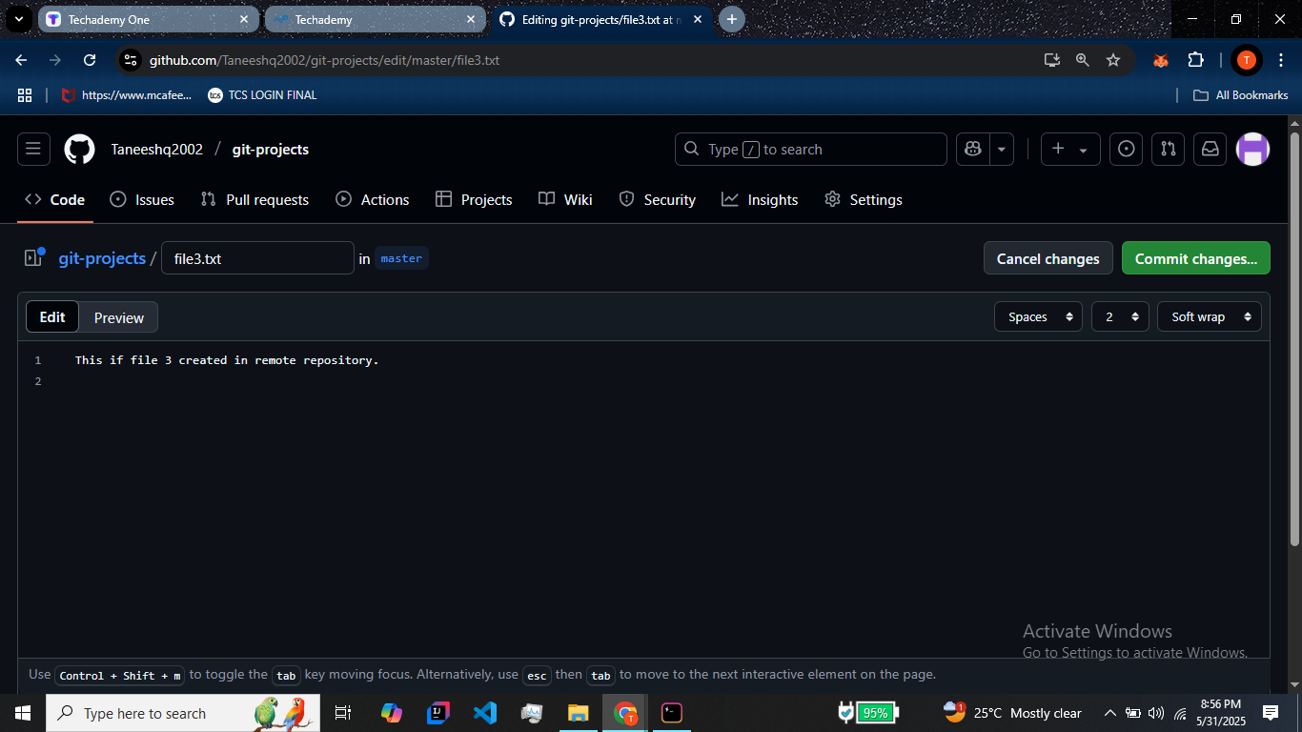

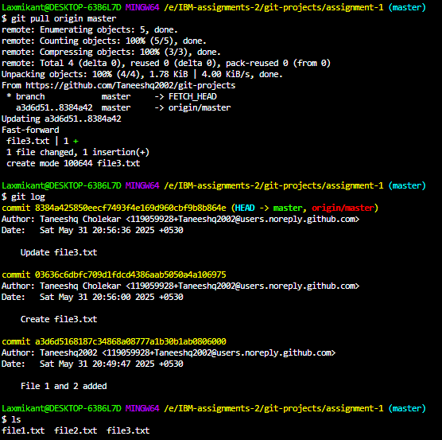

**2) Create the project with git for managing the files by using reverting changes in the file, move files, renaming the files, & also deleting the files.**

The following steps were executed:

**1) To demonstrate revert usage I first modified file1 with new content and logged the content. Then I reverted to previous unmodified file1 using “git revert”**

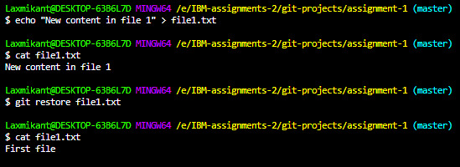

**2) Next, I moved the file “file2” to directory named “archive” and pushed the changes to origin.**

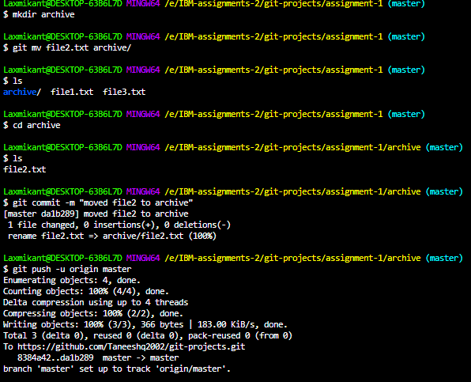

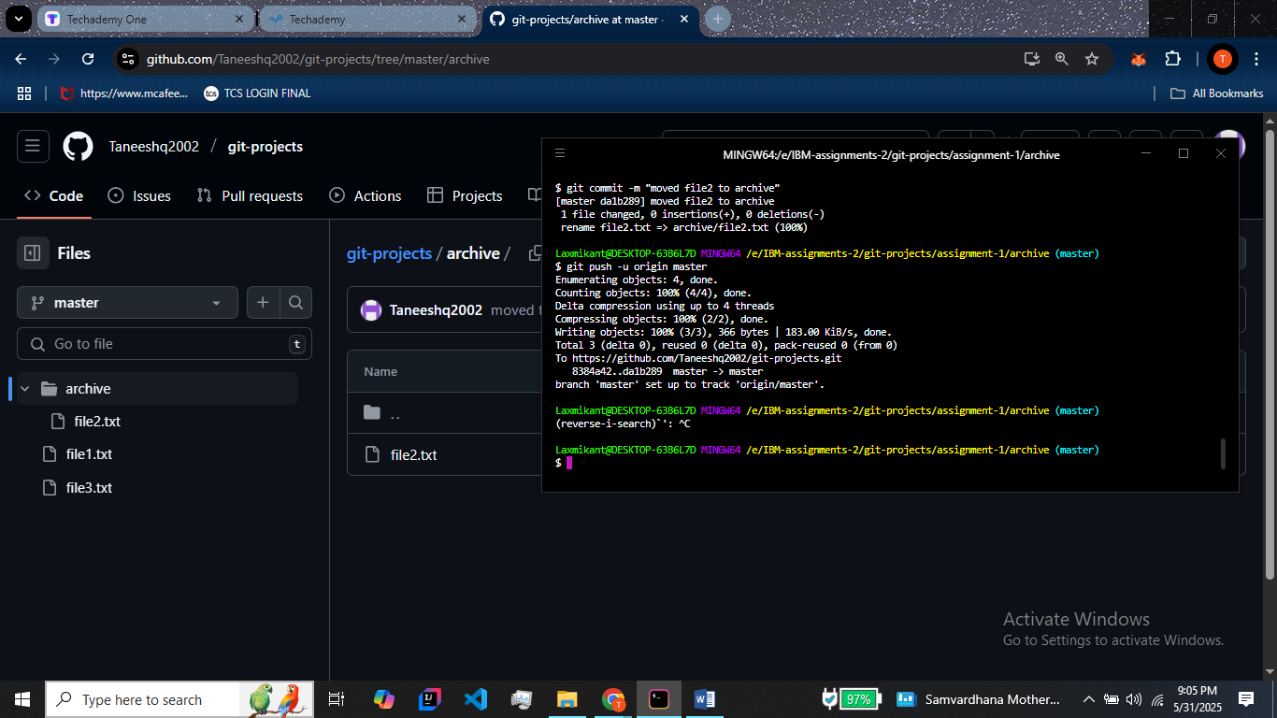

**3) Next I renamed “file1” to “renamed_file1” using git mv.**

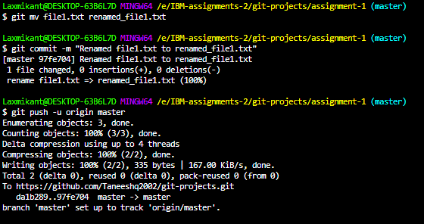

**4) Lastly I deleted “file3” and commited it and finally pushed it to origin.**

