COMMERCIAL REVIEW · FOR APPROVAL

Project Cost and Revenue Approval Report
Staffing assumptions, project economics and approval record
Purpose. Review and approve the commercial assumptions, staffing ramp up, cost allocation and revenue forecast before the project estimate is used for a customer commitment or delivery baseline.

Report identification
Field | Project details | Field | Project details
Project / client | <<Project name>> / <<Client>> | Report ID / version | <<Report ID>> / <<Version>>
Scenario / model | <<Scenario>> / <<T&M, Fixed Price, Outcome-based, Story Points>> | Prepared by / date | <<Owner>> / <<Date>>
Estimate period | <<Start date>> – <<End date>> | Currency / price basis | <<Currency>> / <<Net or gross basis>>

Decision requested
Select one outcome after reviewing the inputs, exclusions and reconciliations in this report.
☐ Approve ☐ Approve with conditions ☐ Return for revision ☐ Reject
Approver | Name | Decision / conditions | Date / signature
Delivery / Project Manager | <<Name>> | <<Decision and conditions>> | <<Date / signature>>
Finance | <<Name>> | <<Decision and conditions>> | <<Date / signature>>
Commercial / Account owner | <<Name>> | <<Decision and conditions>> | <<Date / signature>>

1. Commercial and delivery assumptions
Record the approved baseline and point each input to an estimate, contract clause or source record.
Assumption | Approved value / scope | Evidence or owner
Commercial model and revenue trigger | <<T&M hours / milestone / accepted outcome / accepted story points>> | <<Contract section / owner>>
Staffing, seniority and locations | <<Roles, seniority mix, delivery locations and vendors>> | <<Staffing plan version>>
Work calendar and capacity | <<Hours per FTE, holidays, leave and productive days>> | <<Calendar / source>>
Utilization and billability | <<Billable share, ramp constraints and non-billable work>> | <<Assumption owner>>
Cost and selling rates | <<Rate card version, effective dates, rate unit and currency>> | <<Catalogue / approval>>
Additional costs | <<One-off and recurring expenses; allocation basis>> | <<Cost schedule / owner>>
Foreign exchange and price basis | <<FX source/date; currency conversion; VAT/tax treatment>> | <<Finance source>>
Contingency and exclusions | <<Reserve, scope exclusions and dependencies>> | <<Risk / change reference>>

Financial measure definitions
Use one approved definition throughout the total, location and seniority views.
Measure | Finance-approved formula and scope | Allocation or source basis
Total cost | <<Included cost categories and treatment of overhead>> | <<Actual / planned / allocated>>
Project profit | <<Revenue less approved project cost basis>> | <<Recognition and period basis>>
LM | <<Full name, numerator, denominator and whether amount or %>> | <<Labor revenue / labor cost rule>>
PM | <<Full name, numerator, denominator and whether amount or %>> | <<Project revenue / project cost rule>>
EBIDA / EBITDA | <<Exact company metric and approved definition>> | <<Direct costs, overhead and excluded items>>

Finance confirmation required. The source project defines neither LM nor PM, and the request says EBIDA. Confirm the full names, formulas, accounting scope and segment allocation rules before an approver signs off. Do not silently substitute EBITDA for EBIDA.

2. Staffing ramp up
Show when each group starts and how planned active capacity accumulates over the estimate period.
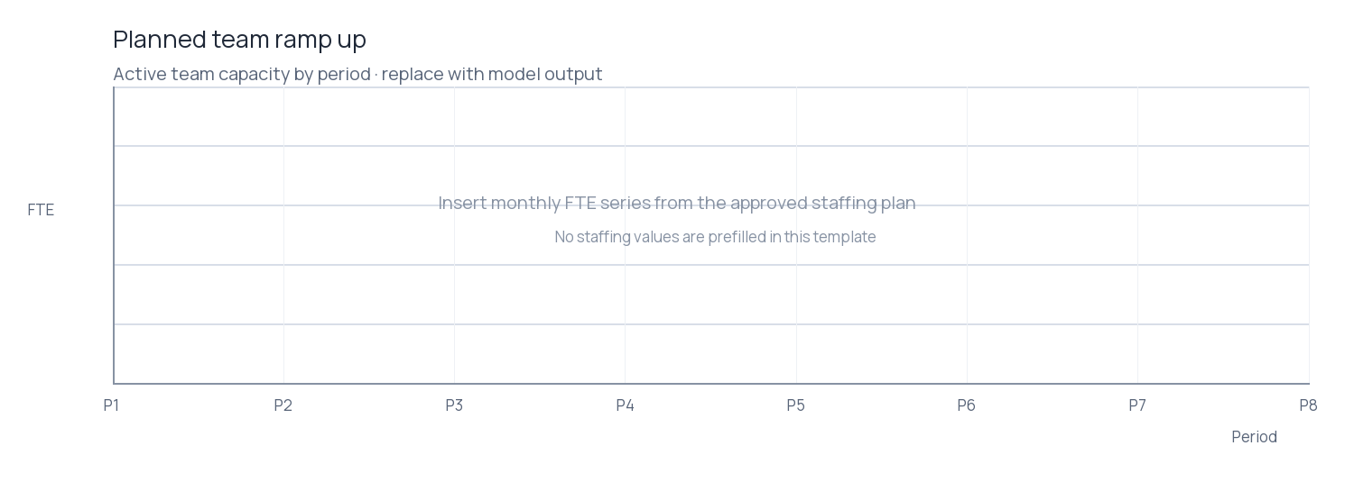
Figure 1. Replace this blank plot with the model-generated FTE-by-period chart. Use period labels from the estimate and distinguish seniority or location only when it improves the approval decision.
Period / start | Location | Role / seniority | New joiners | Active FTE | First billable date
<<Month / date>> | <<Location>> | <<Role / level>> | <<Count>> | <<FTE>> | <<Date>>
<<Month / date>> | <<Location>> | <<Role / level>> | <<Count>> | <<FTE>> | <<Date>>
<<Month / date>> | <<Location>> | <<Role / level>> | <<Count>> | <<FTE>> | <<Date>>
<<Month / date>> | <<Location>> | <<Role / level>> | <<Count>> | <<FTE>> | <<Date>>

Reconcile. The schedule should agree with the approved staffing plan, cost start dates, billable start dates and rate effective periods. Add rows for every location, seniority and material start-date change.

3. Executive economics and team pyramid
Present approved totals first, then show how the same economics distribute across delivery locations.

Whole-project summary
Measure | Amount | Rate / percentage | Definition / note
Total project revenue | <<Amount>> | — | <<Recognition basis>>
Total project cost | <<Amount>> | — | <<Cost scope>>
Project profit | <<Amount>> | <<Profit / revenue %>> | <<Approved formula>>
EBIDA / EBITDA | <<Amount>> | <<% if applicable>> | <<Company definition>>
LM | <<Amount>> | <<LM %>> | <<Approved definition>>
PM | <<Amount>> | <<PM %>> | <<Approved definition>>

Team pyramid by seniority
Use the same seniority labels as the staffing plan. Replace placeholders with planned FTE or headcount and remove unused tiers.
<<Tier 5 / highest seniority>> · <<FTE / people>>
<<Tier 4>> · <<FTE / people>>
<<Tier 3>> · <<FTE / people>>
<<Tier 2>> · <<FTE / people>>
<<Tier 1 / entry seniority>> · <<FTE / people>>

Economics by location
Repeat a row for each location. LM and PM must use the Finance-approved definitions recorded on page 2.
Location | Total cost | Revenue | Profit | EBIDA / EBITDA | LM amount / % | PM amount / %
<<Location A>> | <<Amount>> | <<Amount>> | <<Amount>> | <<Amount>> | <<Amt / %>> | <<Amt / %>>
<<Location B>> | <<Amount>> | <<Amount>> | <<Amount>> | <<Amount>> | <<Amt / %>> | <<Amt / %>>
<<Location C>> | <<Amount>> | <<Amount>> | <<Amount>> | <<Amount>> | <<Amt / %>> | <<Amt / %>>
TOTAL | <<Amount>> | <<Amount>> | <<Amount>> | <<Amount>> | <<Amt / %>> | <<Amt / %>>

Pyramid basis. Specify whether the pyramid shows people or FTE. Reconcile both headcount and FTE to the ramp-up schedule; do not infer a hierarchy for a role family with a different seniority scale.

4. Cost and revenue by location and seniority
Every row represents the intersection of one delivery location and one seniority. Add rows as needed and reconcile the totals to page 3.

Cost breakdown
Location | Seniority | Planned FTE | Labor / vendor cost | Other allocated cost | Total cost
<<Location>> | <<Level>> | <<FTE>> | <<Amount>> | <<Amount>> | <<Amount>>
<<Location>> | <<Level>> | <<FTE>> | <<Amount>> | <<Amount>> | <<Amount>>
<<Location>> | <<Level>> | <<FTE>> | <<Amount>> | <<Amount>> | <<Amount>>
TOTAL | — | <<FTE>> | <<Amount>> | <<Amount>> | <<Amount>>

Revenue breakdown
Location | Seniority | Revenue basis / unit | Revenue | Share of total | Source / trigger
<<Location>> | <<Level>> | <<Hours / milestone / outcome / SP>> | <<Amount>> | <<%>> | <<Contract clause>>
<<Location>> | <<Level>> | <<Hours / milestone / outcome / SP>> | <<Amount>> | <<%>> | <<Contract clause>>
<<Location>> | <<Level>> | <<Hours / milestone / outcome / SP>> | <<Amount>> | <<%>> | <<Contract clause>>
TOTAL | — | — | <<Amount>> | 100% | <<Recognition basis>>

Allocation rule. Show how shared costs and revenue are allocated across seniority and location. Any unallocated amount must be listed separately and must reconcile to the project total.

5. EBIDA / EBITDA by location and seniority
Use the exact measure approved by Finance. Show its components, allocation basis and reconciliation to the whole-project figure.
Location | Seniority | Allocated revenue | Allocated operating cost | EBIDA / EBITDA | Margin %
<<Location>> | <<Level>> | <<Amount>> | <<Amount>> | <<Amount>> | <<%>>
<<Location>> | <<Level>> | <<Amount>> | <<Amount>> | <<Amount>> | <<%>>
<<Location>> | <<Level>> | <<Amount>> | <<Amount>> | <<Amount>> | <<%>>
TOTAL | — | <<Amount>> | <<Amount>> | <<Amount>> | <<%>>

Reconciliation and approval checks
Control | Evidence / result
Location totals equal the whole-project totals | <<Yes / no; variance and explanation>>
Location and seniority rows cover the full staffing plan | <<Yes / no; remaining FTE>>
Revenue trigger and billing units match the commercial model | <<Yes / no; contract reference>>
Cost rates, dates and non-labor costs have an owner and source | <<Yes / no; references>>
LM / PM / EBIDA definitions and allocation rules are approved | <<Finance approval reference>>

Open conditions and decision record
Condition / unresolved assumption | Owner | Due date | Resolution / approver
<<Condition or None>> | <<Owner>> | <<Date>> | <<Resolution>>
<<Condition or None>> | <<Owner>> | <<Date>> | <<Resolution>>

Release gate. Replace every <<placeholder>>, attach the staffing and cost source files, resolve or list every open condition, and record approver decisions before circulating a final estimate.

