**研究生试题 - Coins Segmentation**

You can do this test with hand work (create an actual digital image of a few coins, all coins in one image, with digital camera or cell phone camera), or you can enter the data (Fig.1) into MATLAB or any other image tool and use the tool to answer the following questions.

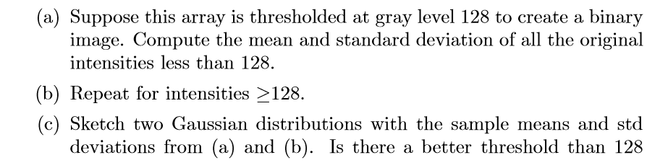

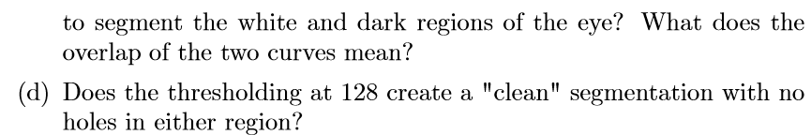

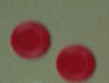

Fig.1: Coins