Training plan overview
Secure file storage

Prepared
Revieved
Approved

Document history
Version | Date | Author(s) | Description
0.1 |  |  | Initial draft
Contents

1. Purpose of the project 4
2. Requirements 5
2.1 Requirement types 5
2.2 Requirement list 5
2.2.1 General 5
2.2.2 Server 5
2.2.3 Client 6
3. Personnel 6
3.1 Roles 6
3.1.1 Server lead 7
3.1.2 Client lead 7
3.1.3 Integration lead 7
3.1.4 Programmer 7
3.1.5 Server integrator 7
3.1.6 Client integrator 7
3.2 Programming team 8
4. Schedule and management 8
4.1 General 8
4.2 Management procedure 8
4.3 Schedule 10
Appendices 11

Purpose of the project
The goal of the second phase of the Linux programming training is to design, implement, integrate and test secure file storage server and client applications.
Each application shall be modular, with well-defined interfaces. The main proposed packages for each application are shown in Image 1.
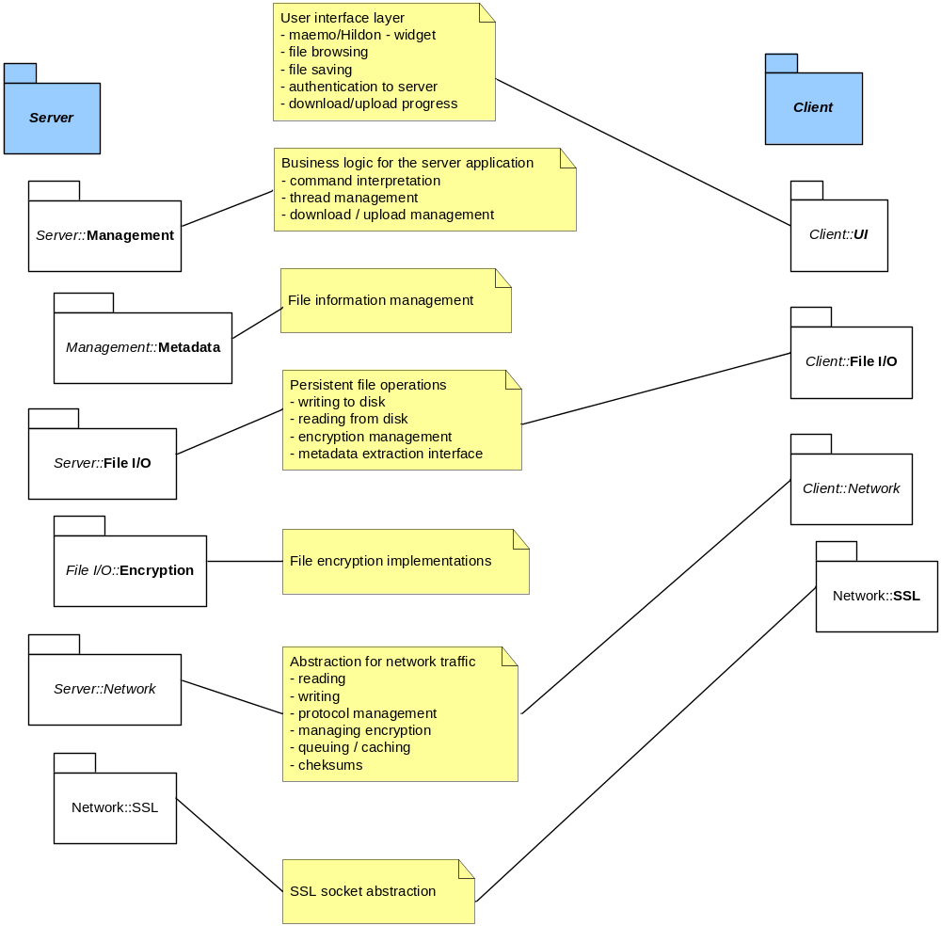
Image 1. Main packages

Requirements

Requirement types
There are three types of requirements scoped out in this document that define what features is required from the Secure File Storage. The following words are used in each requirement to indicate the level of importance:
MUST HAVES: the requirement must be fulfilled, i.e. it is obligatory.
SHOULD HAVES: the requirement should be fulfilled. The system is preferred to fulfil the requirement but it is not obligatory.
MAY HAVES: The requirement may be fulfilled. The requirement indicates a possible feature or functionality as a suggestion.

Requirement list

General
- The system MUST enable the storage of a file sent from the client to disk using strong file encryption
- The system MUST support attaching metadata to each file to be stored
- The system MUST support retrieval of file metadata from the server
- The system MUST enable the retrieval of a file stored to the disk to the client
- The system MUST use secure network transfer
- The system MUST have defined command/transfer protocol in application level
- The command/transfer protocol MUST have a file integrity check
- ...

Server
  - The server MUST be multi-threaded, allowing multiple simultaneous client connections
  - The server SHOULD be configurable to adjust the maximum amount of client connections
  - The server MUST use SSL server authentication
  - The server SHOULD allow changing the SSL certificate over existing established connection
  - The server MUST be configurable using settings file
  - The server SHALL be run-time configurable using setup commands
  - The server MUST log the file transaction events
  - The server MUST support username/password -authentication
  - The server MAY support OS-level authentication from clients
  - The server MAY support re-establishing of downloads/uploads in case of connection failure
  - ...

Client
    - The client MUST be a qualified maemo- application with defined behavior regarding taskbars, termination etc.
    - The client MUST have file browsing capability for both upload and download
    - The client MUST have metadata entering and displaying capability
    - The client MUST ensure successful file download, i.e. check for available disk space etc.
    - The client MUST be able to connect using SSL sockets
    - The client MUST support username/password –authentication to the client
    - The client SHOULD support server management features, such as setting connection limits, changing the certificate etc.
    - ...

Personnel

Roles
Each programming team will have following roles:
- Server Lead
- Client Lead
- Integration Lead
- Programmer
- Server integrator
- Client integrator

Server lead
Server lead is responsible for server design desicions together with the server team. Additionally, server lead shall take part in server programming.

Client lead
Client lead is responsible for client design desicions together with the server team. Additioanlly, client lead shall take part in client programming.

Integration lead
Integration lead is responsible for:
- integration schedule
- integration plan
- verification plan
- version management planning
Additionally, integration lead shall take part either server or client programming.

Programmer
Programmer shall implement the required features, create unit test scripts and perform unit testing prior submitting code to integration.

Server integrator
Server integrator is responsible for ensuring that:
- all server code submitted to version management by the end of the day is compilable
- all designated unit tests are created
- run the unit test scripts before committing the code to daily integration
- design the unit test scripts with the responsible programmer
Additionally, server integrator shall take part on server programming.

Client integrator
Client integrator is responsible for ensuring that:
- all client code submitted to version management by the end of the day is compilable
- all designated unit tests are created
- run the unit test scripts before committing the code to daily integration
- design the unit test scripts with the responsible programmer
Additionally, client integrator shall take part on client programming.

Programming team
The team should be composed of ~ 10 persons, with following role break-up:
- Server Lead
- Client Lead
- Integration Lead
- Programmer 1
- Programmer 2
- Programmer 3
- Programmer 4
- Programmer 5
- Server integrator
- Client integrator

Schedule and management

General
The project schedule and progress is managed by Plenware staff, and the responsible person will act as project manager for all development teams.

Management procedure
The project will be ran as a ‘lightweight’ AGILE/SCRUM project, with following key points:
- Project will start with a kick-off, where main features are discussed in casual manner
- All teams will implement all the high priority features
- After initial planning, the programming is done in weekly cycles
  - Feature implementation order may be changed during the process, if necessary
- In the beginning of each programming week there is a team meeting with project manager
  - previous week achievements
  - feature backlog overview
  - progress monitoring
- All code is integrated daily, with unit tests
- Every day, there will be a 15-20 minute team meeting prior daily integration
  - Integration criteria is decided

Schedule
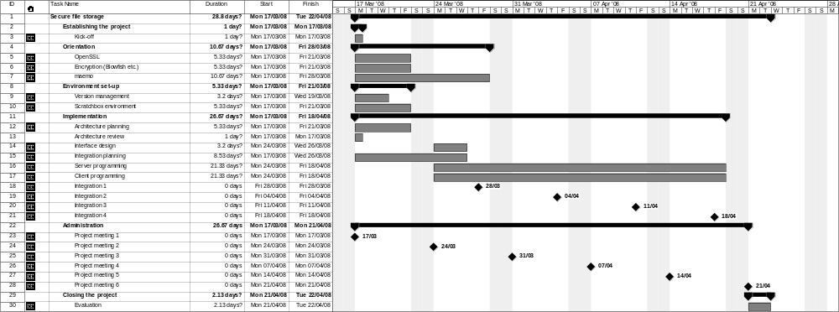

Appendices
- App. 1
- App. 2
- ...

