**COMP526 HW5**

Mo Tang mt60

We have two instructions: the chunked and interleaved.

For each situation, we keep TOTALSIZE fixed at 8192 , then vary the number of processors NUM_PROCESSORS for the values: 1, 2, 4, 8, and 16.

1. Interleave max_delay = 0

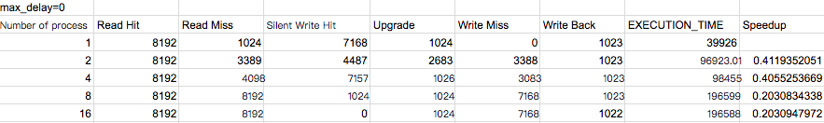

1. Interleave max_delay = 100

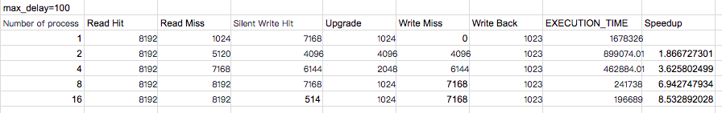

For interleaved situation, we got this figure:

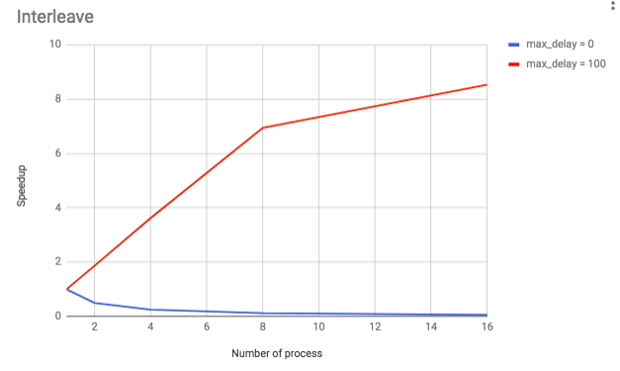

In MSI, each block contained inside a cache can three possible states: Modified, Shared and Invalid. By interleaving the array elements among the processors, we vary the number of process from 1 to 16, and we can see an increase of Speedup when max_delay = 100, and a decrease of Speedup when max_delay = 0. When the time between successive memory requests by a processor increase, the execution time will decrease when number of process increase. On the contrast, the execution time will increase with number of process when the time between successive memory requests by a processor is 0.

1. Chunk max_delay = 0

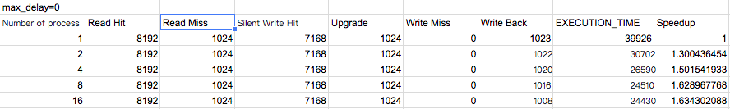

1. Chunk max_delay = 100

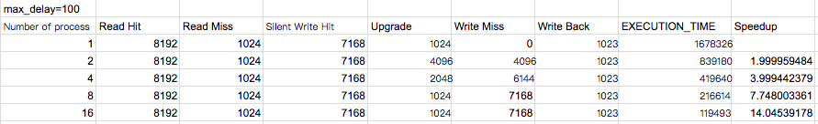

For chunked situation, we got this figure:

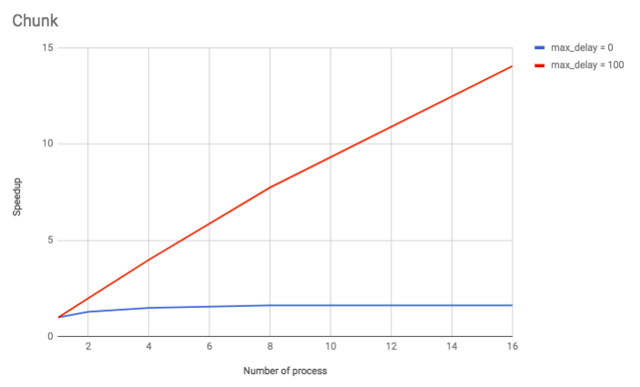

when partitioning the array among the processors either in large contiguous chunks, the tendency is a little different. This time whatever the time between successive memory requests by a processor, the execution will decrease with the increase of number of process. But it will show bigger change for max_delay = 100 situation.