VIETNAM NATIONAL UNIVERSITY

HO CHI MINH CITY UNIVERSITY OF TECHNOLOGY

FACULTY OF COMPUTER SCIENCE AND ENGINEERING

SOFTWARE ENGINEERING

Assignment

“URBAN WASTE COLLECTION – UWC 2.0”

Group: 4

MEMBERS: Phạm Hoàng Minh - 2152771

Tăng Tuấn Đạt – 2152512

Tạ Gia Khang – 2152652

Nguyễn Chánh Tín - 2153043

Table of Contents:

Chapter 2: **System modeling 3**

**2.1: Activity diagrams 3**

**2.2: Sequence diagram: 6**

**2.3 Class diagram 8**

**2.4 MVP 1 for Desktop-view central dashboard 9**

**Chapter 2: System modeling**

**2.1: Activity diagrams**

**2.1.1 Back officer assigning vehicles**

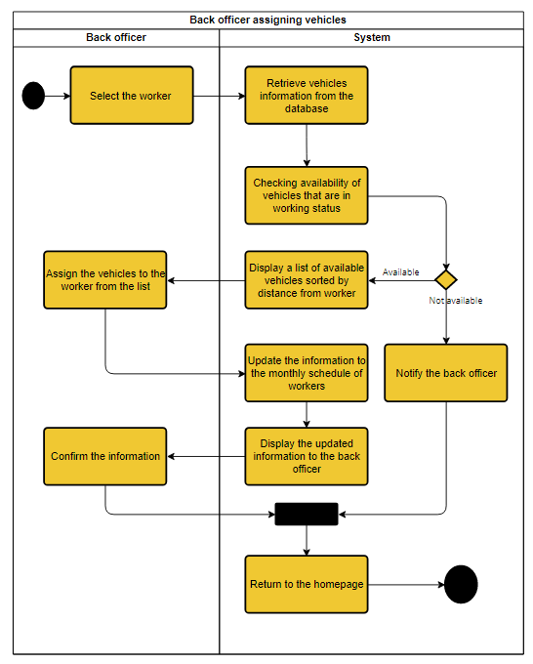

This use-case involves the process of assigning vehicles to sanitization workers for the month. The process starts with the back officer selecting the worker to assign a vehicle to, and ends with the user being returned to the homepage. The type of vehicle will be automatically assigned base on the role of each user. The system retrieves information about the availability of vehicles from the database, and if no vehicle is available, the system notifies the back officer and returns to the homepage. However, if there are vehicles available, the system displays a list of vehicles sorted by the distance from the worker. The back officer selects a suitable vehicle for the worker, and the information is sent to the database. The information is then sent back for a final inspection, and if the back officer wants to make any changes at this step, they will have to redo the use-case.

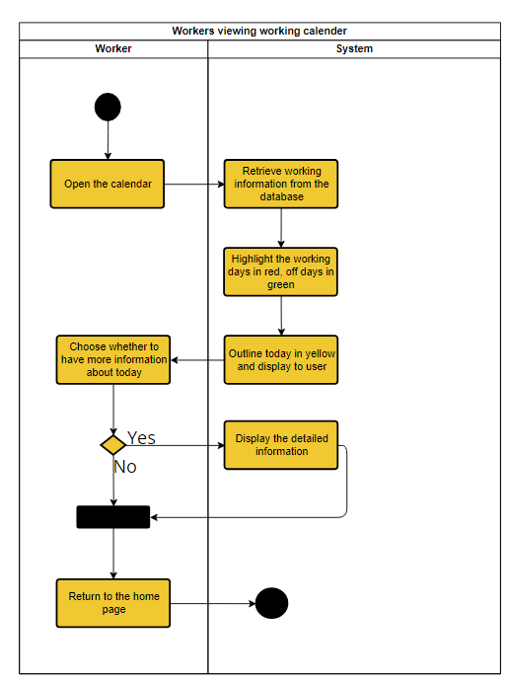

At the start of this use-case, the user is on the homepage of the system. They can access the calendar by clicking on it. Upon opening the calendar, the system will retrieve all the essential information related to the user's schedule such as working days, off days, and highlight the current day with a yellow outline. This information will be displayed to the user. If the user wants to view more information about a particular day, they can click on that day, or they can choose to return to the homepage after viewing the information.

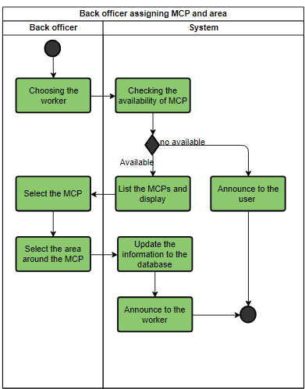

This use-case involves the process of assigning MCP and the area. The process starts with the back officer selecting the janitor to assign a MCP to, and ends with the user being returned to the homepage. After the back officer prompt the user for the availability of the MCPs, the systems will check and display the available MCPs (not out of service or already pre-assigned). If there are none available, the system will announce to the user and return to the homepage. Otherwise, the user will select a MCP from the list and select the area around the MCP to assign to the janitor. Next, the information will be passed to the database to get updated and announce to the user. The module will return to the home page afterward.

**2.2 Sequence diagram**

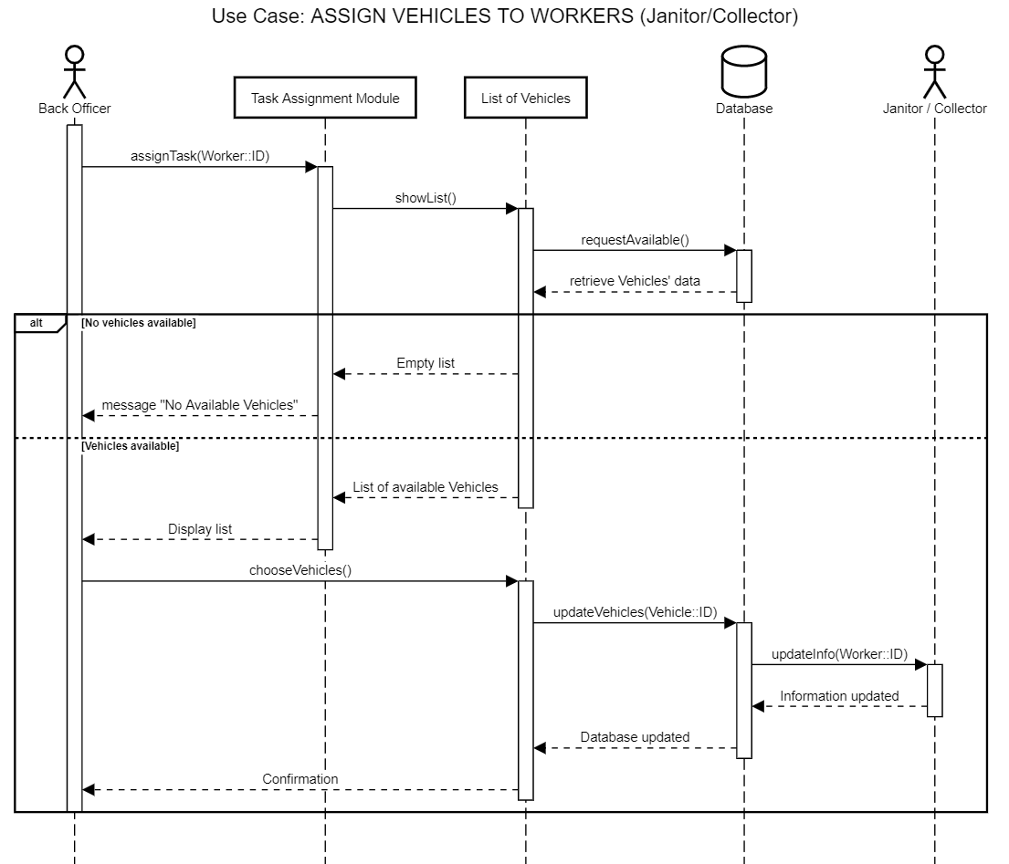

The sequence diagram illustrates the process of assigning vehicles to workers. The process is initiated by the back officer who triggers the task assignment module by providing the Worker ID (choosing a worker). The module then decides the suitable type of vehicle and requests a list of available vehicles. If the list is empty, the module returns a "No Available Vehicles" message. However, if the list is not empty, the module returns the list of available vehicles to the back officer who selects the suitable vehicle for the janitor or collector. Once the vehicle is selected, the module updates the database and sends a message to the worker to announce the chosen vehicle. The module then sends a confirmation to the back officer about the assignment.

**2.3: Class diagram**

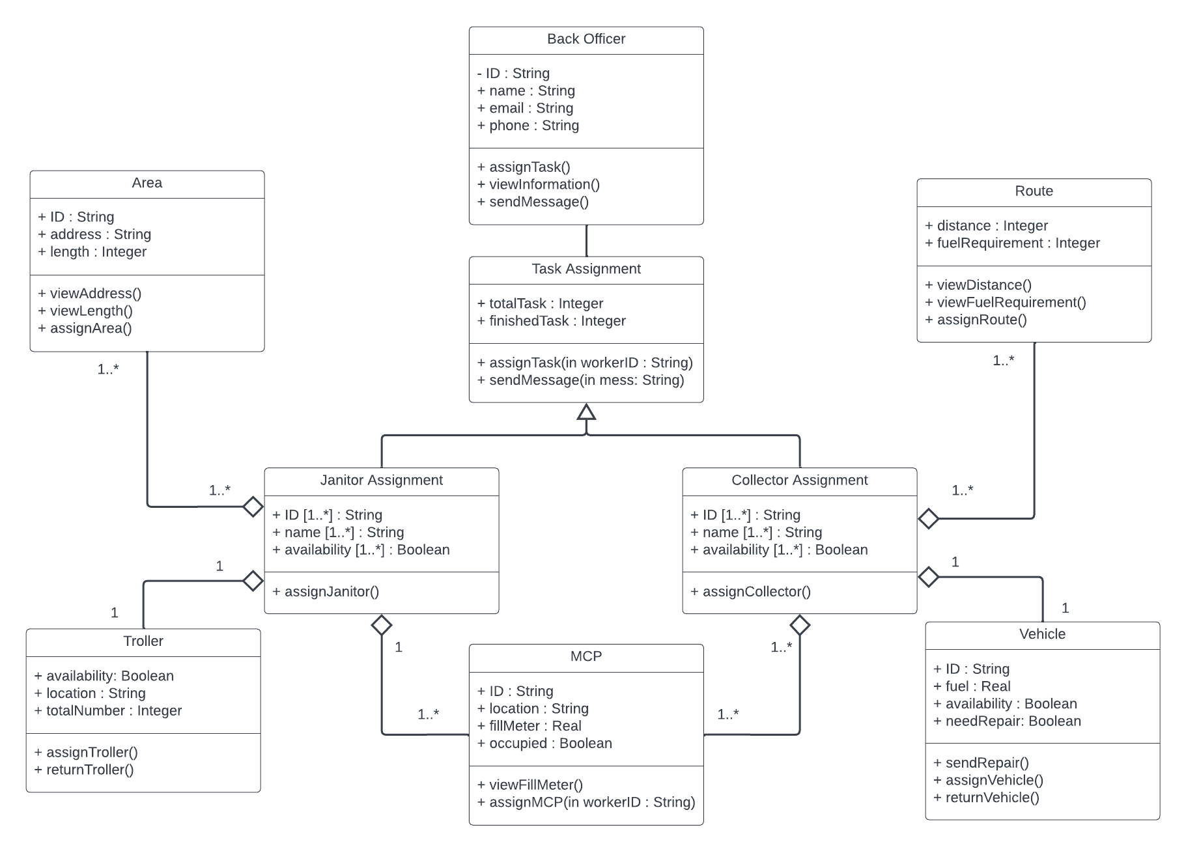

**2.4: Figma MVP of the desktop-view task assignment**

[**https://www.figma.com/file/6B9UuY4VdMjerQutLVJvp7/UWC-2.0-UI-(Community)?node-id=0%3A1&t=Tbi5YYFUNgIkZVxW-1**](https://www.figma.com/file/6B9UuY4VdMjerQutLVJvp7/UWC-2.0-UI-(Community)?node-id=0%3A1&t=Tbi5YYFUNgIkZVxW-1)

**The link above can be used to view the MVP in the functional state**

