VIETNAM NATIONAL UNIVERSITY

HO CHI MINH CITY UNIVERSITY OF TECHNOLOGY

FACULTY OF COMPUTER SCIENCE AND ENGINEERING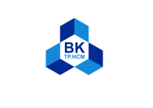

SOFTWARE ENGINEERING

Assignment

“URBAN WASTE COLLECTION – UWC 2.0”

Group: 4

MEMBERS: Phạm Hoàng Minh - 2152771

Tăng Tuấn Đạt – 2152512

Tạ Gia Khang – 2152652

Nguyễn Chánh Tín - 2153043

**USABILITY TESTING REPORT**

**1) Introduction and background**

1.1) The reasons for conducting this test

In the last chapter, we have designed and implemented an MVP, which can perform basic tasks such as showing the UI and somewhat allowing the user to interact with the system. However, as we are not the users from the previous version of UWC, as well as not exposed to the strengths and weaknesses of it. So, our vision of the UWC 2.0 may be unrealistic and impractical with features that the actors do not need, while inconvenient or outright lacking the necessary features. In other words, we need users that used and are using the system to help us design and create the most suitable version of the website possible.

While the requirements, functional and non-functional, have already been established in Chapter 3, the “abstract” requirements like UI friendliness or ease of use are difficult to achieve without actual field testing and having the participants will help in the finalization process. In addition, this will allow us to rearrange and distributed the user interface in the way that is the most beneficial.

All the references are provided at the end of this report

1.2) Introduction

The purpose of this usability test is to gather feedbacks and opinions from participants on the user interface (UI) of the UWC 2.0 MVP. As we are still in the early stages of development, it is crucial to understand how users interact with the UI and what improvements can be made. To ensure a realistic user experience, participants were recruited who were not involved in the development process and had no prior knowledge of the UWC 2.0. Through this test, we hope to gain insights on the UI's usability, user-friendliness, and overall effectiveness.

**2) Methodology**

At the start of the testing process, we planned to conduct a quantitative test to gather feedback about the MVP. However, the results from the initial test revealed that many issues persisted from UWC 1.0 due to the interface displaying either too much or too little information, as well as unnecessary features and hidden features. To obtain a more tailored experience for real users, we decided to include a qualitative test in our methodology.

During the quantitative test, participants were asked to complete a Google form to provide opinions on the aesthetic and predict the usability of the MVP. They were also asked to rate screenshots of the website based on the amount of information provided and whether it was too cluttered or not.

In the qualitative test, we selected five participants who had expressed strong positive or negative opinions about the MVP. We asked them additional questions to gain further insights and allowed them to interact with the MVP to gather feedback at each stage.

2.1) Quantitative testing:

For the quantitative testing, we obtained responses from 20 back officers who filled out a Google form. The questions focused on the aesthetics and usability of the MVP and allowed participants to rate these aspects on a scale of 1 to 5. Scores of 4 or 5 were considered successful, scores between 3 and 4 were passable, and scores below 3 required revisions. We used the built-in features of Google Forms to collect and analyze the data, creating graphs to illustrate the results. While we acknowledge that our sample size was relatively small, we believe that the test provided valuable insights and helped to engage officers in the improvement process by encouraging feedback

2.2) Qualitative testing

Based on the feedback gathered from the quantitative test, we conducted a qualitative test to obtain more detailed feedback on the user interface and user experience of the UWC 2.0 MVP. The aim of this test was to gather insights on the usability, user-friendliness, and overall effectiveness of the UI. We selected five participants for this test who had expressed strong positive or negative opinions about the MVP in the quantitative test or through email correspondence with us.

During the qualitative test, participants were asked to perform specific tasks using the MVP, including accessing the task assignment module from the login page. The task traversal was timed and observed to identify any potential choke points. Additionally, participants were encouraged to provide feedback on the UI and aesthetics of the MVP, as well as ask any questions they had.

3) Results and analysis

3.1) lightweight-ness

“I wish to love your website but it wouldn’t run well with my laptop”. One major issue that emerged from both the qualitative and quantitative testing was the lightweightness of the website. Several participants reported that the website was slow and unresponsive, particularly on older or lower-end devices. This feedback is significant as many back-officers, janitors, and collectors use the system on mobile devices, which requires a fast and easy-to-navigate system for them to check maps and sign-in for their day's work. In the quantitative test, over half of the participants did not feel entirely positive about the website's lightweightness, with a score of only 3.625 points, indicating a negative impact on the user experience. This feedback highlights the need for further optimization of the website's performance to improve usability.

3.2) Aesthetics and designs

Another issue that emerged from both the qualitative and quantitative testing was the aesthetics and design of the website. While some participants found the website easy to navigate, three out of five people who did the in-person test said that the website was too heavy, and the color scheme was too bold. This feedback was also reflected in the quantitative survey, where the initial view of the MVP received only 3.25 points. This can negatively affect the user's usability when performing tasks on the website. Therefore, the aesthetics and design of the website need to be improved to ensure a positive user experience.

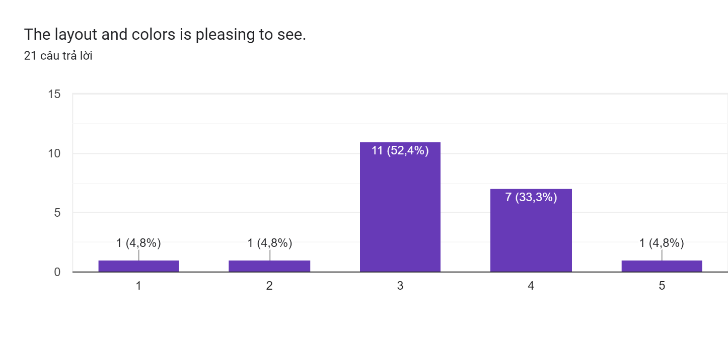

Picture 1

3.3) Intuitiveness

In terms of intuitiveness, our goal for the next version of the UWC is to make it as self-explanatory as possible to facilitate a smooth transition for users. However, feedback from participants in the in-person test indicated that the MVP lacked a help guide to assist new or older users in navigating to their desired destination. Despite this, we were pleased to note that the majority of survey respondents were able to understand the purpose of the website based on their experience with UWC 1.0.

**4) Recommendations and suggestions**

Based on the feedback obtained from the survey and in-person testing, we have identified several recommendations to improve the user experience of the UWC website. Firstly, the website's lightweightness needs to be improved by optimizing it for both desktop and mobile views, reducing transitions between modules, and ensuring that the website can fit on most devices. Secondly, the website's design should be modified to ensure that it does not impede the workers' efficiency, particularly on mobile devices. Lastly, adding a support button at the top left of the screen can assist new or elder users in using the website effectively. These changes will help to improve the overall usability of the UWC website and ensure that it meets the needs of its users.

**5) Appendix and references**

This survey was conducted using Google Forms and followed the [guidelines](https://www.nngroup.com/articles/usability-testing-101/). The qualitative testing questions were open-ended and focused on the following topics:

- Participant opinion on the current website (UWC 1.0)

- Participant opinion on the MVP and the online survey

- Hands-on use of the MVP, including ease of use and aesthetics

- Suggestions for improving the MVP.

Thank you to all participants for taking the time to provide valuable feedback. We also extend our gratitude to anyone who contributed to the project and helped make this survey possible.