

**Version 1.1.5**

**Benjamin J. W. Mills**[**b.mills@leeds.ac.uk**](mailto:b.mills@leeds.ac.uk) **// bjwmills.com // @bjwmills**

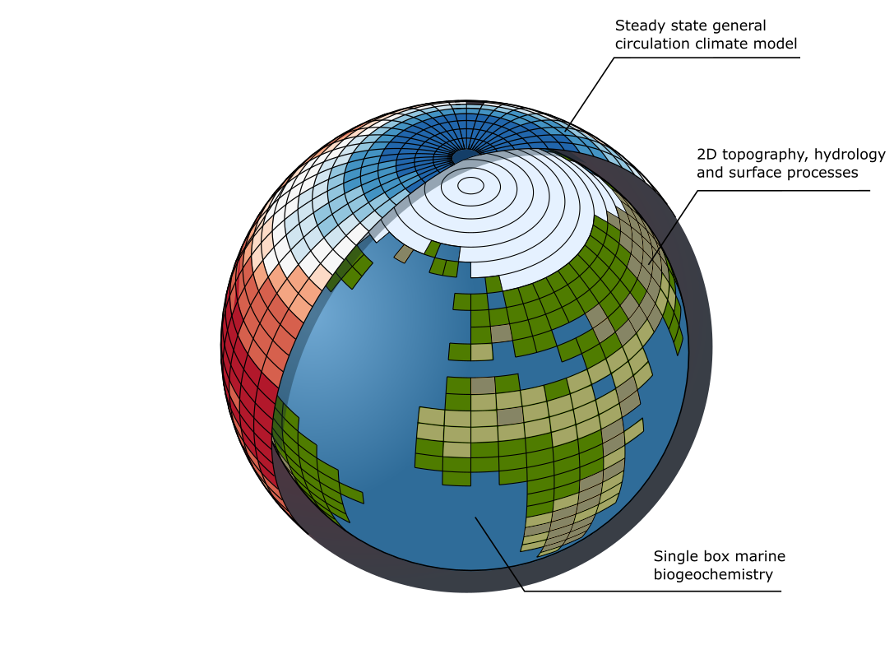**Contents.**

* Model overview
* Version history
* Files in this package
* System requirements
* Running the model and viewing output
* Sensitivity analysis
* Model equations
* Bibliography

**Model overview.**

SCION is a ‘Spatial Continuous IntegratiON’ global climate-biogeochemical model that runs over geological timescales. It runs forwards in time and computes the Earth’s major elemental cycles of carbon, oxygen, sulfur, phosphorus and nitrogen. It makes estimates for the composition of the atmosphere and oceans, as well as the surface climate. It also predicts the values of a suite of geochemical tracers to aid in hypothesis testing. SCION is a ‘predictive’ model in which the boundary conditions are set by tectonic reconstructions and the timing of evolutionary events, and the surface chemistry and climate are an emergent property. Thus, while there are some encouraging correlations, the model climate and chemistry during the Phanerozoic Eon is not completely accurate. The model is a descendent (a *scion*, if you will) of previous approaches to model global biogeochemistry and climate over long timescales (Figure 1).

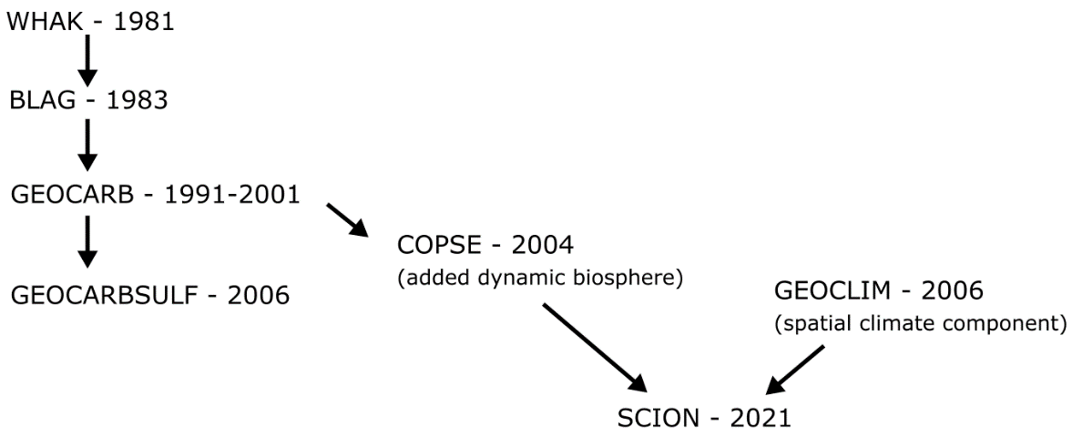

*Figure 1: SCION family tree.*

This document provides information on running and editing the model code and visualising output. For the model derivation and history of long-term global biogeochemical models it is recommended to read the above publications as a minimum. Details are in the bibliography at the end of this document.

**Version history (major | minor | patch)**

V1.1.5b (Jan 2023)

* Plotting bug fix for sensitivity analysis to include new low latitude temperatures

V1.1.5 (Sept 2022)

* Included a calculation for low latitude and tropical temperature outputs
* Modified ‘worldgraphic’ script to run if gridstamps were changed from their defaults
* Added recording of sensitivity parameters for each ensemble member in sensitivity analysis
* Added full model equations to guidebook

V1.1.4 (Oct 2021)

* Model speed improvement. Added topographic slope to model forcings instead of calculating during the run, and improved speed of other interpolation routines.

V1.1.3 (Sept 2021)

* Added run control option SCION_initialise(-2) which computes a fixed forcing run to check the present day steady state.

V1.1.2 (Aug 2021)

* Bug fix. Temperature effect on land biosphere was given value 1 at present, but other function inherited from COPSE model expected a different value. Minor effects.
* Bug fix. ‘land_future’ was unused in model calculations but was calculated incorrectly.

V1.1.1 (Jun 2021)

* Modified sensitivity analysis plotting to use a run grid rather than standardised 1 Myr grid

V1.1.0 (May 2021)

* Improved the gridding of the FOAM climate model dataset, this fixed an issue where a small number of coastal squares were not represented due to different resolutions of topography and climatology files. This fixed key issues with the 15 Ma climate model dataset, which was omitted from the initial model, but is now used.
* Fixed a minor bug inherited from COPSE in which the ridge CO2 input was not taken into account separately in the carbon isotope mass balance. This makes no noticeable difference in the Phanerozoic but could have important implications should the model be extended to the Early Earth.

V1.0.0 (March 2021)

* Version published in Mills et al., 2021 and first model iteration

**Files in this package.**

|  |  |
| --- | --- |
| SCION_initialise.m | This script sets parameter values, loads forcings, initialises the solver, and then calls the plotting scripts. Call this function to begin a single model run. |
| SCION_equations.m | This script contains the model flux and reservoir calculations, it is called by the solver. Do not run directly. |
| SCION_plot_fluxes.m | This script plots the model fluxes. It is called by the initialise script. |
| SCION_plot_worldgraphic.m | This script plots the model 2D fields. It is called by the initialise script. |
| SCION_sens.m | Call this script to begin a sensitivity analysis. |
| SION_plot_sens.m | This script plots the fluxes from the sensitivity analysis. It is called by the sens script. |
| data | Folder containing geochemical data to which the model is compared. |
| documentation | Folder containing documentation – i.e. this guidebook in editable form. |
| forcings | Folder containing model forcing files. |

*Table 1. Model files*

**System requirements.**

The SCION model runs in MATLAB and requires this software to run. It was mostly developed in version R2018a but should run in all newer versions and probably many older ones. SCION is designed to run on a workstation computer or HPC cluster and should run on any MATLAB compatible operating system. Single runs use one processor core and the sensitivity analysis uses all available cores simultaneously so overall compute time roughly scales with core count. A high CPU core count is therefore preferable for running sensitivity analyses. A single model run takes around 10 seconds. Bash scripts for submitting SCION HPC jobs are not included here.

Current MATLAB package requirements:

* interp1qr.m (fast linear interpolation)
* tight_subplot.m (for plotting)
* M_Map plotting package (for plotting: https://www.eoas.ubc.ca/~rich/map.html)

**Running the model and viewing output.**

Single model runs are computed by calling the SCION_initialise script from the MATLAB command line. Calling SCION_initialise(0) runs the model and plots all output.   
Calling SCION_initialise(-1) runs model and plots only fluxes for brevity.   
Calling SCION_initialise(-2) runs model for fixed present day forcings, use to check the present day steady state if modifying the model. Note that due to constant supply of carbon from the mantle and conversion to organic C, crustal organic C increases throughout all model runs.  
  
The initialise script calls the MATLAB built-in solver ODE15s, which is targeted at the equations file.

Below is an example of the console output during a successful run.

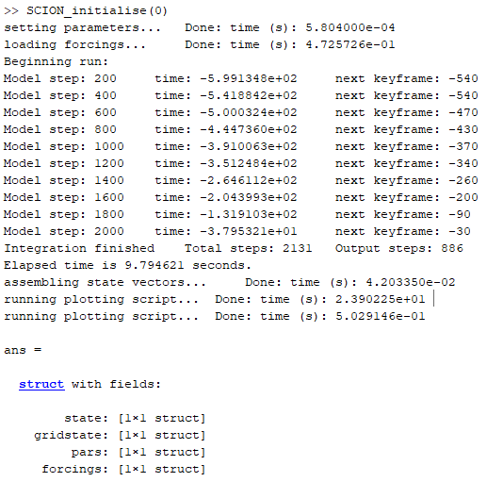

The output structure will be called ‘ans’ unless assigned a different name by typing e.g. myrun = SCION_initialise(0). The structure contains fields which show the bulk fluxes (state), the gridded spatial values (gridstate), the model fixed parameters for that run (pars) and the forcings for that run (forcings). The model does not save output automatically.

If run with the (0) argument the model will produce the spatial maps shown in figure 2, defined at each ‘keyframe’ point, alongside the bulk flux plots shown in figure 3, which are plotted against the geochemical data compilation. If run with the (-1) argument the spatial fields will not be plotted.

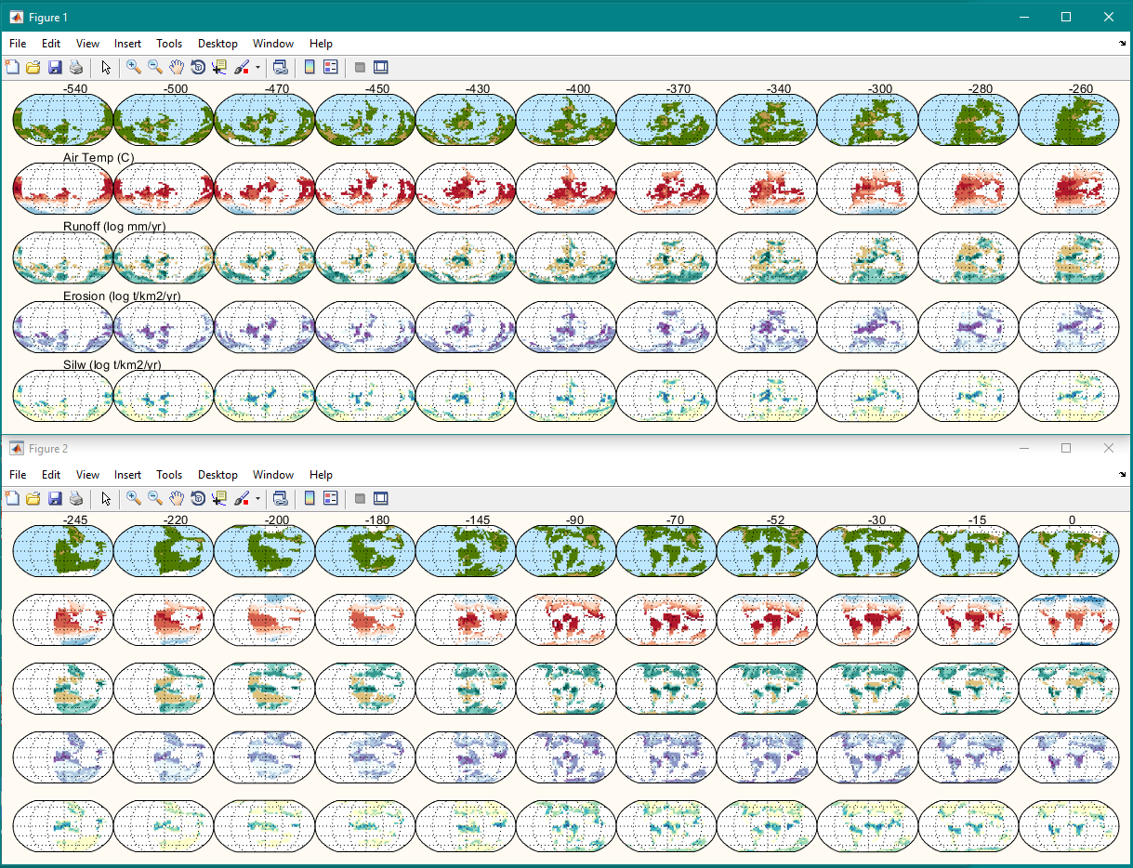

*Figure 2. Model spatial fields for default Phanerozoic run.*

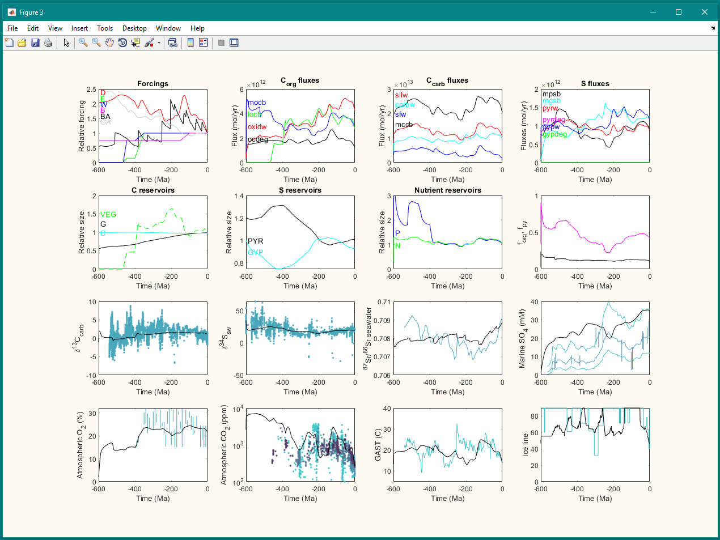

*Figure 3. Model fluxes for default Phanerozoic run.*

**Sensitivity analysis**

To run a sensitivity analysis, call SCION_sens. Edit the sens script to change the number of sensitivity runs and gridding of the results. Sensitivity parameters are included within the initialise and equations scripts. Running on a 4-core CPU looks like this:

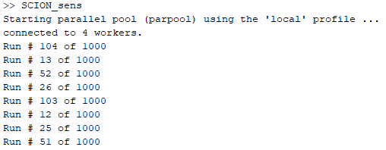

The model will update on run numbers complete. It is advised to estimate how long the analysis will take by multiplying the single model compute time on your system by the sensitivity ensemble size divided by your core count. All data plotted is saved temporarily to the workspace. The default sensitivity analysis does not save gridded data, or data that is not plotted in the sensitivity figure in order to save memory. This can be altered in the equations file. Figure 4 shows the default sensitivity plot.

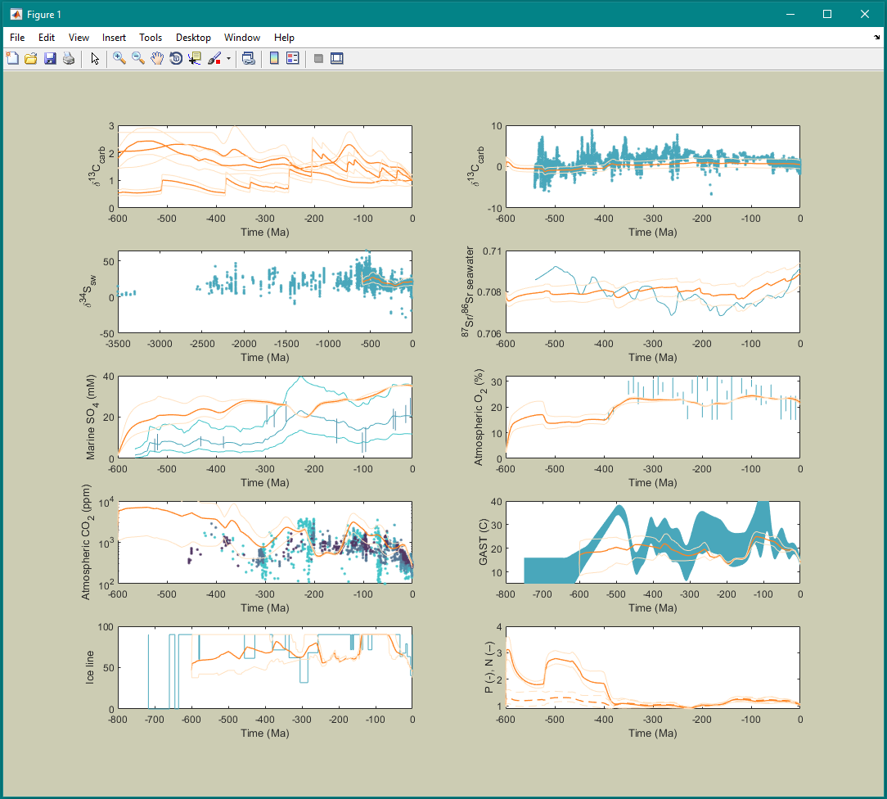

*Figure 4. Model sensitivity plot for default Phanerozoic run.*

**Model derivation**

This section contains a shortened version of the original model derivation found in Mills et al. (2021), and also updates any equation changes to the latest version.

**Model equations**

The model species are shown in Table 2, where each inventory evolves during the model run subject to the inputs and outputs described in Table 3. At each timestep the model requires information from the GCM datastructure to calculate surface processes. The model uses the current CO2 concentration and geological age to generate a ‘Gridstate’ for the two keyframes that bracket the current model timepoint (‘gridpast’ and ‘gridfuture’). At each timestep, 2D surface calculations are run for both *gridpast* and *gridfuture*, and a weighted average is taken for the final bulk flux. For example, for a generic GCM field *F*, we calculate:

(1)

(2)

Where *DU* and *DL* are the distances in log space between the model current CO2 value and the keyframe CO2 values for the upper (*U*) and lower (*L*) GCM runs. Bulk fluxes to be passed to the box model are calculated by summing each of the *gridpast* and *gridfuture* fields over the land surface, and interpolating over time.

(3)

Where *TF* and *TP* are the fractional distances in time to the future and past GCM keyframes, and *Agrid* is the gridbox area, which id dependent on latitude.

**Continental weathering fluxes**

Basin-scale silicate weathering rates are calculated using the following parametric relationship, from West (2012), which combines dependencies on local runoff, temperature and erosion rate.

(4)

Where is the local silicate cation denudation flux and the kinetic term is defined by:

(5)

Where dependencies on local runoff, temperature and erosion rates are calculated as:

(6)

(7)

(8)

Erosion rate () is calculated from topographic slope (*s*) and local runoff (*Q*) using the approach of Maffre et al. (2018).

(9)

The basaltic and granitic fraction of silicate weathering is calculated from the total silicate weathering rate based on the relative exposed areas of these lithologies (e.g. Berner, 2006; Mills et al., 2014, see Figure 3). This assumes a homogenous distribution.

(10)

(11)

Carbonate weathering is assumed to scale with runoff (e.g. Berner, 1994), where an additional parameter, *kscale*, is added to separate the present day rate from the spatial scaling effect.

(12)

Oxidative weathering (*foxidw*), pyrite weathering (*fpyrw*) and gypsum weathering (*fgypw*) are all also assumed to be dependent on local runoff, given the general requirement for moisture to facilitate aqueous chemical reactions. But these processes also involve other processes at the global scale, as in the COPSE model:

(13)

(14)

(15)

Phosphorus weathering sums contributions from silicates, carbonates and organics, as in COPSE:

(16)

We add a multiplier for the length of coastline (*LC*) to the gypsum burial calculation:

This acts to increase the rate of gypsum deposition when basins are closing, although it is a crude representation.

|  |  |  |  |
| --- | --- | --- | --- |
| **Description** | **Name** | **Exists in box** | **Size at present** |
| Hydrosphere CO2 | A | Hydrosphere | mol C |
| Buried organic C | G | Crust | mol C |
| Buried carbonate C | C | Crust | mol C |
| Ocean sulfate | S | Hydrosphere | mol S |
| Buried pyrite sulfur | PYR | Crust | mol S |
| Buried gypsum sulfur | GYP | Crust | mol S |
| Ocean phosphate | P | Hydrosphere | mol P |
| Ocean nitrate | N | Hydrosphere | mol N |
| Atmospheric oxygen | O | Hydrosphere | mol O |
| Ocean strontium | Sr | Hydrosphere | mol Sr |

***Table 2. Model chemical reservoirs.***

|  |  |
| --- | --- |
| **Species** | **Equation** |
| A |  |
| G |  |
| C |  |
| S |  |
| PYR |  |
| GYP |  |
| P |  |
| N |  |
| O |  |
| Sr |  |

***Table 3. Model reservoir mass balance.***

|  |  |
| --- | --- |
| **Flux name** | **Equation** |
| Carbonate C degassing: |  |
| Organic C degassing: |  |
| Marine organic C burial: |  |
| Land organic C burial: |  |
| Marine carbonate burial: |  |
| Seafloor weathering: |  |
| Marine pyrite S burial: |  |
| Fe-phosphate burial: |  |
| Ca-phosphate burial: |  |
| Organic P burial: |  |
| Organic N burial: |  |
| Denitrification: |  |
| Nitrogen fixation: |  |
| P flux to land: |  |
| P flux to sea: |  |

***Table 4. Model flux definitions.***

|  |  |
| --- | --- |
| **Process** | **Equation** |
| Carbon atmospheric fraction |  |
| Relative atmospheric CO2: |  |
| Atmospheric O2 mixing ratio: |  |
| Seafloor weathering T effect: |  |
| Temperature effect on vegetation: |  |
| CO2 effect on vegetation: |  |
| Oxygen effect on vegetation: |  |
| Overall limitation of terrestrial NPP: |  |
| Fire ignition probability scaling: |  |
| Fire effect on terrestrial biomass: |  |
| Mass of terrestrial biota: |  |
| Terrestrial biota weathering effect: |  |
| Marine P concentration: |  |
| Marine N concentration: |  |
| Marine new production: |  |
| Marine anoxic fraction: |  |

***Table 5. Other model processes.***

|  |  |  |
| --- | --- | --- |
| **Description** | **Name** | **Value** |
| Present day marine organic carbon burial |  | mol C yr-1 |
| Present day land organic carbon burial |  | mol C yr-1 |
| Present day organic carbon degassing |  | mol C yr-1 |
| Present day organic carbon weathering |  | mol C yr-1 |
| Present day carbonate burial |  | mol C yr-1 |
| Present day carbonate degassing |  | mol C yr-1 |
| Present day carbonate weathering |  | mol C yr-1 |
| Present day seafloor weathering |  | mol C yr-1 |
| Present day basalt weathering |  | mol C yr-1 |
| Present day granite weathering |  | mol C yr-1 |
| Present day silicate weathering |  | mol C yr-1 |
| Present day phosphorus weathering |  | mol P yr-1 |
| Present day pyrite burial |  | mol S yr-1 |
| Present day gypsum burial |  | mol S yr-1 |
| Present day pyrite weathering |  | mol S yr-1 |
| Present day gypsum weathering |  | mol S yr-1 |
| Present day pyrite degassing |  | mol S yr-1 |
| Present day gypsum degassing |  | mol S yr-1 |
| Present day Ca-P burial |  | mol P yr-1 |
| Present day Fe-P burial |  | mol P yr-1 |
| Present day nitrogen fixation |  | mol N yr-1 |
| Present day denitrification |  | mol N yr-1 |
| Present day ocean oxic fraction |  |  |
| Atmospheric O2 mixing ratio conversion |  |  |
| Pre-plant weathering enhancement factor |  |  |
| Phosphorus input from silicate weathering |  |  |
| Phosphorus input from carbonate weathering |  |  |
| Phosphorus input from carbon oxidation |  |  |
| Fraction of phosphorus buried on land |  |  |
| C:P ratio of buried marine OM - bioturbated |  |  |
| C:P ratio of buried marine OM - laminated |  |  |
| C:N ratio of buried marine organics |  |  |
| Present day atmospheric fraction of CO2 |  |  |
| Erosion rate scaling parameter |  |  |
| Silicate cation weight fraction |  | 0.1 |
| Silicate weathering grain size dependence | *K* |  |
| Silicate weathering water flow dependence | *kw* |  |
| Silicate weathering activation energy | *Ea* | 20 kJ mol-1 |
| Silicate weathering zone depth | *z* | 10 m |
| Reaction time parameter | *σ*+1 | 0.9 |
| Vegetation CO2 minimum |  | ppm |
| Vegetation CO2 half saturation |  | ppm |
| Fire effect on vegetation biomass |  |  |
| Runoff to carbonate weathering scaling factor |  | 200 |
| Steepness of anoxia transition |  |  |
| Marine oxygen utilization parameter |  |  |

***Table 6. Model parameters.***

**Bibliography**

Below are the key model papers mentioned in the SCION family tree.

WHAK:

Walker, J. C. G., Hays, P. B. & Kasting, J. F. A negative feedback mechanism for the long-term stabilization of Earth's surface temperature. *Journal of Geophysical Research* 86, 9776-9782 (1981).

BLAG:

Berner, R. A., Lasaga, A. C. & Garrels, R. M. The carbonate-silicate geochemical cycle and its effect on atmospheric carbon dioxide over the past 100 million years. *American Journal of Science* 283, 641-683 (1983).

GEOCARB:

Berner, R. A. A model for atmospheric CO2 over Phanerozoic time. *American Journal of Science* 291, 339-376 (1991).

Berner, R. A. GEOCARBSULF: A combined model for Phanerozoic atmospheric O2 and CO2. *Geochimica et Cosmochimica Acta* 70, 5653-5664 (2006).

COPSE:

Bergman, N. M., Lenton, T. M. & Watson, A. J. COPSE: A new model of biogeochemical cycling over Phanerozoic time. *American Journal of Science* 304, 397-437 (2004).

Lenton, T. M., Daines, S. J. & Mills, B. J. W. COPSE reloaded: An improved model of biogeochemical cycling over Phanerozoic time. *Earth-Sci. Rev.* 178, 1-28 (2018).

Tostevin, R. & Mills, B. J. W. Reconciling proxy records and models of Earth's oxygenation during the Neoproterozoic and Palaeozoic. *Interface Focus* 10, 20190137 (2020).

GEOCLIM:

Donnadieu, Y., Goddéris, Y., Pierrehumbert, R., Dromart, G., Fluteau, F., Jacob, R. A GEOCLIM simulation of climatic and biogeochemical consequences of Pangea breakup. *Geochemistry, Geophysics, Geosystems* 7 (2006).

Goddéris, Y., Donnadieu, Y., Le Hir, G., Lefebvre, V. & Nardin, E. The role of palaeogeography in the Phanerozoic history of atmospheric CO2 and climate. *Earth-Sci. Rev.* 128, 122-138 (2014).

SCION:

Mills, B. J. W., Donnadieu, Y. & Goddéris, Y. Spatial continuous integration of Phanerozoic global biogeochemistry and climate. *Gondwana Research*, doi:10.1016/j.gr.2021.02.011 (2021).

**Other references**

West, A. J. Thickness of the chemical weathering zone and implications for erosional and climatic drivers of weathering and for carbon-cycle feedbacks. *Geology* **40**, 811-814, doi:10.1130/g33041.1 (2012).

Maffre, P. *et al.* Mountain ranges, climate and weathering. Do orogens strengthen or weaken the silicate weathering carbon sink? *Earth and Planetary Science Letters* **493**, 174-185, doi:10.1016/j.epsl.2018.04.034 (2018).