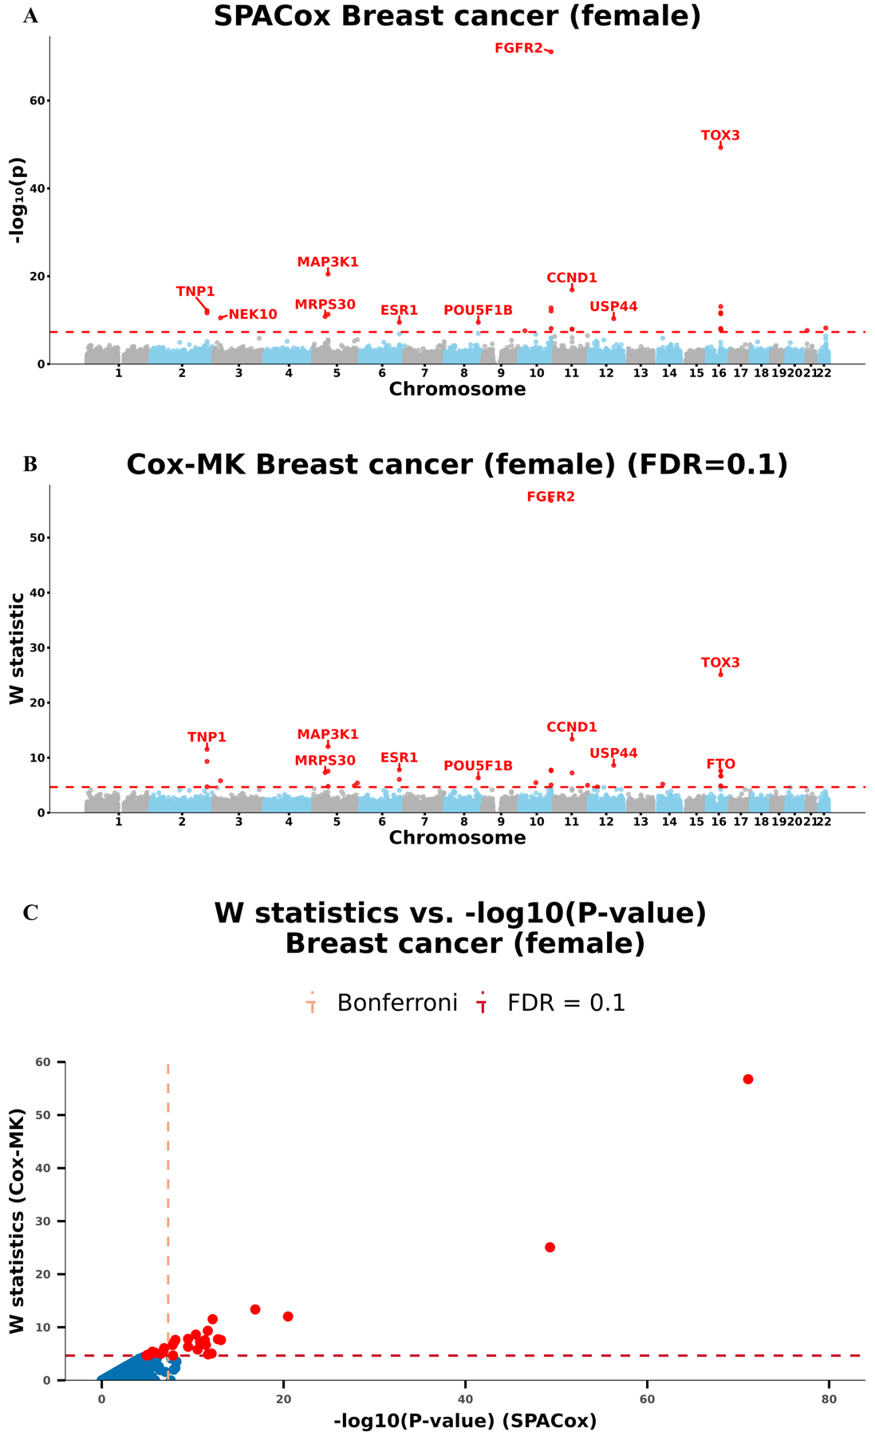
Figure S1. Manhattan plots for GWAS of breast Cancer (female) in the UK Biobank data with White British ancestry
(A and B) GWAS results using (A) SPACox and (B) Cox-MK are shown for breast cancer (female).
- Scatter plot of W knockoff statistics (Cox-MK) vs. −log10(p value) (SPACox) for breast cancer (female).
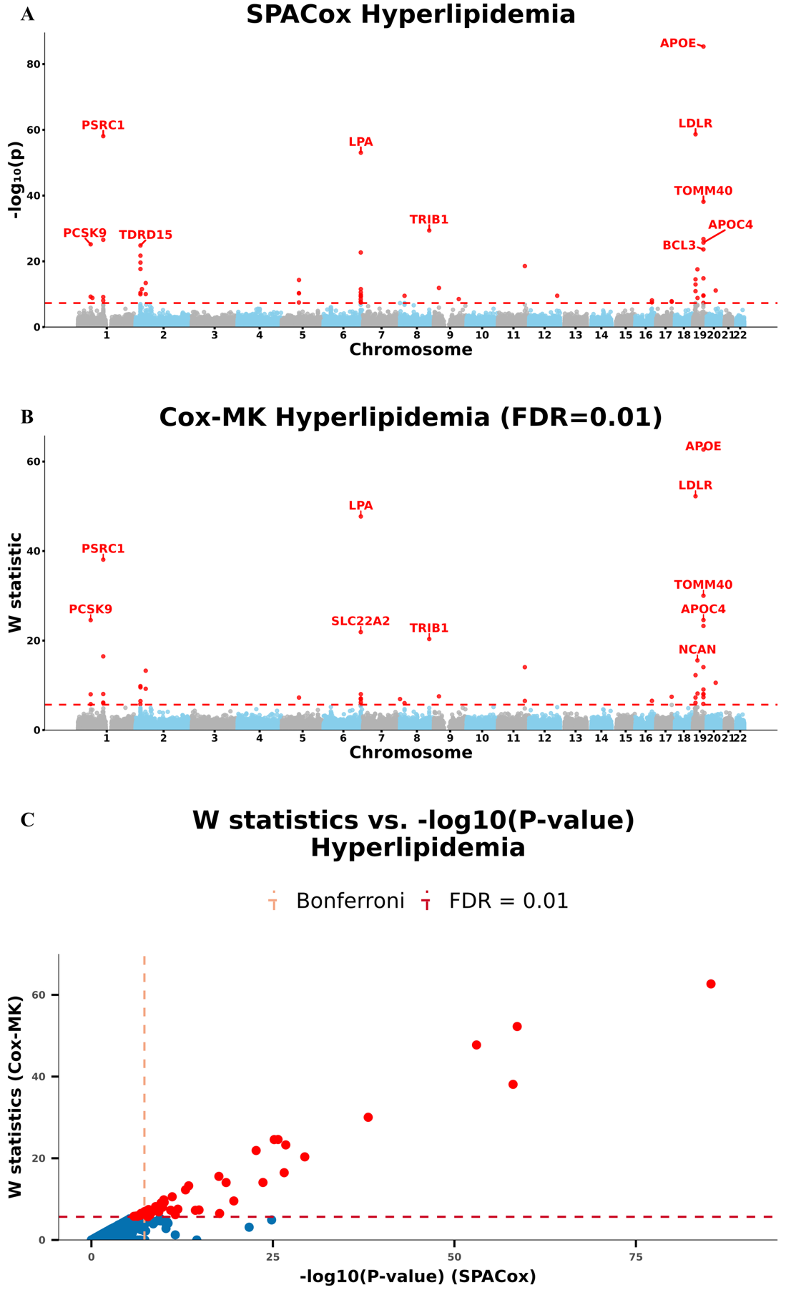
Figure S2. Manhattan plots for GWAS of hyperlipidemia in the UK Biobank data with White British ancestry
(A and B) GWAS results using (A) SPACox and (B) Cox-MK are shown for hyperlipidemia.
- Scatter plot of W knockoff statistics (Cox-MK) vs. −log10(p value) (SPACox) for hyperlipidemia.

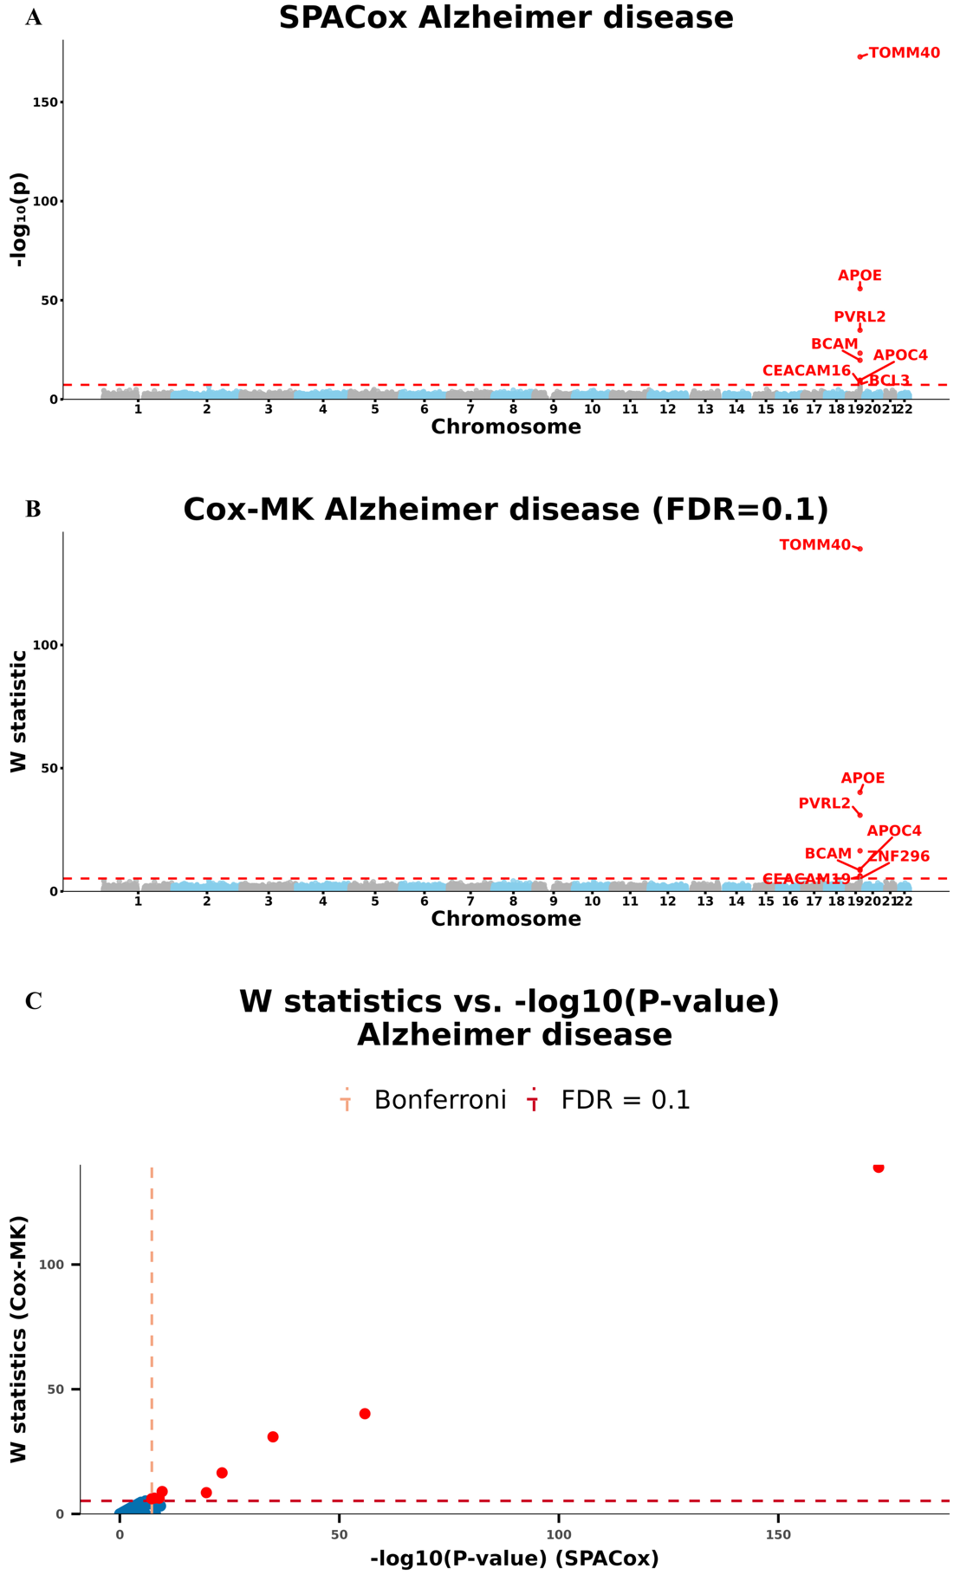
Figure S3. Manhattan plots for GWAS of alzheimer disease in the UK Biobank data with White British ancestry
(A and B) GWAS results using (A) SPACox and (B) Cox-MK are shown for alzheimer disease.
(C) Scatter plot of W knockoff statistics (Cox-MK) vs. −log10(p value) (SPACox) for alzheimer disease.

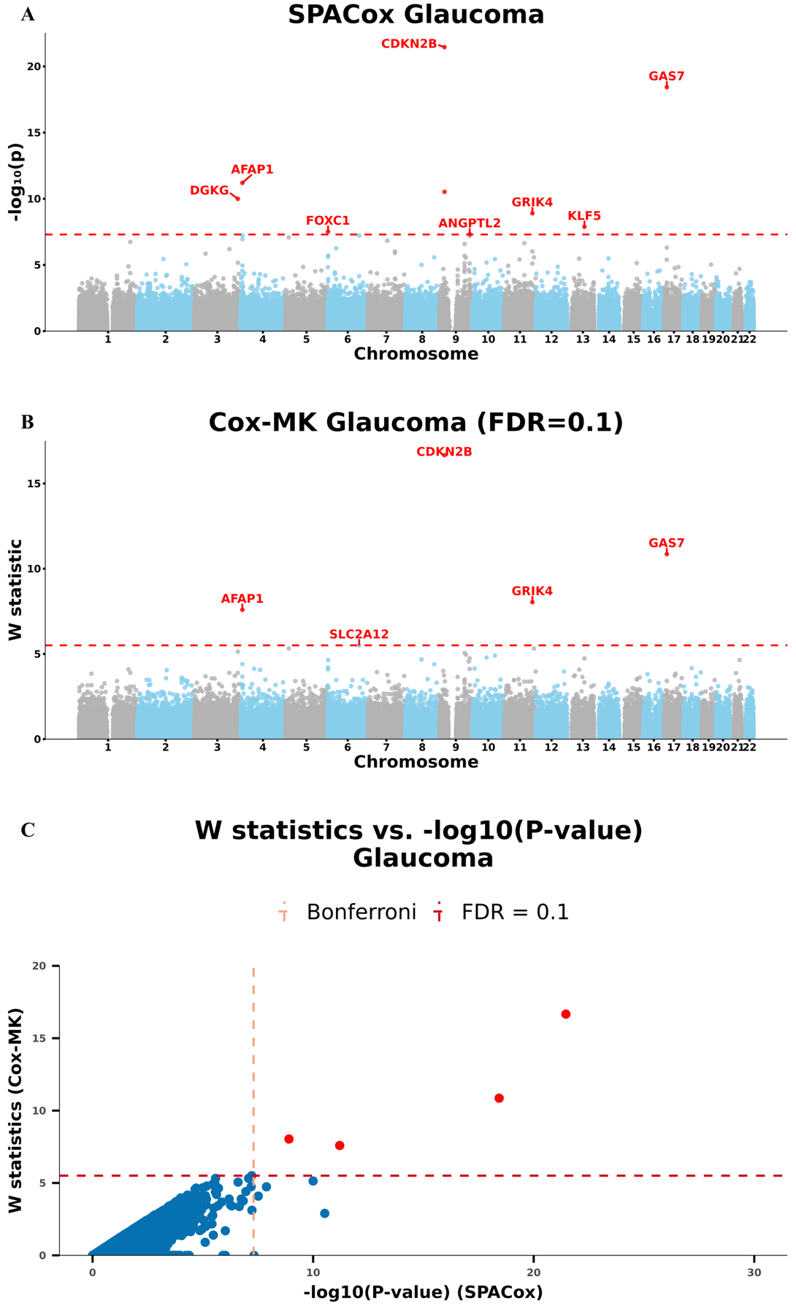
Figure S4. Manhattan plots for GWAS of glaucoma in the UK Biobank data with White British ancestry
(A and B) GWAS results using (A) SPACox and (B) Cox-MK are shown for glaucoma.
- Scatter plot of W knockoff statistics (Cox-MK) vs. −log10(p value) (SPACox) for glaucoma.

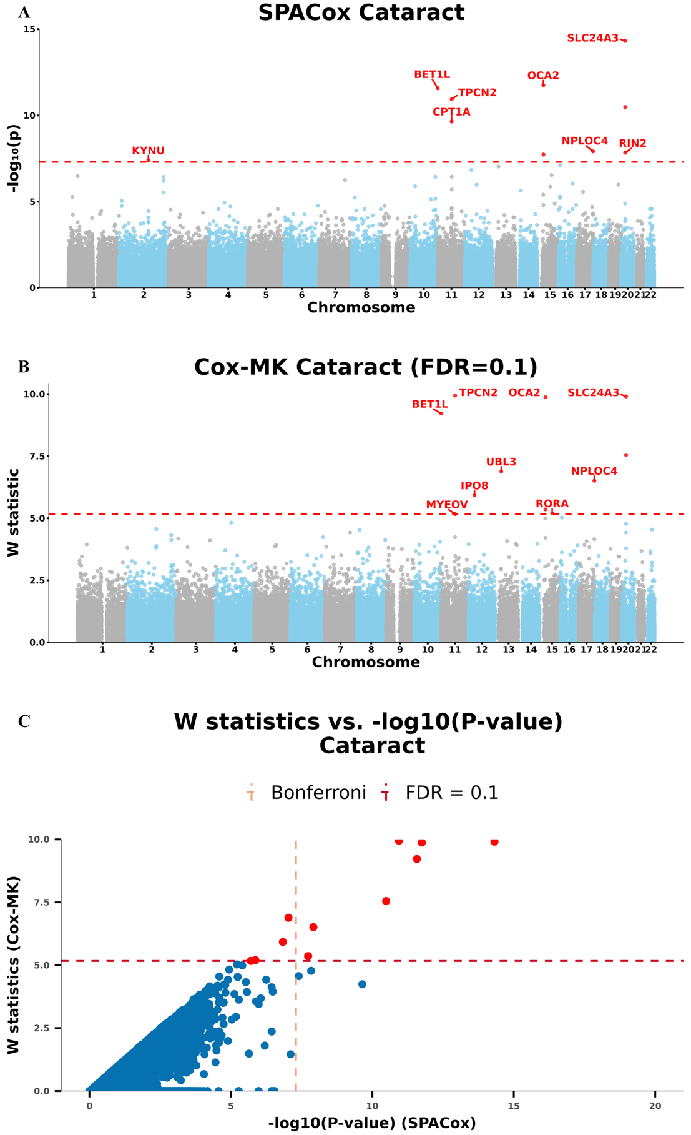
Figure S5. Manhattan plots for GWAS of cataract in the UK Biobank data with White British ancestry
(A and B) GWAS results using (A) SPACox and (B) Cox-MK are shown for cataract.
- Scatter plot of W knockoff statistics (Cox-MK) vs. −log10(p value) (SPACox) for cataract.
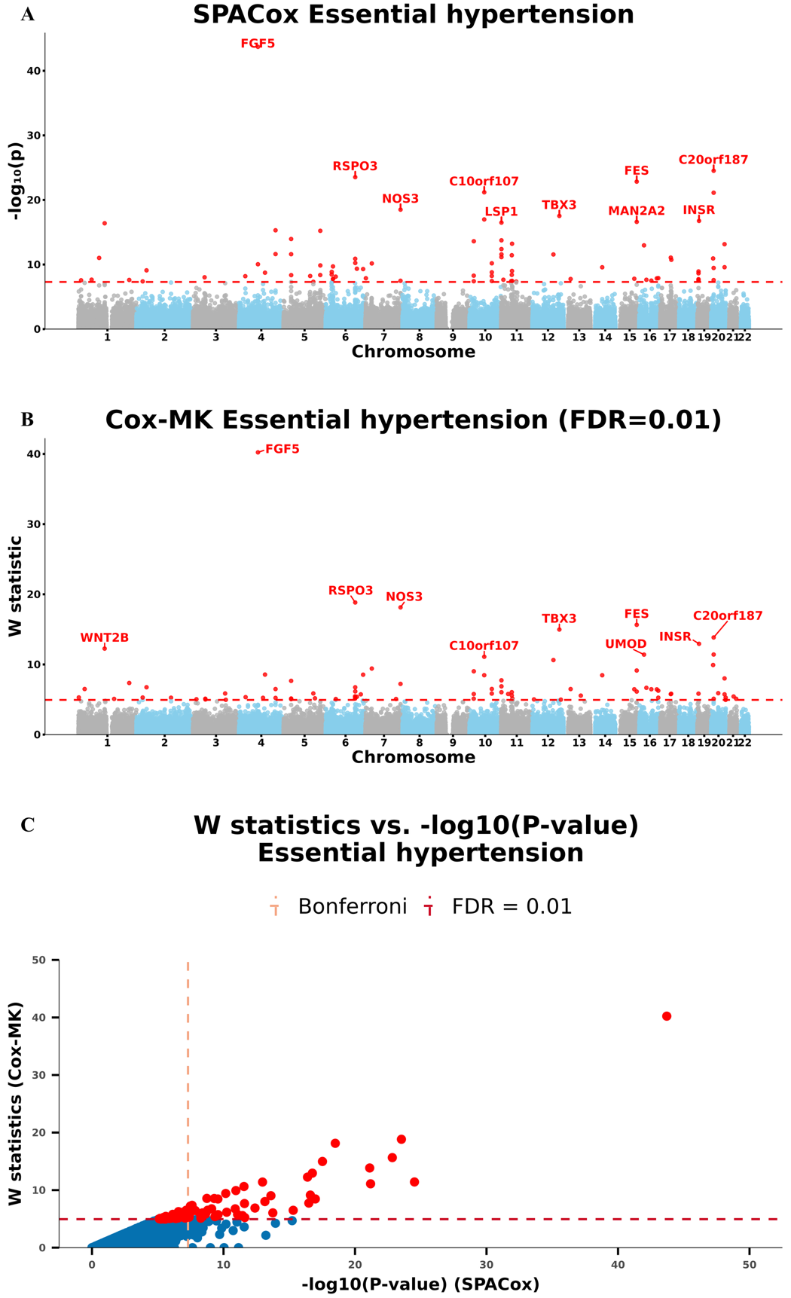
Figure S6. Manhattan plots for GWAS of essential hypertension in the UK Biobank data with White British ancestry
(A and B) GWAS results using (A) SPACox and (B) Cox-MK are shown for essential hypertension.
- Scatter plot of W knockoff statistics (Cox-MK) vs. −log10(p value) (SPACox) for essential hypertension.

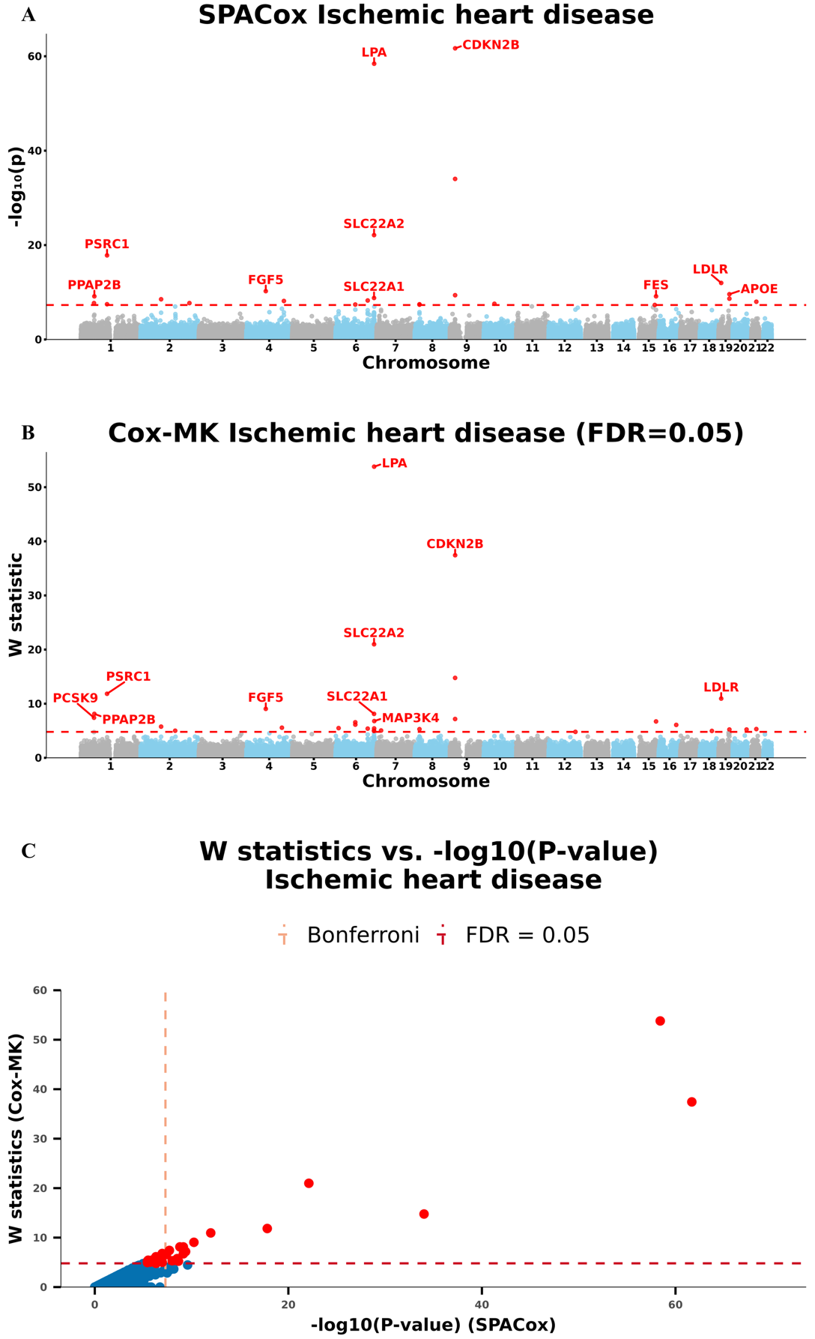
Figure S7. Manhattan plots for GWAS of ischemic heart disease in the UK Biobank data with White British ancestry
(A and B) GWAS results using (A) SPACox and (B) Cox-MK are shown for ischemic heart disease.
- Scatter plot of W knockoff statistics (Cox-MK) vs. −log10(p value) (SPACox) for ischemic heart disease.
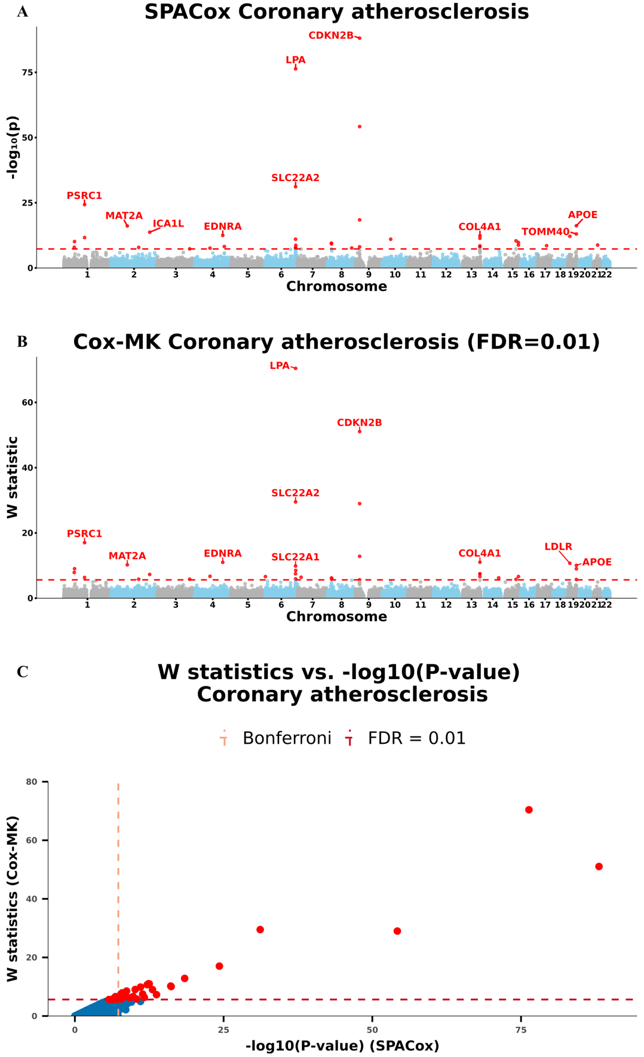
Figure S8. Manhattan plots for GWAS of coronary atherosclerosis in the UK Biobank data with White British ancestry
(A and B) GWAS results using (A) SPACox and (B) Cox-MK are shown for coronary atherosclerosis.
- Scatter plot of W knockoff statistics (Cox-MK) vs. −log10(p value) (SPACox) for coronary atherosclerosis.
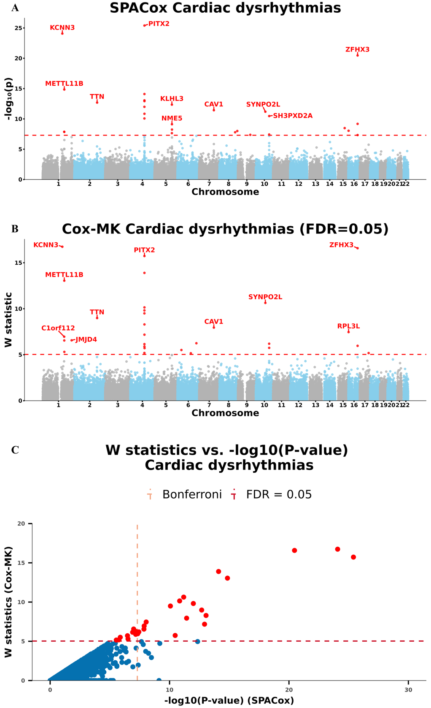
Figure S9. Manhattan plots for GWAS of cardiac dysrhythmias in the UK Biobank data with White British ancestry
(A and B) GWAS results using (A) SPACox and (B) Cox-MK are shown for cardiac dysrhythmias.
- Scatter plot of W knockoff statistics (Cox-MK) vs. −log10(p value) (SPACox) for cardiac dysrhythmias.
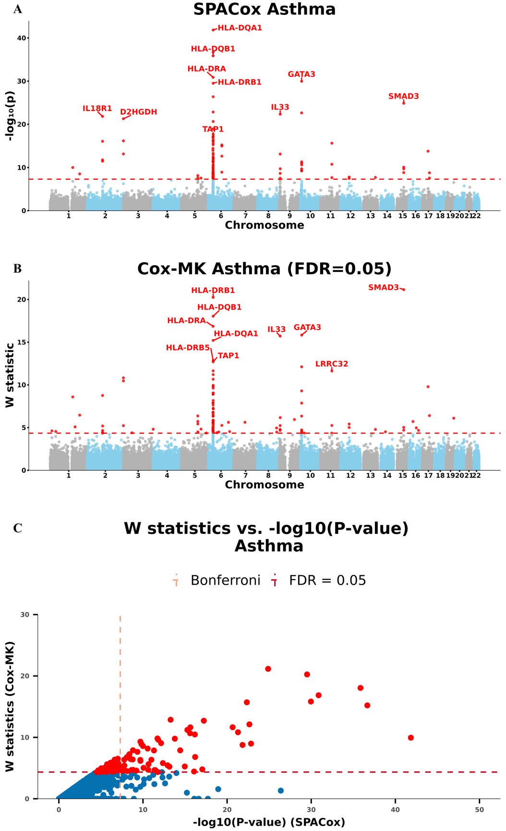
Figure S10. Manhattan plots for GWAS of asthma in the UK Biobank data with White British ancestry
(A and B) GWAS results using (A) SPACox and (B) Cox-MK are shown for asthma.
- Scatter plot of W knockoff statistics (Cox-MK) vs. −log10(p value) (SPACox) for asthma.

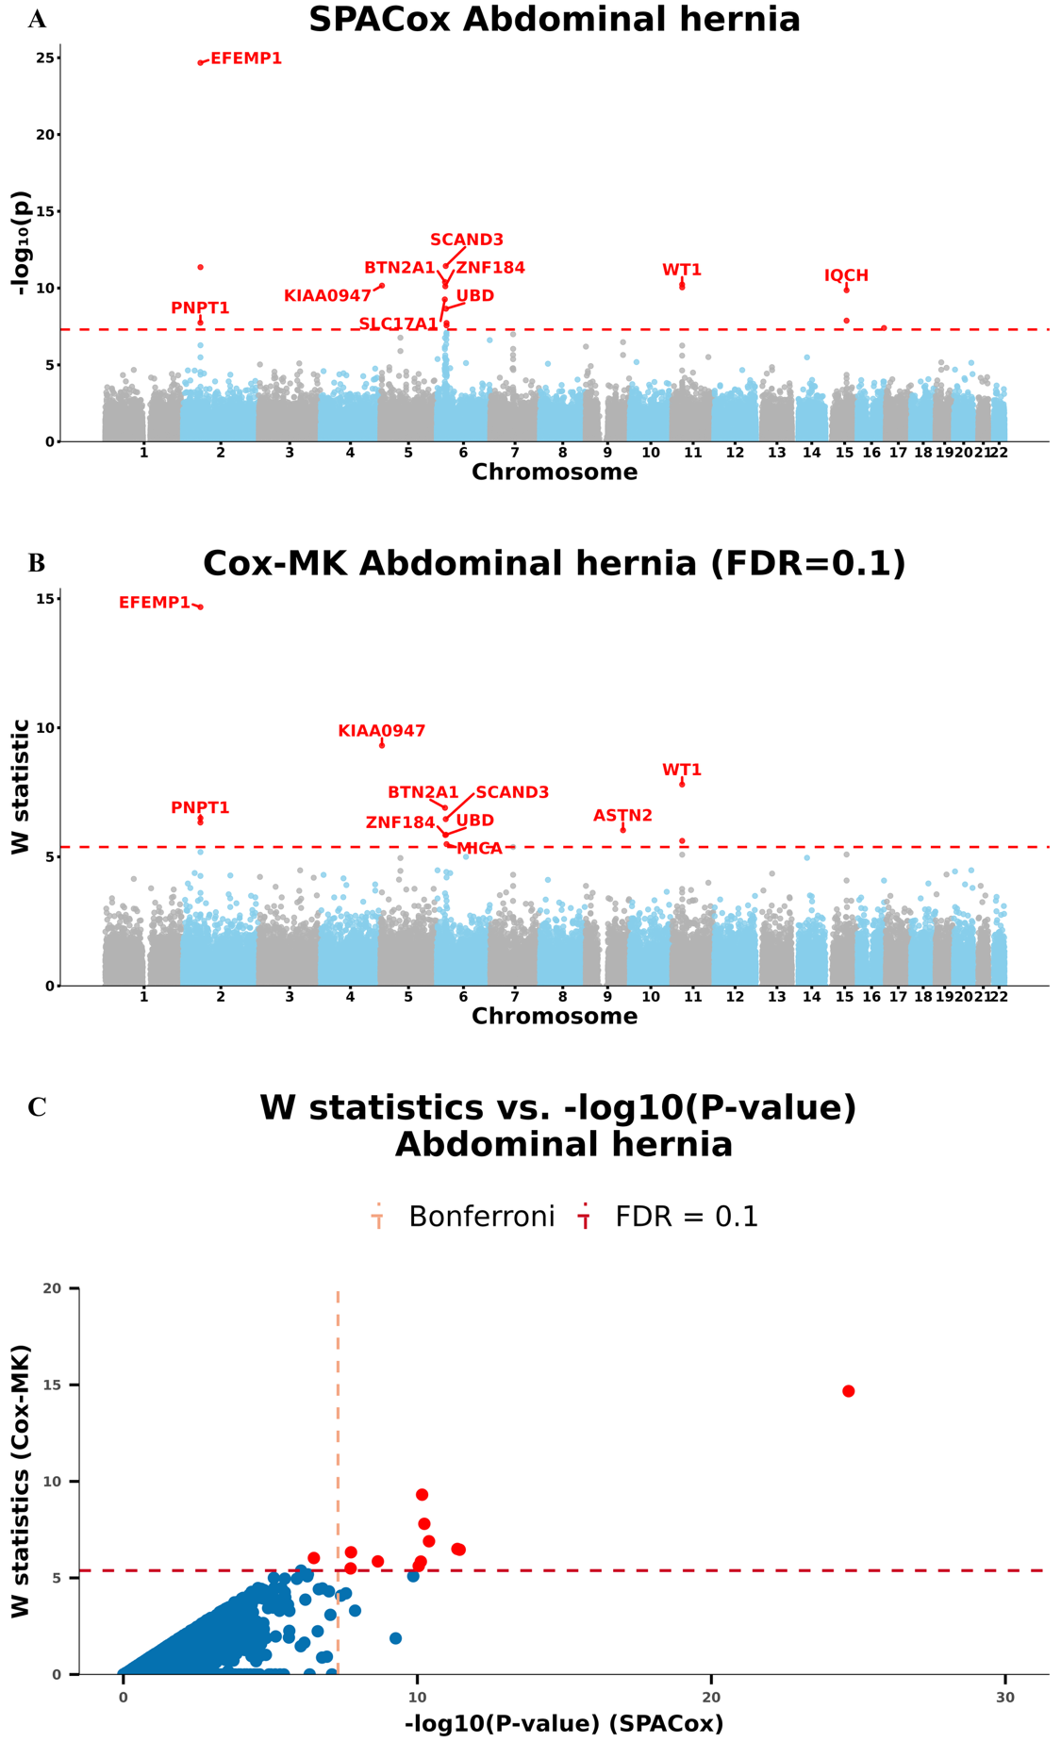
Figure S11. Manhattan plots for GWAS of abdominal hernia in the UK Biobank data with White British ancestry
(A and B) GWAS results using (A) SPACox and (B) Cox-MK are shown for abdominal hernia.
- Scatter plot of W knockoff statistics (Cox-MK) vs. −log10(p value) (SPACox) for abdominal hernia.
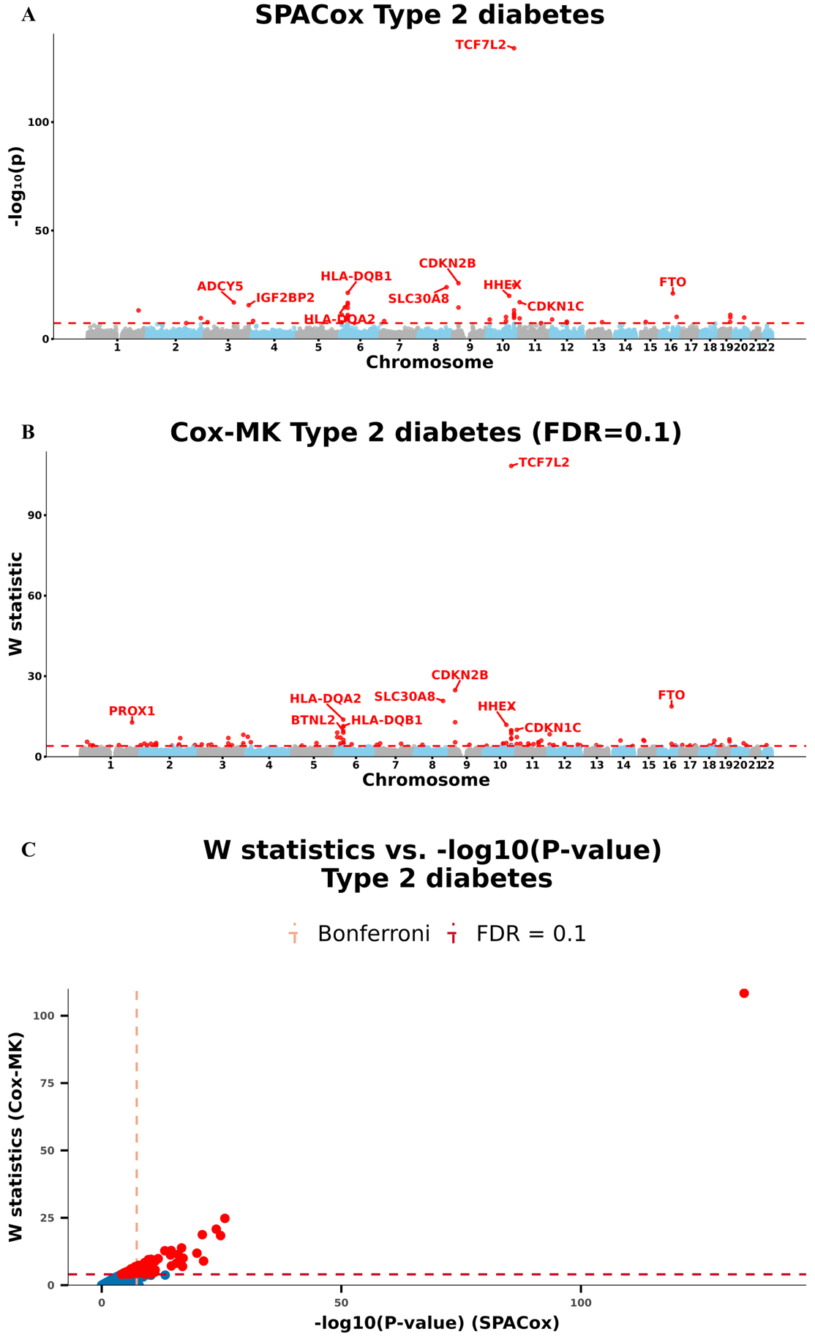
Figure S12. Manhattan plots for GWAS of T2D in the UK Biobank data with White British ancestry
(A and B) GWAS results using (A) SPACox and (B) Cox-MK are shown for T2D.
- Scatter plot of W knockoff statistics (Cox-MK) vs. −log10(p value) (SPACox) for T2D.

