疫苗分配

## 模型

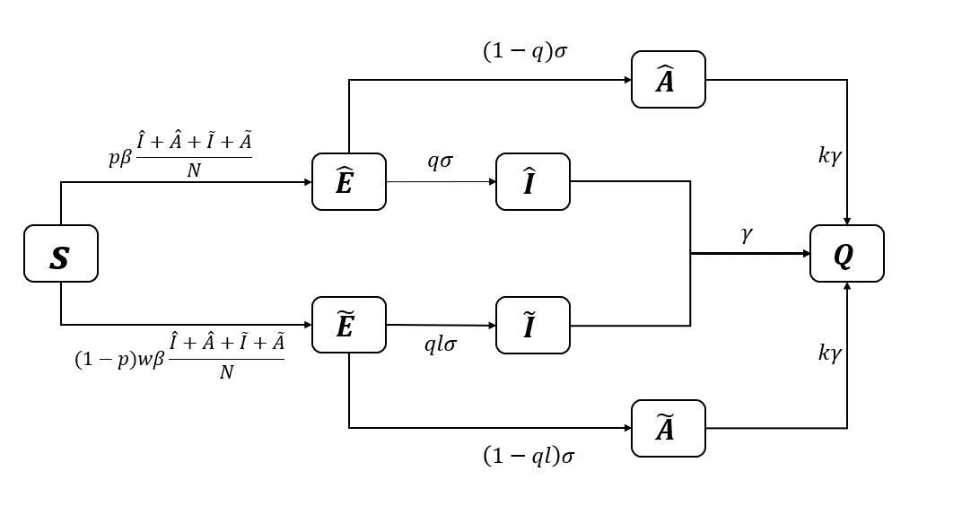

### 传染病方程

（1）

传播部分 $T=\left(\begin{matrix}0 & 0 & pβ & pβ & pβ & pβ \\ 0 & 0 & \left(1-p\right)wβ & \left(1-p\right)wβ & \left(1-p\right)wβ & \left(1-p\right)wβ \\ 0 & 0 & 0 & 0 & 0 & 0 \\ 0 & 0 & 0 & 0 & 0 & 0 \\ 0 & 0 & 0 & 0 & 0 & 0 \\ 0 & 0 & 0 & 0 & 0 & 0\end{matrix}\right)$

转移部分；

接着，计算下一代矩阵K：



得到K的谱半径为基本再生数R0：

$$R0=ρ(K)=\frac{β}{kγ}\{p[(1-q)+kq]+(1-p)w[(1-ql)+kql]\}$$

### R的变化dR

取其中i被j组的传播做ij的传播矩阵。

则传播部分T

$$T=\left(\begin{matrix}0 & 0 & pC_{ij}β & pC_{ij}β & pC_{ij}β & pC_{ij}β \\ 0 & 0 & \left(1-p\right)C_{ij}wβ & \left(1-p\right)C_{ij}wβ & \left(1-p\right)C_{ij}wβ & \left(1-p\right)C_{ij}wβ \\ 0 & 0 & 0 & 0 & 0 & 0 \\ 0 & 0 & 0 & 0 & 0 & 0 \\ 0 & 0 & 0 & 0 & 0 & 0 \\ 0 & 0 & 0 & 0 & 0 & 0\end{matrix}\right)$$

转移部分



$$K ={-TΣ }^{-1}$$

所以i和j的R就是

$$R_{ij}=ρ(K)=\frac{β}{kγ}C_{ij}\{p[(1-q)+kq]+(1-p)w[(1-ql)+kql]\}$$

如果i年龄段p变化，就是对 $R_{ij}$ 发生扰动，则导致 $R_{ij}$ 发生变化 $dR_{ij}$，所以i年龄段 $dR_{i}$ 势必会引起总体传播 $R$ 的变化，量化为如下：

$$dR_{i}=\sum_{j}{{dR}_{ij}}$$

#### 疫苗分配算法[6]

1. Divide the vaccine stock into units as $l=1, 2,……z$.
2. For each group ***i*** {

For each group ***j*** {

Calculate $${dR}_{ij}=ρ(K)=\frac{β}{kγ}C_{ij}\{p[(1-q)+kq]+(1-p)w[(1-ql)+kql]$$

}

Calculate ${dR}_{i}$

}

1. For each unit of vaccine $l=1$ to $l=z$:

Find max $R_{i}$;

Allocate vaccine $l$ to group ***i*** ;

Calculate the vaccinate proportion $p=\frac{l}{groupi}+p$;

Change the vaccinated proportion $p$ of group ***i*** ;

Calculate the new $R_{i}$ of group ***i*** and update;

参考文献

1. Aronna M S, Guglielmi R, Moschen L M. A model for COVID-19 with isolation, quarantine and testing as control measures[J]. Epidemics, 2021, 34: 100437.
2. Ejigu B A, Asfaw M D, Cavalerie L, et al. Assessing the impact of non-pharmaceutical interventions (NPI) on the dynamics of COVID-19: A mathematical modelling study of the case of Ethiopia[J]. PloS one, 2021, 16(11): e0259874.
3. Bauch C T, Galvani A P, Earn D J D. Group interest versus self-interest in smallpox vaccination policy[J]. Proceedings of the National Academy of Sciences, 2003, 100(18): 10564-10567.
4. Shim E, Meyers L A, Galvani A P. Optimal H1N1 vaccination strategies based on self-interest versus group interest[J]. BMC Public Health, 2011, 11(1): 1-17.
5. Bedilu Alamirie Ejigu，Assessing the impact of non-pharmaceutical interventions (NPI) on the dynamics of COVID19: A mathematical modelling study of the case of Ethiopia
6. Wallinga J , Boven M V , Palese L P . Optimizing infectious disease interventions during an emerging epidemic[J]. Proceedings of the National Academy of Sciences, 2010, 107(2):923-928.