疫苗分配

## 模型

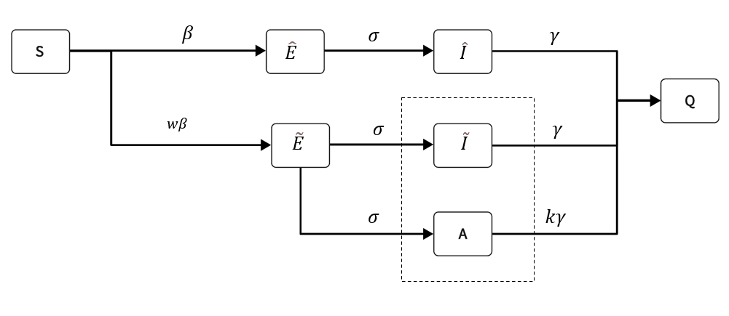

### 传染病方程

### 加入年龄结构计算两个group之间的再生数[7]

设 $x={({\overset{^}{E}}_{1},{\overset{^}{E}}_{2},{\overset{\sim }{E}}_{1},{\overset{\sim }{E}}_{2},A_{1},A_{2},{\overset{^}{I}}_{1},{\overset{^}{I}}_{2},{\overset{\sim }{I}}_{1},{\overset{\sim }{I}}_{2})}^{T}$，将该感染系统写成一下形式：

$$\dot{x=}(T+Σ)x$$

则传播部分T

$$T={(\begin{matrix}O & D & D & D \\ & & 0 & \end{matrix})}_{10×10}$$

其中

$$D=β\left(\begin{matrix}p_{i}C_{11}\frac{N_{1}}{N_{1}} & p_{i}C_{12}\frac{N_{1}}{N_{2}} \\ (1-p_{i})wC_{11}\frac{N_{1}}{N_{1}} & (1-p_{i})wC_{12}\frac{N_{1}}{N_{2}} \\ p_{i}C_{21}\frac{N_{2}}{N_{1}} & p_{i}C_{22}\frac{N_{2}}{N_{2}} \\ (1-p_{i})wC_{21}\frac{N_{2}}{N_{1}} & (1-p_{i})wC_{22}\frac{N_{2}}{N_{2}}\end{matrix}\right)4×2$$

$$O=\left(\begin{matrix}0 & 0 & 0 & 0 \\ 0 & 0 & 0 & 0 \\ 0 & 0 & 0 & 0 \\ 0 & 0 & 0 & 0\end{matrix}\right)4×4$$

$Σ$ 是转移矩阵

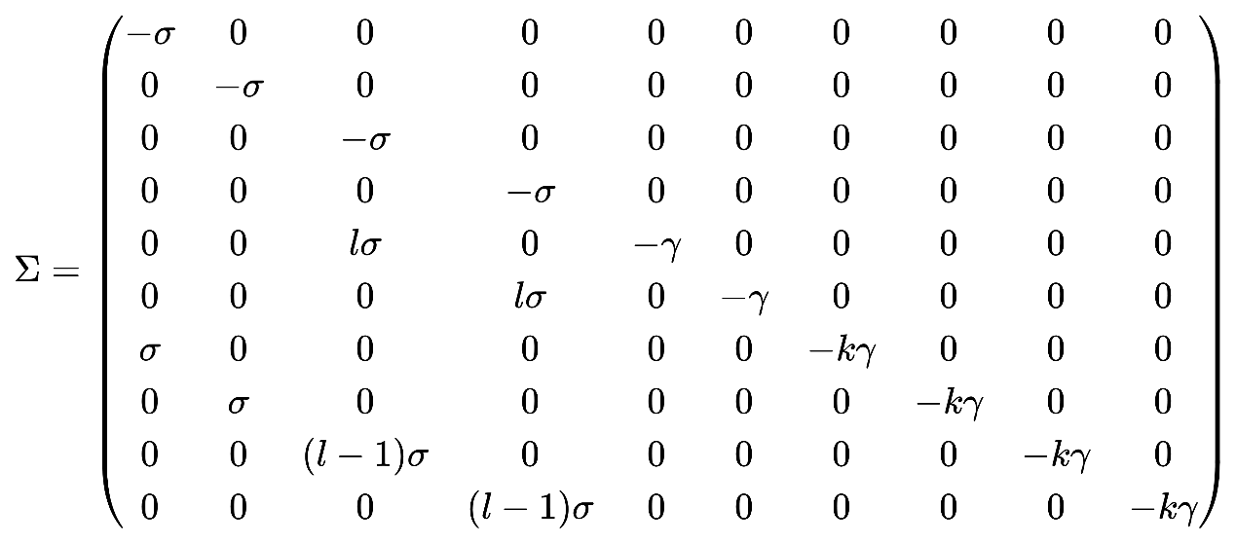

\Sigma=

\begin{pmatrix}

-\sigma & 0 & 0 & 0 & 0 & 0 & 0 & 0 & 0 & 0 \\

0 & -\sigma & 0 & 0 & 0 & 0 & 0 & 0 & 0 & 0 \\

0 & 0 & -\sigma & 0 & 0 & 0 & 0 & 0 & 0 & 0 \\

0 & 0 & 0 & -\sigma & 0 & 0 & 0 & 0 & 0 & 0 \\

0 & 0 & l \sigma & 0 & -\gamma & 0 & 0 & 0 & 0 & 0 \\

0 & 0 & 0 & l \sigma & 0 & -\gamma & 0 & 0 & 0 & 0 \\

\sigma & 0 & 0 & 0 & 0 & 0 & -k \gamma & 0 & 0 & 0 \\

0 & \sigma & 0 & 0 & 0 & 0 & 0 & -k \gamma & 0 & 0 \\

0 & 0 & (l-1) \sigma & 0 & 0 & 0 & 0 & 0 & -k \gamma & 0 \\

0 & 0 & 0 & (l -1) \sigma & 0 & 0 & 0 & 0 & 0 & -k \gamma \\

\end{pmatrix}

$$K ={-TΣ }^{-1}$$

所以i和j的R就是

$$\begin{aligned}R_{ij}=ρ(K) \\ =\frac{β}{kγ}\{p_{i}C_{ij}\frac{N_{i}}{N_{i}}k+(1-p_{i})wC_{ij}\frac{N_{i}}{N_{j}} \\ +p_{i}C_{ji}\frac{N_{j}}{N_{i}}[kl+(1-l)]+(1-p_{i})wC_{ji}\frac{N_{j}}{N_{i}}[kl+(1-l)]\}\end{aligned}$$

如果i年龄段p变化，用 $du_{i}$ 表示此次分配给i组的疫苗量。所以 $dp=du_{i}/groupi$,新的 $p_{new}=p-dp$, $R_{ij}$ 发生扰动，则导致 $R_{ij}$ 发生变化 $dR_{ij}$，所以i年龄段 $dR_{i}$ 势必会引起总体传播 $R$ 的变化，量化为如下：

$$dR_{i}=\sum_{j}{{dR}_{ij}}$$

#### 药物干预-疫苗分配算法[6]

1. Divide the vaccine stock into units as $l=1, 2,……z$.
2. For each group ***i*** {

$$dp=du_{i}/groupi$$

$$p_{new}=p_{i}-dp$$

For each group ***j*** {

Calculate

$$\begin{aligned}R_{ij}=ρ(K) \\ =\frac{β}{kγ}\{p_{i}C_{ij}\frac{N_{i}}{N_{i}}k+(1-p_{i})wC_{ij}\frac{N_{i}}{N_{j}} \\ +p_{i}C_{ji}\frac{N_{j}}{N_{i}}[kl+(1-l)]+(1-p_{i})wC_{ji}\frac{N_{j}}{N_{i}}[kl+(1-l)]\}\end{aligned}$$

$${dR}_{ij}\left(p_{new}\right)=\sqrt{R_{ij}\left(p_{i}\right)}-\sqrt{R_{ij}\left(p_{new}\right)}$$

}

Calculate $$dR_{i}=\sum_{j}{{dR}_{ij}}$$

}

1. For each unit of vaccine $l=1$ to $l=z$:

Find max ${dR}_{i}$;

Allocate vaccine $l$ to group ***i*** ;

Calculate and update the vaccinate proportion $p=p_{new}$ of group i;

Calculate the new $dR_{i}$ of group ***i*** and update;

计算0.1人口数疫苗至0.5人口数疫苗对总感染数的影响：avg为之前的平均分配方式，optimal为上述算法后的最佳分配方式



下面两张图分别是疫苗为总人口数的一半,即Stockplie size=0.5时候平均分配疫苗和最优分配法的各种感染人数。

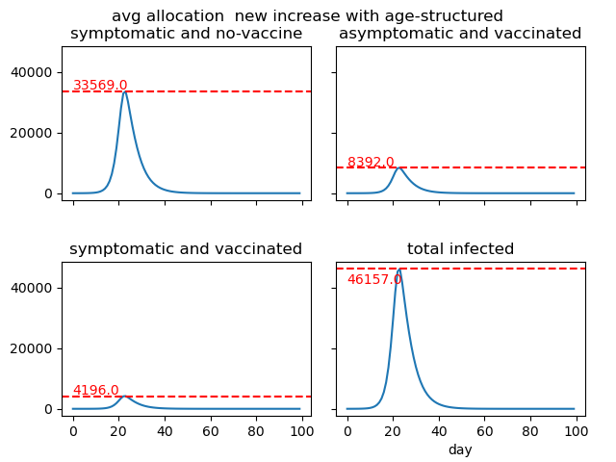

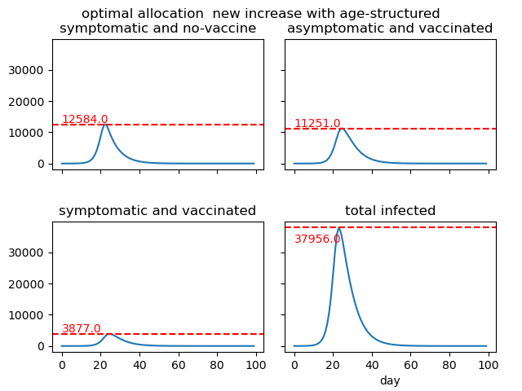

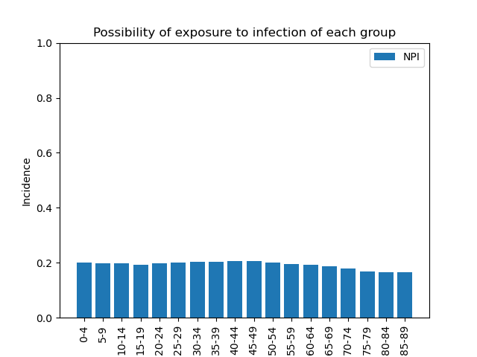

参考文献

1. Aronna M S, Guglielmi R, Moschen L M. A model for COVID-19 with isolation, quarantine and testing as control measures[J]. Epidemics, 2021, 34: 100437.
2. Ejigu B A, Asfaw M D, Cavalerie L, et al. Assessing the impact of non-pharmaceutical interventions (NPI) on the dynamics of COVID-19: A mathematical modelling study of the case of Ethiopia[J]. PloS one, 2021, 16(11): e0259874.
3. Bauch C T, Galvani A P, Earn D J D. Group interest versus self-interest in smallpox vaccination policy[J]. Proceedings of the National Academy of Sciences, 2003, 100(18): 10564-10567.
4. Shim E, Meyers L A, Galvani A P. Optimal H1N1 vaccination strategies based on self-interest versus group interest[J]. BMC Public Health, 2011, 11(1): 1-17.
5. Bedilu Alamirie Ejigu，Assessing the impact of non-pharmaceutical interventions (NPI) on the dynamics of COVID19: A mathematical modelling study of the case of Ethiopia
6. Wallinga J , Boven M V , Palese L P . Optimizing infectious disease interventions during an emerging epidemic[J]. Proceedings of the National Academy of Sciences, 2010, 107(2):923-928.
7. Gaddis, M.D., Manoranjan, V.S.J.M., Applications, C.: Modeling the spread of covid-19 in enclosed spaces 26(4), 79 (2021)

1 Lai, S., N. W. Ruktanonchai, L. Zhou, O. Prosper, W. Luo, J. R. Floyd, A. Wesolowski, M. Santillana, C. Zhang, X. Du, H. Yu & A. J. Tatem (2020) Effect of non-pharmaceutical interventions to contain COVID-19 in China. *Nature,* 585**,** 410-413.

2 Zhang, J., M. Litvinova, Y. Liang, Y. Wang & H. Yu (2020) Changes in contact patterns shape the dynamics of the COVID-19 outbreak in China. *Science,* 368**,** eabb8001.

对参数进行分析，固定参数，分析参数

W固定，q和l分析，p分析，k分析

分析不同的情况下无症状感染者，打了疫苗的无症状感染者和没打疫苗的无症状感染者

1nature那片在NPI期间就是对其进行SEIR模型的参数进行改动