4.15

select c.building,c.room_number,course_id,sec_id,semester,year,time_slot_id,capacity

from section join classroom c

USING (building, room_number);

5.15

-- 编写函数，以公司名作为参数，查找该公司平均工资

create function avg_salary(company_name varchar(20))

    returns real

    begin

        declare ans real;

        select avg(salary) into ans

        from works

        where works.company_name = company_name;

        return ans;

    end;

-- 找出员工平均工资高于'First Bank'的公司

select company_name

from works

group by company_name

having avg_salary(salary) > avg_salary('First Bank');

6.23

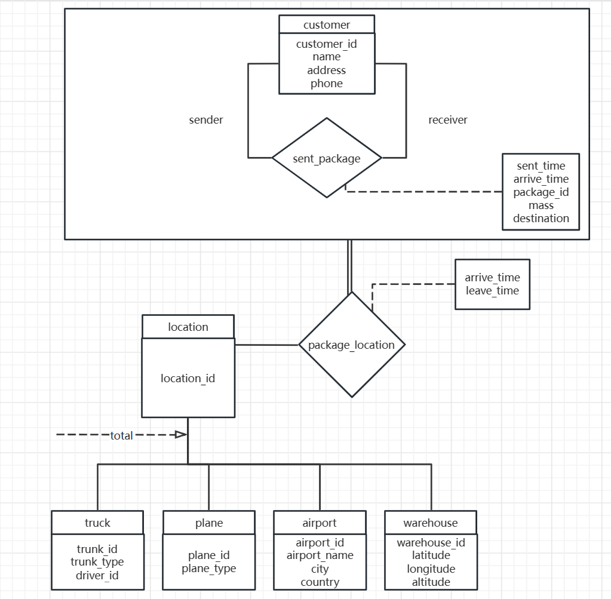

customer(customer_id, name, address, phone)

sent_package(package_id, sender_id, receiver_id, sent_time, arrive_time, mass, destination)

package_location(location_id, package_id, arrive_time, leave_time)

location(location_id)

truck(location_id, truck_id, truck_type, driver_id)

plane(location_id, plane_id, plane_type)

airport(location_id, airport_id, airport_name, city, country)

warehouse(location_id, warehouse_id, latitude, longitude, altitude)

主码：

上述关系模式中，主码均用下划线表示

外码：

sent_package中sender_id, receiver_id引用customer中的customer_id

package_location 中location_id引用location中的location_id

truck, plane, airport, warehouse中的location_id引用location中的location_id

其他约束

sent_package中的sender_id, receiver_id, mass, destination非空

7.26

|  |  |  |
| --- | --- | --- |
| α | β | γ |
| 1 | 2 | 4 |
| 1 | 2 | 8 |
| 2 | 3 | 10 |

此时，α-> β，γ->β，但α的值1映射到了两个不同的γ值，分别为4、8，因此不满足α->γ

7.27

已知α->βγ

求证α->β且α->γ

∵β⊆βγ

∴βγ->β(自反律)

∴α->β(传递律)

同理

α->γ