hw２

YangTengchao

Table of Contents

# 导入数据  
music <- read.csv("music.csv")

# 查看基本信息  
str(music)

## 'data.frame': 150 obs. of 3 variables:  
## $ ID : int 1 2 3 4 5 6 7 8 9 10 ...  
## $ condition : chr "no_music" "no_music" "no_music" "no_music" ...  
## $ productivity: num 188 196 194 190 157 ...

summary(music)

## ID condition productivity   
## Min. : 1.00 Length:150 Min. :104.7   
## 1st Qu.: 38.25 Class :character 1st Qu.:161.0   
## Median : 75.50 Mode :character Median :185.0   
## Mean : 75.50 Mean :184.9   
## 3rd Qu.:112.75 3rd Qu.:205.0   
## Max. :150.00 Max. :285.3

# 分组信息查看  
no_music <- music[music$condition == "no_music",][["productivity"]]  
music_no_choice <- music[music$condition == "music_no_choice", ][["productivity"]]  
music_choice <- music[music$condition == "music_choice", ][["productivity"]]  
summary(no_music)

## Min. 1st Qu. Median Mean 3rd Qu. Max.   
## 110.7 143.1 171.7 174.5 196.7 276.6

summary(music_no_choice)

## Min. 1st Qu. Median Mean 3rd Qu. Max.   
## 104.7 152.4 179.0 177.1 201.0 252.8

summary(music_choice)

## Min. 1st Qu. Median Mean 3rd Qu. Max.   
## 130.9 180.4 195.0 203.0 230.8 285.3

# music_choice hist  
hist(music_choice, freq = F, breaks = 4, main = "music_choice")

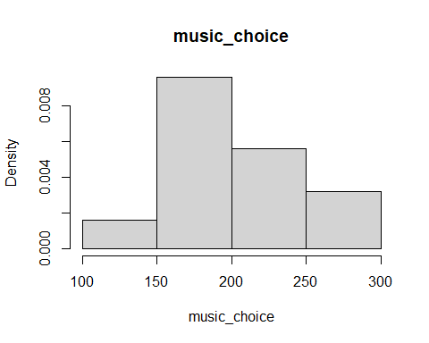

# music_no_choice hist  
hist(music_no_choice, freq = F, breaks = 4, main = "music_no_choice")

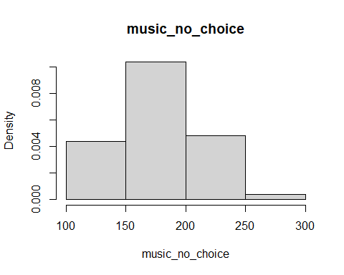

# no_music hist  
hist(no_music, freq = F, breaks = 4, main = "no_music")

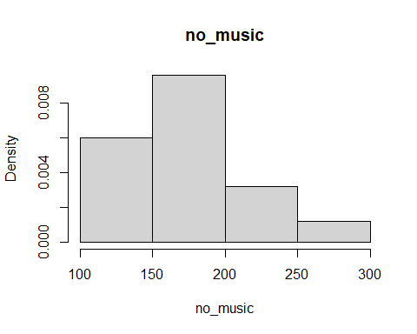

# 方差分析  
res <- aov(productivity ~ condition, data = music)  
  
# 查看结果  
summary(res)

## Df Sum Sq Mean Sq F value Pr(>F)   
## condition 2 24734 12367 9.291 0.000159 ***  
## Residuals 147 195661 1331   
## ---  
## Signif. codes: 0 '***' 0.001 '**' 0.01 '*' 0.05 '.' 0.1 ' ' 1

# 进行Tukey's HSD测试  
TukeyHSD(res)

## Tukey multiple comparisons of means  
## 95% family-wise confidence level  
##   
## Fit: aov(formula = productivity ~ condition, data = music)  
##   
## $condition  
## diff lwr upr p adj  
## music_no_choice-music_choice -25.820579 -43.09679 -8.544367 0.0015539  
## no_music-music_choice -28.466400 -45.74261 -11.190188 0.0004246  
## no_music-music_no_choice -2.645821 -19.92203 14.630391 0.9301260