CHAPTER THREE
SYSTEM ANALYSIS AND DESIGN

3.1 Introduction
This chapter presents a comprehensive analysis and design of the Smart Attendance System (SAS). Building upon the problem statement and objectives established in Chapter One and the literature gaps identified in Chapter Two, this chapter translates the system requirements documented in the Software Requirements Specification (SRS v1.0) into a concrete, implementable design. The chapter covers system architecture, database design, use case modelling, interaction sequences, security architecture, API design, interface design, and deployment configuration.
The design follows a layered, client-server architecture that separates concerns across distinct tiers: a React Native mobile client and React.js web client, a Python FastAPI backend API, a PostgreSQL relational database, and a Redis in-memory cache. External integrations with Microsoft Azure Face API, Firebase Cloud Messaging, and the Google Maps and Expo Location APIs provide the biometric verification, push notification, and geofencing capabilities respectively. All design decisions are justified with reference to the functional and non-functional requirements defined in the SRS.
All diagrams in this chapter represent the system as implemented. The architecture, data model, and API surface reflect the production system deployed at the time of writing, with the Hugging Face Spaces backend, Supabase PostgreSQL database, and Vercel web dashboard.

3.2 System Analysis

3.2.1 Requirements Analysis
The requirements analysis phase identified 52 functional requirements (FR-001 through FR-052) and 24 non-functional requirements (NFR-001 through NFR-024), formally documented in SRS v1.0. Requirements were elicited through analysis of the proxy attendance problem domain, review of related literature on digital attendance systems, and scenario-based validation using a realistic university session case study (Bamenda University SE301).
The key insight derived from requirements analysis is that no existing system closes all proxy attendance attack vectors simultaneously. The requirements therefore mandate a multi-gate verification pipeline that makes each attack vector independently non-trivial to defeat. This insight drives the entire architectural approach: four independent verification gates, each addressing a different class of attack.

3.2.2 Feasibility Analysis
A technical feasibility assessment was conducted across three dimensions:
- Technical feasibility: All required technologies — React Native, FastAPI, PostgreSQL, Redis, Azure Face API, and Firebase FCM — are mature, well-documented, and openly available. The Azure Face API provides enterprise-grade face recognition without requiring in-house AI model development, eliminating the need for specialised machine learning expertise.
- Operational feasibility: The system requires only a standard smartphone from students and a laptop from lecturers. No specialised hardware installation is required at venues, making the system deployable in any classroom with GPS coverage.
- Economic feasibility: All core components are available on free tiers during the MVP phase. Azure Face API provides 30,000 transactions per month free of charge, sufficient for a single-institution deployment of up to approximately 1,500 sessions per month. PostgreSQL on Supabase, Redis, and the web hosting on Vercel are all free at MVP scale.

3.2.3 System Boundaries
The Smart Attendance System operates within the following defined boundaries:
- Input boundary: The system receives QR scan data, GPS coordinates, face image captures, and administrative inputs from authenticated users via the mobile app and web dashboard.
- Output boundary: The system produces attendance records, marks, notifications, anomaly flags, audit entries, and exportable reports.
- External interfaces: Azure Face API (biometric identity verification), Firebase FCM (push notification delivery), Google Maps and Expo Location (geofence distance calculation), and Supabase (managed PostgreSQL hosting).
- Exclusions: The system does not integrate with external Learning Management Systems, does not perform automated grade submission, and does not support email or SMS notifications in Phase 1.

3.3 System Architecture

3.3.1 Architectural Overview
The Smart Attendance System follows a five-tier layered architecture: a client tier, an API gateway tier, a service tier, a data tier, and an external services tier. This layering enforces separation of concerns, supports independent scaling of each tier, and isolates external service dependencies from core business logic. Figure 3.1 illustrates the complete system architecture.
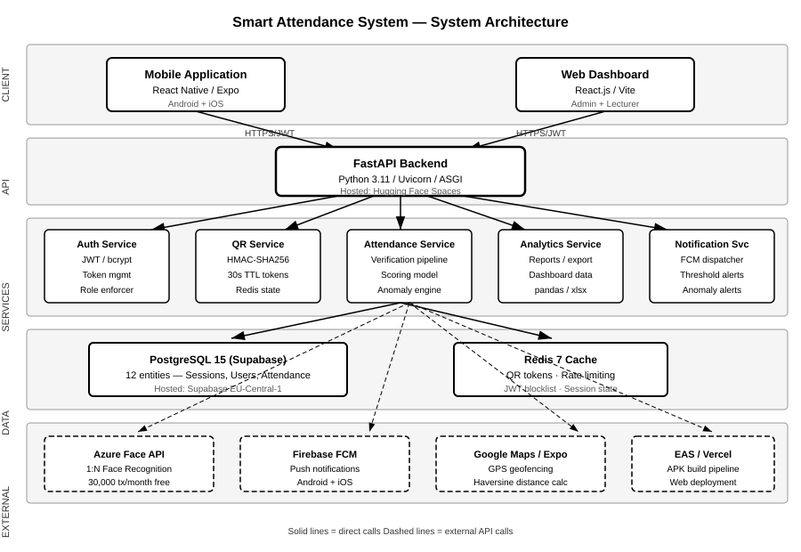
Figure 3.1: Smart Attendance System — System Architecture Diagram

3.3.2 Client Tier
The client tier comprises two front-end applications that interact with the backend exclusively through authenticated REST API calls:
Mobile Application: Built with React Native (Expo SDK 49), the mobile application serves students, lecturers, and class coordinators on Android and iOS. It handles QR code scanning via the Expo Camera module, GPS coordinate capture via Expo Location, face capture for biometric verification, and real-time push notification receipt via the Expo Notifications module. The application stores authentication tokens in Expo SecureStore and implements offline check-in caching in AsyncStorage for resilience against temporary connectivity loss.
Web Dashboard: Built with React 18 and Vite 5, the web dashboard serves Super Admins and Lecturers. It provides course and session management, live attendance monitoring, full report generation and export, anomaly flag review, and user account management. Server state is managed by TanStack Query v5, which provides automatic background refetching and caching. The dashboard is deployed on Vercel at: smart-attendance-system-ebon-delta.vercel.app.

3.3.3 API Gateway Tier
The API gateway tier is implemented as a single Python FastAPI application served by Uvicorn over ASGI. FastAPI was selected for its native async support, automatic OpenAPI 3.0 documentation generation, Pydantic-based request validation, and benchmark performance comparable to Node.js Express. All endpoints are prefixed with /v1/ for versioning.
The backend is deployed on Hugging Face Spaces as a Docker container, accessible at: felicityb4-smart-attendance-backend.hf.space. JWT authentication is enforced on all endpoints except /v1/auth/login and /v1/auth/register. Token validation, role enforcement, and rate limiting are applied as FastAPI dependency injections, ensuring consistent security across all routes.

3.3.4 Service Tier
The service tier contains five logical service modules, each responsible for a distinct domain of business logic:
Service Module | Responsibilities
Auth Service | JWT token issuance and validation, bcrypt password hashing, refresh token management, account lockout after failed attempts
QR Service | HMAC-SHA256 token generation, 30-second TTL management via Redis, single-use enforcement, session binding
Attendance Service | Four-gate verification pipeline (QR → GPS → Face → Record), time-based scoring model, threshold evaluation, anomaly detection engine
Analytics Service | Report generation (weekly/monthly/semester/year), student dashboard aggregation, CSV/Excel export via pandas
Notification Service | FCM push dispatch for all eight defined trigger events, notification persistence in PostgreSQL before dispatch

3.3.5 Data Tier
PostgreSQL 15 (Supabase): The primary persistent store hosts all 12 entities of the SAS data model. Supabase provides a managed PostgreSQL instance with a session pooler endpoint that ensures IPv4 compatibility for hosting environments. The database uses native PostgreSQL ENUM types for role, status, category, and method fields, JSONB for the audit log details column, and database-layer triggers to enforce the immutability of audit log records.
Redis 7: The Redis in-memory cache serves three functions: (1) storing the current active QR token per session with a 30-second time-to-live (TTL) enforced by Redis key expiry; (2) maintaining sliding-window rate limiting counters for the check-in endpoint (maximum 5 requests per student per minute); and (3) holding the JWT refresh token blocklist for tokens that have been explicitly invalidated before their natural expiry.

3.4 Database Design

3.4.1 Entity Relationship Diagram
The SAS database comprises 12 entities. The ERD presented in Figure 3.2 shows all entities, their key attributes, primary keys, foreign key relationships, and cardinality. Dark-header entities represent primary business entities; grey-header entities represent junction, log, or supporting tables.
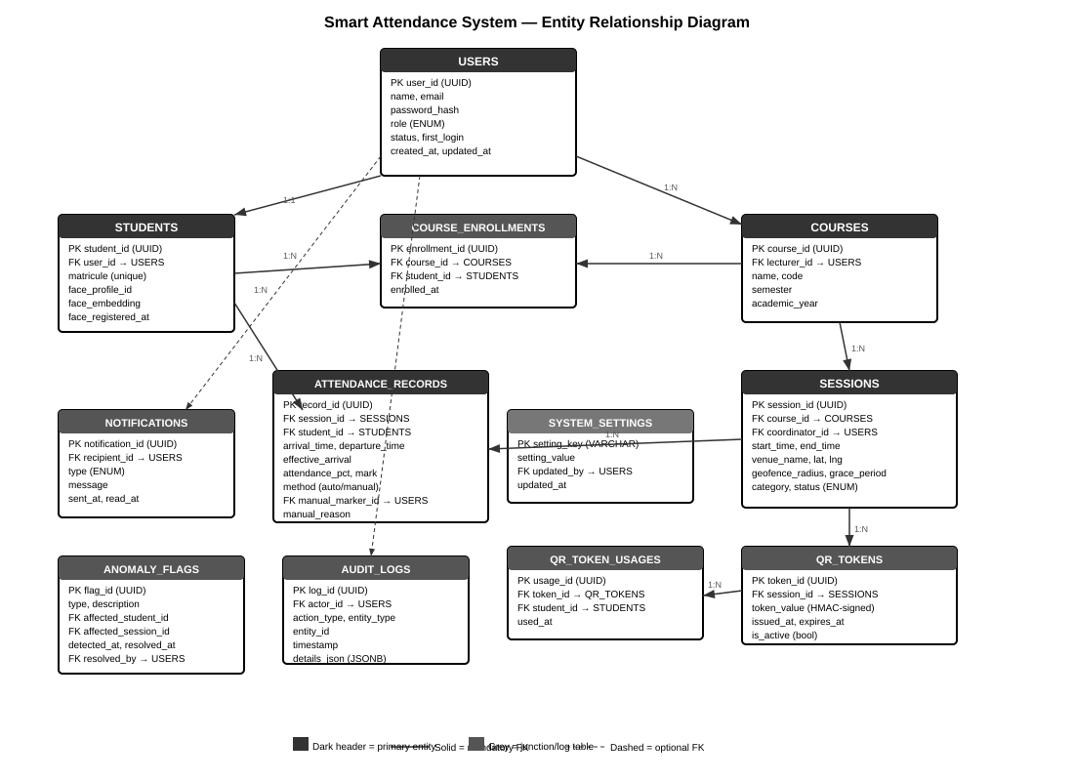
Figure 3.2: Smart Attendance System — Entity Relationship Diagram

3.4.2 Entity Descriptions
The following provides a description of each entity and its role in the system:
USERS:
The central identity entity. Every person in the system — Super Admin, Lecturer, Coordinator, or Student — has a USERS record. The role field uses a PostgreSQL ENUM type (super_admin, lecturer, coordinator, student) enforced at the database layer. Passwords are stored as bcrypt hashes with a minimum cost factor of 12. The first_login flag triggers a mandatory password change flow for newly created accounts.
STUDENTS:
An extension table for users with the student role. Stores the institution matricule number (unique identifier for the student at the university), the Azure Face API PersonId reference (face_profile_id), a locally computed face embedding vector (face_embedding), and the timestamp of most recent face profile registration. The student_id is the same UUID as the corresponding user_id, enforcing a strict 1:1 relationship.
COURSES and COURSE_ENROLLMENTS:
COURSES stores the academic course definition, linked to a lecturer via foreign key. COURSE_ENROLLMENTS is a junction table that records which students are enrolled in which courses, with a unique constraint on (course_id, student_id) to prevent duplicate enrollments.
SESSIONS:
Represents a single scheduled class event. Key fields include the geofence centre coordinates (latitude, longitude), the configurable geofence_radius (10–5000 metres), and the grace_period (0–60 minutes). The status ENUM (pending, open, closed, cancelled) drives the QR token lifecycle. An optional coordinator_id links to a designated Class Coordinator user.
QR_TOKENS and QR_TOKEN_USAGES:
QR_TOKENS stores each generated session token with its HMAC-SHA256 signed value, issue timestamp, expiry timestamp, and active flag. QR_TOKEN_USAGES records which student used which token, enforcing the single-use constraint via a unique constraint on (token_id, student_id).
ATTENDANCE_RECORDS:
The core output entity. Each record captures arrival_time, departure_time, effective_arrival (adjusted for grace period), the computed attendance_pct, the resulting mark (0–10), and the method (auto for verified check-in, manual for lecturer/coordinator override). A unique constraint on (session_id, student_id) prevents duplicate records per session.
NOTIFICATIONS, ANOMALY_FLAGS, AUDIT_LOGS:
Support entities that provide the observability and accountability layers. AUDIT_LOGS uses a database trigger that raises an exception on any UPDATE or DELETE, making the audit trail immutable at the storage layer, independent of application code.

3.5 Data Dictionary
The following tables provide a complete data dictionary for all primary entities in the SAS database.

Table 3.1: USERS
Column | Type | Constraints | Description
user_id | UUID | PK, NOT NULL | Unique identifier, auto-generated (gen_random_uuid)
name | VARCHAR(150) | NOT NULL | Full display name of the user
email | VARCHAR(255) | UNIQUE, NOT NULL, INDEX | Login email address
password_hash | VARCHAR(255) | NOT NULL | bcrypt hash, cost factor ≥12
role | ENUM | NOT NULL | Values: super_admin, lecturer, coordinator, student
status | ENUM | DEFAULT active | Values: active, suspended, deleted
fcm_token | VARCHAR(512) | NULLABLE | Firebase FCM device token for push delivery
avatar_base64 | TEXT | NULLABLE | Base64-encoded profile avatar image
first_login | BOOLEAN | DEFAULT false | True triggers mandatory password change flow
created_at | TIMESTAMPTZ | DEFAULT NOW() | Record creation timestamp
updated_at | TIMESTAMPTZ | DEFAULT NOW() | Last modification timestamp

Table 3.2: SESSIONS
Column | Type | Constraints | Description
session_id | UUID | PK, NOT NULL | Unique session identifier
course_id | UUID | FK → COURSES, NOT NULL | Parent course reference
coordinator_id | UUID | FK → USERS, NULLABLE | Optional delegated Class Coordinator
start_time | TIMESTAMPTZ | NOT NULL | Scheduled session start
end_time | TIMESTAMPTZ | NOT NULL, > start_time | Scheduled session end
venue_name | VARCHAR(200) | NOT NULL | Human-readable venue description
latitude | NUMERIC(10,7) | NOT NULL | Geofence centre latitude
longitude | NUMERIC(10,7) | NOT NULL | Geofence centre longitude
geofence_radius | INTEGER | DEFAULT 50, 10–5000 | Allowed distance from venue (metres)
grace_period | INTEGER | DEFAULT 15, ≥0 | Late arrival credit window (minutes)
category | ENUM | DEFAULT regular | Values: mandatory, regular, optional
status | ENUM | DEFAULT pending | Values: pending, open, closed, cancelled

Table 3.3: ATTENDANCE_RECORDS
Column | Type | Constraints | Description
record_id | UUID | PK, NOT NULL | Unique record identifier
session_id | UUID | FK → SESSIONS, NOT NULL | Session the record belongs to
student_id | UUID | FK → STUDENTS, NOT NULL | Student the record belongs to
arrival_time | TIMESTAMPTZ | NULLABLE | Actual QR scan timestamp
departure_time | TIMESTAMPTZ | NULLABLE | Check-out timestamp or inferred departure
effective_arrival | TIMESTAMPTZ | NULLABLE | Arrival adjusted for grace period
attendance_pct | NUMERIC(5,2) | 0–100 | (Time Attended / Session Duration) × 100
mark | NUMERIC(4,2) | 0–10 | attendance_pct × 10 / 100
method | ENUM | DEFAULT auto | Values: auto (verified), manual (override)
manual_marker_id | UUID | FK → USERS, NULLABLE | Lecturer or Coordinator who manually marked
manual_reason | TEXT | NULLABLE, required if manual | Stated reason for manual override
is_makeup | BOOLEAN | DEFAULT false | True for makeup sessions

3.6 Use Case Design

3.6.1 Actors
The SAS defines four actor types, each with a distinct set of system interactions:
Actor | Description | Primary Interactions
Super Admin | Single institutional administrator with unrestricted system access | User management, system analytics, audit log review, anomaly resolution
Lecturer | Academic staff who own courses and sessions | Course/session creation, QR display, manual marking, report export
Class Coordinator | Student delegated by Lecturer to assist with session management | Manual marking (≤3 per session), session announcement, live attendance view
Student | Enrolled student who attends sessions | QR check-in, face verification, dashboard view, notification receipt

3.6.2 Use Case Diagram
Figure 3.3 presents the complete use case diagram showing all actors and their associated system interactions. Dashed arrows indicate include relationships where one use case is a mandatory sub-step of another.
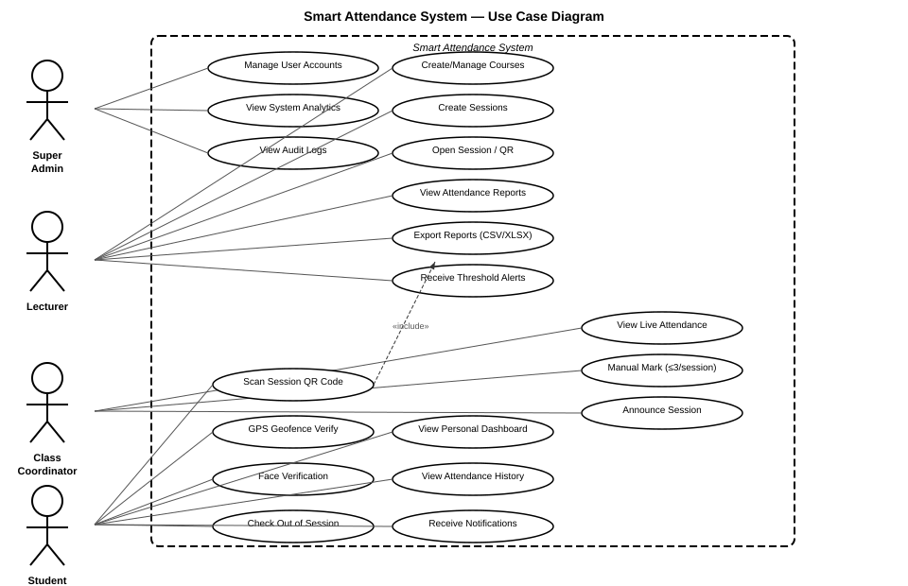
Figure 3.3: Smart Attendance System — Use Case Diagram

3.6.3 Key Use Case Descriptions
UC-01: Student Check-In
Field | Description
Actor | Student
Precondition | Student is enrolled in the course; session is open; student has registered face profile
Main Flow | 1. Student opens mobile app and navigates to active session 2. Student scans Session QR code 3. System validates QR token (Gate 1) 4. System captures and validates GPS coordinates against geofence (Gate 2) 5. System captures face image and submits to Azure Face API (Gate 3) 6. System records attendance with arrival timestamp (Gate 4) 7. Student receives FCM check-in confirmation notification
Alternative Flow | If any gate fails: system displays specific error message and rejects check-in without recording partial data
Postcondition | Attendance record created; attendance_pct and mark calculated; threshold evaluated

UC-02: Manual Attendance Marking

Field | Description
Actor | Lecturer or Class Coordinator
Precondition | Actor is authenticated; session exists; student is enrolled in the session course
Main Flow | 1. Actor navigates to session detail and selects manual mark 2. Actor selects student and provides reason 3. System validates actor role and (if Coordinator) checks 3-entry cap 4. System creates attendance record with method=manual and 100% attendance 5. System creates immutable audit log entry with actor ID, timestamp, and reason
Alternative Flow (Coordinator cap exceeded) | System rejects the mark at API layer and sends FCM alert to Super Admin
Postcondition | Manual attendance record created; audit entry logged; visual flag applied to record in all reports

3.7 Interaction Design — Sequence Diagrams

3.7.1 Check-In Verification Sequence
Figure 3.4 presents the complete interaction sequence for the student check-in process. The diagram shows all six system participants — the student’s mobile app, the FastAPI backend, Redis cache, PostgreSQL database, Azure Face API, and Firebase FCM — and the precise sequence of messages exchanged during a successful check-in. The four verification gates are annotated on the left side of the diagram.
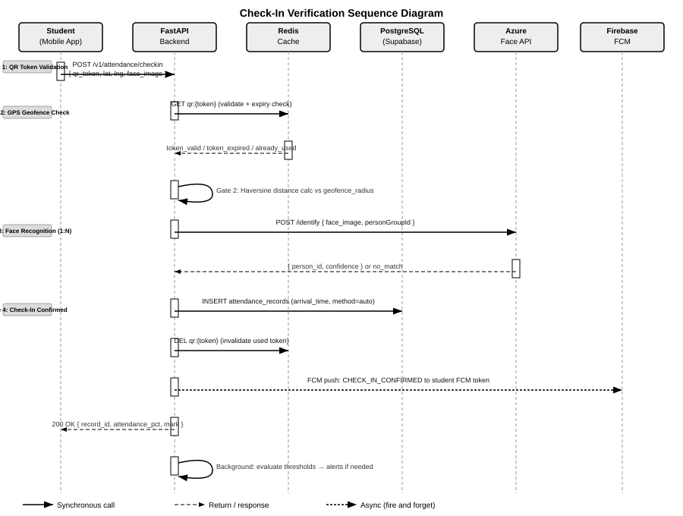
Figure 3.4: Check-In Verification Sequence Diagram

3.7.2 Session QR Lifecycle
The QR token lifecycle is managed jointly by the FastAPI backend and Redis. When a Lecturer opens a session, the backend generates an HMAC-SHA256 signed token, stores it in Redis with a 30-second TTL (key: qr:{session_id}), and returns the token to the lecturer’s QR display screen. Every 30 seconds the display screen requests a new token, which the backend generates fresh and updates in Redis. When a student scans the QR code, the backend performs the following atomic sequence:
- Retrieve token from Redis (GET qr:{session_id})
- Verify HMAC-SHA256 signature
- Check token TTL has not expired
- Verify no existing QR_TOKEN_USAGES record for this (token_id, student_id) pair
- If all checks pass, mark token as used in QR_TOKEN_USAGES and proceed to Gate 2
If the Lecturer closes the session, the backend immediately deletes the Redis key and sets session status to closed, invalidating all active tokens regardless of their TTL.

3.7.3 Anomaly Detection Engine
The anomaly detection engine runs as an APScheduler background task, executing every 5 minutes during active session periods. It monitors the following five patterns against the PostgreSQL attendance_records and sessions tables:
Anomaly Type | Detection Trigger | Action
ATTENDANCE_DROP | Student attendance falls >20% in a single week vs the previous week | Insert ANOMALY_FLAGS record; notify Admin via FCM
COORDINATOR_ABUSE | Coordinator manual entries exceed 3 in a single session | API-layer block; immediate Super Admin alert
REPEATED_FACE_FAILURE | Same student fails face recognition in 3+ consecutive sessions | Flag for manual review; notify Lecturer
GRACE_PERIOD_GAMING | Student arrives within last minute of grace period in 5+ sessions | Log pattern flag; notify Lecturer
GEOFENCE_SPIKE | Geofence rejection rate for a specific venue exceeds 30% over 5 sessions | Flag possible venue mapping error; notify Admin

3.8 Security Architecture

3.8.1 Four-Gate Verification Pipeline
The core security innovation of the Smart Attendance System is its four-gate sequential verification pipeline. Each gate independently closes a different class of proxy attendance attack vector. No single gate failure allows check-in to proceed — all four must pass. Figure 3.5 illustrates the pipeline.
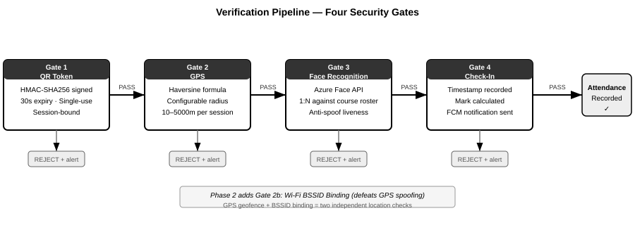
Figure 3.5: Verification Pipeline — Four Security Gates
The gates are designed such that each successive gate defends against attacks that defeat the previous one:
Gate | Mechanism | Attack Defeated | Residual Risk
Gate 1: QR Token | HMAC-SHA256 signed, 30s TTL, single-use, session-bound | Screenshot sharing, QR reuse, expired token replay | Real-time forwarding within 30s window
Gate 2: GPS Geofence | Haversine distance ≤ configured radius (10–5000m) | Check-in from home or wrong building | GPS spoofing apps on rooted devices
Gate 3: Face Recognition | Azure Face API 1:N against course PersonGroup | Proxy impersonation, wrong-person check-in | Photograph attack (mitigated by liveness in Phase 2)
Gate 4: Record Creation | Atomic INSERT with timestamp; FCM confirmation | Confirmation forgery | None at this stage

3.8.2 Transport and Authentication Security
Beyond the verification pipeline, the SAS implements the following security measures:
- TLS 1.2+: All API communication is encrypted in transit. HTTP connections are rejected; HTTPS is enforced by the Hugging Face Spaces reverse proxy.
- JWT Access Tokens: 15-minute expiry. Signed with HS256 using a 256-bit secret key (JWT_SECRET_KEY environment variable). All protected endpoints validate the token signature, expiry, and issuer before processing the request.
- Refresh Tokens: 7-day expiry. Stored server-side in Redis blocklist on logout or password change, preventing reuse of invalidated refresh tokens before their natural expiry.
- bcrypt Password Hashing: All passwords are hashed with bcrypt at cost factor 12 before storage. Plaintext passwords are never stored or logged.
- Rate Limiting: The check-in endpoint enforces a maximum of 5 requests per student per minute using Redis sliding-window counters, preventing automated attack scripts.
- Immutable Audit Trail: PostgreSQL trigger-based immutability prevents UPDATE or DELETE on audit_logs records, ensuring all administrative actions are permanently traceable.

3.8.3 Biometric Data Protection
In compliance with data minimisation principles, the SAS does not store biometric face feature vectors or templates in the SAS database. The only biometric reference stored is the Azure-issued PersonId (a non-reversible opaque identifier) in the students.face_profile_id column. All face recognition processing, storage, and deletion is handled exclusively by Microsoft Azure Face API, which is subject to Azure’s enterprise data processing agreements and GDPR compliance framework.

3.9 API Design

3.9.1 API Architecture
The SAS REST API follows the OpenAPI 3.0 specification and is automatically documented by FastAPI at the /docs endpoint. All endpoints are versioned under the /v1/ prefix. The API uses JSON for all request and response bodies, with the exception of file export endpoints which return binary CSV or Excel streams.
Authentication is JWT Bearer token based. The Authorization header format is: Authorization: Bearer {access_token}. Unauthenticated requests return HTTP 401. Requests with insufficient role permissions return HTTP 403.

3.9.2 API Endpoints
Authentication Endpoints
Method | Endpoint | Auth | Description
POST | /v1/auth/login | None | Authenticate user; returns access_token and refresh_token
POST | /v1/auth/register | None | Register new student account with face profile setup
POST | /v1/auth/refresh | Refresh token | Issue new access token from valid refresh token
POST | /v1/auth/logout | Bearer | Invalidate refresh token; add to Redis blocklist
GET | /v1/auth/me | Bearer | Return current authenticated user profile

User Management Endpoints
Method | Endpoint | Auth | Description
GET | /v1/users/ | Admin/Lecturer | List all users with optional role/status filters
POST | /v1/users/ | Admin | Create single user account
POST | /v1/users/bulk-csv | Admin | Bulk import students from CSV file
GET | /v1/users/{user_id} | Admin/Self | Retrieve specific user profile
PATCH | /v1/users/{user_id} | Admin/Self | Update user profile fields
DELETE | /v1/users/{user_id} | Super Admin | Soft-delete user (status=deleted)
PATCH | /v1/users/me | Bearer | Update own profile (name, phone, bio, avatar)

Course and Session Endpoints
Method | Endpoint | Auth | Description
GET | /v1/courses/ | Bearer | List courses (filtered by lecturer or enrolled student)
POST | /v1/courses/ | Lecturer | Create new course with name, code, academic year
GET | /v1/courses/{id}/sessions | Bearer | List all sessions for a course
POST | /v1/sessions/ | Lecturer | Create session with geofence and grace period config
POST | /v1/sessions/{id}/open | Lecturer | Open session and generate first QR token
GET | /v1/sessions/{id}/qr | Lecturer | Get current active QR token
POST | /v1/sessions/{id}/close | Lecturer | Close session and invalidate all tokens
POST | /v1/sessions/{id}/announce | Lecturer/Coordinator | Broadcast FCM notification to enrolled students

Attendance and Check-In Endpoints
Method | Endpoint | Auth | Description
POST | /v1/attendance/checkin | Student/Coordinator | Execute 4-gate verification pipeline and record check-in
POST | /v1/attendance/checkout | Student | Record departure time via second QR scan
POST | /v1/attendance/manual | Lecturer/Coordinator | Manual attendance mark with reason (Coordinator capped at 3)
GET | /v1/attendance/session/{id} | Lecturer/Admin | Get all attendance records for a session
GET | /v1/attendance/student/{id} | Self/Lecturer | Get attendance history for a student across courses

Analytics and Reporting Endpoints
Method | Endpoint | Auth | Description
GET | /v1/analytics/overview | Admin/Lecturer | System-wide summary statistics
GET | /v1/analytics/student/{id}/dashboard | Self | Personal dashboard: mark, trend, sessions remaining
GET | /v1/analytics/reports | Admin/Lecturer | Parameterised report (course, date range, type)
GET | /v1/analytics/export | Admin/Lecturer | Download CSV or Excel report
GET | /v1/anomalies/ | Admin | List all anomaly flags with filter/sort
PATCH | /v1/anomalies/{id}/resolve | Admin | Mark anomaly flag as resolved
GET | /v1/audit/ | Super Admin | Paginated immutable audit log

3.9.3 Standard Response Format
All API responses follow a consistent JSON envelope:
HTTP Status | Meaning | Response Body
200 OK | Request succeeded | { data: {...}, message: 'Success' }
201 Created | Resource created | { data: { id: '...', ... }, message: 'Created' }
400 Bad Request | Validation failed | { detail: [ { loc, msg, type } ] }
401 Unauthorized | Token missing or invalid | { detail: 'Not authenticated' }
403 Forbidden | Insufficient role | { detail: 'Permission denied' }
404 Not Found | Resource not found | { detail: 'Resource not found' }
422 Unprocessable | Schema validation error | { detail: [ { loc, msg, type } ] }
429 Too Many Requests | Rate limit exceeded | { detail: 'Rate limit exceeded' }
500 Server Error | Unhandled exception | { detail: 'Internal server error' }

3.10 User Interface Design

3.10.1 Design Principles
The SAS user interface was designed according to the following principles:
- Minimal interaction: The student check-in flow requires no more than 4 user interactions from app open to confirmed check-in, as required by NFR-016.
- Clear error feedback: Every verification gate failure presents a specific, actionable error message (e.g. “You are 45 metres outside the session boundary. Move closer and try again.”), as required by NFR-017.
- Role-appropriate interface: Students see only check-in screens and their personal dashboard. Lecturers see session management and QR display. Admins see full system controls. Role-irrelevant features are not displayed.
- Accessibility: The interface supports screen widths from 360px upward (NFR-018). Status indicators use both colour and iconography to support colour-blind users (WCAG 2.1 AA, NFR-019).
- Bilingual support: All interface text is available in English and French, implemented via a language context and translation key map, supporting the bilingual academic environment of the University of Bamenda.

3.10.2 Web Dashboard Screen Designs
The web dashboard provides four primary screens for administrative and lecturer users:
Screen | Primary Users | Key Features
Login / Authentication | All roles | Email/password form; JWT token management; first-login password change prompt
Overview Dashboard | Admin, Lecturer | KPI stat cards (active courses, sessions today, at-risk students, open anomalies); today’s session list; attendance trend chart; at-risk student widget
Courses & Sessions | Lecturer, Admin | Course creation and enrollment management; session creation with geofence and grace period configuration; session open/close controls; QR display mode; live attendance count
Users Management | Super Admin, Admin | User list with role/status filters; bulk CSV import; account creation; role assignment; account suspension
Reports & Analytics | Admin, Lecturer | Parameterised report generation; CSV/Excel export; anomaly flag list with resolution workflow; audit log view

3.10.3 Mobile Application Screen Designs
The mobile application provides distinct navigation flows for student and lecturer roles:
Screen | Role | Description
Login Screen | All | Full-screen gradient design; email/password inputs; first-login change password flow
Home Screen | Student, Lecturer | Greeting with time-aware message; attendance rate overview; today’s sessions list with status indicators and check-in button
Check-In Flow | Student | Step 1: QR Scanner (camera overlay with animated scan frame); Step 2: Face Capture (oval face guide with detection state animation); Step 3: Confirmation screen with mark and attendance percentage
QR Display Screen | Lecturer | Live QR code with 30-second countdown ring; student check-in count; close session button
Personal Dashboard | Student | Circular attendance progress indicator; per-course marks and trend bars; sessions remaining before threshold drop
Profile & Settings | All | Profile photo, contact info, department; theme toggle (light/dark); language toggle (EN/FR); notification preferences
Notifications | All | Grouped notification list (Today/This Week/Earlier); mark-as-read; type-coded accent colours

3.10.4 Colour Coding and Status Indicators
Both the web dashboard and mobile application use a consistent four-level colour coding system for attendance status, aligned with the threshold definitions in SRS Section 3.4.2:
Status | Threshold | Colour | Dashboard Indicator
Good | 80–100% | Green (#16A34A) | Green badge; no alert
Warning | 60–79% | Amber (#D97706) | Amber badge; FCM notification to student + lecturer
At Risk | 40–59% | Orange (#EA580C) | Orange badge; FCM notification to student, lecturer, admin
Critical | Below 40% | Red (#DC2626) | Red badge; dashboard flag; escalation alert

3.11 Technology Stack Justification

3.11.1 Backend Framework Comparison
Criterion | FastAPI | Django REST | Flask | Node.js Express
Async support | Native (ASGI) | Limited (WSGI) | Limited (WSGI) | Native (Event loop)
Auto documentation | OpenAPI 3.0 auto-gen | Manual / DRF | Manual | Manual
Request validation | Pydantic (type hints) | Serialisers | Manual | Manual
Performance (I/O bound) | Very high | Moderate | Moderate | Very high
Python type safety | Full | Partial | None | N/A
Selected? | YES | No | No | No

FastAPI was selected for its native async request handling (critical for concurrent face verification API calls), automatic OpenAPI documentation (which directly satisfies NFR-022), and Pydantic integration which eliminates an entire class of request validation bugs.

3.11.2 Database Selection
Criterion | PostgreSQL 15 | MySQL 8 | SQLite | MongoDB
Native ENUM types | Yes | Yes (limited) | No | No
JSONB support | Yes (indexed) | JSON (no index) | No | Native
Trigger-based constraints | Yes (PL/pgSQL) | Limited | No | No
UUID primary keys | Native gen_random_uuid() | Manual | Manual | ObjectId
ACID compliance | Full | Full (InnoDB) | Full | Partial
Managed free hosting | Supabase | PlanetScale (discontinued) | N/A | Atlas
Selected? | YES | No | No | No

3.11.3 Face Recognition Provider Comparison
Criterion | Azure Face API | AWS Rekognition | Google Cloud Vision | DeepFace (open source)
1:N identification | Yes (PersonGroup) | Yes (Collection) | Limited | Yes
Free tier | 30,000 tx/month | 5,000 tx/month (trial) | 1,000 units/month | Free (self-hosted)
Managed hosting | Yes (Azure SLA) | Yes (AWS SLA) | Yes (Google SLA) | No (own server)
GDPR data agreements | Yes (Azure DPA) | Yes (AWS DPA) | Yes | Self-managed
SDK / REST API | REST API + SDK | REST API + SDK | REST API + SDK | Python library
Selected? | YES | No | No | No

Azure Face API was selected primarily for its 1:N PersonGroup identification capability, which allows the system to identify a student from a face image without requiring the student to announce their identity — a critical requirement for the anti-proxy design. The 30,000 free transactions per month satisfies MVP scale requirements.

3.12 Deployment Architecture

3.12.1 Infrastructure Overview
Figure 3.6 presents the deployment architecture showing how system components are mapped to hosting infrastructure. The SAS follows a cloud-native, serverless-where-possible deployment strategy, utilising free-tier managed services to minimise operational overhead during the MVP phase.
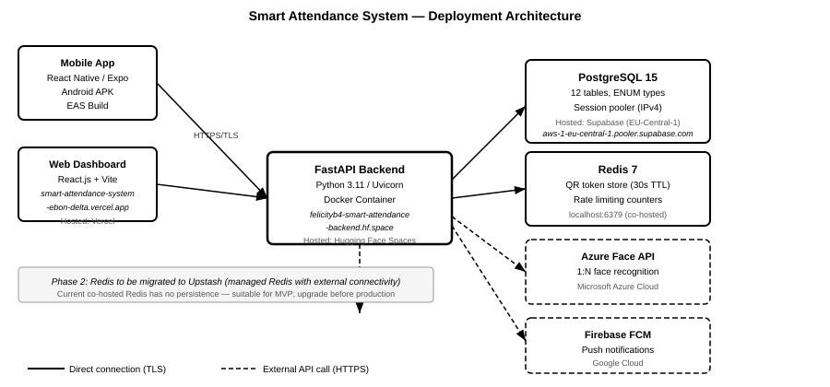
Figure 3.6: Smart Attendance System — Deployment Architecture

3.12.2 Component Hosting Summary
Component | Hosting Platform | URL / Endpoint | Notes
FastAPI Backend | Hugging Face Spaces | felicityb4-smart-attendance-backend.hf.space | Docker container; Python 3.11; Uvicorn; free CPU tier
Web Dashboard | Vercel | smart-attendance-system-ebon-delta.vercel.app | Automatic CI/CD from GitHub main branch
PostgreSQL Database | Supabase | aws-1-eu-central-1.pooler.supabase.com | Session pooler for IPv4 compatibility; EU-Central-1 region
Redis Cache | Co-hosted (backend server) | localhost:6379 | Phase 2: migrate to Upstash for external access
Android APK | EAS Build | Built via eas build -p android | Production: app-bundle; Preview: APK
Azure Face API | Microsoft Azure | External REST API | Free tier: 30,000 tx/month
Firebase FCM | Google Firebase | External REST API (HTTP v1) | OAuth 2.0 service account auth

3.12.3 Docker Configuration
The FastAPI backend is containerised using a Python 3.11-slim Docker base image. The container exposes port 7860 (required by Hugging Face Spaces) and executes the following startup sequence:
- Run Alembic database migrations (alembic upgrade head)
- Start Uvicorn ASGI server bound to 0.0.0.0:7860
Environment variables (DATABASE_URL, JWT_SECRET_KEY, QR_HMAC_SECRET, REDIS_URL, etc.) are injected as Hugging Face Spaces repository secrets, ensuring sensitive credentials are never committed to source control.

3.12.4 CI/CD Pipeline
The web dashboard benefits from automatic continuous deployment: every push to the main branch of the GitHub repository triggers a Vercel build and deployment, making new features available at the production URL within approximately 60 seconds of a code push. The mobile APK is built on-demand using the EAS Build service, which compiles the React Native application into a signed Android APK using the eas build --platform android --profile preview command.

3.13 Summary
This chapter has presented a complete system design for the Smart Attendance System, covering all layers of the application from client-side interfaces through API design, service logic, data modelling, and deployment infrastructure. The design is grounded in the functional and non-functional requirements of SRS v1.0 and addresses every major design challenge identified in the literature review.
The five-tier layered architecture ensures separation of concerns, independent scalability, and clear boundaries between the client, API, service, data, and external integration tiers. The four-gate sequential verification pipeline — QR token validation, GPS geofencing, face recognition, and check-in confirmation — addresses every known proxy attendance attack vector identified in the literature, with no single point of failure.
The PostgreSQL data model comprising 12 entities captures all required relationships between users, courses, sessions, attendance records, QR tokens, notifications, anomaly flags, and audit logs. The database-layer constraints, including trigger-enforced audit log immutability and ENUM-enforced role and status values, provide a resilient foundation that cannot be circumvented at the application layer.
The REST API design, with 30+ versioned endpoints across six functional domains, provides a comprehensive and consistent interface between the front-end clients and the backend business logic. The deployment architecture demonstrates a cost-effective, cloud-native approach using free-tier managed services that satisfies all MVP-scale requirements.
The subsequent chapters describe the implementation of this design (Chapter Four) and the testing and evaluation of the implemented system against the requirements and performance targets defined in the SRS (Chapter Five).
— End of Chapter Three —

