软件需求工程实验报告三

14011408 张赛琳 2014303510

实验目的：

1、掌握需求开发中从业务需求、用户需求到功能性和非功能性需求的逐步细化的需求获取技术和方法；

2、掌握需求规格说明书(SRS)的编写；

3、掌握对系统最终的需求用需求规格说明文档进行描述的方法；

预习与实验要求：

1、预习实验指导书及教材的有关内容，了解需求规格说明文档的编写规范及模板；

2、掌握需求规则说明文档的内容，掌握需求细化，逐步分析获取的方法；并能把细化分析的需求编写到规格说明文档中；

3、实验前认真听讲，服从安排，尽可能独立思考并完成实验。

实验原理：

1、软件需求规格说明，需求标识；

2、需求细化分析的方法及完善模型的技术；

3、软件需求规格说明模板；

4、编写需求文档的原则

实验过程：

第一部分：

1. 找到在线股票交易系统的初始需求

trade quotes;

obtain real- time stock quotes;

ability to research stock;

ability to fund trading account directly from a savings account held in another financial institution;

Web access instead of having to install client software;

receive updates to the software;

install on a machine running Microsoft Windows 98 or higher or an Apple running Mac OSX；

（2）阅读需求规格说明书

（3）标记任何我认为是软件需求的部分

第二部分：

1. 列出我找到的需求

trade securities online,using a Web interface;

log on to the Internet anywhere;

perform all the basic operations for securities trading:open accounts,trade stocks and other securities,transfer assets among RU e-st accounts;

obtain current and historical information about their accounts;

execute many types of trade orders:market trading,transfers from one mutual to another within one account,limit trading,transfer cash;

transfer cash on an account to or from financial istitutions;

obtain information about what is happening in the securities markets；obtain price quotes and news headlines；

broadcast news headlines periodically;

1. 比较不同成员找到的需求的数量的差异
2. 集体讨论

为什么会有数量的差异？如何处理这些差异？

**答**： 不同的人对需求的定义不同，对材料的理解程度也不同，所以找到的需求的数量存在差异。对于这些差异，小组成员应当聚集在一起，逐条审核，排除冗余，找出最恰当的需求。

标准化文档的好处有哪些？需求的鉴定方法有哪些？

**答**：提高软件的可靠性、可维护性和可移植性；提高软件的生产率，提高软件人员的技术水平；提高软件人员之间的通信效率，减少差错与误解；有利于软件管理；有利于降低软件产品的成本和运行维护成本；有利于缩短软件开发周期。组成表法、问题分析法、差异分析法、原型法、其他方法，例如面向对象方法，系统用例法，生命周期法等。

当你从用户那里获取到一个需求时，你怎样处理？

**答**：了解实际用户任务和目标以及这些任务所支持的业务需求；分析源于用户的信息以区别用户任务需求、功能需求、业务规则、质量属性、建议解决方法和附加信息；将系统级的需求分为几个子系统,并将需求中的一部份分配给软件组件；了解相关质量属性的重要性；商讨实施优先级的划分；将所收集的用户需求编写成文档和模型。

你的参与者列表是否发生变化？

答：参与者列表发生了变化。

第三部分：

1. Review the list of sample stakeholder requests.
2. List the needs in section 3.7 of your Vision document .

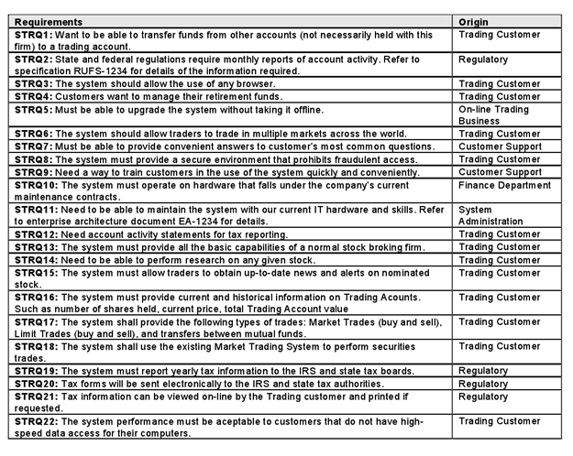

第四部分：确定系统的特征

（1）问题描述：

|  |  |
| --- | --- |
| The problem of | 客户流失 |
| Affects | 客户股票交易困难、公司盈利减少，甚至亏损。 |
| The impact of which is | 公司亏损 |
| A successful solution would | 方便客户股票交易、公司盈利发展、便于维护与测试、便于管理 |

利益相关者：Customers、Financial institution、Maintain people、The existing financial network system、The existing quote system。

参与者：Customers、Administrator、Financial institution、Maintain people、The existing financial network system、The existing quote system、The existing news system、Account、the IRS and state tax boards、Testing group.

鱼骨图：

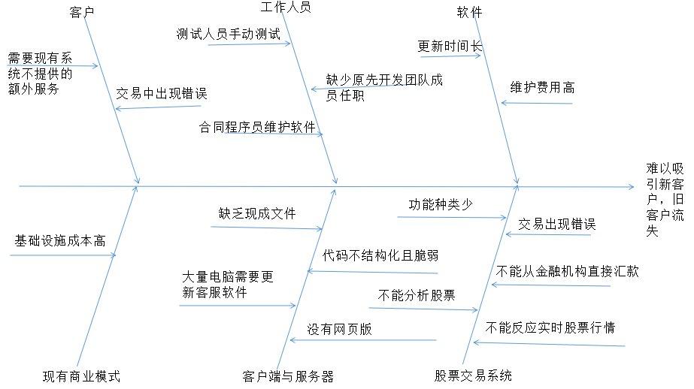

关键利益相关者：Customers、Financial institution

用户需求：trade securities online,using a Web interface;

log on to the Internet anywhere;

perform all the basic operations for securities trading:open accounts,trade stocks and other securities,transfer assets among RU e-st accounts;

obtain current and historical information about their accounts;

execute many types of trade orders:market trading,transfers from one mutual to another within one account,limit trading,transfer cash;

transfer cash on an account to or from financial istitutions;

obtain information about what is happening in the securities markets； obtain price quotes and news headlines；

约束条件：数据库、法律条文。

1. Are there any stakeholder requests that do not trace to one or more features? What should you do in this situation?

**答：Yes,there are.**

将它们单独列出，单独处理。

How does the Product Position Statement differ from the Problem Statement? Why is it useful to have both of them in your Vision document?

**答：**Product Position Statement主要反映系统的作用，从好的影响方面着手；Problem Statement主要反映系统存在的问题，弊端，从缺点方面着手。视图文档中包含着两者很有用，因为可以软件人员大体了解该系统的主要价值和需要改进的地方，明确了工作的方向与目标，减少误解与差错，提高了工作效率。

How does viewing the results of putting together a Vision document influence your perception of your project?

**答**：视图文档给了所开发的产品一个大致定位，接下来的开发工作都围绕此进行，所以会影响项目的结果。

1. 写出产品职位清单

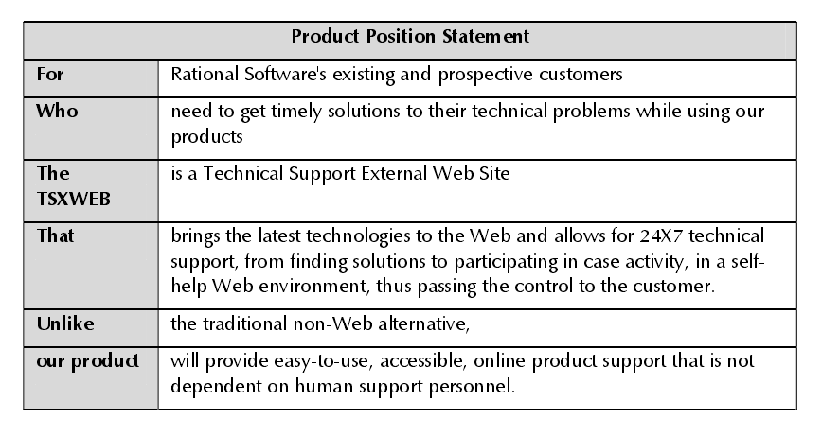

第五部分：确定项目的参与者和用例，画出用例图。

What are the goals of each actor?

|  |  |
| --- | --- |
| Actor | Goal |
| Trading customer | Obtain information,trade securities |
| The IRS and state tax boards | Receive and view yearly tax information |
| The existing news system | Provide and broadcast news headlines |
| The existing quote system | Provide information about quotes |
| The existing financial network system | Transfer cash |
| Maintain people | Maintain the system |
| Testing group | Perform testing of the system |
| Administrator | Control the system |
| Account | Transfer assets |

What will the actor use the system for? Will the actor create, store, change, remove, or read data in the system? why?

|  |  |  |  |  |  |
| --- | --- | --- | --- | --- | --- |
| Actor | create | store | change | remove | read |
| Trading customer | √ | √ | √ | √ | √ |
| The IRS and state tax boards | × | × | × | × | √ |
| The existing news system | √ | √ | × | √ | √ |
| The existing quote system | √ | √ | √ | √ | √ |
| The existing financial network system | √ | √ | √ | √ | √ |
| Maintain people | × | × | √ | × | √ |
| Testing group | × | × | × | × | √ |
| Administrator | √ | √ | √ | √ | √ |
| Account | √ | √ | √ | √ | √ |

Will the actor need to inform the system about external events or changes?

**答：Yes,they will.**

Will the actor need to be informed about certain occurrences in the system?

**答：Yes,they need.**

Does the system supply the business with all of the correct behavior?

**答：No,it doesn’t.**

How does your solution compare with the sample solution? What is different? What is the same?

**答：**各有所长。

不同处：解决办法范例着重更新股票在线交易系统，我的方法是重新定义需求，从而对系统进行更加准确的定位。

相同处：目标一致，都是为了增加用户量；都从用户需求方面着手。

Are the use cases too small? Should some use cases be combined?

**答：No.**

**No.**

Does the brief description provide a good overview of the use cases purpose? Is there too much detail, not enough detail, or just enough detail?

**答：Yes,it does.**

**There is not enough detail.**

Does the diagram cover all activities? Can you think of any activities not covered?

**答：No,it doesn’t.**

E**xecute many types of trade orders:market trading,transfers from one mutual to another within one account,limit trading,transfer cash;**

How do you know what is done in each use case?

**答：Query the use-case disgram.**

Does your use-case model satisfy the goals of all stakeholders?

**答：Yes.**

Did you identify any new actors?

**答：No.**

用例图如下：

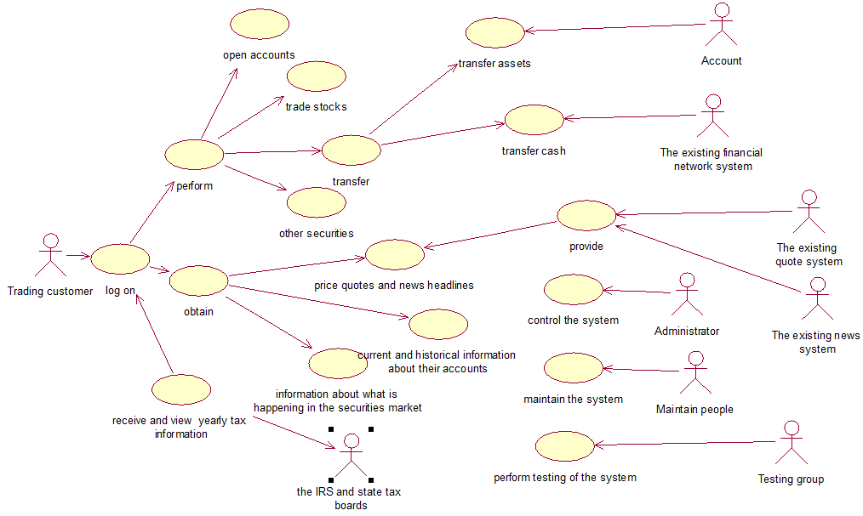

实验心得：

这次实验是做到目前为止最复杂，最难的一次实验，这次实验还用到了实验二的部分内容，让我们在实验二的基础上对需求分析有了更深层次的理解，并对实验二的结果进行了一定程度上的改进，使需求分析的结果更加完善。这是一个精益求精的过程，我收获良多。