姓名：唐买手三 | 专业：信息管理与信息系统 | 班级：20181171 | 学号：2016117224
科目：Android应用开发 |  | 实验日期： 2021-6-21
实验题目：第三章
【实验目的】

【实验内容】
项目整体代码结构
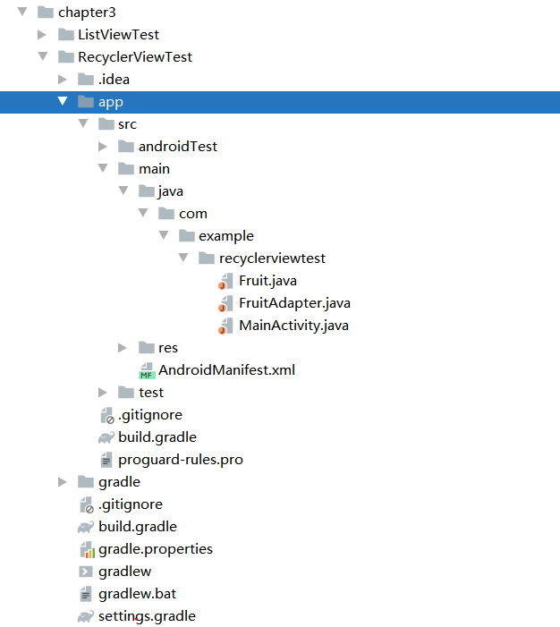
- 关键代码：
FruitAdapter.java:
package com.example.recyclerviewtest;

import android.support.v7.widget.RecyclerView;
import android.view.LayoutInflater;
import android.view.View;
import android.view.ViewGroup;
import android.widget.ImageView;
import android.widget.TextView;
import android.widget.Toast;

import java.util.List;

public class FruitAdapter extends RecyclerView.Adapter<FruitAdapter.ViewHolder>{

private List<Fruit> mFruitList;

static class ViewHolder extends RecyclerView.ViewHolder {
View fruitView;
ImageView fruitImage;
TextView fruitName;
TextView fruitNo;

public ViewHolder(View view) {
super(view);
fruitView = view;
fruitImage = (ImageView) view.findViewById(R.id.fruit_image);
fruitName = (TextView) view.findViewById(R.id.fruit_name);
fruitNo =(TextView) view.findViewById(R.id.fruit_no);
}
}

public FruitAdapter(List<Fruit> fruitList) {
mFruitList = fruitList;
}

@Override
public ViewHolder onCreateViewHolder(ViewGroup parent, int viewType) {
View view = LayoutInflater.from(parent.getContext()).inflate(R.layout.fruit_item, parent, false);
final ViewHolder holder = new ViewHolder(view);
holder.fruitView.setOnClickListener(new View.OnClickListener() {
@Override
public void onClick(View v) {
int position = holder.getAdapterPosition();
Fruit fruit = mFruitList.get(position);
Toast.makeText(v.getContext(), "you clicked view " + fruit.getName(), Toast.LENGTH_SHORT).show();
}
});
holder.fruitImage.setOnClickListener(new View.OnClickListener() {
@Override
public void onClick(View v) {
int position = holder.getAdapterPosition();
Fruit fruit = mFruitList.get(position);
Toast.makeText(v.getContext(), "you clicked image " + fruit.getName(), Toast.LENGTH_SHORT).show();
}
});
return holder;
}

@Override
public void onBindViewHolder(ViewHolder holder, int position) {
Fruit fruit = mFruitList.get(position);
holder.fruitImage.setImageResource(fruit.getImageId());
holder.fruitName.setText(fruit.getName());
holder.fruitNo.setText(String.valueOf(position+1));
}

@Override
public int getItemCount() {
return mFruitList.size();
}

}
gradle.xml:
<?xml version="1.0" encoding="UTF-8"?>
<project version="4">
<component name="GradleSettings">
<option name="linkedExternalProjectsSettings">
<GradleProjectSettings>
<compositeConfiguration>
<compositeBuild compositeDefinitionSource="SCRIPT" />
</compositeConfiguration>
<option name="distributionType" value="DEFAULT_WRAPPED" />
<option name="externalProjectPath" value="$PROJECT_DIR$" />
<option name="modules">
<set>
<option value="$PROJECT_DIR$" />
<option value="$PROJECT_DIR$/app" />
</set>
</option>
<option name="resolveModulePerSourceSet" value="false" />
<option name="testRunner" value="PLATFORM" />
</GradleProjectSettings>
</option>
</component>
</project>

2.实验结果：
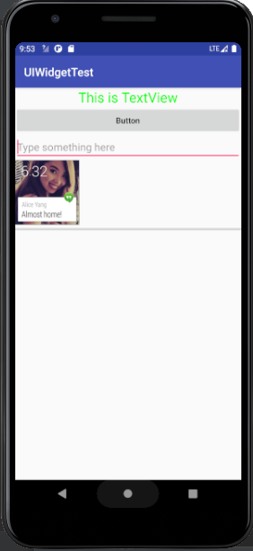
【教师评语和成绩】

成绩： 指导教师： 日期：

