姓名：唐买手三 | 专业：信息管理与信息系统 | 班级：20181171 | 学号：2016117224
科目：Android应用开发 |  | 实验日期： 2021-6-21
实验题目：第六章
【实验目的】

【实验内容】
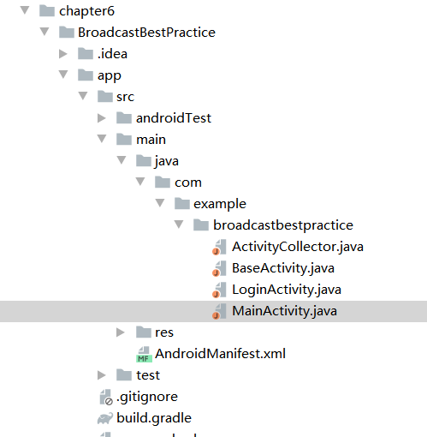
1.关键代码：
MainActivity.java:
package com.example.broadcastbestpractice;

import android.content.Intent;
import android.support.v7.app.AppCompatActivity;
import android.os.Bundle;
import android.view.View;
import android.widget.Button;

public class MainActivity extends BaseActivity {

@Override
protected void onCreate(Bundle savedInstanceState) {
super.onCreate(savedInstanceState);
setContentView(R.layout.activity_main);
Button forceOffline = (Button) findViewById(R.id.force_offline);
forceOffline.setOnClickListener(new View.OnClickListener() {
@Override
public void onClick(View v) {
Intent intent = new Intent("com.example.broadcastbestpractice.FORCE_OFFLINE");
sendBroadcast(intent);
}
});
}

}

LonginActivity.java:
package com.example.broadcastbestpractice;

import android.content.Intent;
import android.content.SharedPreferences;
import android.preference.PreferenceManager;
import android.support.v7.app.AppCompatActivity;
import android.os.Bundle;
import android.view.View;
import android.widget.Button;
import android.widget.CheckBox;
import android.widget.EditText;
import android.widget.Toast;

public class LoginActivity extends BaseActivity {

private SharedPreferences pref;

private SharedPreferences.Editor editor;

private EditText accountEdit;

private EditText passwordEdit;

private Button login;

private CheckBox rememberPass;

@Override
protected void onCreate(Bundle savedInstanceState) {
super.onCreate(savedInstanceState);
setContentView(R.layout.activity_login);
pref = PreferenceManager.getDefaultSharedPreferences(this);
accountEdit = (EditText) findViewById(R.id.account);
passwordEdit = (EditText) findViewById(R.id.password);
rememberPass = (CheckBox) findViewById(R.id.remember_pass);
login = (Button) findViewById(R.id.login);
boolean isRemember = pref.getBoolean("remember_password", false);
if (isRemember) {
// 将账号和密码都设置到文本框中
String account = pref.getString("account", "");
String password = pref.getString("password", "");
accountEdit.setText(account);
passwordEdit.setText(password);
rememberPass.setChecked(true);
}
login.setOnClickListener(new View.OnClickListener() {
@Override
public void onClick(View v) {
String account = accountEdit.getText().toString();
String password = passwordEdit.getText().toString();
// 如果账号是admin且密码是123456，就认为登录成功
if (account.equals("admin") && password.equals("123456")) {
editor = pref.edit();
if (rememberPass.isChecked()) { // 检查复选框是否被选中
editor.putBoolean("remember_password", true);
editor.putString("account", account);
editor.putString("password", password);
} else {
editor.clear();
}
editor.apply();
Intent intent = new Intent(LoginActivity.this, MainActivity.class);
startActivity(intent);
finish();
} else {
Toast.makeText(LoginActivity.this, "account or password is invalid",
Toast.LENGTH_SHORT).show();
}
}
});
}

}

2.实验结果：
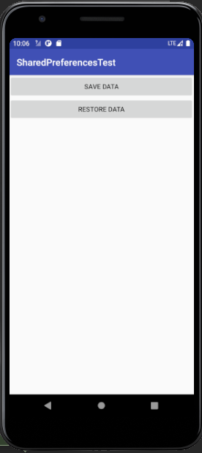
【教师评语和成绩】

成绩： 指导教师： 日期：

