**Biography**

**Dr. Alejandro César Grosso Laguna**

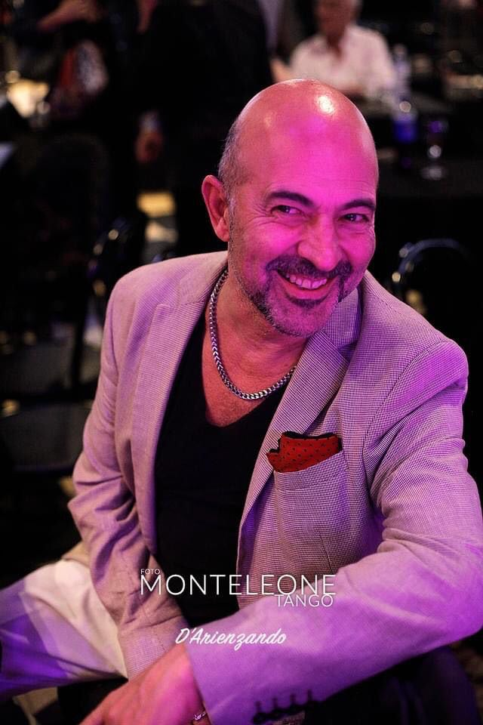 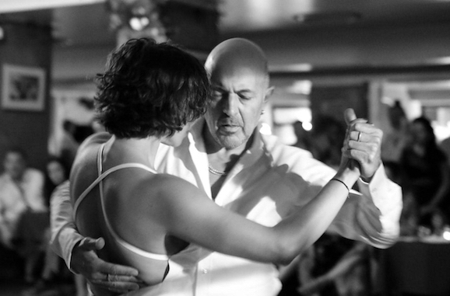

línea horizontal

Alejandro is an Argentinian (Buenos Aires) researcher with a PhD in Performing Arts (Non-verbal - implicit and explicit cross knowledge), Professional Tango Dancer and Teacher, Conservatory Trained Musician specialized in Contemporary and Modern Dance Technique, Advanced Trainer in Gyrotonic Expanded System, and Organizer of one of the oldest and most active milongas on the world stage. Alejandro is currently engaged in empirical research on Collaborative Artistic Reconfiguration of Tango Dance applied to Fado. He is based in Lisbon.

***Autobiographic Summary***

*I come from a family of painters, writers, musicians and bohemians. My father was a true follower of the Buenos Aires culture of Tango and its orchestras in the 40s.*

*I have known Tango since I was a child, listening to my grandmother Amália sing at her house. As a young child, I accompanied classical music by percussing on pans, and at the age of 9 I followed all the dance beat TV programs, copying their dance steps.*

*At the age of 12, I started studying the guitar so that I could play The Beatles’ music, and two years later formed my first rock band. From the age of 16, I became interested in Argentine folklore and bossa nova.*

*At 18, I began my music and guitar studies at the Superior Conservatory of Music and the Faculty of Fine Arts of Buenos Aires, obtaining* *a degree in music in 1990. In 1996 I started learning Tango with Carlos and Inés Borquez and Aurora Lubiz.*

*In 1998 I established the first Milonga in Portugal, followed a year later by the Milonga d'A Barraca from where I began to promote Tango dancing based on Fado music. In 2024, the Barraca milonga will celebrate its 25th anniversary.*

*In 2007, I began my doctoral studies, obtaining my PhD Degree in early 2013 from the University of Évora. My studies were funded by an international scholarship from the Foundation for Science and Technology of Portugal (FCT). In 2015 I was awarded an international scholarship from the FCT to carry out Postdoctoral research for 7 years, specializing in body dance movement (in contexts with music), its emotions and the non-verbal and intersubjective forms of its communication with others.* *I have* *published 30 works in scientific journals of art.*

*In 2022 I began an artistic partnership with the dancer Camila Delphim with the aim of immersing ourselves in the emotion of Fado and finding ways to express this through dance. This project is based on our previous experience with tango and our regular visits to Fado houses. We like to present this project as "Um abraço dançado em Fado" (An embrace danced in Fado).*

**EXTENDED CV SUMMARY**

**EDUCATION**  
Alejandro completed the DOCTOR OF PHILOSOPHY in Artistic Studies at the University of Évora. He was awarded a grant by the Foundation for Science and Technology of Portugal (FCT.IP). His doctoral thesis addresses communication problems between dancers and between dancers and musicians in dance technique classes.

Alejandro holds a DEGREE IN MUSIC EDUCATION from the University of Évora (2007) and Musical Education and Classical Guitar (1990) at the Higher Conservatory of Music “Manuel de Falla” of Buenos Aires. He also studied at the Faculty of Arts of National University of La Plata.

Since 2000, Alejandro has been training Barra à Terre intensively. From 2007 to the present, he has had advanced training in GYROTONIC, Movement Technique and main notions of classical ballet technique with (2011) Barbora Hruskova, PRINCIPAL DANCER of the National Ballet Company of Portugal (CNB) and current ballet master of this company.

**PROFESSIONAL TANGO DANCER**

Since the late 90’s, he has trained with notable Argentinian dancers including Aurora Lubitz, Carlos Borquez, Inés Borquez, Nélida Miglione, Jorge Ramirez, Sergio Natário, Alejandra Arrué, Ana Maria Schapira. His training is supported by the experience of dancing in some of the most important Buenos Aires milongas for more than 25 years (El Beso, Salón Canning, Lo de Celia, among many others).

Since 2015, Alejandro has been academically investigating the roots and foundations of the Villa Urquiza style of TANGO SALÓN. In this context he has maintained close ties with the iconic choreographer and dancer Milena Plebs (Laguna 2018), and studied with the dancer Graciela González (Laguna 2021), considered a teacher of teachers. Renowned dancers such as Claudio Villagra have influenced his thinking on traditional tango (Laguna 2019).

Since 2017, Alejandro has been studying ‘TANGO SALÓN’ (Villa Urquiza) with the renowned dancers Alfredo Alonso and Silvia Mucci ('Los Alonso'), a couple considered the principal active reference of the traditional style.

In 2022, Alejandro took masterclasses in Buenos Aires with Gustavo Naveira and Giselle Anne, and a series of seminars about “popular tango phrases” with Olga Besio.

Since 2022, Alejandro has been studying the roots of body movement in Salsa Caleña with Colombian dancer José Ortiz.

**RESEARCH / PRODUCTION**

Alejandro’s professional career highlights include a seven-year POSTDOCTORAL RESEARCHER grant, awarded by the FCT.IP. His projects have two themes: “Aspects of communication in multimodal expressive performance: Crossing propositional and non-propositional content*s”* and “How to think of art from the body? Phenomenological Investigation on the Construction and Transmission of Non-Propositional Knowledge.”

Alejandro has PUBLISHED 30 works in SCIENTIFIC JOURNALS OF ART, including *Research Dance in Education* (published by Taylor and Francis), a best ranked (Q1) journal for investigation in dance

**AFFILIATION / SCIENCE**

Alejandro is currently a member of the R&D Ethnomusicology Institute - Music and Dance Research Centre (INET-MD) - University of Aveiro (Portugal) and R&D Laboratory for the Study of Musical Experience (LEEM) of the Faculty of Arts, National University of La Plata (Argentina).

In recent years, Alejandro has participated in two competitively funded research projects. The PICT-2008-0927, "Intersections between musical experience and early childhood in the framework of corporate cognition and the PICT-2013-0368 "Communicative Musicality In the Time Arts and Early Childhood", both funded by the National Agency for the Promotion of Science and Technology, Argentina and developed at LEEM.

**UNIVERSITY TEACHING**

Since 2014, he has taught in Doctoral, Masters and Degree seminars at the Faculty of Human Kinetics of the University of Lisbon; Laboratory for the Study of Musical Experience (UNLP), Argentina; and Dance Faculty of University Autonomous of Chiapas, Mexico.

Alejandro has more than 15 years' experience as a DANCE MUSICIAN specialized in modern and contemporary dance (Assistant Professor at the Lisbon Higher School of Dance). A highlight is his five-year collaboration with the dancer Antonio Carallo (Tanztheater Wuppertal Pina Bausch). ​

**TANGO in PORTUGAL**

Alejandro was the first teacher to give regular Tango classes in Lisbon (May 1997, Athenéu Comercial of Lisbon). In June 1997 he began to organize ‘the práctica’ in Lisbon at ABS Privado. A year later (September 1998) he created, the first milonga in Portugal (Rua de Santo Amaro, 8 - Campo de Ourique) together with the Portuguese dancer Solange Galvão. During 1999 they founded three other milongas. The first in the neighbourhood of Madragoa in the Vendedores de Jornais Futebol Club (early 1999), the second in the Club Estefânia (late 1999), and the third, the iconic MILONGA d'A BARRACA, in the neighbourhood of Santos (July 1999). These projects were dedicated to disseminating the Buenos Aires culture of milonga “porteña” and tango social dance.

The Milonga d'A Barraca takes place in the mythical Bar of the A Barraca Theater - Cinearte and is directed by Alejandro weekly since 1999. It is considered one of the oldest traditional regular milongas in Europe, organized by an Argentine dancer, in the same space every Sunday.

In April 2020 Alejandro created a TANGO LABORATORY that aims to develop a methodology to study and transmit non-propositional knowledge that shapes the roots and foundations of traditional Tango Dance.

In January 2022 Alejandro created the LADIES project. In this unique laboratory in Portugal, women who dance tango learn in a multidimensional and sensorial way the skills brought into play by the role of the conductor (which was traditionally exclusive to men) on the Tango floor. The project also addresses problems such as empowerment and bullying in Tango.

**TANGO & FADO**

Through the Milonga d'A Barraca, Alejandro has promoted encounters between TANGO and FADO for over two decades. In this setting, inside the milonga with the same light as a Fado house, a magical moment takes place in a space reserved for "dancing the fado" through a free interpretation of the tango figures.

Around 80 *fadistas* have performed at the Milonga d'A Barraca. Among the most eminent are Celeste Rodrigues, António Chainho, Katia Guerreiro, Maria Amélia Proença, José Manuel Neto, Helder Moutinho, Fernando Alvim, Luís Guerreiro, Carlos Manuel Proença, and Pedro de Castro.

Since mid-2022 Alejandro has been dancing with Camila Delphim, a talented Brazilian professional dancer born in Rio de Janeiro who was a finalist in the World Tango Dance Tournament (Buenos Aires) in the stage category. Camila thus became part of the project “Collaborative Artistic Reconfiguration of the Tango Dance towards Fado.” (Laguna 2023).   
Alejandro and Camila maintain a close bond with the houses of Fado, their rituals, their musicians and their *fadistas*. Since beginning their collaboration, they have performed in several Fado houses such as Fado ao Carmo, Tasca da Bela, Mesa de Frades, A Nini.   
Since November 2023, Alejandro has been part of the Show 'Noctivagabundagem, Fados and Bohemian Songs' with his partner Camila Delphim.   
In 2024, Camila and Alejandro are presenting their interpretation, named “an embrace danced in Fado”, in [Got Talent Portugal](https://pt.wikipedia.org/wiki/Got_Talent_Portugal) (semi-finalists).

Links to their presentations.   
(1) <https://www.youtube.com/watch?v=X0qDhRLkigY>   
(2) <https://www.youtube.com/watch?v=E7RscmeMrTE>

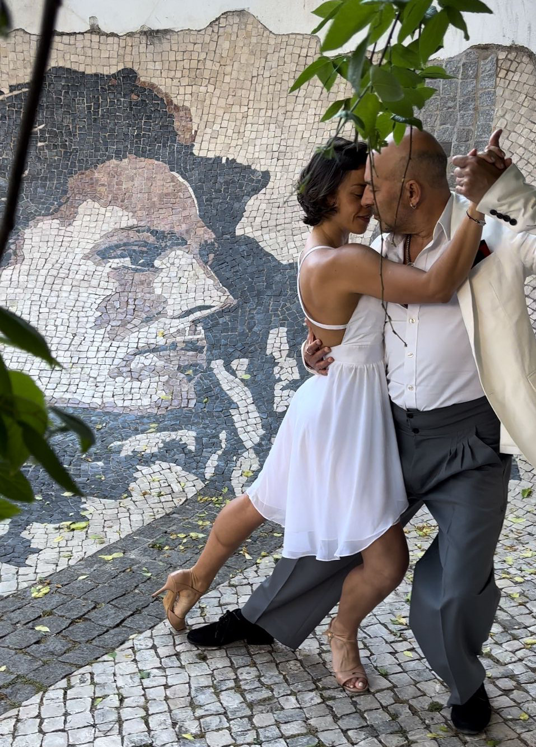  
Camila Delphim-Alejandro Laguna.   
Portrait of Amália Rodrigues by Vhils 2015. Alfama. Lisboa.

**Full CV**

https://www.cienciavitae.pt/191E-174E-5492

**Key Publications in Scientific journals**

You can consult the following and other titles on the author's profile page on ResearchGate: <https://www.researchgate.net/profile/Alejandro-Grosso-Laguna>

Laguna, Alejandro, Hayley Stevenson and Favio Shifres. **Colonizing Corporality: The Political Economy of Tango** (under revision).

Grosso Laguna, Alejandro. **"Collaborative Artistic Reconfiguration of the Tango Dance towards Fado"**. Crosswinds: Collaborative Creativity as Transformative Practice [International Symposium], Aveiro University (2023). https://doi.org/10.48528/8q8n-5z69

(2022) Grosso Laguna, A and Favio Shifres. **Visual and Sound Gesture in Dance Communication**. *Research in Dance Education*. Routledge. Taylor & Francis.

(2021) Grosso Laguna, Alejandro. **Graciela González: Bodily experience and generational change in traditional tango**. *European Review Of Artistic Studies.*

(2020) Grosso Laguna, Alejandro. **Biomechanical Analysis and Metric Interpretation of ‘Walking’ in Tango Dance**. *European Review of Artistic Studies.*

(2020) Grosso Laguna, A and Favio Shifres. **Understanding Movement from Dance and Music**. *European Review of Artistic Studies.*

# (2019). Grosso Laguna, Alejandro. Cuando el cuerpo es música al bailar. Entrevista a Claudio Villagra. *Epistemus.*

(2018) Grosso Laguna, A. **Milena Plebs. Tango y Pensamiento Critico. Conexiones con la vivencia de los procesos de enseñanza y aprendizaje de la música**. *Epistemus.*

(2018) Grosso Laguna, Alejandro. **"Participatory Embodiment of the Musical Metric in Argentinian Tango"**.15th International Conference on Music Perception and Cognition. https://www.hml.hmtmhannover.de/fileadmin/www.hml/Beitraege_ICMPC15ESCOM10https://static.uni-graz.at/fileadmin/veranstaltungen/music-psychology-conference2018/documents/ICMPC15ESCOM10abstractbook.pdf, Graz.