**Introduction**

Car Rental Management System is a system which is designed to keep the data about the cars that the Car Rental company owns, the branch offices which are active under the company, the employees who are working there and also the customers who are borrowing the cars for usage. This system is designed to provide the admins as well as the managers and the employees to manage and modify certain levels of the database to update the information about the required fields. The administrator will also have the privilege to add or remove the employee’s information. The manager and the employees on the other hand can only manipulate the data about the cars and the customers. The cars can have insurance information which can be updated based on the due dates. This system also includes the payment information for the contracts and also the required information about the contracts. The main aim of the system is to provide an easy to manage and maintain data storage and modification facility. In this project the storage design is covered based on the requirements.

**Case Study**

Based on the requirements of the system, the entities and the relations were identified and designed as follows:

**Entities:**

1. **Customer:** Customer is the entity who will deal with the office to borrow cars. This entity will have the following attributes;
   1. Customer ID (Primary key).
   2. Customer name.
   3. Address.
   4. Gender.
   5. Email.
   6. Phone (Multivalued attribute).
2. **Office:** Office is the entity where employees work and makes the required contracts. This entity will have the following attributes:
   1. Office ID (Primary key).
   2. Office name.
   3. Address.
3. **Employee:** This entity works in the offices. This entity will have the following attributes:
   1. Employee ID (Primary key).
   2. Employee name.
   3. Age.
   4. Salary.
   5. Address.
   6. Phone (Multivalued attribute).
4. **Car:** This entity covers the details of the cars available for rent. This entity will have the following attributes:
   1. Car number (Primary key).
   2. Car company.
   3. Car model.
   4. Rental price.
5. **Insurance:** This entity covers the safety of the car in case of damage. This entity will have the following attributes:
   1. Insurance number (Primary key).
   2. Insurance type.
6. **Payment:** This entity covers the payment related information. This entity will have the following attributes:
   1. Payment ID (Primary key).
   2. Payment amount.
   3. Payment method.

**Relations:**

1. **Customer to Office:** Customers make deal with offices to borrow a car. Many customers can make deals with many offices as necessary. So, there will be many to many relations between them.
2. **Office to Employee as Employee:** Employees work in offices. One employee can work in only one office. But one office can have many employees. So, there will be a one to many relationship between them.
3. **Office to Employee as Manager:** Manager manages a certain office. One office can have only one manager. So, there will be a one to one relationship between them.
4. **Customer to Car:** Customers can borrow cars. One customer can borrow many cars as necessary. But one car can only be borrowed by one customer. So, there will be a one to many relationship between them.
5. **Office to Car:** Offices can have and rent many cars. There can be many cars which are rented under the same office. But one car can be rented from one office only. So, there will be a one to many relationship among them.
6. **Car to Insurance:** Each car can have one insuranceand each insurance can be issued to one car only. So, there will be a one to one relationship between them.
7. **Customer to Payment:** Each customer needs to make payments based one their borrowing. One customer can make many payments. But one payment can be made by one customer only. So, there will be a one to many relationship between them.
8. **Office to Payment:** Each officecan receive multiple payments. But one payment can be received by one office only. So, there will be a one to many relationship between them.

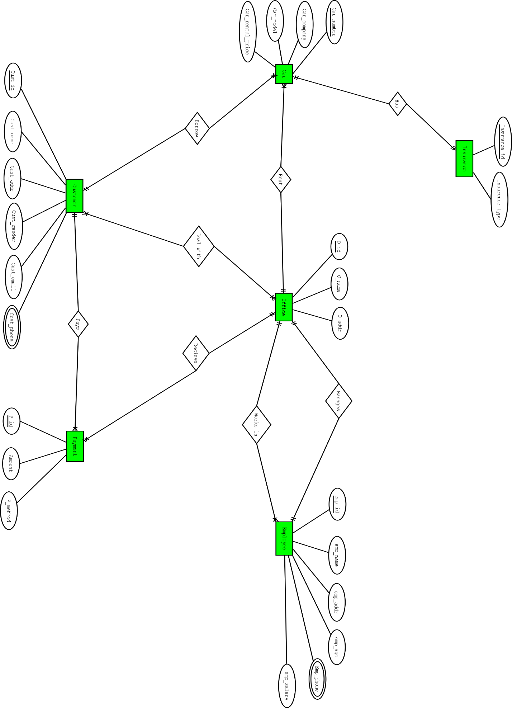

**Normalization**

**Customer-----*-----deals with-----*-----office**

**Relation Entities:**

(Cust_ID, Cust_name, Cust_addr, Cust_gender, Cust_email, *Cust_phone,* O_id, O_name, O_addr)

**1NF:**

Cust_phone multivalued attribute.

**2NF:** Eliminating partial dependencies:

1. Cust_ID, Cust_name, Cust_addr, Cust_gender, Cust_email, Cust_phone, C_O_ID,
2. O_id, O_name, O_addr, C_O_ID
3. C_O_ID, Cust_ID, O_id

**3NF:** There is no transitive dependencies.

1. Cust_ID, Cust_name, Cust_addr, Cust_gender, Cust_email, Cust_phone, C_O_ID,
2. O_id, O_name, O_addr, C_O_ID
3. C_O_ID, Cust_ID, O_id

**Tables:**

1. Cust_ID, Cust_name, Cust_addr, Cust_gender, Cust_email, Cust_phone, C_O_ID,
2. O_id, O_name, O_addr, C_O_ID
3. C_O_ID, Cust_ID, O_id

**Employee-----*-----work in-----1-----office**

**Relation Entities:**

(Emp_ID, Emp_name, Emp_addr, Emp_salary, Emp_age, *Emp_phone,* O_ID, O_name, O_addr)

**1NF:**

Emp_phone multivalued attribute.

**2NF:** Eliminating partial dependencies:

1. Emp_ID, Emp_name, Emp_addr, Emp_salary, Emp_age, Emp_phone, O_ID,

2. O_ID, O_name, O_addr.

**3NF:** There is no transitive dependencies.

1. Emp_ID, Emp_name, Emp_addr, Emp_salary, Emp_age, Emp_phone, O_ID,

2. O_ID, O_name, O_addr.

**Tables:**

1. Emp_ID, Emp_name, Emp_addr, Emp_salary, Emp_age, Emp_phone, O_ID,

2. O_ID, O_name, O_addr.

**Employee-----1-----manages-----1-----office**

**Relation Entities:**

(Emp_ID, Emp_name, Emp_addr, Emp_salary, Emp_age, *Emp_phone,* O_ID, O_name, O_addr)

**1NF:**

Emp_phone multivalued attribute.

**2NF:** Eliminating partial dependencies:

1. Emp_ID, Emp_name, Emp_addr, Emp_salary, Emp_age, Emp_phone

2. O_ID, O_name, O_addr. Emp_ID as Manager_ID

**3NF:** There is no transitive dependencies.

1. Emp_ID, Emp_name, Emp_addr, Emp_salary, Emp_age, Emp_phone

2. O_ID, O_name, O_addr. Manager_ID

**Tables:**

1. Emp_ID, Emp_name, Emp_addr, Emp_salary, Emp_age, Emp_phone

2. O_ID, O_name, O_addr. Manager_ID

**Customer-----1-----borrow-----*-----cars**

**Relation Entities:**

(Cust_ID, Cust_name, Cust_addr, Cust_gender, Cust_email, Cust_phone*,*, Car_number, Car_company, Car_model, Car_rental_price)

**1NF:**

Cust_phone multivalued attribute.

**2NF:** Eliminating partial dependencies:

1. Cust_ID, Cust_name, Cust_addr, Cust_gender, Cust_email, Cust_phone*,*

2. Car_number, Car_company, Car_model, Car_rental_price, Cust_ID

**3NF:** There is no transitive dependencies.

1. Cust_ID, Cust_name, Cust_addr, Cust_gender, Cust_email, Cust_phone*,*

2. Car_number, Car_company, Car_model, Car_rental_price, Cust_ID

**Tables:**

1. Cust_ID, Cust_name, Cust_addr, Cust_gender, Cust_email, Cust_phone*,*

2. Car_number, Car_company, Car_model, Car_rental_price, Cust_ID

**Office-----1----rent-----*-----cars**

**Relation Entities:**

(O_ID, O_name, O_addr, Car_number, Car_company, Car_model, Car_rental_price)

**1NF:**

No multivalued attribute.

**2NF:** Eliminating partial dependencies:

1. O_ID, O_name, O_addr

2. Car_number, Car_company, Car_model, Car_rental_price, O_ID

**3NF:** There is no transitive dependencies.

1. O_ID, O_name, O_addr

2. Car_number, Car_company, Car_model, Car_rental_price, O_ID

**Tables:**

1. O_ID, O_name, O_addr

2. Car_number, Car_company, Car_model, Car_rental_price, O_ID

**Car-----1-----Has-----1-----Insurance**

**Relation Entities:**

(Car_number, Car_company, Car_model, Car_rental_price*,* Insurance_ID, Insurance_type)

**1NF:**

No multivalued attribute.

**2NF:** Eliminating partial dependencies:

1. Car_number, Car_company, Car_model, Car_rental_price,

2. Insurance_ID, Insurance_type, Car_number.

**3NF:** There is no transitive dependencies.

1. Car_number, Car_company, Car_model, Car_rental_price,

2. Insurance_ID, Insurance_type, Car_number.

**Tables:**

1. Car_number, Car_company, Car_model, Car_rental_price,

2. Insurance_ID, Insurance_type, Car_number.

**Customer-----1-----pays-----*-----Payment**

**Relation Entities:**

(Cust_ID, Cust_name, Cust_addr, Cust_gender, Cust_email, *Cust_phone,* P_ID, amount, P_method)

**1NF:**

Cust_phone multivalued attribute.

**2NF:** Eliminating partial dependencies:

1. Cust_ID, Cust_name, Cust_addr, Cust_gender, Cust_email, Cust_phone*,*

2. P_ID, amount, P_method, Cust_id

**3NF:** There is no transitive dependencies.

1. Cust_ID, Cust_name, Cust_addr, Cust_gender, Cust_email, Cust_phone*,*

2. P_ID, amount, P_method, Cust_id

**Tables:**

1. Cust_ID, Cust_name, Cust_addr, Cust_gender, Cust_email, Cust_phone*,*

2. P_ID, amount, P_method, Cust_id

**Office-----1----receives-----*-----Payment**

**Relation Entities:**

(O_ID, O_name, O_addr, P_ID, amount, P_method)

**1NF:**

No multivalued attribute.

**2NF:** Eliminating partial dependencies:

1. O_ID, O_name, O_addr

2. P_ID, amount, P_method, O_ID

**3NF:** There is no transitive dependencies.

1. O_ID, O_name, O_addr

2. P_ID, amount, P_method, O_ID

**Tables:**

1. O_ID, O_name, O_addr

2. P_ID, amount, P_method, O_ID

**Rough Tables:**

1. Cust_ID, Cust_name, Cust_addr, Cust_gender, Cust_email, Cust_phone,C_O_ID,
2. O_id, O_name, O_addr, C_O_ID
3. C_O_ID, Cust_ID, O_id
4. Emp_ID, Emp_name, Emp_addr, Emp_salary, Emp_age, Emp_phone, O_ID,
5. ~~O_ID, O_name, O_addr.~~
6. ~~Emp_ID, Emp_name, Emp_addr, Emp_salary, Emp_age, Emp_phone~~
7. O_ID, O_name, O_addr. Manager_ID
8. ~~Cust_ID, Cust_name, Cust_addr, Cust_gender, Cust_email, Cust_phone~~*,*
9. Car_number, Car_company, Car_model, Car_rental_price, Cust_ID
10. ~~O_ID, O_name, O_addr~~
11. Car_number, Car_company, Car_model, Car_rental_price, O_ID
12. ~~Car_number, Car_company, Car_model, Car_rental_price,~~
13. Insurance_ID, Insurance_type, Car_number.
14. ~~Cust_ID, Cust_name, Cust_addr, Cust_gender, Cust_email, Cust_phone~~*~~,~~*
15. P_ID, amount, P_method, Cust_id
16. ~~O_ID, O_name, O_addr~~
17. P_ID, amount, P_method, O_ID

**Final Tables:**

1. Cust_ID, Cust_name, Cust_addr, Cust_gender, Cust_email, Cust_phone,C_O_ID,
2. O_id, O_name, O_addr, C_O_ID
3. C_O_ID, Cust_ID, O_id
4. Emp_ID, Emp_name, Emp_addr, Emp_salary, Emp_age, Emp_phone, O_ID
5. O_ID, O_name, O_addr. Manager_ID
6. Car_number, Car_company, Car_model, Car_rental_price, Cust_ID
7. Car_number, Car_company, Car_model, Car_rental_price, O_ID
8. Insurance_ID, Insurance_type, Car_number.
9. P_ID, amount, P_method, Cust_id
10. P_ID, amount, P_method, O_ID