Ausarbeitung UE08

1. Trigger
-- 1.1
CREATE OR REPLACE PROCEDURE check_salary(jid IN jobs.job_id%TYPE, salary IN jobs.min_salary%TYPE) IS
min_sal jobs.min_salary%TYPE;
max_sal jobs.max_salary%TYPE;
salary_too_high EXCEPTION;
BEGIN
-- get salaries from job
SELECT min_salary,
max_salary
INTO min_sal, max_sal
FROM jobs
WHERE job_id = jid;

IF (salary > max_sal) THEN -- if max salary < salary -> raise exception
RAISE salary_too_high;
ELSIF (salary < min_sal) THEN -- if min salary > salary -> change min salary
UPDATE jobs
SET min_salary = salary
WHERE job_id = jid;
END IF;

EXCEPTION
WHEN salary_too_high
THEN
RAISE_APPLICATION_ERROR(-20202, 'Invalid salary ' || salary || '. Salary too high for job ' || jid || '.');
END;

BEGIN
check_salary('AD_PRES', 50000);
END;
/

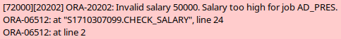

-- 1.2
CREATE OR REPLACE TRIGGER check_salary_trg
BEFORE INSERT OR UPDATE
ON employees
FOR EACH ROW
BEGIN
CHECK_SALARY(:new.job_id, :new.salary);
END;

-- 1.3
UPDATE employees
SET salary = 10000
WHERE employee_id = 100;

SELECT *
FROM employees
WHERE employee_id = 100;

UPDATE employees
SET salary = 50000
WHERE employee_id = 100;
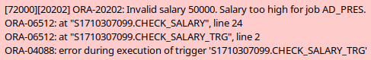

ROLLBACK;

1.4
Informationen über den Mitarbeiter gehen beim Kontext-Wechsel vom Trigger in die Prozedur verloren. Man müsste entweder direkt die manager_id oder eine beliebige andere Information an die Prozedur übergeben, über die sich der Manager des eingefügten oder bearbeiteten Mitarbeiters ableiten lässt. Streng genommen gibt es kein Problem wenn man diese Überprüfung im Trigger machen will, anstatt in der Prozedur. (Zumindest habe ich keines entdeckt). Es wäre allerdings auch nicht sonderlich sauber.
-- 1.5
ALTER TABLE employees
ADD (date_modified DATE, user_modified VARCHAR2(255));

CREATE OR REPLACE TRIGGER log_employees
BEFORE INSERT OR UPDATE
ON employees
FOR EACH ROW
BEGIN
:new.user_modified := USER;
:new.date_modified := SYSDATE;
END;

-- TEST: default use case
UPDATE employees
SET salary = 19000
WHERE employee_id = 101;

-- TEST: invalid employee
UPDATE employees
SET salary = 19000
WHERE employee_id = 10;

-- TEST: salary > max_salary
UPDATE employees
SET salary = 50000
WHERE employee_id = 100;
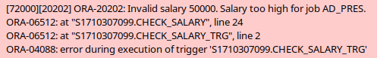

2. INSTEAD OF-Trigger
-- 2.1
CREATE OR REPLACE VIEW emp_details AS
SELECT employee_id,
last_name,
salary,
department_id,
department_name,
dept_sal,
location_id,
city,
country_name,
c_emps
FROM new_emps
INNER JOIN new_depts USING (department_id)
INNER JOIN new_locs USING (location_id)
INNER JOIN new_countries USING (country_id);

SELECT *
FROM user_updatable_columns
WHERE table_name = 'EMP_DETAILS';
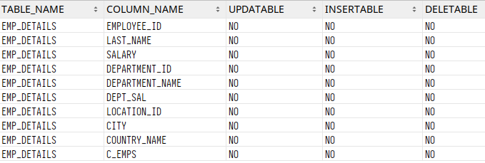

-- 2.2
CREATE OR REPLACE TRIGGER dml_emp_details
INSTEAD OF INSERT OR UPDATE OR DELETE
ON emp_details
FOR EACH ROW
BEGIN
IF INSERTING THEN -- (b)
-- insert employee
INSERT INTO new_emps
VALUES (:new.employee_id, :new.last_name, :new.salary, :new.department_id);

-- raise dept_sal
UPDATE new_depts
SET dept_sal = (SELECT AVG(salary) FROM new_emps WHERE department_id = :new.department_id)
WHERE department_id = :new.department_id;

-- increase country "population"
UPDATE new_countries
SET c_emps = c_emps + 1
WHERE country_name = :new.country_name;

ELSIF UPDATING ('salary') THEN -- (c)
-- update salary
UPDATE new_emps
SET salary = :new.salary
WHERE employee_id = :new.employee_id;

-- also update average department salary
UPDATE new_depts
SET dept_sal = (SELECT AVG(salary) FROM new_emps WHERE department_id = :new.department_id)
WHERE department_id = :new.department_id;

ELSIF UPDATING ('department_id') THEN -- (d)
-- update employee dept_id
UPDATE new_emps
SET department_id = :new.department_id
WHERE employee_id = :new.employee_id;

-- update average salary for both involved depts
UPDATE new_depts
SET dept_sal = (SELECT AVG(salary) FROM new_emps WHERE department_id = :old.department_id)
WHERE department_id = :old.department_id;

UPDATE new_depts
SET dept_sal = (SELECT AVG(salary) FROM new_emps WHERE department_id = :new.department_id)
WHERE department_id = :new.department_id;

-- update country "population"
UPDATE new_countries
SET c_emps = (SELECT COUNT(*) FROM new_emps WHERE department_id = :old.department_id)
WHERE country_name = :new.country_name;

ELSIF DELETING THEN -- (a)
-- delete from employees
DELETE
FROM new_emps
WHERE employee_id = :old.employee_id;

-- lower dept_sal
UPDATE new_depts
SET dept_sal = (SELECT AVG(salary) FROM new_emps WHERE department_id = :old.department_id)
WHERE department_id = :old.department_id;

-- decrease country "population"
UPDATE new_countries
SET c_emps = c_emps - 1
WHERE country_name = :old.country_name;

END IF;
END;

INSERT INTO emp_details (employee_id,
last_name,
salary,
department_id,
country_name)
VALUES (1, 'HEHE', 17000, 110, 'Canada');

UPDATE emp_details
SET salary = 16000
WHERE employee_id = 1;

UPDATE emp_details
SET department_id = 90
WHERE employee_id = 1;

DELETE
FROM emp_details
WHERE employee_id = 1;

ROLLBACK;

3. Trigger für Systemereignisse
CREATE OR REPLACE TRIGGER user_logging_trg
AFTER LOGON ON SCHEMA
BEGIN
INSERT INTO user_logging
VALUES (SYS_CONTEXT('USERENV', 'SESSIONID'),
SYSDATE,
USER,
SYS_CONTEXT('USERENV', 'OS_USER'),
SYS_CONTEXT('USERENV', 'IP_ADDRESS'),
SYS_CONTEXT('USERENV', 'HOST'));
-- A failing trigger can prevent user login
-- so I added this exception handler, hoping that
-- this is all it takes to bypass this behavior.
EXCEPTION
WHEN OTHERS
THEN
dbms_output.PUT_LINE('Error in trigger!');
END;

SELECT *
FROM user_logging;
