Ausarbeitung UE12

1. Modellierung ADAPT
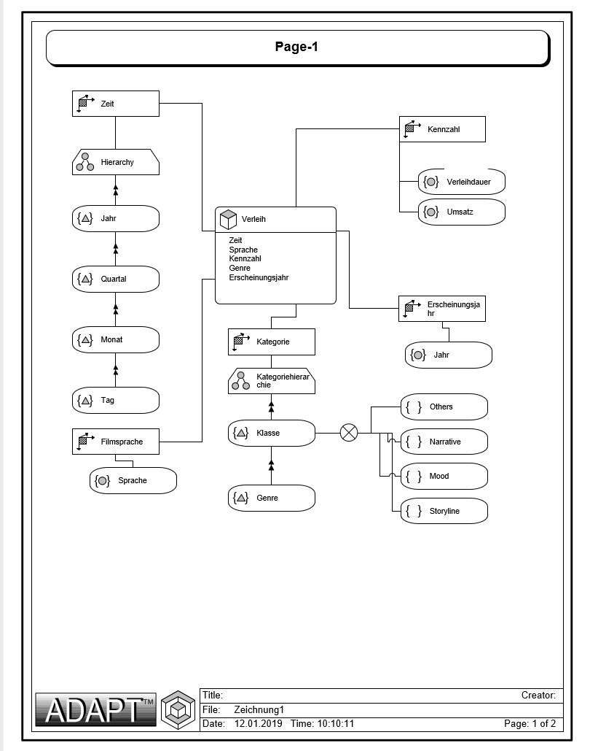

2. Modellierung STAR-Schema
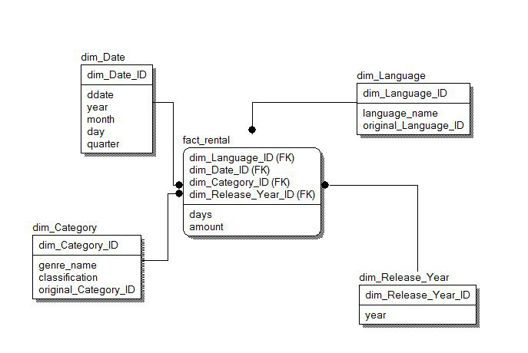

3. Erstellung STAR-Schema
DROP TABLE dim_category;
DROP TABLE dim_date;
DROP TABLE dim_language;
DROP TABLE dim_release_year;
DROP TABLE fact_rental;
DROP SEQUENCE identifiers;

----------------------------- GLOBAL PK GENERATOR -----------------------------
CREATE SEQUENCE identifiers
START WITH 1
INCREMENT BY 1
MAXVALUE 10000000000;

----------------------------- DIMENSION RELEASE YEAR -----------------------------
CREATE TABLE dim_release_year AS
SELECT identifiers.nextval AS dim_release_year_id, year
FROM (
SELECT DISTINCT release_year AS year
FROM film
);

ALTER TABLE dim_release_year
ADD CONSTRAINT dim_release_year_pk
PRIMARY KEY (dim_release_year_id);

ALTER TABLE dim_release_year
MODIFY year NUMBER NOT NULL;

----------------------------- DIMENSION CATEGORY -----------------------------
CREATE TABLE dim_category AS
SELECT identifiers.nextval AS dim_category_id,
name AS genre_name,
'no_classification' AS classification,
category_id AS original_category_id
FROM (
SELECT name, category_id
FROM category
);

ALTER TABLE dim_category
ADD CONSTRAINT
dim_category_pk PRIMARY KEY (dim_category_id);

UPDATE dim_category
SET classification = 'Storyline'
WHERE genre_name IN ('Animation', 'Sci-Fi', 'Sports');

UPDATE dim_category
SET classification = 'Narrative'
WHERE genre_name IN ('Children', 'Comedy', 'Documentary',
'Drama', 'Family', 'Foreign', 'Travel');
UPDATE dim_category
SET classification = 'Mood'
WHERE genre_name IN ('Action', 'Horror', 'Music');

UPDATE dim_category
SET classification = 'Others'
WHERE genre_name NOT IN ('Animation', 'Sci-Fi', 'Sports',
'Children', 'Comedy', 'Documentary',
'Drama', 'Family', 'Foreign',
'Travel', 'Action', 'Horror', 'Music');

----------------------------- DIMENSION LANGUAGE -----------------------------
CREATE TABLE dim_language AS
SELECT identifiers.nextval AS dim_language_id,
name AS language_name,
language_id AS original_language_id
FROM (
SELECT name, language_id
FROM language
);

ALTER TABLE dim_language
ADD CONSTRAINT
dim_language_pk PRIMARY KEY (dim_language_id);

----------------------------- DIMENSION DATE -----------------------------
CREATE TABLE dim_date
(
dim_date_id NUMBER,
ddate DATE NOT NULL,
year NUMBER NOT NULL,
month NUMBER NOT NULL,
quarter NUMBER NOT NULL,
day NUMBER NOT NULL
);

ALTER TABLE dim_date
ADD CONSTRAINT dim_date_pk PRIMARY KEY (dim_date_id);

DECLARE
mindate DATE;
maxdate DATE := TRUNC(SYSDATE);
BEGIN
SELECT MIN(payment_date) INTO mindate FROM payment;
FOR i IN 0..(maxdate - mindate)
LOOP
INSERT INTO dim_date (dim_date_id, ddate, year, month, quarter, day)
VALUES (TO_CHAR(mindate + NUMTODSINTERVAL(i, 'day'), 'yyyymmdd'),
mindate + NUMTODSINTERVAL(i, 'day'),
EXTRACT(YEAR FROM (mindate + NUMTODSINTERVAL(i, 'day'))),
EXTRACT(MONTH FROM (mindate + NUMTODSINTERVAL(i, 'day'))),
TO_CHAR(mindate + NUMTODSINTERVAL(i, 'day'), 'Q'),
TO_CHAR(mindate + NUMTODSINTERVAL(i, 'day'), 'DD'));
END LOOP;
END;
/

CREATE MATERIALIZED VIEW fact_rental REFRESH COMPLETE
START WITH (add_months(TRUNC(SYSDATE, 'mm'), 1) + 0) - 1 / 24
NEXT (add_months(TRUNC(SYSDATE, 'mm'), 2) + 0) - 1 / 24
AS
SELECT CEIL(return_date - rental_date) days,
amount,
dim_language.dim_language_id,
dim_release_year.dim_release_year_id,
dim_category.dim_category_id,
dim_date.dim_date_id
FROM rental
LEFT JOIN payment USING (rental_id)
INNER JOIN inventory USING (inventory_id)
INNER JOIN film USING (film_id)
INNER JOIN film_category USING (film_id)
INNER JOIN dim_category ON (film_category.category_id = dim_category.original_category_id)
INNER JOIN dim_language ON (film.language_id = dim_language.original_language_id)
INNER JOIN dim_release_year ON (film.release_year = dim_release_year.year)
INNER JOIN dim_date ON (TRUNC(payment_date) = ddate);
BEGIN
dbms_mview.REFRESH('fact_rental');
END;

SELECT *
FROM fact_rental;

4. Abfragen & Interpretation
------------------------------- Nr. 1 -------------------------------
SELECT count,
language_name
FROM (
SELECT dim_language_id, COUNT(*) AS count
FROM fact_rental
GROUP BY dim_language_id
ORDER BY COUNT(*) DESC FETCH FIRST 2 ROWS
WITH TIES
)
INNER JOIN dim_language USING (dim_language_id);

-- Count Language
-- ----- --------
-- 3111 German
-- 2940 Italian

-- Interpretation: Vielleicht hat das Unternehmen in Deutschland und Italien die meisten
-- Filialen oder einfach nur die größte Kundschaft.

------------------------------- Nr. 2 -------------------------------
SELECT ROUND(SUM(amount) / COUNT(*), 3) AS avg_revenue
FROM fact_rental;

-- Average Revenue
-- ---------------
-- 7.208

-- Interpretation: Im Durchschnitt wird mit einem Verleihvorgang 7.21€ Umsatz erzielt.

------------------------------- Nr. 3 -------------------------------
SELECT genre_name,
ROUND(SUM(amount) / COUNT(day), 3) AS avg_revenue_per_day
FROM fact_rental
INNER JOIN dim_date USING (dim_date_id)
INNER JOIN dim_category USING (dim_category_id)
GROUP BY genre_name
ORDER BY avg_revenue_per_day DESC FETCH FIRST ROW ONLY;

-- Genre Name Average revenue per day
-- ---------- -----------------------
-- Sci-Fi 8.7

-- Interpretation: Man sollte sich überlegen, mehr Sci-Fi Filme in den Bestand aufzunehmen.

------------------------------- Nr. 4 -------------------------------
SELECT SUM(amount) AS total_revenue,
quarter
FROM fact_rental
INNER JOIN dim_date USING (dim_date_id)
GROUP BY quarter
ORDER BY total_revenue DESC FETCH FIRST ROW ONLY;

-- Total Revenue Quarter
-- ------------- -------
-- 31764.09 1

-- Interpretation: Weihnachts-, Oster- und Semesterferien sind alle im 1. Quartal, vielleicht haben
-- da einfach die meisten Kunden Zeit zum Filmschauen?

------------------------------- Nr. 5 -------------------------------
SELECT ROUND(AVG(days), 2) AS duration,
quarter,
month
FROM fact_rental
INNER JOIN dim_date USING (dim_date_id)
GROUP BY ROLLUP (quarter, month);

-- Duration Quarter Month
-- -------- ------ -----
-- 5.54 1 1
-- 5.14 1 2
-- 4.68 1 3
-- 5.11 1 <null>
-- 4.51 2 4
-- 4.21 2 5
-- 3.99 2 6
-- 4.23 2 <null>
-- 4.05 3 7
-- 4.34 3 8
-- 4.5 3 9
-- 4.29 3 <null>
-- 4.49 4 10
-- 4.78 4 11
-- 5.36 4 12
-- 4.84 4 <null>
-- 4.6 <null> <null>

-- Interpretation: Im 1. Quartal ist die Verleihdauerdauer am längsten, was sich mit der Vermutung aus Nr. 4
-- deckt, dass Kunden in Q1 mehr Zeit zum Filmschaun haben. Nachdem Q1 M1 und Q4 M12 die längste
-- Verleihdauer aufweisen, wird dies weiter bestätigt.

------------------------------- Nr. 6 -------------------------------
SELECT genre_name,
language_name,
SUM(amount) AS revenue,
COUNT(*)
FROM fact_rental
INNER JOIN dim_category USING (dim_category_id)
INNER JOIN dim_language USING (dim_language_id)
GROUP BY CUBE (genre_name, language_name);

-- ROW Genre Revenue
-- --- -------- -------
-- 8 Sci-Fi 9579.03
-- 9 Family 8380.94
-- 10 Documentary 8147.83
-- 11 Sports 8143.9
-- ROW Language Revenue
-- --- -------- --------
-- 2 German 22050.77
-- 3 Italian 21423.05
-- 4 Japanese 21086.4
-- Interpretation: Die Genres Sci-Fi, Family, Documentary und Sports sowie die Sprachen German, Italian und
-- Japanese sind am lukrativsten und aus diesem Grund sollten Filme mit diesen Attributen
-- nachgekauft werden.

------------------------------- Nr. 7 -------------------------------
SELECT year, language_name, COUNT(*) AS rental_amounts
FROM fact_rental
INNER JOIN dim_release_year USING (dim_release_year_id)
INNER JOIN dim_language USING (dim_language_id)
GROUP BY ROLLUP (year, language_name)
ORDER BY rental_amounts ASC, year ASC;

-- Year Rental Amounts
-- ---- --------------
-- 1983 384
-- Language Rental Amounts
-- -------- --------------
-- Mandarin 29
-- English 53
-- German 54

-- Interpretation: Filme aus dem Jahr 1983 wurden am wenigsten ausgeliehen. Warum auch immer man die am wenigsten
-- oft verliehenen Filme nachkaufen wollen würde? Filme der Sprachen Mandarin, Englisch und
-- German wurden in diesem Jahr am wenigsten oft ausgeliehen.

------------------------------- Nr. 8 -------------------------------
SELECT year,
month,
rental_amount,
total_revenue,
SUM(rental_amount) OVER (
PARTITION BY year ORDER BY year ASC
ROWS BETWEEN UNBOUNDED PRECEDING AND
CURRENT ROW) AS rentals_up_to_month_x -- adds the accumulation of rental amounts during a year
FROM (
SELECT year,
month,
COUNT(*) AS rental_amount,
SUM(amount) AS total_revenue
FROM fact_rental
INNER JOIN dim_date USING (dim_date_id)
INNER JOIN dim_category USING (dim_category_id)
WHERE classification = 'Narrative'
GROUP BY year, month
ORDER BY year ASC, month ASC, rental_amount ASC, total_revenue ASC
);

-- Year Month Rental Amount Total Revenue Rentals Up To Month X
-- ---- ----- ------------- ------------- ---------------------
-- 2013 12 176 1431.96 176
-- 2014 1 312 2670.62 312
-- 2014 2 260 2258.82 572
-- 2014 3 301 2289.47 873
-- 2014 4 298 2195.34 1171
-- 2014 5 287 2044.02 1458
-- 2014 6 284 1798.96 1742
-- 2014 7 333 2130.33 2075
-- 2014 8 328 2253.95 2403
-- 2014 9 256 1885.39 2659
-- 2014 10 322 2378.18 2981
-- 2014 11 287 2230.53 3268
-- 2014 12 309 2527.21 3577
-- 2015 1 301 2512.96 301
-- 2015 2 279 2197.39 580
-- 2015 3 322 2367.02 902
-- 2015 4 281 2223.34 1183
-- 2015 5 316 2245.68 1499
-- 2015 6 317 1959.34 1816
-- 2015 7 347 2418.49 2163
-- 2015 8 319 2166.48 2482
-- 2015 9 282 1979.1 2764
-- 2015 10 318 2298.68 3082
-- 2015 11 127 933.16 3209

-- Interpretation: Wir haben die ganze Tabelle eingefügt, weil in der Angabe keine explizite Interpretation
-- gefordert war und wir auch nicht wissen, was wir mit den erhaltenen Daten anstellen sollen.
-- Die Tabelle ist sicher nützlich als Zwischenprodukt für weitere Datenauswertungen, sagt in
-- dieser Form aber wenig aus. Gegen Ende des Jahres wurden meistens (akkumuliert) mehr Filme
-- ausgeliehen als im Jänner ¯\_ツ_/¯

