Ausarbeitung UE11

1. Indizes
-- 1.1
CREATE TABLE customer_detail AS
SELECT customer_id,
first_name,
last_name,
email,
phone,
district,
postal_code,
city,
country
FROM customer
INNER JOIN address USING (address_id)
INNER JOIN city USING (city_id)
INNER JOIN country USING (country_id);

-- 1.2
SELECT *
FROM customer_detail
WHERE last_name LIKE 'MAR%';
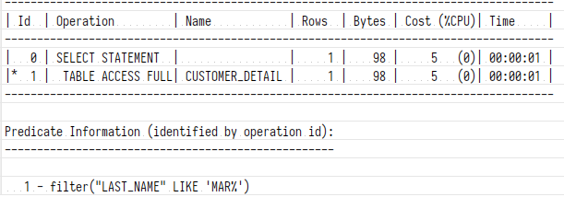
-- 1.3
CREATE INDEX customer_detail_lname ON customer_detail (last_name);

SELECT *
FROM customer_detail
WHERE last_name LIKE 'MAR%';
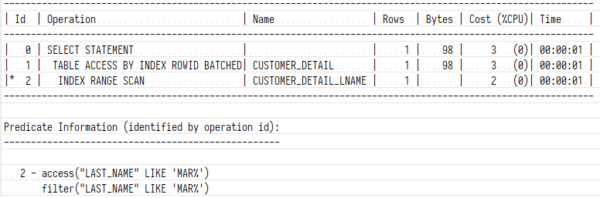Illustration 1: Ausführungsplan berücksichtigt erstellten Index!
--1.4
SELECT *
FROM customer_detail
WHERE SUBSTR(last_name, 0, 3) = 'MAR';
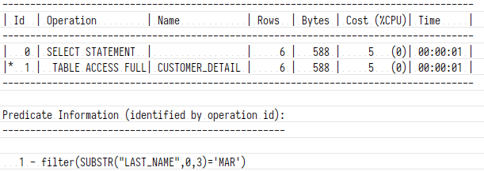Illustration 2: SUBSTR benötigt trotz Index einen full table access!

--1.5
CREATE INDEX customer_detail_lname_substr ON customer_detail (SUBSTR(last_name, 0, 3));

SELECT *
FROM customer_detail
WHERE SUBSTR(last_name, 0, 3) = 'MAR';
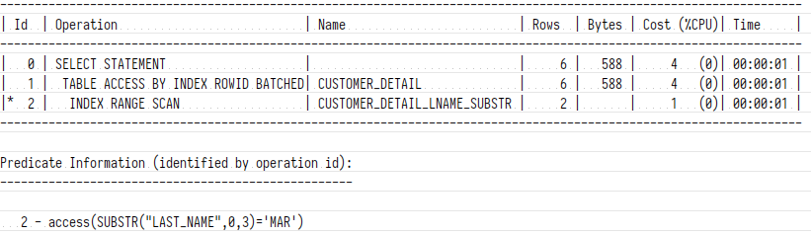Illustration 3: Neuer function-based Index wird zur Optimierung herangezogen.

2. Optimizer Hints
-- 2.1
CREATE INDEX customer_detail_country ON customer_detail (country);

SELECT *
FROM customer_detail
WHERE country = 'India'
AND last_name LIKE 'MAR%';
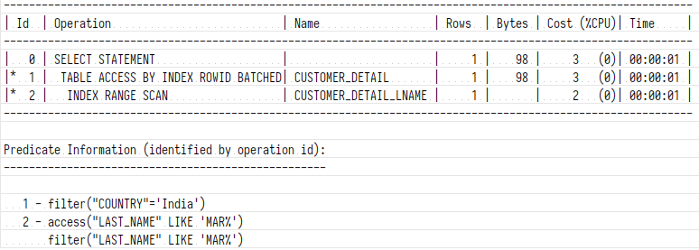Illustration 4: Lt. Ausführungsplan wird der neu erstellte Index nicht verwendet.

-- 2.2
SELECT /*+ INDEX (customer_detail customer_detail_country)*/ *
FROM customer_detail
WHERE country = 'India'
AND last_name LIKE 'MAR%';
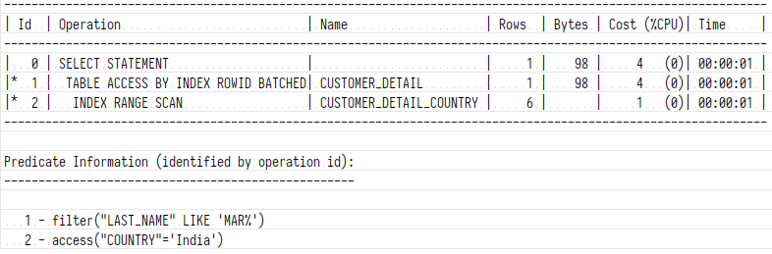Illustration 5: Mit explizitem Hinweis verwendet der Query optimizer den neuen Index!

3. Optimierung von SQL-Statements
Anmerkung: Gleichheit der Ergebnistupelmengen der jeweils unoptimierten und optimierten Versionen werden nur in der anliegenden SQL Datei getestet und in diesem Dokument nicht angeführt.
-- 3.1
SELECT customer_id, first_name, last_name
FROM customer
INNER JOIN rental USING (customer_id)
INNER JOIN inventory USING (inventory_id)
INNER JOIN film USING (film_id)
INNER JOIN film_category USING (film_id)
INNER JOIN category USING (category_id)
WHERE (name IN ('Comedy', 'Family', 'Children') AND length < 100)
OR name IN ('Classics', 'Animation');
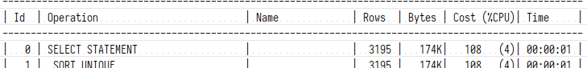Illustration 6: Abfrage 3.1 ohne Optimierung
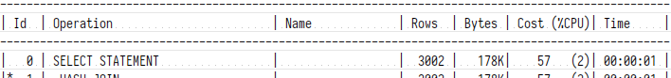Illustration 7: Abfrage 3.1 mit Optimierung

-- 3.2
SELECT *
FROM (
SELECT COALESCE(to_char(payment_date, 'yy'), 'total') AS year,
customer_id,
first_name,
last_name,
SUM(amount) AS umsatz
FROM customer
INNER JOIN payment USING (customer_id)
GROUP BY GROUPING SETS (
(to_char(payment_date, 'yy'), customer_id, first_name, last_name),
(customer_id, first_name, last_name)
)
)
PIVOT (
AVG(umsatz)
FOR year
IN ('13' AS umsatz13,
'14' AS umsatz14,
'15' AS umsatz15,
'total' AS umsatzgesamt)
);
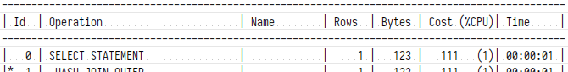Illustration 8: Abfrage 3.2 ohne Optimierung
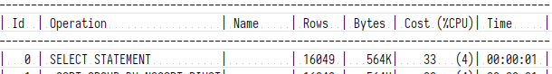Illustration 9: Abfrage 3.2 mit Optimierung
-- 3.3
SELECT film_id,
title,
RANK() OVER (
PARTITION BY category_id
ORDER BY length DESC) - 1 AS longerfilmsincategory
FROM film
INNER JOIN film_category USING (film_id)
ORDER BY film_id;
Illustration 10: Abfrage 3.3 ohne Optimierung
Illustration 11: Abfrage 3.3 mit Optimierung

