Ausarbeitung Übung 02

# Grundlagen

*-- 1.1***SELECT first_name** || **' '** || **last_name AS** "Name"  
**FROM** actor  
**ORDER BY last_name ASC**;  
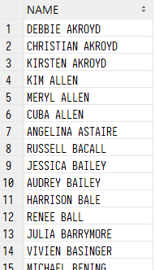  
*-- 1.2***SELECT  
 title**,  
 **length  
FROM** film  
**WHERE length** < 50;  
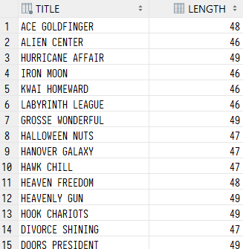  
*-- 1.3***SELECT** *INITCAP*(**title**) **AS** "Name"  
**FROM** film  
**WHERE title LIKE '___A%'**;  
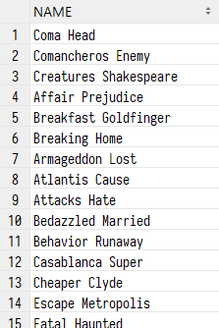  
*-- 1.4***SELECT title  
FROM** film  
**WHERE original_language_id IS NOT NULL**;  
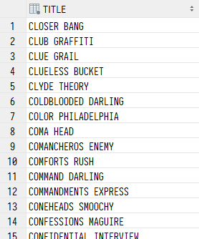  
*-- 1.5***SELECT** *COUNT*(*\**) **AS** "Nr. of rented films"  
**FROM** rental  
**WHERE rental_date** < *TO_DATE*(**'31.12.2015'**, **'DD.MM.YYYY'**) **AND  
 rental_date** > *TO_DATE*(**'01.01.2015'**, **'DD.MM.YYYY'**);  
  
*-- 1.6***SELECT inventory_id  
FROM** inventory  
**MINUS  
SELECT inventory_id  
FROM** rental;  
  
*-- 1.7***SELECT  
 first_name**,  
 **last_name  
FROM** customer  
 **INNER JOIN** address **USING** (**address_id**)  
 **INNER JOIN** city **USING** (**city_id**)  
**WHERE city IN** (**'Newcastle'**, **'Linz'**, **'London'**);  
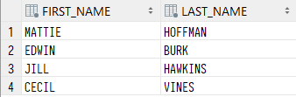  
*-- 1.8***SELECT** *to_char*(**rental_date**, **'Day, DD.Mon.YYYY'**) **AS** rental_date,  
 **amount  
FROM** payment p  
 **INNER JOIN** rental **r USING** (**rental_id**)  
**WHERE** p.**customer_id** = 420;  
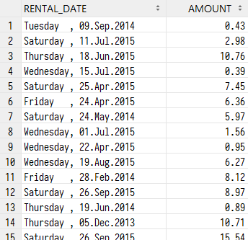

# Gruppierungen und Unterabfragen

*-- 2.1***SELECT** *ROUND*(*AVG*(**rental_rate**), 2),  
 **category_id  
FROM** film  
 **INNER JOIN** film_category **USING** (**film_id**)  
**GROUP BY category_id**;  
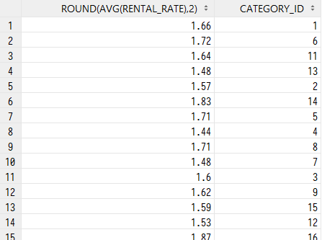  
*-- 2.2***SELECT title  
FROM** film  
**WHERE length** > (**SELECT length  
 FROM** film  
 **WHERE film_id** = 50) **AND  
 replacement_cost** > (**SELECT replacement_cost  
 FROM** film  
 **WHERE film_id** = 101);  
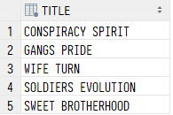  
*-- 2.3***SELECT title  
FROM** film  
 **INNER JOIN** film_category **USING** (**film_id**)  
**WHERE length** < 60 **AND  
 category_id IN** (**SELECT category_id  
 FROM** film  
 **INNER JOIN** film_category **USING** (**film_id**)  
 **WHERE film_id IN** (10, 20, 30));  
  
*-- 2.4***SELECT  
 first_name**,  
 **last_name**, *Count*(*\**) **AS** "Nr. of films"  
**FROM** actor  
 **INNER JOIN** film_actor **USING** (**actor_id**)  
**WHERE actor_id IN** (**SELECT actor_id  
 FROM** film_actor  
 **GROUP BY actor_id  
 HAVING** *COUNT*(*\**) > 35)  
**GROUP BY actor_id**, **first_name**, **last_name**;  
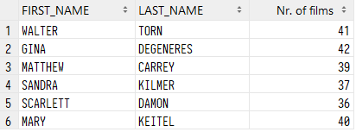  
*-- 2.5***SELECT  
 title**,  
 **length  
FROM** film  
**WHERE length** > (**SELECT** *AVG*(**length**)  
 **FROM** film);  
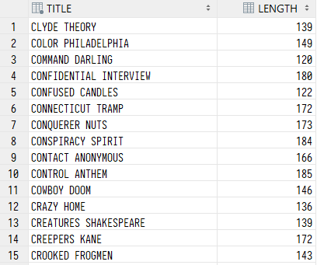  
*-- 2.6***SELECT UNIQUE name  
FROM** film_category  
 **INNER JOIN category USING** (**category_id**)  
**WHERE category_id IN** (**SELECT category_id  
 FROM** film_category  
 **GROUP BY category_id  
 HAVING** *COUNT*(**film_id**) < 60);  
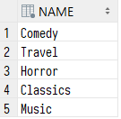  
*-- 2.7***SELECT  
 title**,  
 **length**,  
 **release_year  
FROM** film f1  
**WHERE length** >= **ALL** (**SELECT length  
 FROM** film f2  
 **WHERE** f2.**release_year** = f1.**release_year**);  
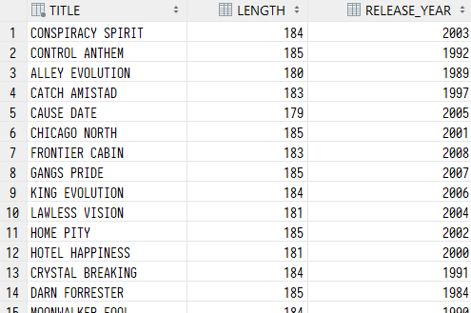  
*-- 2.8***SELECT  
 film_id**,  
 *to_date*(**rental_date**, **'YYYY-MM-DD'**) **AS** rental_date  
**FROM** (**SELECT** *\** **FROM** rental  
 **INNER JOIN** inventory **USING** (**inventory_id**)  
 **INNER JOIN** film **USING** (**film_id**)  
 **ORDER BY rental_date DESC**)  
**FETCH FIRST** 9 **ROWS ONLY**;  
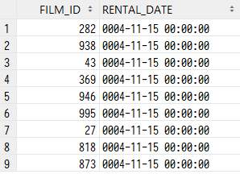

# Insert, Update und Delete *-- 3.1* **CREATE TABLE** new_film **AS** (**SELECT** *\** **FROM** film **WHERE release_year** >= (**SELECT** *MAX*(**release_year**) **FROM** film)); *-- 3.2* **INSERT INTO** new_film (**film_id**, **title**, **language_id**, **rental_duration**, **rental_rate**, **replacement_cost**, **release_year**, **last_update**) **VALUES** (1001, **'Jason Bourne'**, 1, 5, 1.75, 16.99, 2016, (**SELECT** *sysdate* **FROM** *dual*)); *-- 3.3* **UPDATE** new_film **SET rental_rate** = **rental_rate** * 1.15 **WHERE rental_rate** < 2; *-- 3.4* **CREATE OR REPLACE VIEW** cheap_film **AS SELECT title**, **description**, **rental_rate**, **length FROM** new_film **WHERE rental_rate** <= 2 **WITH CHECK OPTION**; *-- 3.5: COMMIT and ROLLBACK does not affect the session since -- data-dictionary manipulations (3.4) are followed by an automatic commit -- 3.6* **UPDATE** cheap_film **SET** rental_rate = rental_rate * 1.15 **WHERE** rental_rate < 2;

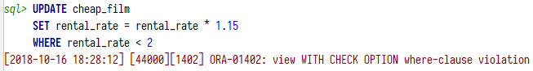  
*-- Does not work since some films' rental_rate would  
-- exceed the upper boundary (2)  
  
-- 3.7***DELETE  
FROM** new_film  
**WHERE rental_rate** > 1.79;  
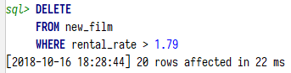  
*-- 3.8 (1.79 * 1.15) > 2, Since those entries are deleted in 3.7, all other values (x * 1.15)*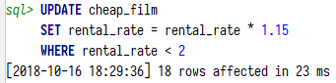

*-- 3.9***DROP TABLE** new_film;

  
**DROP VIEW** cheap_film;

