Ausarbeitung Übung 03

# Abbildung Generalisierung

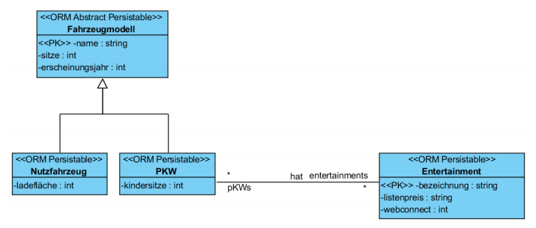

Die Generalisierung ist *complete*, da das Fahrzeugmodell als abstrakte Klasse modelliert ist. Sie ist außerdem *disjoint*, da ein Modell laut Angabe in beide Sparten PKW **und** Nutzfahrzeug fallen kann. Beim Einrelationenmodell wäre die Beziehung **hat** polymorph, was gegen die Modellierung spricht. Durch die Vollständigkeit der Generalisierung bietet sich die volle Redundanz eher schlecht an. Aus der Verbleibenden Auswahl empfinde ich das Partitionierungsmodell als umständlich da für eine Projektion mit allen Attributen mehrere Verbunde notwendig sind. So habe ich mich also für das Basisrelationenmodell entschieden:

Fahrzeugmodell: {[ name: string, sitze: int, erscheinungsjahr: int ]}

Nutzfahrzeug: {[ name: string, sitze: int, erscheinungsjahr: int, ladefläche: int ]}

Fahrzeugmodell: {[ name: string, sitze: int, erscheinungsjahr: int, kindersitze: int ]}

Entertainment: {[ bezeichung: string, listenpreis: string, webconnect: int ]}

hat: {[ name: string, bezeichnung: string ]}

# Aggregate und Gruppierungen

*-- 2 a***SELECT department_id**, **department_name**, *Count*(*\**)  
**FROM** departments  
 **INNER JOIN** employees **USING** (**department_id**)  
**GROUP BY department_id**, **department_name  
HAVING** *Count*(*\**) < 3;  
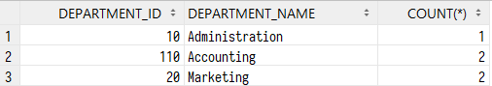  
*-- 2 b***SELECT department_id**, **department_name**, *Count*(*\**)  
**FROM** departments  
 **INNER JOIN** employees **USING** (**department_id**)  
**GROUP BY department_id**, **department_name  
HAVING** *Count*(*\**) = (**SELECT** *MAX*(*COUNT*(**employee_id**))  
 **FROM** departments  
 **INNER JOIN** employees **USING** (**department_id**)  
 **GROUP BY department_id**);  
  
*-- 2 c***SELECT department_id**, **department_name**, *Count*(*\**)  
**FROM** departments  
 **INNER JOIN** employees **USING** (**department_id**)  
**GROUP BY department_id**, **department_name  
HAVING** *Count*(*\**) = (**SELECT** *MIN*(*COUNT*(**employee_id**))  
 **FROM** departments  
 **INNER JOIN** employees **USING** (**department_id**)  
 **GROUP BY department_id**);



# Aggregate und Gruppierungen

*-- 3.1 Assumption: The exercise asks for actors who played in multiple films***SELECT first_name**, **last_name**, **actor_id  
FROM** actor  
 **INNER JOIN** film_actor **USING** (**actor_id**)  
**GROUP BY first_name**, **last_name**, **actor_id  
HAVING** (*COUNT*(*\**) > 1);  
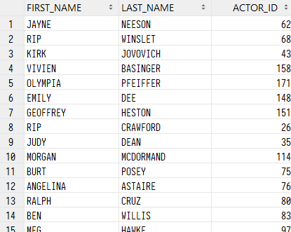  
*-- 3.2***SELECT title  
FROM** film  
**WHERE film_id NOT IN** (**SELECT film_id FROM** inventory);  
  
*-- 3.3***SELECT r**.**staff_id**, **s**.**store_id**, *COUNT*(*\**), *SUM*(**amount**)  
**FROM** rental **r  
 INNER JOIN** payment **USING** (**rental_id**)  
 **INNER JOIN** staff **s ON** (**s**.**staff_id** = **r**.**staff_id**)  
**GROUP BY r**.**staff_id**, **s**.**store_id**;

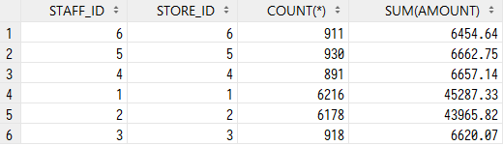  
*-- 3.4***SELECT first_name**, **last_name**, *COUNT*(*\**)  
**FROM** customer  
 **INNER JOIN** rental **USING** (**customer_id**)  
**GROUP BY first_name**, **last_name  
ORDER BY** *COUNT*(*\**) **DESC**;  
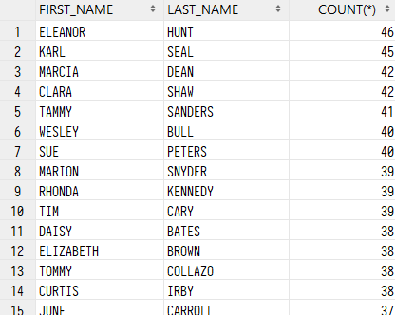  
*-- 3.5***SELECT customer_id**, **last_name**, **store_id**, *SUM*(**amount**)  
**FROM** payment **INNER JOIN** customer c1 **USING** (**customer_id**)  
**GROUP BY customer_id**, **last_name**, **store_id  
HAVING** *SUM*(**amount**) >= **ALL** (**SELECT** *SUM*(**amount**)  
 **FROM** payment **INNER JOIN** customer c2 **USING** (**customer_id**)  
 **WHERE** c1.**store_id** = c2.**store_id  
 GROUP BY customer_id**, **last_name**, **store_id**);  
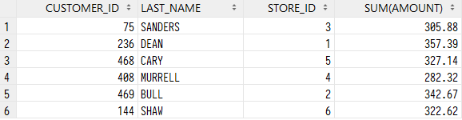  
*-- 3.6***SELECT first_name**, **last_name**, *COUNT*(*\**) **AS** number_of_horror_rental  
**FROM** customer  
 **INNER JOIN** rental **USING** (**customer_id**)  
 **INNER JOIN** inventory **USING** (**inventory_id**)  
 **INNER JOIN** film_category **USING** (**film_id**)  
 **INNER JOIN category USING** (**category_id**)  
**WHERE name** = **'Horror'  
GROUP BY first_name**, **last_name  
HAVING** *COUNT*(*\**) >= 4  
**ORDER BY** *COUNT*(*\**) **DESC**;  
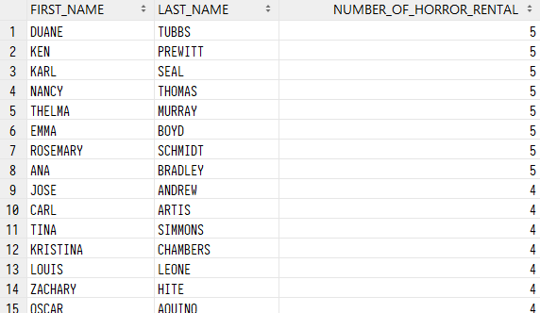  
*-- 3.7***SELECT actor_id**, **last_name  
FROM** actor  
 **INNER JOIN** film_actor **USING** (**actor_id**)  
**GROUP BY actor_id**, **last_name  
ORDER BY** *COUNT*(*\**) **DESC  
FETCH FIRST** 10 **ROWS ONLY**;  
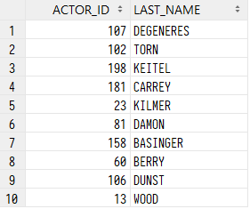  
*-- 3.8***SELECT name**, **category_id**, *COUNT*(*\**)  
**FROM category  
 INNER JOIN** film_category **USING** (**category_id**)  
 **INNER JOIN** film **USING** (**film_id**)  
 **INNER JOIN** inventory **USING** (**film_id**)  
**GROUP BY category_id**, **name  
ORDER BY** *COUNT*(*\**) **ASC  
FETCH FIRST** 5 **ROWS ONLY**;  
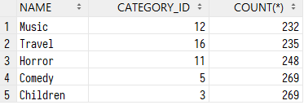  
*-- 3.9***SELECT film_id**, **title**, **length**, **category_id  
FROM** film  
 **INNER JOIN** film_category **USING** (**film_id**)  
**WHERE** (**category_id**, **length**) **IN** (**SELECT category_id**, *MAX*(**length**)  
 **FROM** film  
 **INNER JOIN** film_category fc **USING** (**film_id**)  
 **GROUP BY category_id**)  
**ORDER BY length ASC  
FETCH FIRST** 1 **ROWS WITH TIES**;

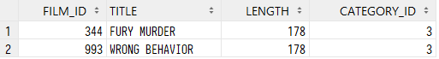

# GROUP BY und ROLLUP

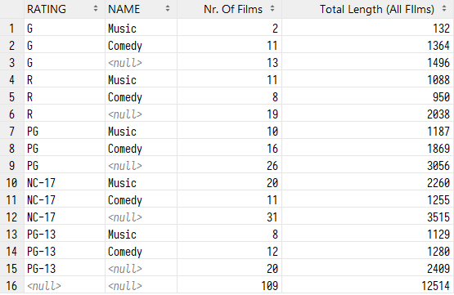

Figure 1 Ergebnis für alle drei Abfragen

*-- 4.1***SELECT rating**, **name**, *COUNT*(*\**) **AS** "Nr. Of Films", *SUM*(**length**) **AS** "Total Length (All FIlms)"  
**FROM** film  
 **INNER JOIN** film_category **USING** (**film_id**)  
 **INNER JOIN category USING** (**category_id**)  
**WHERE name IN**(**'Comedy'**, **'Music'**)  
**GROUP BY ROLLUP** (**rating**, **name**);  
  
*-- 4.2***SELECT rating**, **name**, *COUNT*(*\**) **AS** "Nr. Of Films", *SUM*(**length**) **AS** "Total Length (All FIlms)"  
**FROM** film  
 **INNER JOIN** film_category **USING** (**film_id**)  
 **INNER JOIN category USING** (**category_id**)  
**WHERE name IN**(**'Comedy'**, **'Music'**)  
**GROUP BY GROUPING SETS** ( (**rating**),  
 (**name**, **rating**),  
 ());  
  
*-- 4.3***SELECT rating**, **name**, *COUNT*(*\**) **AS** "Nr. Of Films", *SUM*(**length**) **AS** "Total Length (All Films)"  
**FROM** film  
 **INNER JOIN** film_category **USING** (**film_id**)  
 **INNER JOIN category USING** (**category_id**)  
**WHERE name IN**(**'Comedy'**, **'Music'**)  
**GROUP BY rating**, **name  
UNION ALL  
SELECT rating**, **NULL AS name**, *COUNT*(*\**) **AS** "Nr. Of Films", *SUM*(**length**) **AS** "Total Length (All Films)"  
**FROM** film  
 **INNER JOIN** film_category **USING** (**film_id**)  
 **INNER JOIN category USING** (**category_id**)  
**WHERE name IN**(**'Comedy'**, **'Music'**)  
**GROUP BY rating**, **NULL  
UNION ALL  
SELECT NULL AS** rating, **NULL AS name**, *COUNT*(*\**) **AS** "Nr. Of Films", *SUM*(**length**) **AS** "Total Length (All Films)"  
**FROM** film  
 **INNER JOIN** film_category **USING** (**film_id**)  
 **INNER JOIN category USING** (**category_id**)  
**WHERE name IN**(**'Comedy'**, **'Music'**);

# GROUP BY mit CUBE

*-- 5.1***SELECT manager_staff_id**, **store_id**, *SUM*(**amount**)  
**FROM store s  
 INNER JOIN** staff **USING** (**store_id**)  
 **INNER JOIN** payment **USING** (**staff_id**)  
**GROUP BY CUBE** (**manager_staff_id**, **store_id**);  
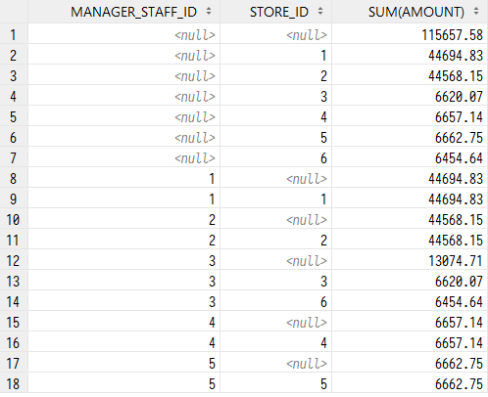  
*-- 5.2***SELECT manager_staff_id**, **store_id**, *SUM*(**amount**),  
 *GROUPING*(**manager_staff_id**) grp_msi,  
 *GROUPING*(**store_id**) grp_sid  
**FROM store s  
 INNER JOIN** staff **USING** (**store_id**)  
 **INNER JOIN** payment **USING** (**staff_id**)  
**GROUP BY CUBE** (**manager_staff_id**, **store_id**);  
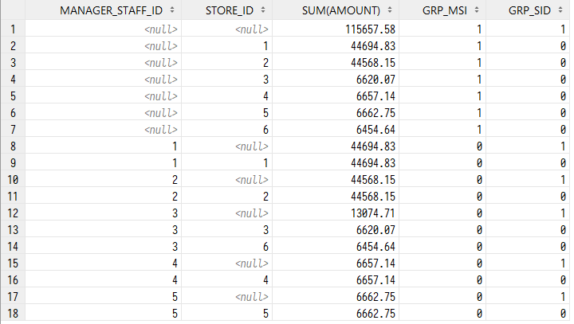  
*-- 5.3***SELECT manager_staff_id**, **store_id**, **staff_id**, *SUM*(**amount**)  
**FROM store s  
 INNER JOIN** staff **USING** (**store_id**)  
 **INNER JOIN** payment **USING** (**staff_id**)  
**GROUP BY GROUPING SETS** ((**manager_staff_id**, **store_id**, **staff_id**),  
 (**manager_staff_id**, **store_id**),  
 (**store_id**, **staff_id**));  
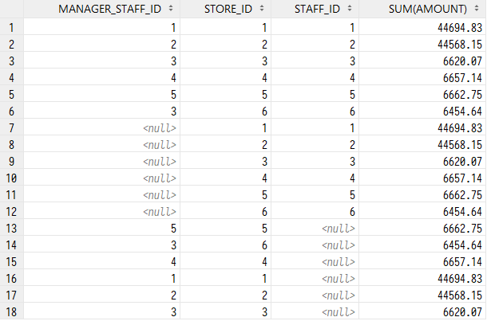  
*-- 5.4***SELECT country**, *EXTRACT*(**YEAR FROM payment_date**), **r**.**staff_id**, *sum*(**amount**), *count*(*\**)  
**FROM** payment  
 **INNER JOIN** rental **r USING** (**rental_id**)  
 **INNER JOIN** staff **s ON r**.**staff_id** = **s**.**staff_id  
 INNER JOIN** inventory **i USING** (**inventory_id**)  
 **INNER JOIN store** sto **ON** sto.**store_id** = **i**.**store_id  
 INNER JOIN** address **a ON** sto.**address_id** = **a**.**address_id  
 INNER JOIN** city **USING** (**city_id**)  
 **INNER JOIN** country **USING** (**country_id**)  
**GROUP BY GROUPING SETS** ( (**country_id**, **country**, *EXTRACT*(**YEAR FROM payment_date**)),  
 (**r**.**staff_id**, *EXTRACT*(**YEAR FROM payment_date**)),  
 ());

