Ausarbeitung Übung 04

Table of Contents

Hierarchische Abfragen (HR) 1

Hierarchische Abfragen (Sakila) 3

PIVOT und UNPIVOT 4

Analytische Abfragen 6

# Hierarchische Abfragen (HR)

*-- 1.1a*

**SELECT employee_id**,

**last_name**,

**hire_date**,

**salary**

**FROM** employees

*-- basically WHERE manager_id = 102;*

**START WITH manager_id** = 102

**CONNECT BY PRIOR employee_id** = **manager_id**

**AND** *level* = 1;



*-- 1.1b*

**SELECT employee_id**,

**last_name**,

**hire_date**,

**salary**

**FROM** employees

**START WITH employee_id** = 102

**CONNECT BY PRIOR employee_id** = **manager_id**;

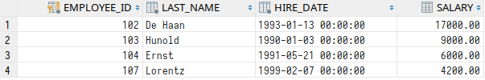

*-- 1.2*

**SELECT employee_id**,

**last_name**,

**hire_date**,

**salary**

**FROM** employees

**WHERE** *level* = 3

**START WITH employee_id** = 102

**CONNECT BY PRIOR employee_id** = **manager_id**;



*-- 1.3*

**SELECT employee_id**,

**manager_id**,

*LPAD*(**last_name**, *LENGTH*(**last_name**) + *level*, **'-'**) **AS hierarchy**

**FROM** employees

**START WITH manager_id IS NULL**

**CONNECT BY PRIOR employee_id** = **manager_id**;

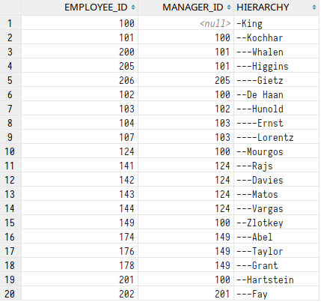

*-- 1.4*

**WITH** superiors **AS** (**SELECT CONNECT_BY_ROOT first_name AS** first_name,

**CONNECT_BY_ROOT last_name AS** last_name

**FROM** employees

**WHERE** *level* > 1

**CONNECT BY PRIOR employee_id** = **manager_id**)

**SELECT** first_name,

last_name,

*COUNT*(*\**)

**FROM** superiors

**GROUP BY** first_name, last_name;

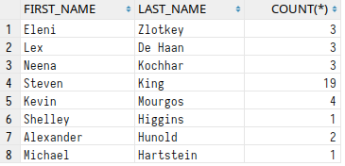

# Hierarchische Abfragen (Sakila)

*-- 2*

**CREATE OR REPLACE VIEW** partners **AS**

**SELECT** a1.**actor_id AS** actor_id,

a2.**actor_id AS** partner_id,

a1.**film_id AS** film_id

**FROM** film_actor a1

**INNER JOIN** film_actor a2 **ON** a1.**actor_id** != a2.**actor_id AND**

a1.**film_id** = a2.**film_id**

**WHERE** a1.**film_id** <= 13;

*-- Nick Wahlberg is has actor_id 2!*

**SELECT DISTINCT partner_id,**

**last_name**,

**first_name**

**FROM** partners p

**INNER JOIN** actor **a ON** p.**partner_id** = **a**.**actor_id**

**WHERE partner_id NOT IN**

(**SELECT partner_id**

**FROM** partners

**WHERE actor_id** = 2)

**START WITH** p.**actor_id** = 2

**CONNECT BY NOCYCLE PRIOR partner_id** = p.**actor_id**

**AND partner_id** != 2

**AND** *level* = 2;

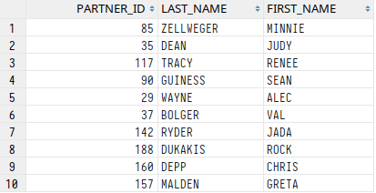

# PIVOT und UNPIVOT

*-- 3.1*

**SELECT** *\**

**FROM**

(**SELECT staff_id**,

**name AS category**

**FROM** rental

**INNER JOIN** inventory **USING** (**inventory_id**)

**INNER JOIN** film **USING** (**film_id**)

**INNER JOIN** film_category **USING** (**film_id**)

**INNER JOIN category USING** (**category_id**))

**PIVOT**

(*COUNT*(*\**) **AS** anzahl

**FOR staff_id**

**IN** (1 **AS** verk1, 2 **AS** verk2))

**ORDER BY category ASC**;

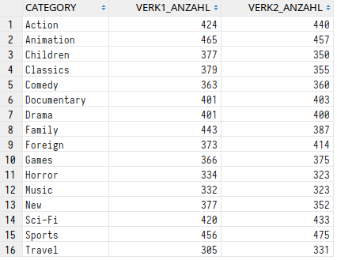

*-- 3.2*

***SELECT name****,*

*ROUND*(family, 2),

*ROUND*(children, 2),

*ROUND*(animation, 2)

**FROM**

(**SELECT** lang.**name**,

cat.**name AS category**,

**length**

**FROM category** cat

**INNER JOIN** film_category **USING** (**category_id**)

**INNER JOIN** film **USING** (**film_id**)

**INNER JOIN language** lang **USING** (**language_id**))

**PIVOT**

(*AVG*(**length**)

**FOR category**

**IN** (**'Family' AS** family, **'Children' AS** children, **'Animation' AS** animation));

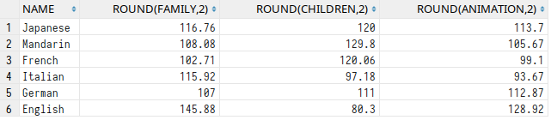

*-- 3.3*

**SELECT** *\**

**FROM**

(**SELECT title**,

**l**.**name AS** lang,

ol.**name AS** original

**FROM** film f

**INNER JOIN language l ON** f.**language_id** = **l**.**language_id**

**INNER JOIN language** ol **ON** f.**original_language_id** = ol.**language_id**

**WHERE release_year** = 1983)

**UNPIVOT**

(**language**

**FOR kind**

**IN** (lang **AS 'L'**, original **AS 'OL'**))

**ORDER BY title ASC**;

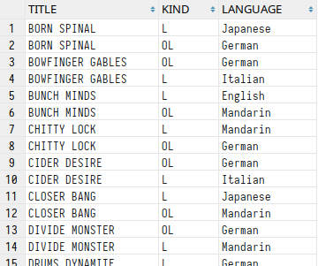

# Analytische Abfragen

*-- 4.1*

**SELECT title**,

**rental_date**,

*RANK*() **OVER** (**PARTITION BY title ORDER BY rental_date**) **AS** rank

**FROM** rental

**INNER JOIN** inventory **USING** (**inventory_id**)

**INNER JOIN** film **USING** (**film_id**)

**ORDER BY rental_date DESC**

**FETCH FIRST** 10 **ROWS WITH TIES**;

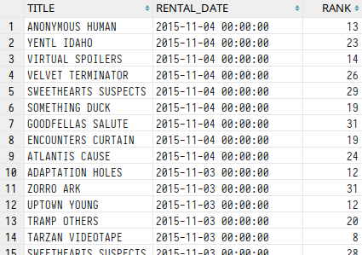

*-- 4.2*

**SELECT name**,

**title**,

**release_year**

**FROM**

(**SELECT name**,

**title**,

**release_year**,

*ROW_NUMBER*() **OVER** (**PARTITION BY category_id ORDER BY release_year**) **AS** rn

**FROM** film_category

**INNER JOIN** film **USING** (**film_id**)

**INNER JOIN category USING** (**category_id**))

**WHERE** rn < 4;

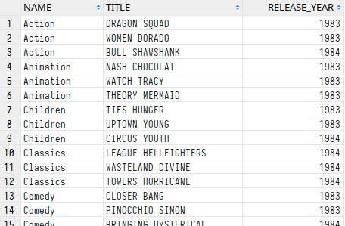

*-- 4.3*

*-- I tried to partition by customer id*

*-- and then let a window of size 2 compare*

*-- 2 adjacent dates recursively but calculating*

*-- the date difference turned out to be quite*

*-- tricky so I used regular joins. :)*

**WITH** dates **AS** (**SELECT customer_id**,

**rental_date**,

*ROW_NUMBER*() **OVER** (**PARTITION BY customer_id ORDER BY rental_date ASC**) **AS** rn

**FROM** rental)

**SELECT** d1.**customer_id**,

**c**.**last_name**,

*ROUND*(*AVG*(d2.**rental_date** - d1.**rental_date**)) **AS** average_rental_interval

**FROM** dates d1

**INNER JOIN** dates d2 **ON** d1.**customer_id** = d2.**customer_id AND**

d1.rn + 1 = d2.rn *-- CONNECT BY (...) AND PRIOR rn + 1 = rn*

**INNER JOIN** customer **c ON** (d1.**customer_id** = **c**.**customer_id**)

**GROUP BY** d1.**customer_id**, **c**.**last_name**;

