**Gait phase:**

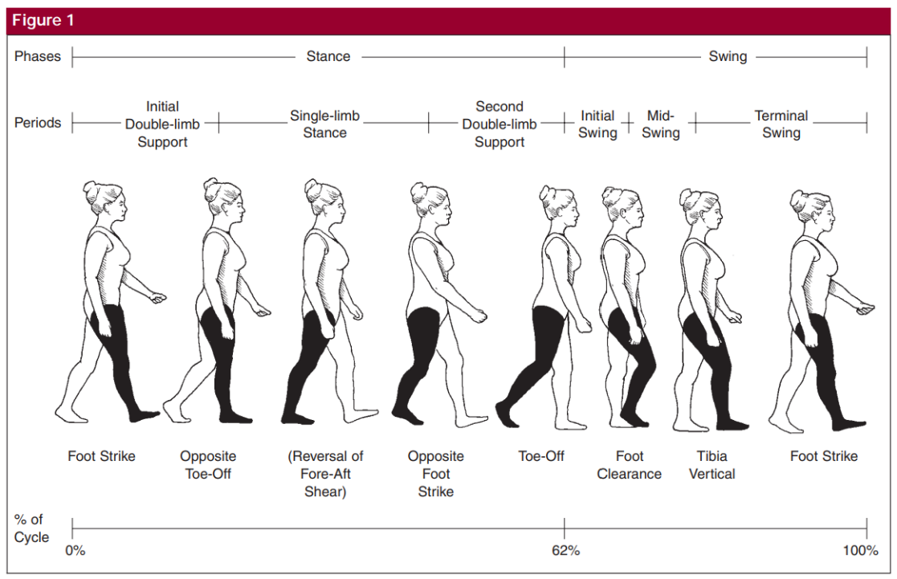

Let the left leg as a representative limb; for forwarding propulsion, the first step is heel off: the subject will lift their left heel, then the body will lean forward as the subject pushes the ground backward until the left toe-off. Toe-off is when terminal contact is made with the toe and is a special case of terminal contact in clinical terms, which denotes the interval at which the foot leaves the ground. As a pendulum maximizes its potential energy, the shank energy is maximized while the left leg continues to swing backward. After a particular interval, the energy is transferred from potential energy to kinetic energy, and the left leg swing in the forward direction. At the lowest point, a left Heel-Strike occurs, which is termed as Initial contact in gait and land to support the body weight, and the other leg enters the swing phase. The same cyclic motion is found in the right leg, continuing the cycle.

**Clinical gate abnormalities:**

A list of common abnormal gaits: <https://stanfordmedicine25.stanford.edu/the25/gait.html>

**Data sources:**

1. Gait parameters:

Some spatio-temporal measures that are considered part of objective gait evaluation:

Acceptable range of values for healthy individuals in different age groups:

1. Ground reaction forces

* Vertical ground reaction forces
* Head and trunk ground reaction forces
* Upper limb ground reaction forces
* Lower limb ground reaction forces
* Anterior-posterior ground reaction forces
* Medial-lateral ground reaction forces

Through measuring the various forces acting on the subject, we can classify the force data into various categories.

1. Gait speed

It is the time taken by the person to cover a particular area over the shortest distance.

1. Histogram features

* Variance: Variability plays a significant role in gait analysis. It is the fluctuation in various kinds of measurements encompassing the joint angles (kinematic), various forces (ground reaction forces, which fall under kinetic features), stride interval (Spatio-temporal parameters), or measurement of electromyographic.
* Skewness: Lack of symmetry is considered an important parameter for the gait analysis. Skewness deals with the symmetrical distribution of the data. It can be categorized as positively skewed or negatively skewed.
* Kurtosis: Kurtosis is a statistical measure to describe the distribution. Kurtosis is used to measure extreme values in either of the tail.

**Factors to consider:**

1. “It is well known that precision of gait descriptions acquired by vision systems can be severely affected by a number of factors that influence either the motion pattern or the gait perception. Motion may be altered by footwear, surface, mood, age, body weight, physical injuries, neurological disorders, or even by people’s own volition. Regarding the last, it has been noticed that some patients affected by a neurological disease tend to conceal motion impairments when they know that they are being recorded.” - **Vision-based gait impairment analysis for aided diagnosis**
2. INIT Dataset has perfectly segmented silhouettes!

**Datasets**

1. Physiobank - <https://archive.physionet.org/physiobank/database/>
2. NTU RGB Dataset - <https://rose1.ntu.edu.sg/dataset/actionRecognition/>