**Account-Book-Pro**

Year 4, B.Sc. (Hons) in Software Development --- [Mobile Applications development](https://github.com/TangqiFeng/Account-Book-Pro/wiki)

1. Server (set up on AWS now)
   1. Introduction

This server is a SpringBoot project write in Java. Data store in **MongoDB**, which interact with springboot project.

Also, this server generated **docker** file, which can deploy eaisier.

* 1. APIs

1. /sign-up?username=value1&password=value2 (POST)

value1 is the email address of new user

value2 is the paaword of new user

1. /login?username=value1&password=value2 (GET)

value1 is the email address of new user

value2 is the paaword of new user

1. /additem (POST)

a Item object is include in the request body (POST)

1. /getitembydate?username=value1&month=value2&year=value3 (GET)

value1 is the email address of user

value2 is the month you want to search

value3 is the year you want to search

1. /getitembyloc?username=value1&location=value2 (GET)

value1 is the email address of user

value2 is the location you want to search

1. /getallitem? username=value1 (GET)

value1 is the email address of user

1. /deleteitem? username=value1&detail=value2

value1 is the email address of user

value2 is the detail of item you want to delete

1. UWP project
   1. Introduction

This project uses MVVM design approach, includes GPS component. Handle the interaction with back-end server by using Http request.

* 1. Design

DATA – MODEL – VIEW - VIEWMODEL

Data: methods handle data with database

Model: bean classes

View: pages

ViewModel: INotifyPropertyChanged, handle property change events (both UI and data source). Update data automatically

* 1. Pages

1. Login/register page & Register page

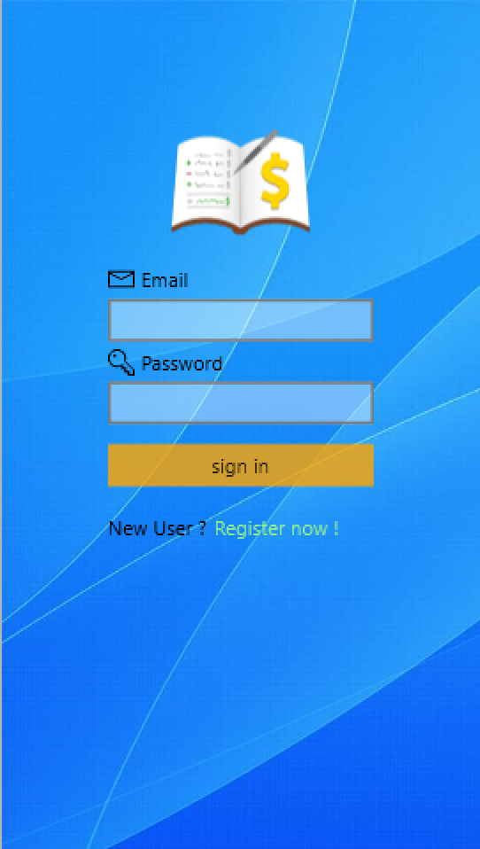 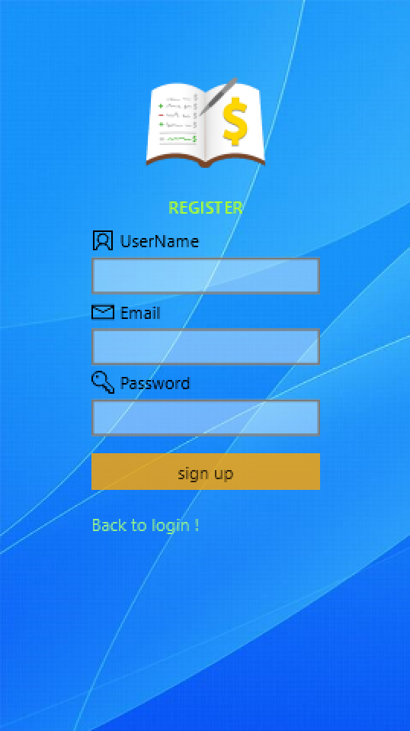

1. Add item & search item page

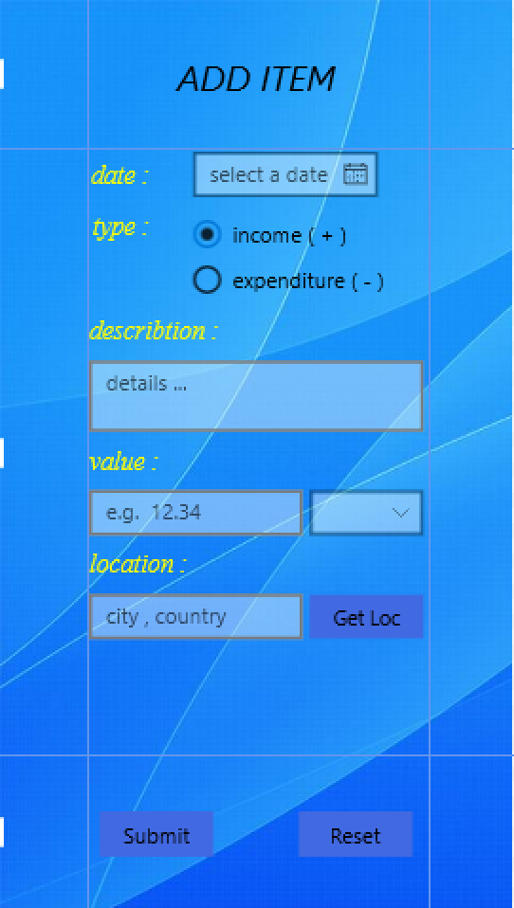 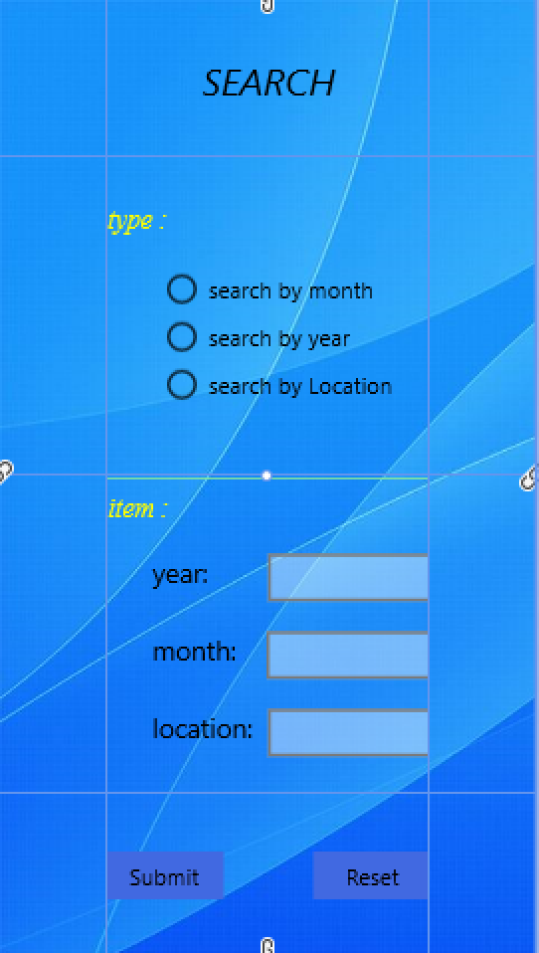

1. Result display & popup window page

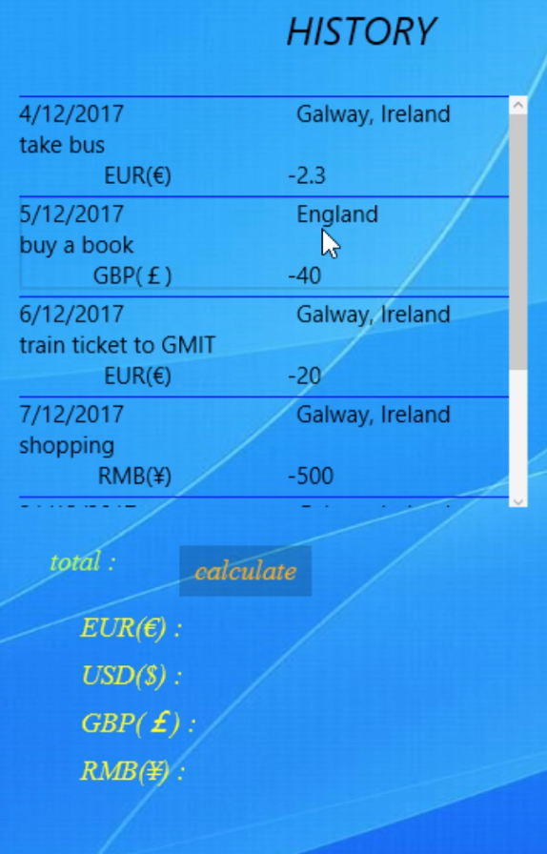 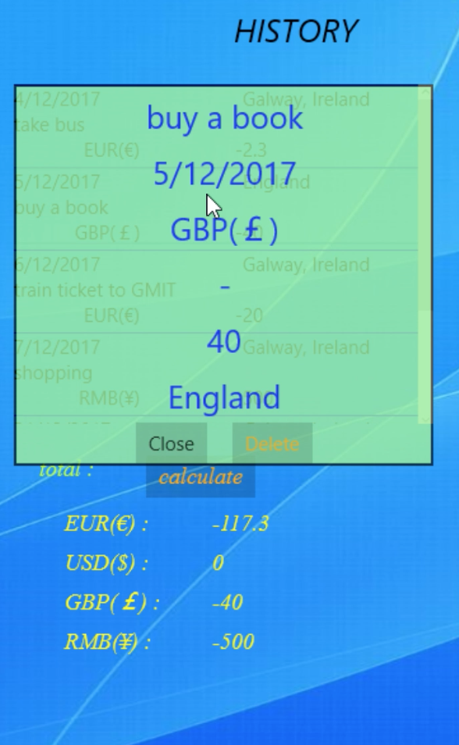

1. Welcom & setting page

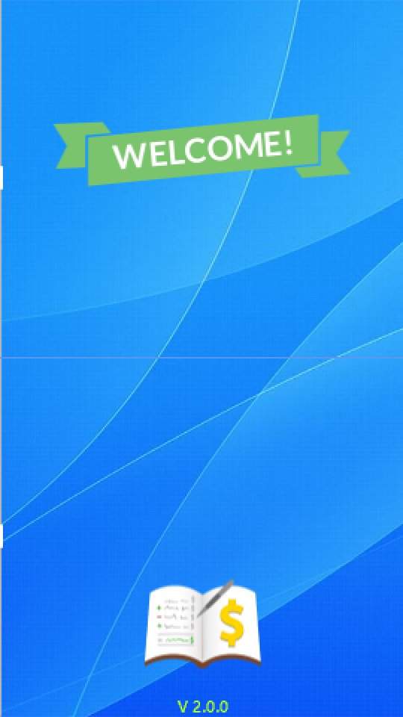 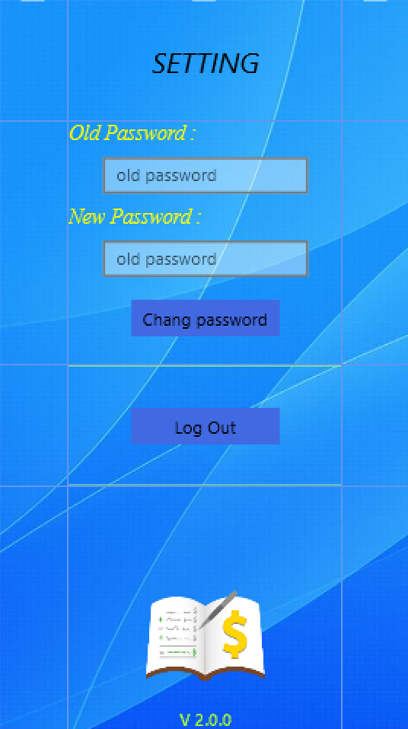

Note:

If you changed the place server running, make sure update the ip address in **App.xaml.cs**