COMP 7940 Lab 5
Tang Shuyang 25441728
- The deployment is triggered by an SSH command that executes a remote script. The key command is
ssh -o StrictHostKeyChecking=no ${{ secrets.EC2_USER }}@${{ secrets.EC2_HOST }} << 'EOF'
git pull origin main
This connects to the EC2 instance and pulls the latest code from the GitHub repository.

Local Repo
Git pull
Action runner, establish ssh connections to
SSH connection to

EC2 instance
Git push
SSH connection to

Github repo

- Storing passwords in config.ini is insecure because the file is often accidentally committed to version control, exposing secrets, it stores sensitive data in plaintext, readable by anyone with file access, also it's hard to manage and update across different environments. The secrets in Github improve the security by encrypting sensitive data and keeping it separate from the codebase, allowing secure injection into workflows without exposing values in logs, and enabling fine-grained access control and easy rotation without code changes.
- 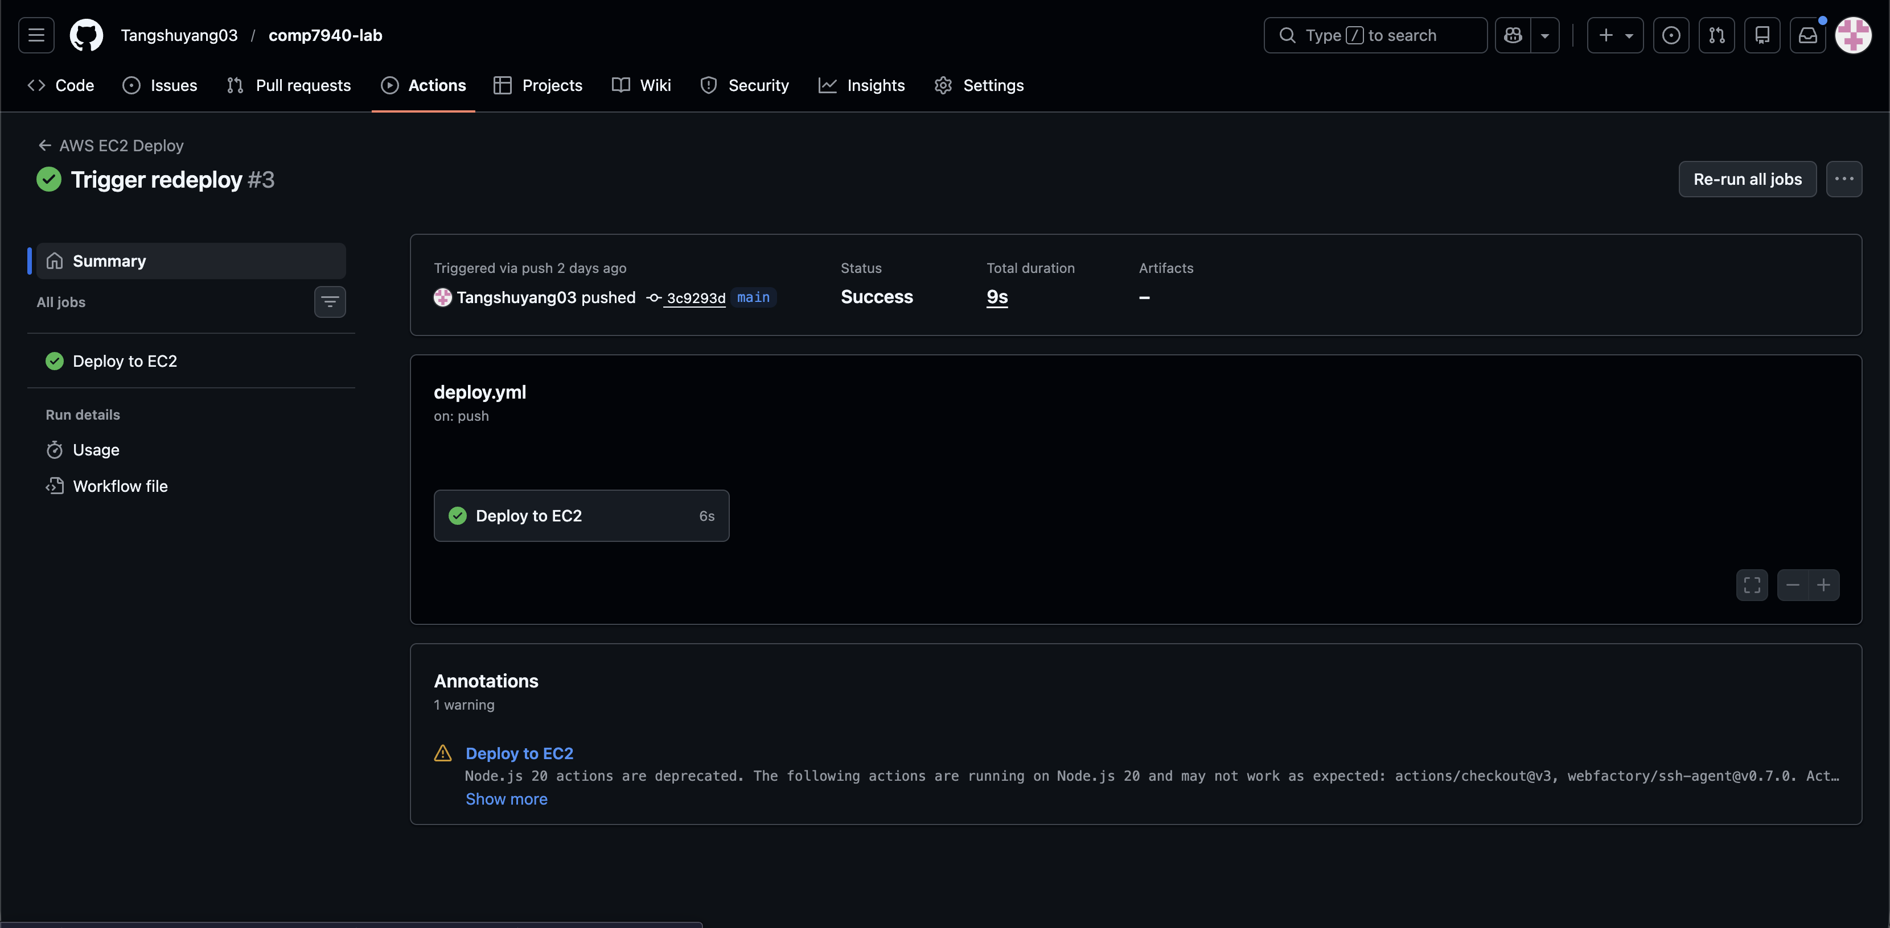
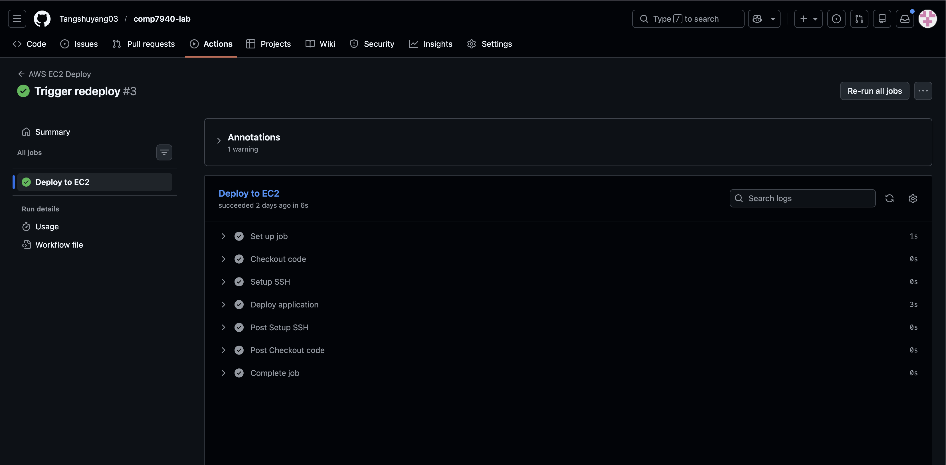
These screenshots shows that the action runner is ser correctly and successfully connected with EC2.

