GrantScout
Honest grant discovery and drafting for African NGOs and social enterprises. An ADK 2.0 multi-agent pipeline that finds grants you can actually win, drafts the two highest-value application sections, and pauses for human review. It surfaces eligibility gaps honestly and never submits anything.
Competition: AI Agents: Intensive Vibe Coding Capstone Project (Kaggle)
Track: Agents for Good
Deadline: Monday, July 6, 2026, 11:59 PM PT
Video: [PASTE YOUTUBE LINK] Code: [PASTE PUBLIC GITHUB REPO LINK]

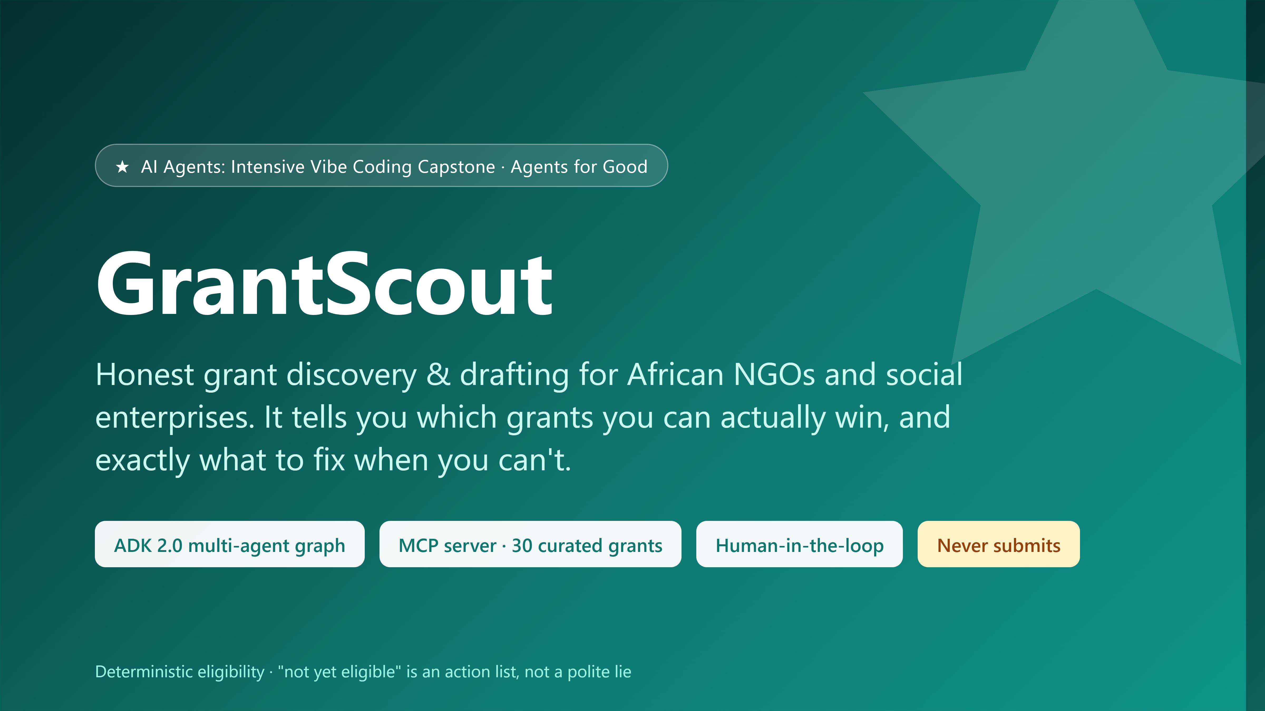
Cover image for the Kaggle media gallery (submission/screenshots/cover_image.png).

The problem
African NGOs, community-based organizations, and social enterprises run on grant funding, but unlike the US (Grants.gov), there is no single free official African-grants API. Real funding opportunities are abundant yet scattered across newsletters, blog roundups, and gated platforms. Two failures follow:
- Discovery is hard. Finding opportunities you actually qualify for means trawling many sources by hand, every month.
- Honesty is rare. Tools and hopeful humans alike over-state readiness. A three-person community organization that spends three weeks writing a proposal for a funder that requires audited accounts it does not have has been actively harmed by whoever told it “looks like a great fit!”. For small organizations, wasted proposal-writing time is the scarcest resource they have.
The second failure is the one almost nobody builds for, because optimism demos better. GrantScout is built around fixing it.

Why agents?
This problem is genuinely agentic: it needs (a) tool calls against a structured catalog and, optionally, the live web; (b) multi-step reasoning that turns a messy organizational profile into ranked, explained matches and grounded draft text; and (c) a hard requirement that a human stays in control of anything consequential. A single prompt cannot do this; a pipeline of specialized agents with tools, deterministic checks, and a real human-in-the-loop pause can.
Equally important is what the agent must not do. Grant applications are high-stakes, so GrantScout is deliberately a drafting copilot with brakes: the LLM never decides eligibility, every unverifiable fact is an explicit [ORG TO PROVIDE] marker rather than an invention, and the system never submits anything anywhere.

The solution
GrantScout consolidates 30 real, source-attributed African funding opportunities from public roundups (AfricanNGOs.org, FundsforNGOs, GlobalGiving/Instrumentl, Africa-Grants.com) into one queryable MCP catalog. That consolidation is itself a contribution, since no such free API exists. On top of it runs a four-node ADK 2.0 workflow: researcher, matcher, drafter, review gate.
The user describes their organization once (type, country, years operating, governance, focus areas, mission). GrantScout returns ranked matches where fit and eligibility are scored separately, drafts a Problem Statement and a Funder Alignment section for the grants worth pursuing, and pauses at a real human review gate where each section can be approved, edited inline, or rejected. The finalized package exports to Word (.docx) and is stamped “submitted: false”.

Architecture
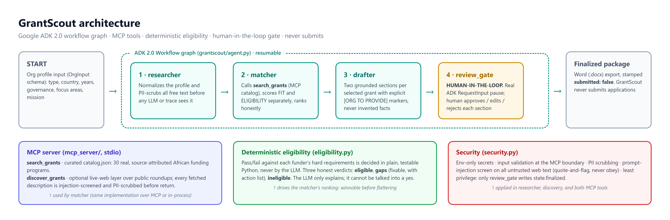
Figure 1. The ADK 2.0 workflow graph with its MCP tools, deterministic eligibility engine, and security layer.
- ADK 2.0 Workflow graph (grantscout/agent.py): a straight spine, START → researcher → matcher → drafter → review_gate, built with google-adk 2.3.0 and wrapped in an App with ResumabilityConfig(is_resumable=True) so the human-in-the-loop pause can genuinely suspend and resume the graph.
- researcher normalizes the profile and PII-scrubs all free text (emails, phone numbers, embedded credentials) before any LLM or trace sees it.
- matcher calls the search_grants tool, scores focus-area fit and eligibility independently, and ranks honestly: an eligible grant outranks a higher-fit grant the organization cannot win.
- drafter produces two grounded sections per selected grant. Anything the organization must supply (beneficiary numbers, budgets, evidence) is an explicit [ORG TO PROVIDE] marker; the LLM is used only to polish prose, and a guard rejects any polish that drops a marker.
- review_gate is a real ADK RequestInput pause (a FunctionNode with rerun_on_resume=True). The human decision resumes the graph, and this node is the only writer of state.finalized.

MCP server
mcp_server/server.py (FastMCP, stdio) exposes two tools:
- search_grants(focus_areas, country, org_type, max_deadline) filters the curated catalog. Each grant carries structured eligibility_requirements ({code, value, label} records) so eligibility can be decided deterministically, plus a source attribution and funder URL.
- discover_grants(focus_areas, country) is an optional live-web freshness layer over public roundup pages. Every fetched description is screened for prompt injection and scrubbed of PII before it is returned; it is off by default and fails closed so it can never break the catalog spine.
The same implementations back both the MCP server and the in-process matcher, so the tool contract is identical over MCP or direct calls.

The honesty mechanism (the most important part)
Eligibility pass/fail is decided in plain Python (grantscout/eligibility.py), never by the LLM. Whether an organization meets a funder’s hard requirements (right org type, in-scope country, legally registered, 3+ years operating, audited accounts, functioning board) is a factual, checkable question. Language models reliably round up: they tell a hopeful NGO it “looks eligible” because the framing rewards optimism. That is precisely the failure this project exists to avoid, so the verdict lives where it is auditable, unit-tested, and cannot be talked into a yes. The LLM only explains gaps in plain language.
There are three honest outcomes: eligible (meets every hard requirement), gaps (fails a fixable requirement; “not yet eligible” with a concrete action list), and ineligible (fails a structural one; stated plainly, ranked last). The screenshots below show the mechanism working: WaterAid and the Conrad N. Hilton Safe Water Initiative come back at 100% focus fit but ranked last, each with the exact fixes shown. A conventional matcher would have put those two at the top and cost the organization weeks.

Security
grantscout/security.py implements defense in depth:
- Secrets via environment only. No keys in code or git; .env is gitignored and the repo was scanned for key patterns before publishing.
- Input validation at the MCP boundary. Malformed tool payloads are rejected with ValueError.
- PII scrubbing. Emails, phone numbers, and URL-embedded credentials are redacted before text reaches an LLM or a trace, in the researcher and on all discovered web text.
- Prompt-injection screening on untrusted web data. Adversarial instructions in fetched grant descriptions are detected and neutralized as inert UNTRUSTED_DATA (quote-and-flag, never obey), with tests covering both directions.
- Least privilege. Each node calls only the tools it needs; only the review gate can finalize; the agent has no submission capability at all.

The product (screenshots)
Everything below runs locally with no API key: uv pip install -e ".[dev,web]", then uv run python run_web.py. With no key, the reasoning nodes use deterministic fallbacks so the catalog + eligibility + review-gate spine works end-to-end offline; setting GOOGLE_API_KEY lights up the Gemini prose path (with 429-aware retry and quota-conscious batching). The MCP server also runs standalone (python -m mcp_server.server), and the hermetic test suite (39 tests) covers eligibility edge cases, honest ranking, both security screens, catalog integrity, discovery screening, and the review gate.
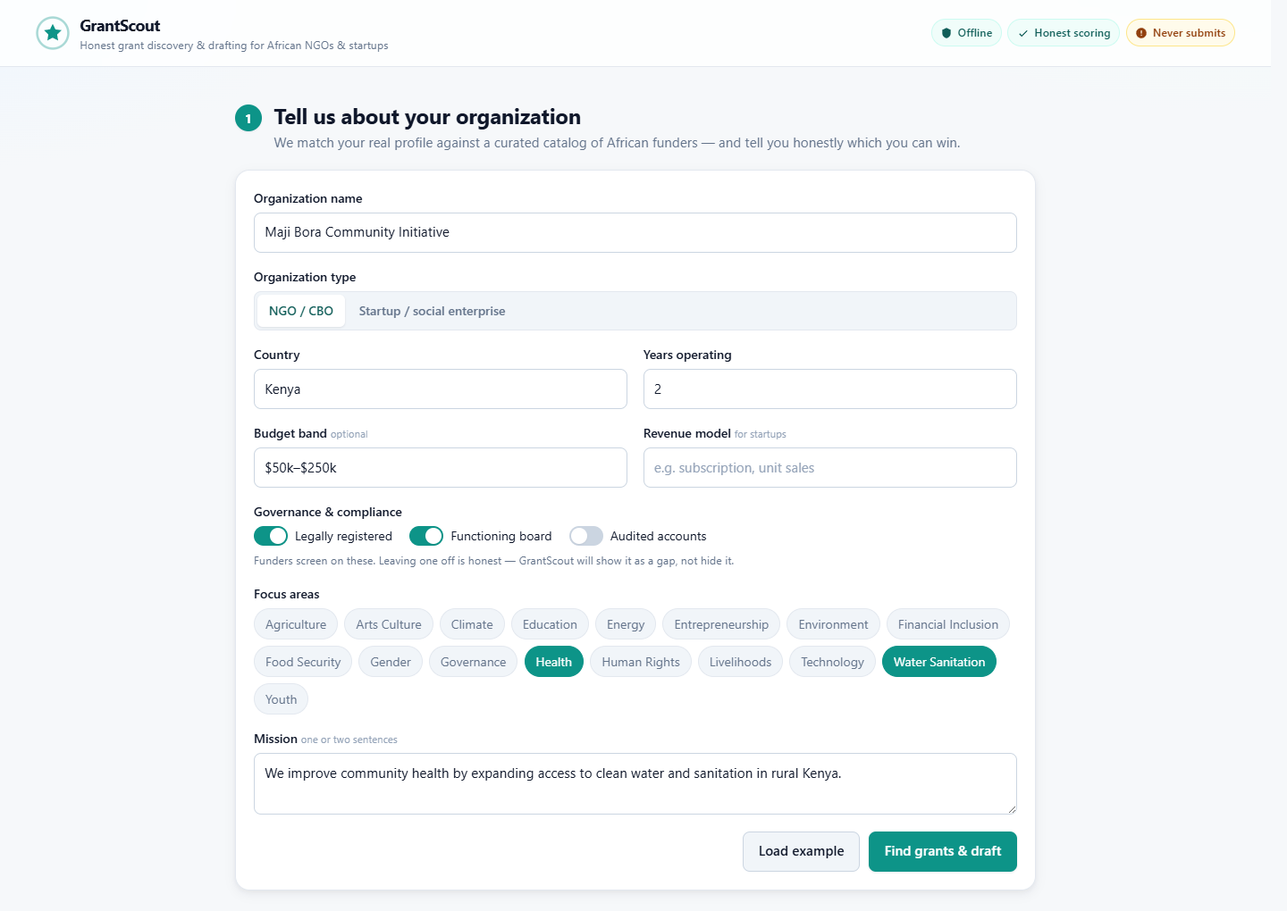
Figure 2. Step 1: the organization profile. The governance switches are deliberately honest inputs; leaving one off becomes a visible gap, not a hidden lie.
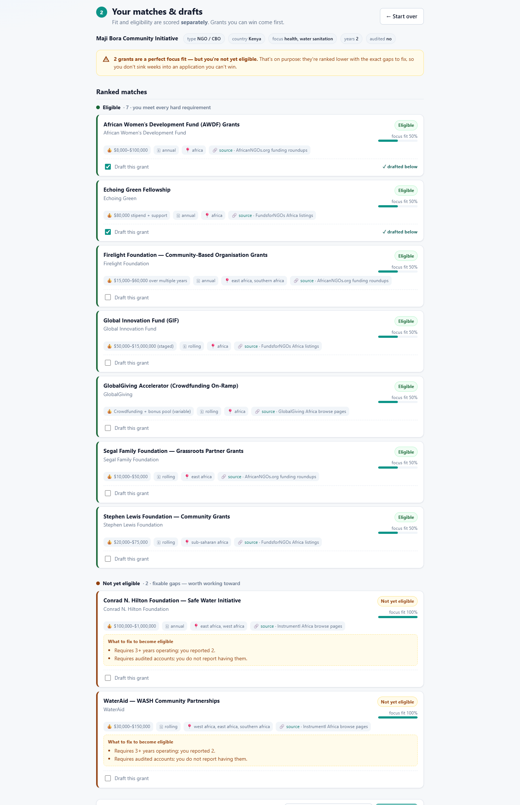
Figure 3. Step 2: ranked matches. Fit and eligibility are scored separately. The honesty banner explains why two 100%-focus-fit WASH funders are ranked last: the org is two years old and lacks audited accounts, and each card lists exactly what to fix.
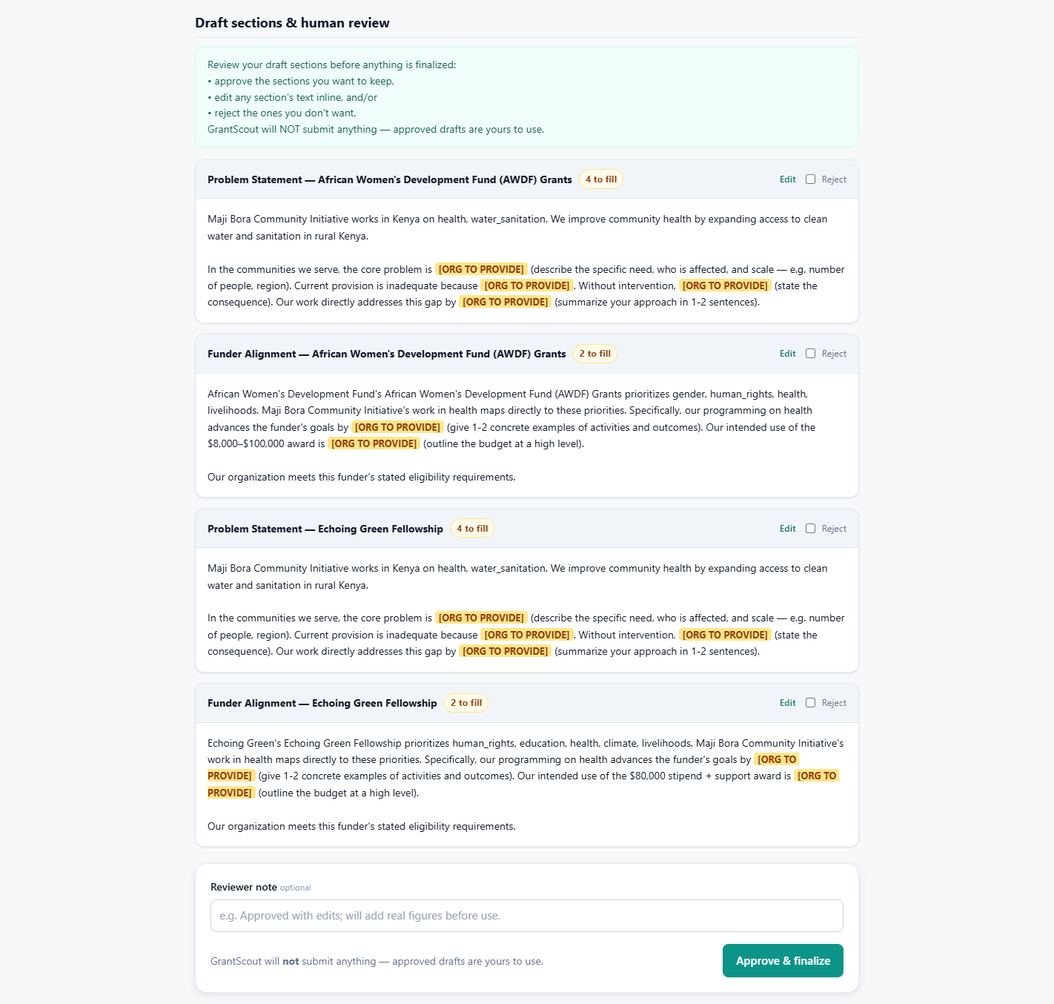
Figure 4. Step 3: drafted sections at the human-in-the-loop gate. Every unverifiable fact is a highlighted [ORG TO PROVIDE] marker; the human can approve, edit inline, or reject each section.
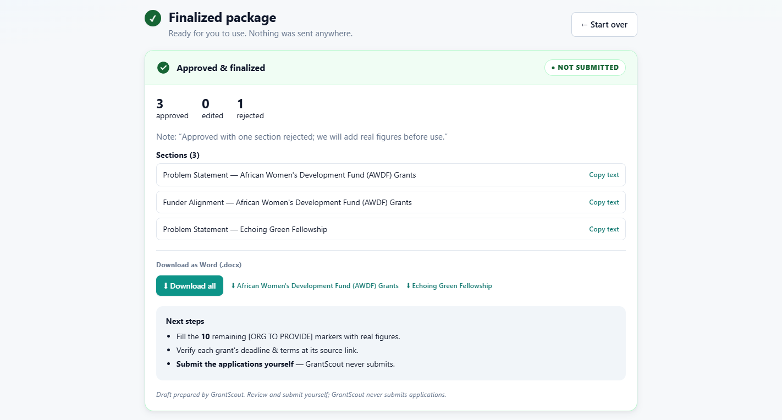
Figure 5. Step 4: the finalized package after review (3 approved, 1 rejected), stamped NOT SUBMITTED, with Word (.docx) downloads per grant.

Course concepts demonstrated
Concept | Where it is demonstrated
Agent / multi-agent system (ADK) | grantscout/agent.py: ADK 2.0 Workflow graph of four nodes with resumability (code)
MCP server | mcp_server/server.py: FastMCP with search_grants + discover_grants over stdio (code)
Security features | grantscout/security.py + tests: PII scrub, injection screen, validation, env-only secrets, least privilege (code)
Human-in-the-loop | grantscout/nodes/review_gate.py: real RequestInput pause/resume (code + video)
Agent skills / Agents CLI | Project scaffolded and managed with agents-cli (agents-cli-manifest.yaml, Agent Runtime target) (code + video)
Antigravity | Google-tooling phase built in Antigravity; shown in the video

The build (vibe coding journey)
GrantScout was built in two deliberate phases, entirely through vibe coding with AI coding agents. Phase 1 produced everything machine-independent: the graph, MCP server, curated catalog, deterministic eligibility engine, security utilities, both UIs, and the test suite, written against a spec (grantscout.spec.yaml) with a factual handoff document (PHASE1_HANDOFF.md) recording every deviation discovered along the way, such as the real ADK 2.x import paths and why rerun_on_resume=True is required for the resume to write finalized state. Phase 2, in Antigravity with the Google Agents CLI, wired up the Google tooling: real Gemini calls with quota-aware retry, agents-cli scaffolding with an Agent Runtime deployment target, and the demo captured in the video. The two-phase, spec-and-handoff workflow is itself a vibe-coding practice worth recommending: it kept the honest-by-construction core testable and offline, and made the cloud integration a thin, verifiable layer on top.

Limitations and next steps
The catalog is curated, not live; entries carry source attributions and funder URLs, and users are told to verify current deadlines at the source. discover_grants is best-effort freshness, not coverage. Next steps: scheduled catalog refresh with human review, more grant sections (budget narrative, monitoring and evaluation), country-specific compliance checklists, and partnerships with the roundup publishers whose public work the catalog credits.
GrantScout’s core claim is simple: for organizations whose scarcest resource is time, an honest “not yet, and here’s what to fix” is worth more than a flattering maybe, and building that honesty into the architecture, rather than the prompt, is what makes an agent trustworthy enough to help.

Remaining steps before the deadline
These require accounts only you control. Full details in submission/SUBMISSION_CHECKLIST.md.
- Push the repo to public GitHub. The repo currently has no remote; a public project link is mandatory.
- Record and upload the YouTube video (5 minutes or less). Show the demo, the architecture diagram, and Antigravity + agents-cli on screen; Antigravity can only be demonstrated in the video.
- Create the Kaggle Writeup. Paste submission/WRITEUP.md, set the title and subtitle, and select the Agents for Good track.
- Fill the two placeholders (YouTube link and GitHub repo link) in the writeup.
- Upload media. cover_image.png as the cover, screenshots 01–05, and attach the video.
- Attach the project link (the GitHub repo URL).
- Click Submit before July 6, 11:59 PM PT. Draft writeups are not judged.

