Thomas Satterly

AAE 550, HW 2

**I. Constrained Minimization in *N* Variables – Direct Methods**

Design a hollow circular beam-column with minimum weight for two conditions:

1. When P = 55 kN, the axial stress must not exceed the allowable stress
2. When P = 0, the deflection due to self weight should be less that 0.001 of the beam’s length

The manufacturing process limits the radius and thickness of the beam and ratio of the radius and thickness of the beam as follows:

0.02 m <= R <= 0.2 m

0.001 m <= t <= 0.01 m

R / t <= 18

The beam is fabricated with the following material properties:

Density: 7850 kg/m^3

Allowable Axial Stress: 405 MPa

Modulus of Elasticity: 250 GPa

**Find:**

1. Provide an optimization problem statement. Clearly present the variables intended to use as the design variables. Formulate the constraints into gi <= 0 and clearly present them. Present how the variable bounds will be treated. Consider variable scaling and note any conditioning used.
2. Solve the beam design problem with one of the two available constrained optimization methods that make use of linear programming (SLP of Method of Centers). Be sure to indicate which method will be used. Also indicate the value of move limits used. Use at lease two different x0 points, if not more. Tabulate the complete results.
3. Solve the problem using the GRG method in the Excel solver. Use at least two different x0 and tabulate the results as before. Also include the number of iterations needed to reach the solution. Include a cut and paste of the important cells in the workbook.
4. Solve the problem using the SQP method available in Matlab’s *fmincon* function. Use numerical gradients. Again, use at least two different x0 starting points and tabulate the results. Include the number of iterations needed to reach a solution.
5. Repeat question (4) using analytic gradients.
6. Describe the results. Do different choices of x0 result in different values of x*? How do different x0 values impact the chosen LP method? Does one method appear to use fewer iterations on average? Are there any features of this problem that make one of these methods more suitable? In this problem, were there any transformations or scaling that were helpful?

**Solution:**

1. See attached for the problem statement, objective function and constraint definitions, and gradient calculations
2. For this problem, the Sequential Linear Programming method is used. See attached for Matlab code. The move limits were set constant at [0.1, 0.01], although the method never utilized the full limits during any part of the optimization.

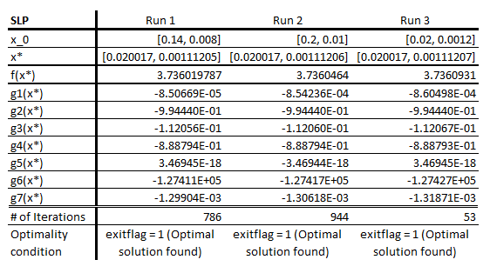

1. See attached for Excel workbook setup

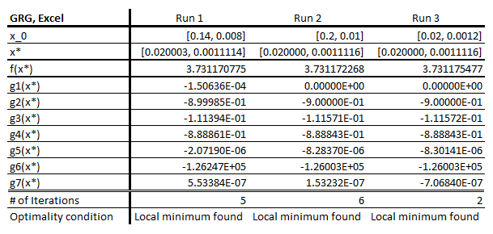

1. See attached for Matlab code

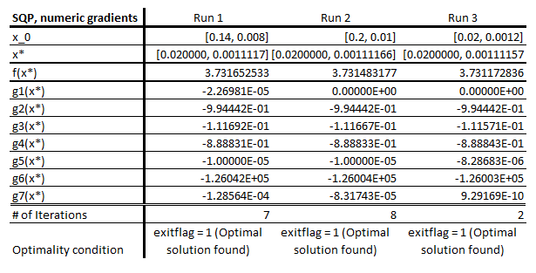

1. See attached for Matlab code

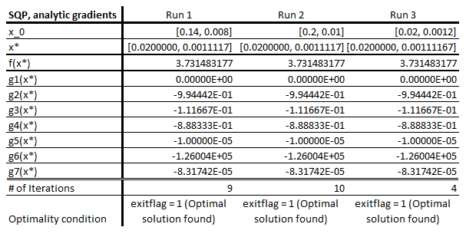

1. While choosing a different x0 does produce different optimization results, the final values for x* typically vary by less than 0.003%, making the solution difference negligible. However, different x0 values can significantly impact how quickly an optimization method is able to find an optimal solution. For example, the number of iterations required for the SLP method to find an optimal solution varied between 786 and 53 iterations depending on how close the initial point was to the optimal solution. Comparatively, the SQP method only took between 4 and 10 iterations for the same set of initial points. This highlights the weakness of sequential linear programming optimization, in that finding the optimal solution can be slow if the objective and constraint functions are near linear.

Based on the different starting points used, the GRG method consistently used the fewest number of iterations to reach an optimal solution. However, it should be noted that the SQP method, using either numerical or analytic gradients, still had very few iterations on the same order of the GRG method. For a balance between the most consistent results regardless of starting point and the fewest iterations, the SQP method with analytic gradients would seem like the most desirable choice.

For this problem, the gradients of the constraint function required scaling to be on the same order of the objective function in order for the SLP method to converge. Otherwise, the method would continuously hop between two points which surround the optimal point. Other means of eliminating this behavior were attempted, including reducing the move limits if the algorithm was hopping between two points and the current point was valid, but this would run into errors of still hopping out of bounds and failing to find a path back into feasible space. Constraint and objective function scaling was also attempted, but in the end, constraint gradient scaling proved the most reliable. All other methods needed no such additional treatment.