Thomas Satterly

AAE 550, HW 3

11/14/17

**I. Nelder-Mead Simplex**

The Matlab routing “fminsearch” uses the Nelder-Mead Simplex algorithm. Use the algorithm to solve the Rastrigin function is defined as follows:

$$f\left(x\right)=10d+\sum_{i=1}^{d}{(x_{i}^{2}-10\cos\left(2πx_{i}\right))}$$

$$-5.12≤x_{i}≤5.12$$

1. Formulate an appropriate objective function for the Nelder-Mead Simplex to account for the bounds of the design variables. Recall that the function and/or slope continuity is not a requirement when developing the penalty function
2. Solve the problem starting from x0 =[0.3 0.3]T. Be sure to use the first x* as x0 for a re-start of the algorithm. Summarize in a table.
3. Solve the problem again starting from x0=[-2.5 0]T. As before, use the first x* as x0 for a re-start of the algorithm and summarize in a table
4. Solve the problem again starting from x0=[3.5 -3.5]T. As before, use the first x* as x0 for a re-start of the algorithm and summarize in a table
5. Recall that the Nelder-Mead Simplex is generally better at non-smooth optimization than it is global optimization. Do the results indicate this?

**Solution**

1. A
2. A
3. A
4. A
5. A known global minimum for the Rastrigin function is at x=[0 0]T. While part (2) manages to find this global minimum, parts (3) and (4) settle upon different local minima, indicating that the Nelder-Mead Simplex is more apt at finding local minima over a non-smooth surface than a global minimum.

**II. Simulated Annealing**

Minimize the Rastagrin function as defined in part (I) using the Simulated Annealing (SA) Algorithm..

1. Start from x0 =[3 3]T. Choose a value of T0 and rT. Run the SA algorithm again to see the effect of the random number generator. Adjust the maximum number of iterations so it does not effect the resulting answer. Use a different starting point, and solve using the SA algorithm twice again. Summarize the results in a table
2. Run the SA algorithm from one of the x0 points in part (1), first with a higher initial temperature, than a lower initial temperature. Summarize the results in a table. What impact does temperature have on the quality of the results? What effect does initial temperature have on the computational cost?
3. Choose the best initial temperature from part (2) and run the SA algorithm at two different cooling rates than used in part (1) and (2). Summarize the results in a table. What impact does the cooling rate have on the quality of the result and the computational expense?

**III. Genetic Algorithm**

Minimize the Rastagrin function as defined in part (I) using the Genetic Algorithm..

1. Start by using 10 bits to encode each design variable. Use the guidelines discussed in class for population size and mutation rates. Examine the effect of the random number generator by running the program at least two more times.
2. Repeat part (1) using 5 bits for each variable. Repeat using 20 bits for each variable. Change the population and mutation rates according to the guidelines. How do these different coding resolutions affect the quality of the results and the runtime of the algorithm?

**IV. A Combinatorial Problem with the Genetic Algorithm**

Use the Genetic Algorithm (GA) to solve a combinatorial problem. The problem is to minimize the weight of the truss shown below by varying the cross-sectional area and material choice while avoiding yielding on any member.

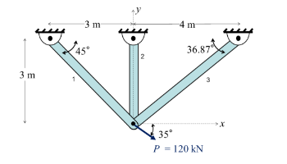

Four possible materials are available for each beam member. The properties for each are given below. Assume that the allowable stress for both compression and tension is the same.

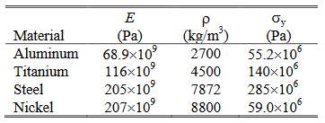

Because this problem is combinatorial, the objective function must include the density of the material and the constraints must incorporate Young’s modulus and yield stress. Because there are four materials, the material selection for each truss can be represented as 2 bits. The mass of the truss can be computed as follows:



The lengths of the truss members can be treated as constant. The stiffness matrices are:

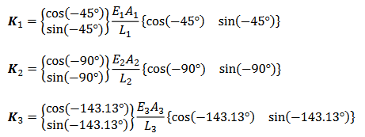



The load vector is defined as follows:



The displacement of the free node, u, is obtained by solving the system Ku=p. Therefore, the change in length of any element can be found:

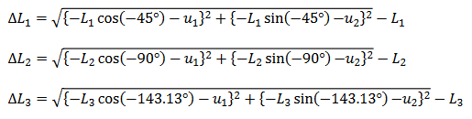

Finally, the stress in each element is the strain multiplied by Young’s modulus:



1. Encode the material selection in two bits as suggested above. Choose upper and lower bound variables for the cross sectional area of the beams. Choose the number of bits used to encode the cross section area. What resolution does this provide between each adjacent value? Determine the population and mutation rate for this problem, following the guidelines for uniform crossover and tournament selection.
2. Develop a fitness function that uses and exterior penalty to enforce the constraints. Be sure to state and explain any penalty multipliers. Recall that the quadratic form is not necessary, linear or step-linear forms are acceptable.
3. Run the GA to find a solution, evaluate the objective, constraint and fitness function values at this best design. Adjust the penalty multiplier until the constraints behave well. Include the GA function and any necessary supporting functions in the report.
4. Run the GA three times. Record the number of generations, function evaluations, best design and objective, constraint and fitness functions values at the best design.
5. Consider the best x* found. Based on this solution and considering the constraints at or near the objective bounds, recommend a change to the basic truss configuration that would improve the truss structure needed to support the design load.

**Solution**

1. A
2. B
3. C
4. D
5. The near-active constraints on the optimal design were the yield stress on beams 1 and 3, and the lower limit of cross section area on beam 2. This intuitively makes sense, as the applied load is closest to be align with beam 1, while the remaining load would be most effective taken by a beam perpendicular to beam 1, of which beam 3 is the closest. In this way, only two load components need resolved, while three members exist to resolve those loads, implying that at least one beam is redundant. In order to improve the truss structure, beam 2 should be eliminated, and beam 1 should be aligned at 35o, collinear with the expected load. Beam 3 should remain to resolve any torque from self-weight or load variations not explicitly present in this problem.