ubiquitous computing Assignment

Group Report
Lab Exercise 1
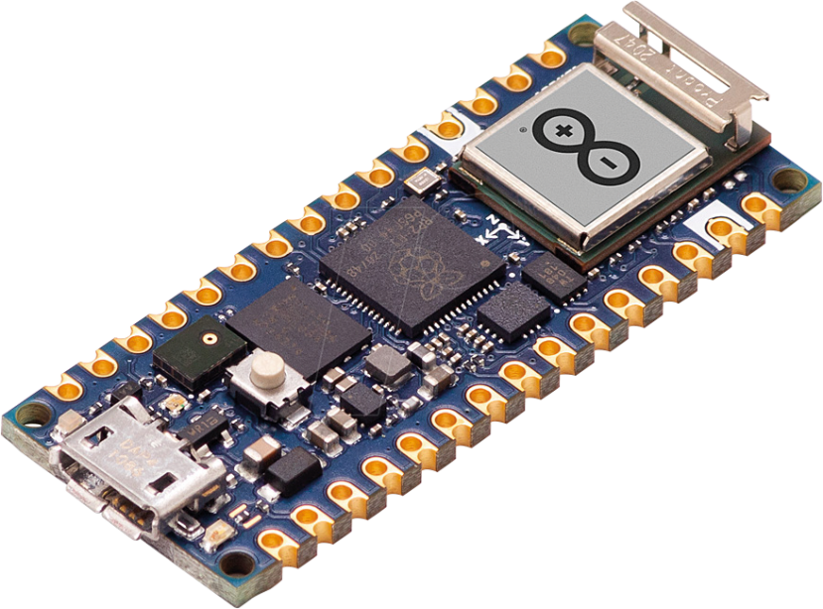

Courses accompanied by:
Prof. Dr. Ralf Seepold
Dr. Maksym Gaiduk

Assignment done by:
Tanguy Le Morzadec
307639

Theoretical Answers

What does the IMU do?
The IMU is a Hardware Module for all kinds of Systems. Usually, they can be found in embedding devices such as the Arduino nano rp2040. The name IMU stands for (Inertial Measurement Unit) and inhibits a sensor with which the acceleration and rotational acceleration can be measured with.
With the acceleration part the current movement of the device can be determined. Thus, possibly used in devices which shall detect if e.g. a fall is happening and act accordingly.
With the rotational acceleration, also known via the measurement of a Gyroscope, you can determine the Tilt of given device. The usage can present itself worthy for e.g. the avionics section to determine the tilt / orientation of the plane.
A IMU can also offer a Magnetometer which thus can be served as a compass by virtue of earth’s magnetic fields.

How does PWM work?
“PWM (Pulse-Width modulation) contains every method of representing a signal as a rectangular Waves.” What that means, is usually the communication on bases of power and amplitude delivered by an electric signal. Usually, it is used within low level electronics, e.g. Microcontroller or fan controls.
It can transport information by rapidly switching a signal between on and off. The ratio of on-time to the total cycletime (duty cycle) determines how much power is effectively delivered. I.e. the dutytime is a fraction of a periodical timespan which tells how much power shall be delivered.

Why can measurments have wrong readings?
If I may cite prof. Michael Mächtel: “wer misst, misst Misst.” Translated that means: “whom measurements, measures crap” (sounds funnier in german). Due to inherent limitations in the equipment, environment factors, humans’ error, and procedural mistakes, the measurements may not the true value. This can be due to multiple problems such as a parallax error, miscalibration, or for certain measurements e.g. electromagnetic radiation.

Practical Steps and Results

Pracitcal Steps
Subtask 1 RGB led
For the first task Internal RGB, the completion was very straight forward. We oriented us strongly on the offered Tutorial. We extracted the initialization process of the led, and put the timing in the loop function. This worked very well straight out of the box.

Subtask 2 Thermometer
Exercise 2 was also very straight forward. Firstly, I oriented myself again towards the given tutorial and extracted the part I needed.
I also used the previous subtask as base for that one.
The Temp sensor could be used via the imu again so we imported again the IMU lib with wifiNina.
In setup we checked then the IMU module and whether the temp would be available. If so, it went into the loop function.
After reading the temperature we went into a basic if else logic for the different cases given within the task.
Subtask 3 Microphone
In the End also that subtask was very straight forward. The slightly more complex part was the implementation of the ISR (service interrupt routine). This one is triggered as soon as enough samples have been recorded. Those samples are then copied into sampleBuffer which can thus be accessed in the loop function.
If that is done the loop function do then iterate through the samples and if above a certain buffer it toggles between on and off and adjusts the led accordingly.
Subtask 4 Gyroscope
Here as well we took firstly the given base. Since the crux of the exercise was to use the Magwick library I started to remove The CurieIMU parts. After looking into the library documentation of magwick I found out that the values are quite like the CurieIMU. Thus, we kept most of the given code and exchanged the lib call from
“CurieIMU.readMotionSensor(aix, aiy, aiz, gix, giy, giz); “
To:
“
IMU.readAcceleration(aix, aiy, aiz);
IMU.readGyroscope(gix, giy, giz);
“
.
Furthermore, I decided to print the orientation every 500th iteration to not flood the serial bus.
In addition to that we put in a flag that in case the temp or not within a span of 20 – 30 ° C or not in a pitch of 80 – 100.

Results
Subtask 1
Since the task was very simple the result was also very satisfyingly correct on the first try.
Subtask 2
The result of the temp measurements were a bit off, due to the fact, that the sensor is right next to the Arduinos CPU which heats up a bit. Thus we decided to take of a coefficient from the measurement of 10°C.
Subtask 3.
Since the code was already given the resulted worked also flawlessly. Understanding the codebase was also manageable with modern tooling. Furthermore the base was not very complicated.
Subtask 4.
Due to the fact, that the sensors are not the best and the whole setup is made to be cheap the result were of an according quality.

Reflection and Challenges

What were the learnings?
Well, the biggest learning I have with the first lab was to experience the easy usage of Arduinos. To see how fast a sensor or server can be set up with it, was nice.

What were the Challenges?
Since the task were quite easy and very straight forward, we did not experience any challenges. In the beginning I thought a function would be needed to fix the temperature in a e.g. logarithmic way accordingly what temperature arises. Only after further questioning to the lecturer I found out, that a coefficient was sufficient.

Are there Improvements which could have been applied?
The only improvement I thought of was maybe the to exchange the coefficient with a proper function for correct scaling.

ubiquitous computing Assignment

individual Report
Lab Exercise 1


Courses accompanied by:
Prof. Dr. Ralf Seepold
Dr. Maksym Gaiduk

Assignment done by:
Tanguy Le Morzadec
307639

Theoretical Answers

How can the function be used to check for a better studying environment?
Task1
It would be possible to use the microphone as alert. If it would exceed a certain threshold outside of a loop, a corresponding signal can be sent. A possible signal could be the RGB led to check for sound problems.
Furthermore, extended pitching can also be be signalled for maintaining correct posture.
Task2
Thanks to the Wifi Module of the Arduino RP2040 it can be used as a local webserver. That server then can be used for loads of different things. The Limitations though will be the computational power of the microcontroller. On the other hand it, thus use way less power which enables the possibility to run without needing to keep the power consumption in mind.

Practical Steps and Results
Task1
The Idea was to take most of the previous code snippets and merge them together, to have one combined version which offers us a reflection on our study environment.
I started out on copy and paste everything from the previous code into one file. After removing duplicate initialization everything work quite flawlessly.
For the microphone I decided to implement an avg calculation so that the alert functionality would tend to oscillate less and stay more consistent.
For the Pitch I went with the decision to keep the Arduino horizontal and calculate its pitch. The Idea would be to have it on your head. Thus it will also tell us about the details of our celebral position.

Task 2:
After following the offered Tutorial in the exercise I found out, how easy it is to setup a little Server. I am well aware that the functionality for a real Server will be limited due to the contained processing power of the Arduino. Most difficult for the future will be probably the implementation of the HTML code since I barely got any experience with it.

Reflection and Challenges
Task 1:
I barely got no problems by implementing a roomstudy environment checker with the Arduino rp2040. The biggest challenge though in this subtask was to think about any further possibilities I could implement. I thought that everything needed already has been done and thus no additional features were implemented.
Frankly, I still enjoyed this task.

Task 2:
The webserver was very straight forward. For this task I was most unsure about what to do. The tutorial worked straight away and I had fun seeing it. As already mentioned the HTML code is for me the biggest bummer. And due to is limited computation power I thought, that the usage would be best as some sort of IOT, or smart home device instead of a webserver. Running whole smart home systems such as next cloud will show itself limiting, since there would be no operating system running on that thing, thanks to the computational limits.

