ResNet3D Multimodal Fusion
CN vs AD Classification — Multi-Seed Test Set Results

Dataset
Combined trajectory dataset (ADNI + OASIS + NACC)
- Train: 4,245 / Val: 910 / Test: 910 samples (78% CN / 22% AD)
- 16 tabular features: demographics, cognitive tests, medical history
- MRI: 3D brain volumes (128 × 128 × 128)

Backbone: ResNet3D
- MONAI ResNet50 3D pretrained on 23 medical imaging datasets (MedicalNet). Outputs 2048-dimensional feature vectors from 3D MRI volumes.
- Fine-tuning: backbone frozen for 3 first epochs, then unfrozen with differential learning rate (backbone 10x lower). Mixed precision (AMP).

Fusion Strategies

1. Early Fusion: ResNet3D + MLP
Both modalities are encoded into feature vectors, concatenated, and fed to a joint MLP classifier. The entire model is trained end-to-end.
- MRI branch: ResNet3D (MedicalNet) → 2048-d features
- Tabular branch: MLP encoder [64, 32] with LayerNorm
- Fusion: concatenation (2080-d) → MLP [256, 128] → classification

2. Early Fusion: ResNet3D embeddings + XGBoost
ResNet3D is first fine-tuned on MRI classification. Then, 2048-d embeddings are extracted and concatenated with 16 tabular features. A single XGBoost model is trained on the combined 2064-d feature vector.
- Phase 1: Fine-tune ResNet3D with linear head (30 epochs)
- Phase 2: Extract 2048-d embeddings + 16 tabular features → XGBoost

3. Late Fusion: Separate predictions + probability combination
Each modality makes its own independent prediction. The MRI branch (fine-tuned ResNet3D with linear head) produces P(AD|MRI), and the tabular branch (MLP or XGBoost) produces P(AD|tabular). The two probabilities are combined via:
- Average: simple mean of probabilities
- Weighted average: weights optimized on validation set
- Stacking: Logistic Regression trained on both branch probabilities

Results
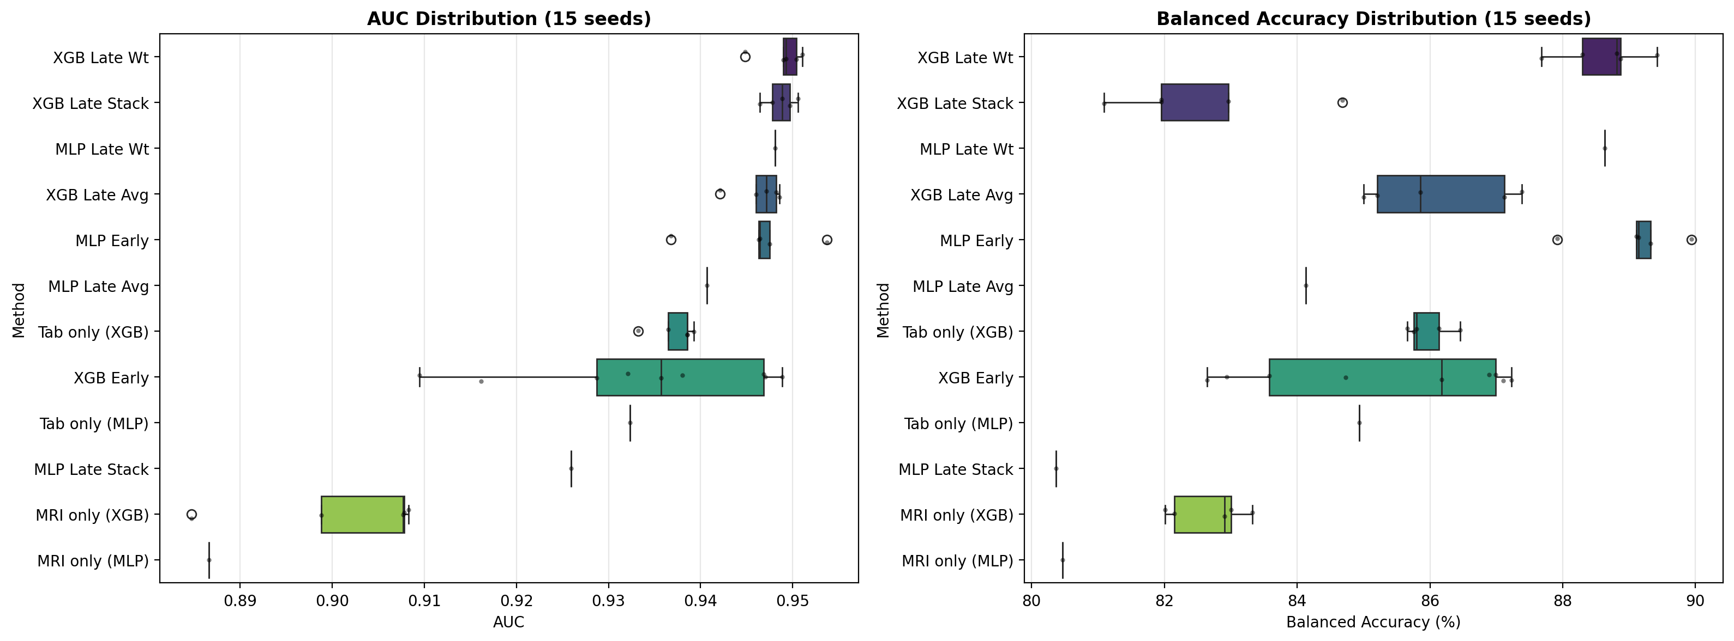
Figure: AUC and Balanced Accuracy distribution across seeds.
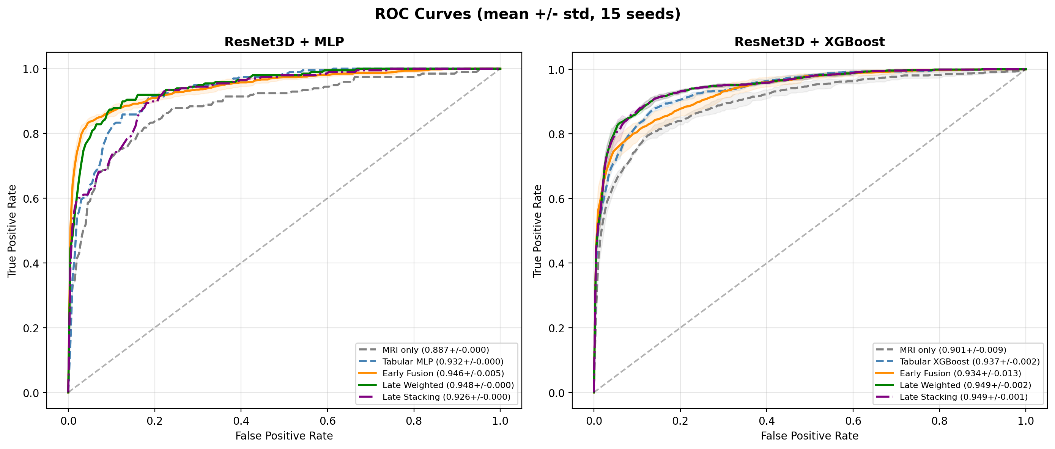
Figure: ROC curves (mean ± std) across all methods.
Table: Test set results for all ResNet3D multimodal fusion methods (mean ± std). N = number of seeds. Bold values indicate best performance per metric.
Method | Fusion | N | Acc (%) | Bal Acc (%) | Sens (%) | Spec (%) | AUC
MRI only (ResNet3D) | — | 5 | 86.7 ± 0.7 | 82.7 ± 0.5 | 75.6 ± 2.5 | 89.8 ± 1.5 | 0.901 ± 0.009
MRI only (ResNet3D) | — | 1 | 86.3 | 80.5 | 70.2 | 90.7 | 0.887
Tabular only (XGBoost) | — | 5 | 88.8 ± 0.2 | 86.0 ± 0.3 | 80.9 ± 1.0 | 91.0 ± 0.5 | 0.937 ± 0.002
Tabular only (MLP) | — | 1 | 83.8 | 84.9 | 86.9 | 83.0 | 0.932
ResNet3D + MLP concat | Early | 5 | 91.9 ± 0.7 | 89.1 ± 0.7 | 84.0 ± 1.7 | 94.1 ± 1.1 | 0.946 ± 0.005
ResNet3D emb + Tab → XGB | Early | 9 | 89.8 ± 1.2 | 85.4 ± 1.8 | 77.4 ± 3.0 | 93.3 ± 1.0 | 0.934 ± 0.013
ResNet3D + XGBoost (Avg) | Late | 5 | 89.7 ± 1.0 | 86.1 ± 1.0 | 79.7 ± 2.4 | 92.5 ± 1.6 | 0.946 ± 0.002
ResNet3D + XGBoost (Weighted) | Late | 5 | 92.0 ± 0.7 | 88.6 ± 0.6 | 82.6 ± 1.2 | 94.6 ± 1.0 | 0.949 ± 0.002
ResNet3D + XGBoost (Stacking) | Late | 5 | 91.0 ± 0.3 | 82.5 ± 1.2 | 67.5 ± 2.9 | 97.6 ± 0.5 | 0.949 ± 0.001
ResNet3D + MLP (Avg) | Late | 1 | 88.6 | 84.1 | 76.3 | 92.0 | 0.941
ResNet3D + MLP (Weighted) | Late | 1 | 89.3 | 88.6 | 87.4 | 89.9 | 0.948
ResNet3D + MLP (Stacking) | Late | 1 | 87.3 | 80.4 | 68.2 | 92.6 | 0.926

DeLong Test
Pairwise DeLong test on mean probabilities. Methods with a single seed are marked N/A as the comparison is not reliable without repeated runs.
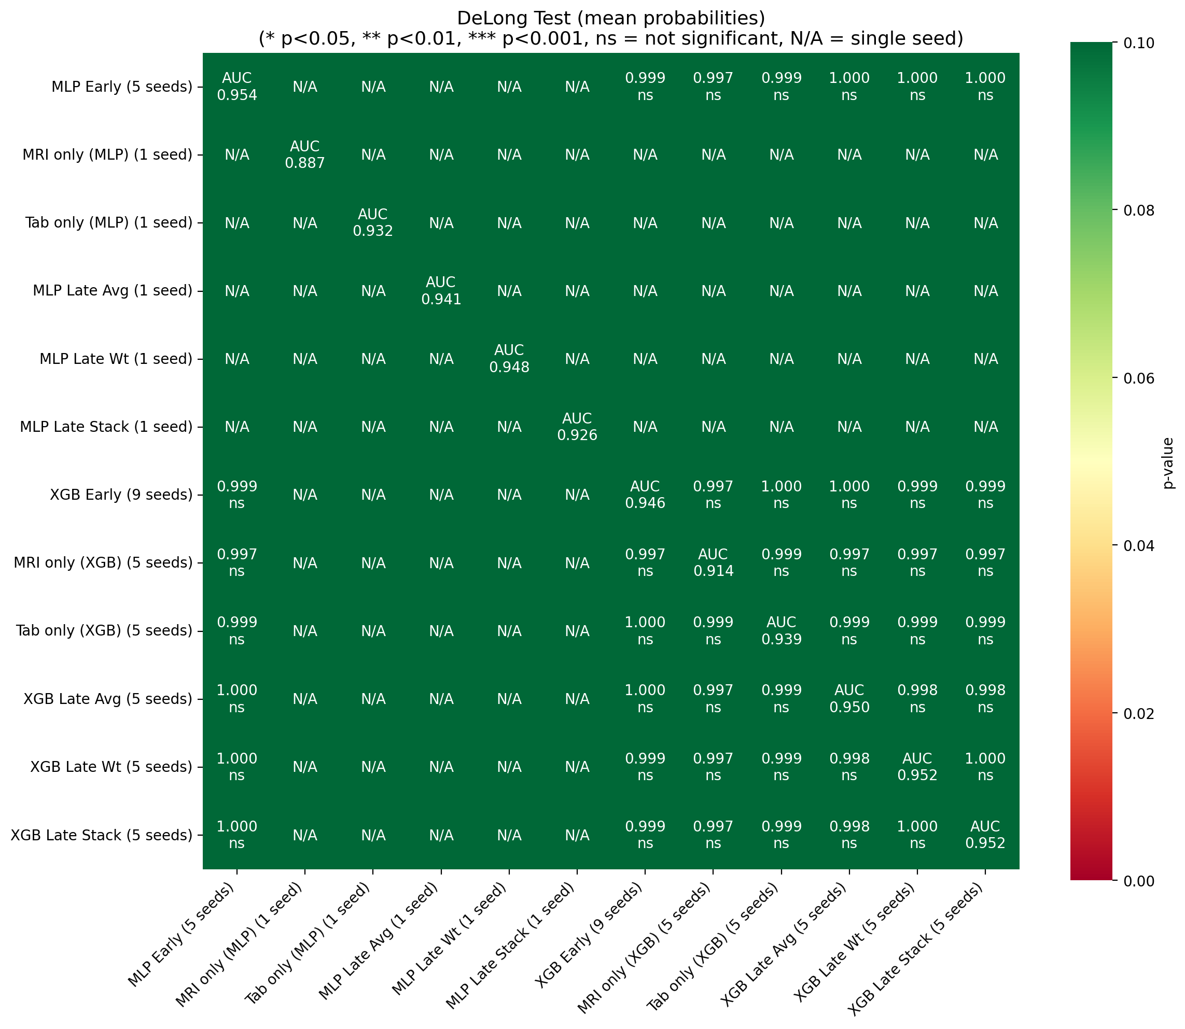

Confusion Matrices
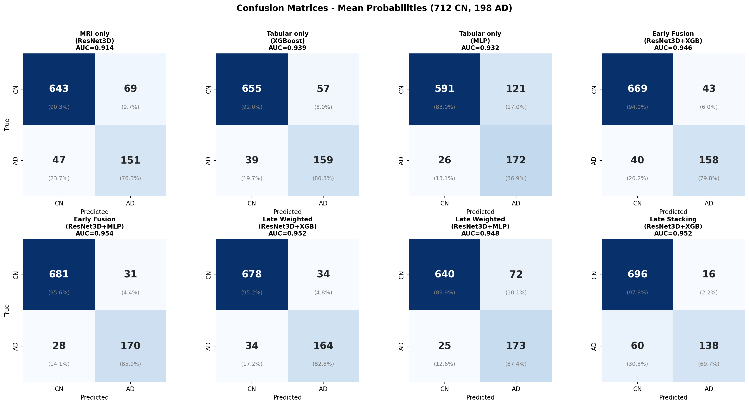

Training Details
ResNet3D backbone | MONAI ResNet50, MedicalNet pretrained (23 datasets)
Fine-tuning | 30 epochs, frozen 3 first epochs, differential LR (backbone 10x lower)
Mixed precision | AMP enabled, gradient accumulation (2 steps, effective batch=4)
MLP tabular | LayerNorm, hidden dims [128, 64, 32], dropout=0.3, 100 epochs
XGBoost tabular | max_depth=6, lr=0.1, subsample=0.8, 300 rounds, early stopping=30
Class imbalance | Weighted CrossEntropyLoss (78% CN / 22% AD)
Early stopping | Patience=20, min_epochs=30, monitored: balanced accuracy
Optimizer | AdamW with cosine annealing + warmup (5 epochs)

