ResNet3D Fusion — Multi-Seed Analysis Report
Classification CN vs AD using ResNet50 3D (MedicalNet pretrained) with clinical tabular features. Multi-seed evaluation (5 seeds) across 4 fusion strategies.

1. Performance Summary
Method | Acc % | Bal Acc % | Sens % | Spec % | AUC | Seeds
MLP Late Wt | 90.9 +/- 1.5 | 89.1 +/- 0.5 | 86.0 +/- 1.6 | 92.2 +/- 2.3 | 0.950 +/- 0.003 | 4
XGB Late Wt | 92.0 +/- 0.8 | 88.6 +/- 0.7 | 82.6 +/- 1.4 | 94.6 +/- 1.1 | 0.949 +/- 0.002 | 5
XGB Late Stack | 91.0 +/- 0.3 | 82.5 +/- 1.4 | 67.5 +/- 3.3 | 97.6 +/- 0.5 | 0.949 +/- 0.002 | 5
XGB Late Avg | 89.7 +/- 1.1 | 86.1 +/- 1.1 | 79.7 +/- 2.6 | 92.5 +/- 1.7 | 0.946 +/- 0.003 | 5
MLP Late Avg | 89.6 +/- 1.5 | 86.2 +/- 1.5 | 80.1 +/- 4.7 | 92.3 +/- 2.7 | 0.946 +/- 0.005 | 4
MLP Early | 91.9 +/- 0.8 | 89.1 +/- 0.7 | 84.0 +/- 1.9 | 94.1 +/- 1.3 | 0.946 +/- 0.006 | 5
Tab only (XGB) | 88.8 +/- 0.2 | 86.0 +/- 0.3 | 80.9 +/- 1.1 | 91.0 +/- 0.5 | 0.937 +/- 0.002 | 5
Tab only (MLP) | 84.7 +/- 1.2 | 85.7 +/- 0.7 | 87.5 +/- 1.3 | 83.9 +/- 1.8 | 0.933 +/- 0.002 | 4
XGB Early | 89.6 +/- 1.3 | 85.3 +/- 2.3 | 77.7 +/- 4.1 | 92.9 +/- 0.6 | 0.931 +/- 0.018 | 5
MLP Late Stack | 88.2 +/- 1.1 | 81.7 +/- 1.3 | 70.2 +/- 4.4 | 93.2 +/- 2.4 | 0.904 +/- 0.030 | 4
MRI only | 86.7 +/- 0.7 | 82.7 +/- 0.6 | 75.6 +/- 2.8 | 89.8 +/- 1.7 | 0.901 +/- 0.010 | 5

2. DeLong Test — Pairwise AUC Comparison
The DeLong test assesses whether AUC differences between models are statistically significant. The heatmap below shows pairwise p-values. Green cells indicate significant differences (p < 0.05).
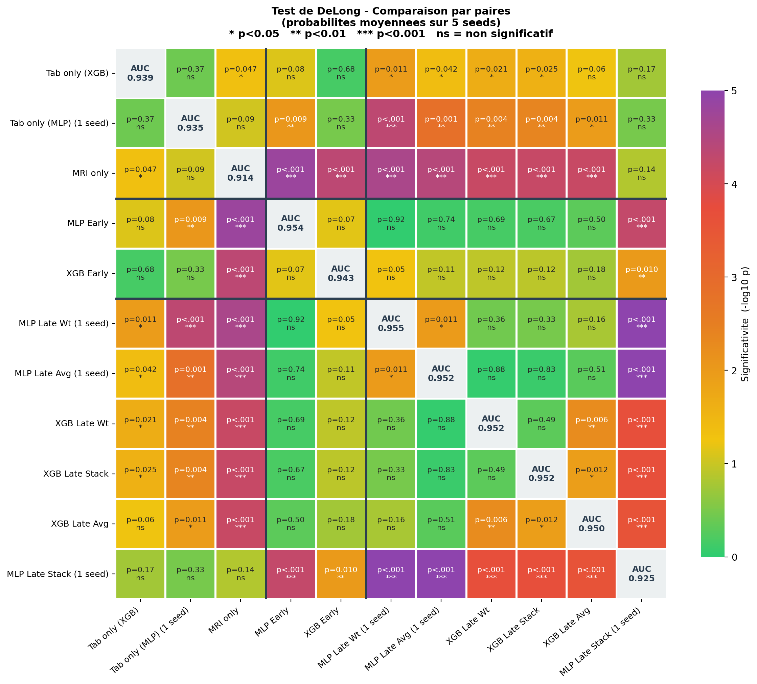
Key findings from DeLong test:
- All fusion methods significantly outperform MRI-only (p < 0.001), confirming the value of multimodal integration.
- MLP Late Wt and XGB Late Wt achieve the highest AUCs (0.950 and 0.949) with no significant difference between them (p = 0.36).
- Tabular-only models (XGB/MLP) significantly underperform the best fusion methods, showing that MRI adds discriminative information beyond clinical features.
- MLP Late Stack is the weakest fusion method, significantly below all others.

3. ROC Curves
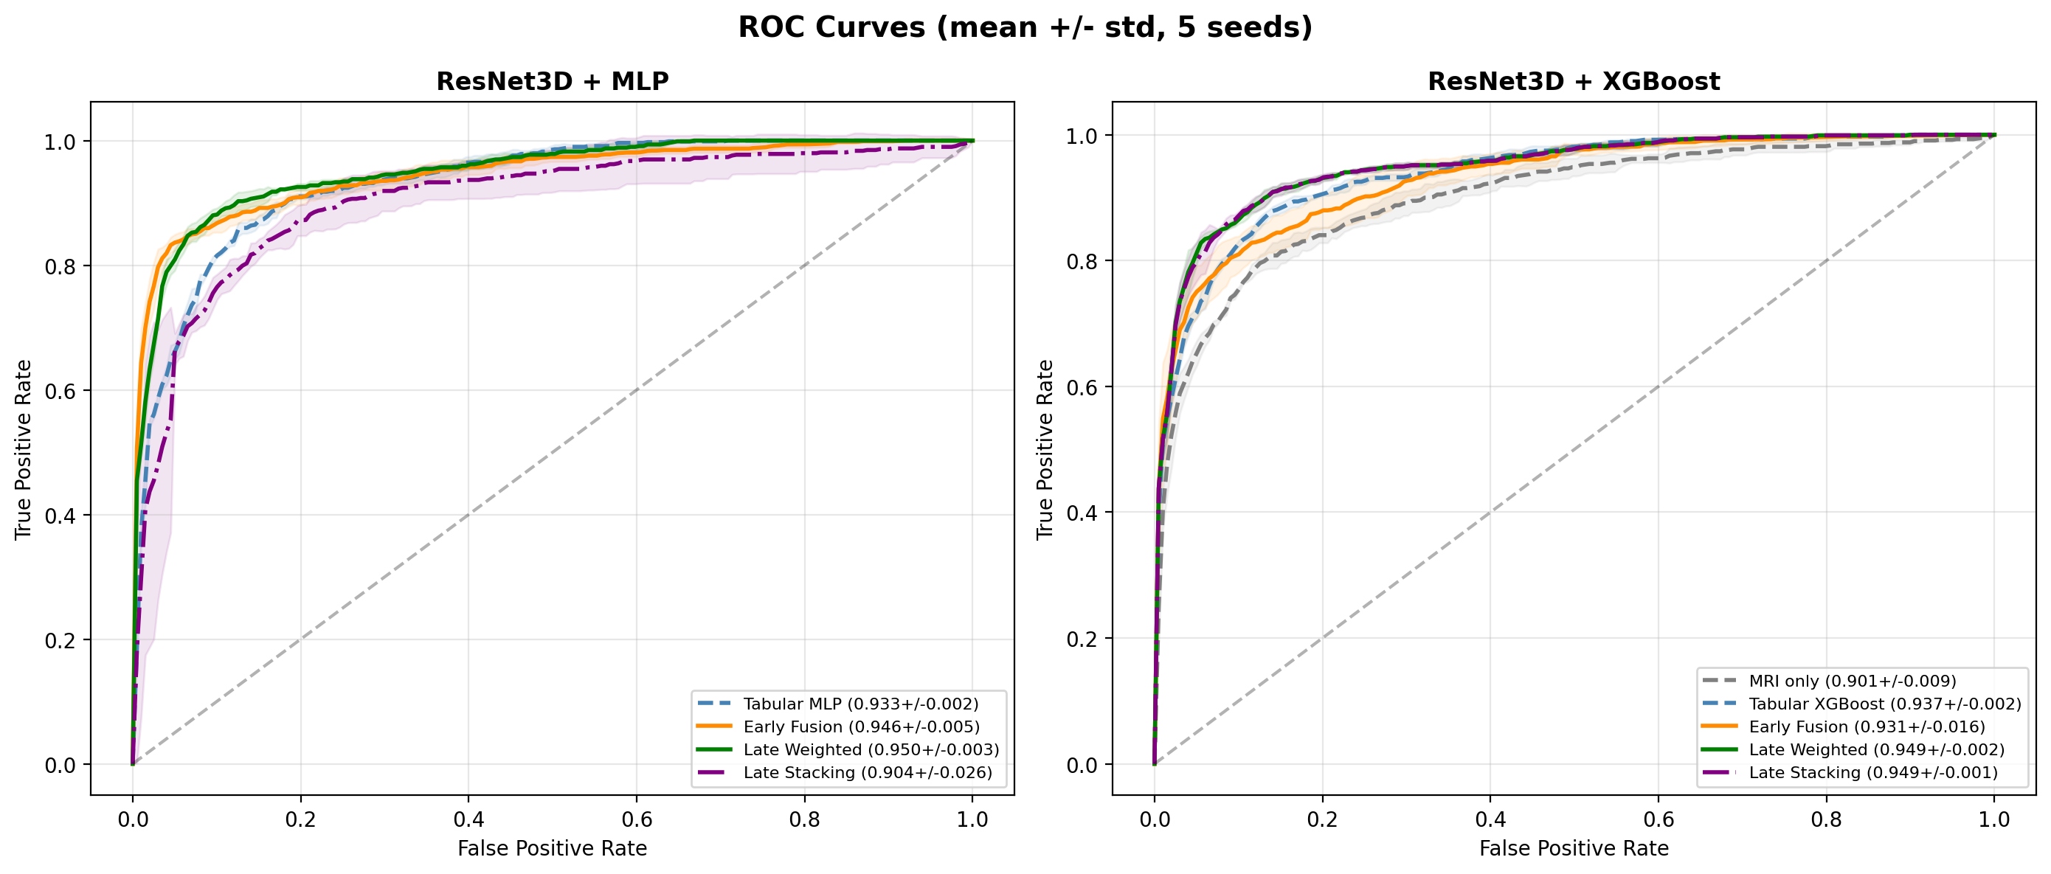

4. Interpretability — Integrated Gradients
Integrated Gradients (Sundararajan et al., 2017) provides voxel-level attribution maps at full input resolution (128x128x128). Unlike GradCAM which is limited by feature map resolution (~4x4x4), Integrated Gradients computes attributions directly in input space by integrating gradients along a path from a zero baseline to the input. This yields precise localization of brain regions driving the model's decision.

4.1 Example: Alzheimer's Disease Patient
High-confidence AD prediction (p(AD) = 0.997). Bright regions indicate voxels with high attribution for the AD prediction. Activations are concentrated in the medial temporal lobe (hippocampus, entorhinal cortex), consistent with known patterns of AD-related neurodegeneration.
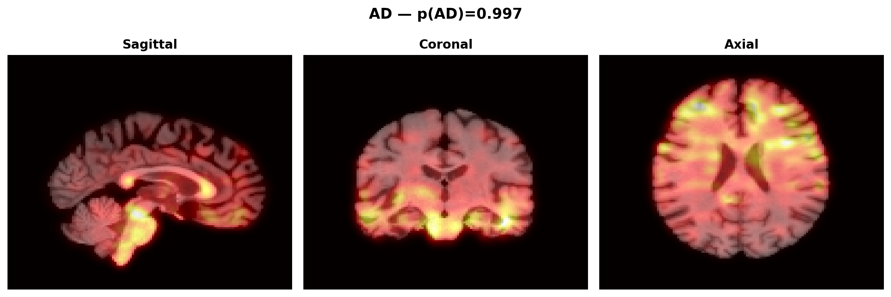
Figure: Integrated Gradients — AD patient (MLP Early Fusion, seed 2)

4.2 Example: Cognitively Normal Patient
High-confidence CN prediction (p(AD) = 0.003). Attribution pattern is more diffuse and distributed across cortical regions, with less concentration in medial temporal structures. This suggests the model recognizes the structural integrity of hippocampal and temporal regions as indicative of normal cognition.
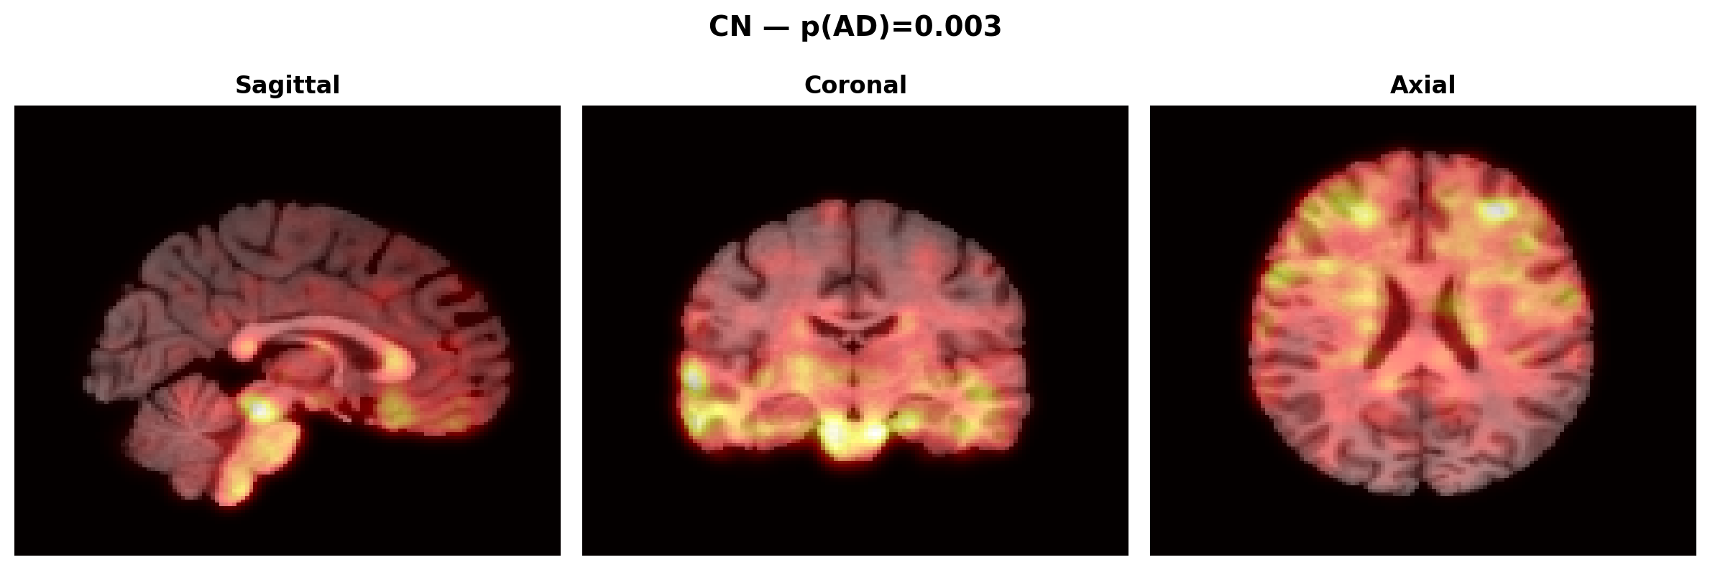
Figure: Integrated Gradients — CN patient (MLP Early Fusion, seed 2)

5. Interpretability Folder Contents
The accompanying interpretability/ folder contains Integrated Gradients visualizations for all 4 models, computed on the same 5 AD and 5 CN patients for direct comparison. The structure is as follows:
- mlp_early_fusion/ Integrated Gradients for the MLP Early Fusion model (ResNet3D + Tabular MLP, end-to-end). Contains AD_01..05.png, CN_01..05.png (individual patient maps, 3 views each) and grid_mlp_early_fusion.png (all 10 patients).
- mlp_late_fusion/ Same for MLP Late Fusion (ResNet3D MRI branch only, trained separately from tabular MLP). Shows what the MRI-only branch focuses on.
- xgb_early_fusion/ Same for XGBoost Early Fusion (finetuned ResNet3D backbone, features fed to XGBoost). IG computed through the CNN backbone.
- xgb_late_fusion/ Same for XGBoost Late Fusion (ResNet3D MRI branch, separate XGBoost on tabular). Shows MRI branch attributions.
- cross_model_comparison.png Summary grid: 10 patients (rows) x 4 models (columns), axial view. Allows direct comparison of what each model attends to on the same brain.
- group_average_AD.png Average attribution map across 50 correctly classified AD patients. Highlights consistently important regions for AD prediction.
- group_average_CN.png Average attribution map across 50 correctly classified CN patients.
- group_difference_AD_minus_CN.png Differential attribution map (AD average minus CN average). Red = more important for AD (medial temporal lobe), Blue = more important for CN (frontal/parietal). This is the most informative figure for understanding model behavior.
- summary_figure.png Paper-ready figure combining individual examples, group average, and difference map.
- *.npy files Raw numpy arrays of group averages and difference maps for further analysis or custom visualization.
All attribution maps were computed using Integrated Gradients with 100 interpolation steps and a zero baseline, from the best-performing seed (seed 2, AUC = 0.954). The same 5 AD and 5 CN patients (selected by prediction confidence) are used across all 4 models to enable direct comparison.

