ResNet3D Multimodal Fusion
CN vs AD Classification — Test Set Results

Dataset
Combined trajectory dataset (ADNI + OASIS + NACC)
- Train: 4,245 / Val: 910 / Test: 910 samples (78% CN / 22% AD)
- 16 tabular features: demographics, cognitive tests, medical history
- MRI: 3D brain volumes (128 x 128 x 128)

Backbone: ResNet3D
- MONAI ResNet50 3D pretrained on 23 medical imaging datasets (MedicalNet). Outputs 2048-dimensional feature vectors from 3D MRI volumes.
- Fine-tuning: backbone frozen for 3 first epochs, then unfrozen with differential learning rate (backbone 10x lower). Mixed precision (AMP).

Fusion Strategies

1. Early Fusion: ResNet3D + MLP
Both modalities are encoded into feature vectors, concatenated, and fed to a joint MLP classifier. The entire model is trained end-to-end.
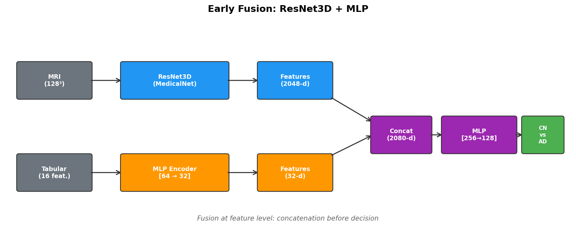
- MRI branch: ResNet3D (MedicalNet) -> 2048-d features
- Tabular branch: MLP encoder [64, 32] with LayerNorm
- Fusion: concatenation (2080-d) -> MLP [256, 128] -> classification

2. Early Fusion: ResNet3D embeddings + XGBoost
ResNet3D is first fine-tuned on MRI classification. Then, 2048-d embeddings are extracted and concatenated with 16 tabular features. A single XGBoost model is trained on the combined 2064-d feature vector.
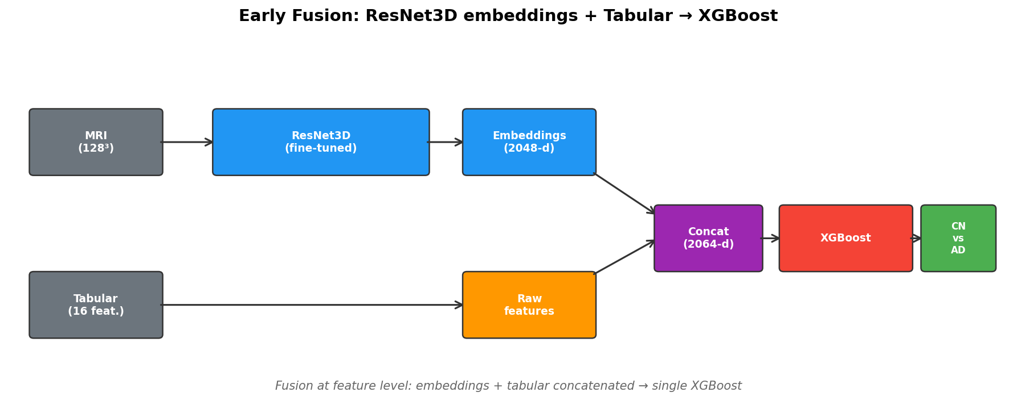
- Phase 1: Fine-tune ResNet3D with linear head (30 epochs)
- Phase 2: Extract 2048-d embeddings + 16 tabular features -> XGBoost

3. Late Fusion: Separate predictions + probability combination
Each modality makes its own independent prediction. The MRI branch (fine-tuned ResNet3D with linear head) produces P(AD|MRI), and the tabular branch (MLP or XGBoost) produces P(AD|tabular). The two probabilities are then combined using one of three strategies.
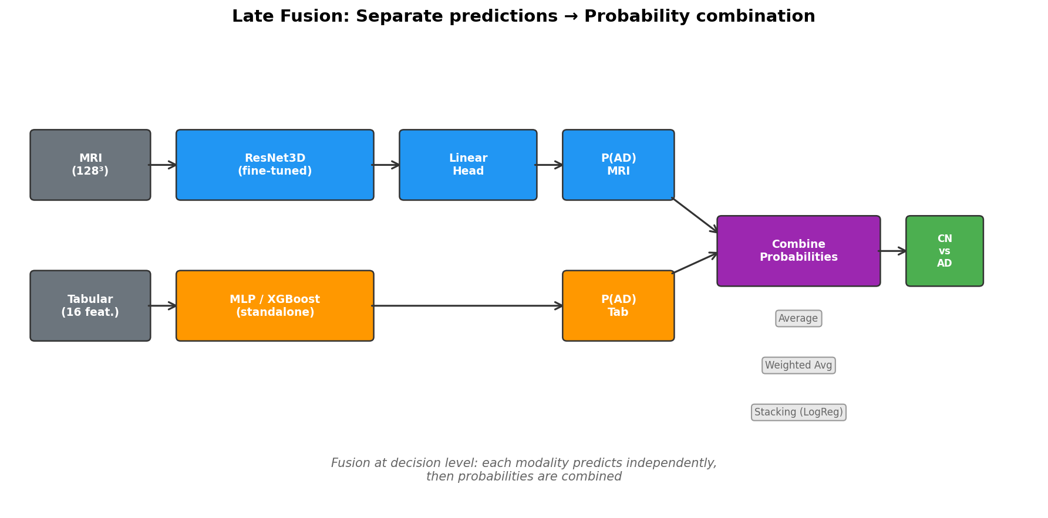
- Average: simple mean of probabilities
- Weighted average: weights optimized on validation set
- Stacking: Logistic Regression trained on both branch probabilities

Results
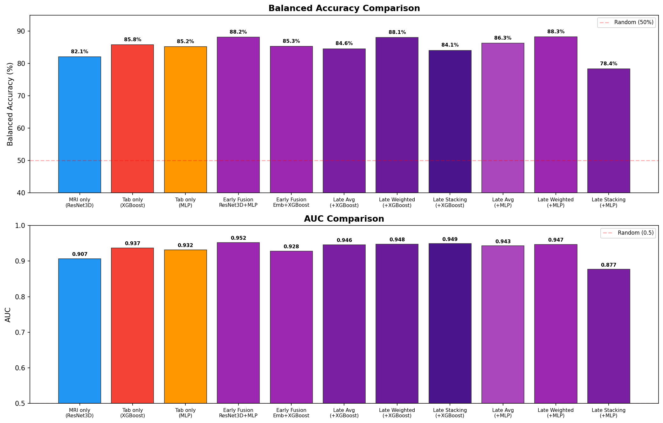
Figure: Balanced Accuracy and AUC comparison across all methods.

Method | Fusion | Acc (%) | Bal Acc (%) | Sens (%) | Spec (%) | AUC
MRI only (ResNet3D) | — | 88.0 | 82.1 | 71.7 | 92.6 | 0.907
Tabular only (XGBoost) | — | 88.4 | 85.8 | 81.3 | 90.3 | 0.937
Tabular only (MLP) | — | 83.2 | 85.2 | 88.9 | 81.6 | 0.932
ResNet3D + MLP concat | Early | 90.7 | 88.2 | 83.8 | 92.6 | 0.952
ResNet3D emb + Tab -> XGB | Early | 89.6 | 85.3 | 77.8 | 92.8 | 0.928
ResNet3D + XGBoost (Avg) | Late | 90.4 | 84.6 | 74.2 | 94.9 | 0.946
ResNet3D + XGBoost (Weighted) | Late | 92.5 | 88.1 | 80.3 | 95.9 | 0.948
ResNet3D + XGBoost (Stacking) | Late | 91.4 | 84.1 | 71.2 | 97.1 | 0.949
ResNet3D + MLP (Avg) | Late | 88.0 | 86.3 | 83.3 | 89.3 | 0.943
ResNet3D + MLP (Weighted) | Late | 88.9 | 88.3 | 87.4 | 89.3 | 0.947
ResNet3D + MLP (Stacking) | Late | 88.5 | 78.4 | 60.6 | 96.2 | 0.877
Table: Test set results for all ResNet3D multimodal fusion methods. Bold values indicate best performance per metric.

Key Findings
- Multimodal fusion consistently outperforms unimodal baselines, confirming the complementarity of MRI and clinical features for AD classification.
- Early fusion (ResNet3D + MLP, end-to-end) achieves the best AUC (0.952), suggesting that joint feature learning captures cross-modal interactions effectively.
- Late fusion with weighted averaging achieves the best accuracy (92.5% with XGBoost) and highest balanced accuracy (88.3% with MLP).
- Tabular features alone are highly discriminative (XGBoost AUC=0.937), while MRI alone is less performant (AUC=0.907), but the combination improves both.
- Late fusion stacking (Logistic Regression) underperforms weighted averaging, likely due to overfitting on the limited validation set probabilities.

Training Details
Component | Configuration
ResNet3D backbone | MONAI ResNet50, MedicalNet pretrained (23 datasets)
Fine-tuning | 30 epochs, frozen 3 first epochs, differential LR (backbone 10x lower)
Mixed precision | AMP enabled, gradient accumulation (2 steps, effective batch=4)
MLP tabular | LayerNorm, hidden dims [128, 64, 32], dropout=0.3, 100 epochs
XGBoost tabular | max_depth=6, lr=0.1, subsample=0.8, 300 rounds, early stopping=30
Class imbalance | Weighted CrossEntropyLoss (78% CN / 22% AD)
Early stopping | Patience=20, min_epochs=30, monitored: balanced accuracy
Optimizer | AdamW with cosine annealing + warmup (5 epochs)

