CIS 415 Database Processing---Final Project

Course Registration

Zekun Tang

2015/12/11

Contents

1. Summary
2. Logical design
3. Physical design
4. User's guide
5. Contents of tables
6. Conclusion
7. **Summary**

This project basically is a course registration program. All most data is real that I collected from University of Oregon’s course registration system. This program includes data about courses, group requirements, date, buildings, instructors, students, and department. In my website page, users are allowed to search information about a specific student’s name or ID to check his of her registered courses or personal information. Also, users are permitted to select a specific course name to find out who registered. Finally, users can insert new course or new instructor to my database as long as they provide enough information about that new one.

Here is the link to my website:

<http://ix.cs.uoregon.edu/~zekun/final_project/first_page.php>

1. **Logical Design**

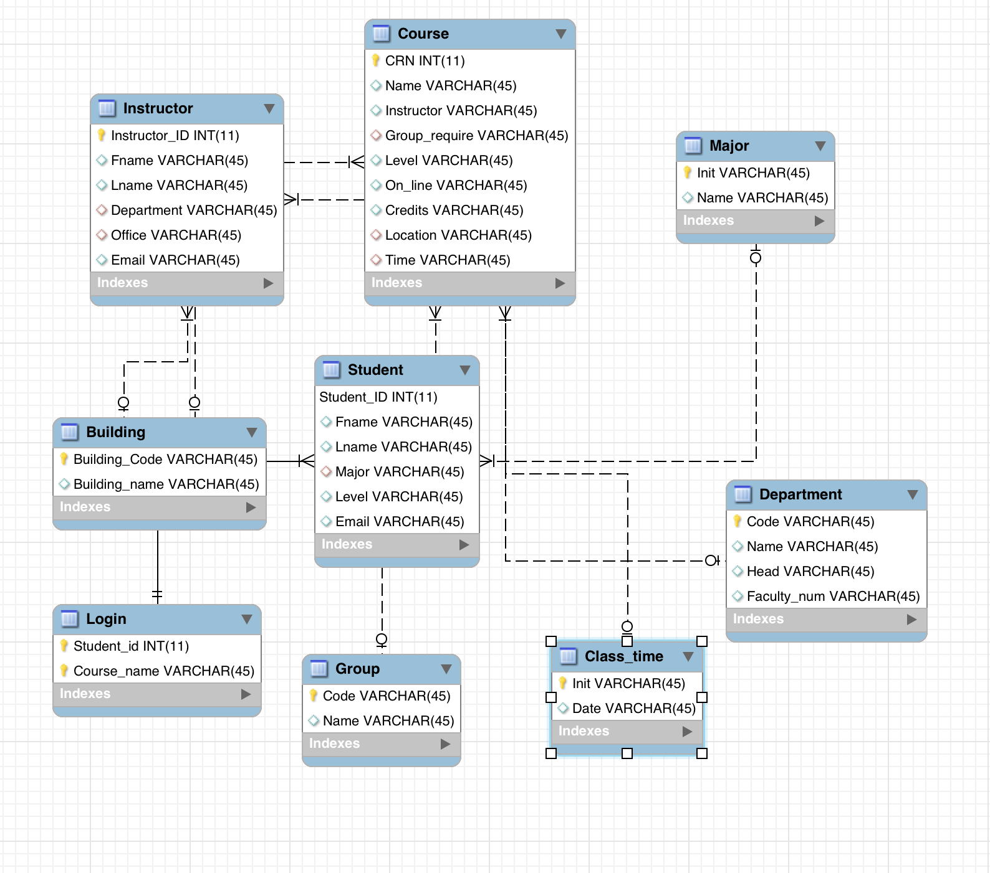

1. Physical Design

For **course**, it has a CRN number as its primary key. Also, it provides detail information about this course, course name, what group requirement it satisfy, instructor name, how many credits of this course, for graduate or undergraduate, on line course or not, where is this class, time of it.

For **student**, it has a student ID as its primary key. And there is detail information like, first name, last name, major, graduate or undergraduate, and email.

For **instructor**, there is a primary key called instructor ID. In this table, there is first name, last name, office, department and email information about this instructor.

For **department**, department ID is its primary key. This table includes department name, department code and head of this department.

For **group**, group code is its primary key and it incudes group name.

For **building**, building code is its primary key, and it includes building name.

For **class time**, initial of date is its primary key, and date.

For **major**, initial of each provided major is its primary key, and the full name of each major.

For **login**, it has two primary key, student ID and course name. It connects with student and course table to record which student registered what courses.

1. User Guide

When users try to a specific student’s course information, just select the student’s name in the list, which is alphabetically ordered, then, the program, will show him/her the information.

When a user tries to find a student’s personal information, he or she just selects a student ID to check.

If a user want to find out who registered a specific course, he or she just selects a course. And then, the program will show him or her student IDs and student names.

If a user would like to create a new instructor or new course, just fill the forms, then, the new instructor or new course will be insert to the database.

1. Conclusion

If I have more time, I would like to add more limited code to my program to guide users to input information that satisfies my database information format.