SOFTWARE REQUIREMENTS SPECIFICATION
Movie Hub Website
Lê Văn Huy, Nguyễn Lê Tuấn Anh, Quách Vĩnh Cơ
23520020@gm.uit.edu.vn, 23520030@gm.uit.edu.vn, 23520064@gm.uit.edu.vn
Prepared for
Movie Hub Project
Version 1.0.0
Revision and Signoff Sheet
Change Record
Author | Version | Change reference | Date
 | 0.0.0 | Initial creation and layout organization
 | 0.1.0 | Sections assemble and cross checking
 | 1.0.0 | Final revision and format adjusting
Reviewers
Name | Company | Version | Position | Date
Trinh-Dong Nguyen |  | 1.0.0 | AD Team Lead

Table of Contents
Mục lục
1 Introduction 5
1.1 Purpose 5
1.2 Scope 5
1.3 Intended Audiences and Document Organization 5
1.4 References 7
2 Functional Requirements 7
2.1 Use Case Description 7
2.1.1 User Management UseCase 7
2.1.2 Cinema Management 18
2.1.3 Hall Management 29
2.1.4 Ticket Pricing Management 38
2.1.5 Movie Catalog 41
2.1.6 Movie Releases 50
2.1.7 Genre Management 54
2.1.8 Movie Reviews 62
2.1.9 Showtime Scheduling 69
2.1.10 User Booking Operations 84
2.1.11 Admin Booking Operations 100
2.1.12 Real-time Seat Selection 112
2.1.13 Payment Transaction 120
2.1.14 Ticket Management 134
2.1.15 Refund Management 149
2.1.16 Concessions FB 159
2.1.17 Promotions Discounts 168
2.1.18 Loyalty Points 180
2.1.19 System Configuration 186
2.2 List Description 189
2.3 View Description 190
3 Non-functional Requirements 190
3.1 User Access and Security 190
3.1.1 Authentication and Authorization 190
3.1.2 Data Protection 190
3.1.3 API Security 190
3.2 Performance Requirements 192
3.2.1 Response Time 192
3.2.2 Throughput 192
3.2.3 Scalability 192
3.2.4 Availability 192
3.3 Implementation Requirements 192
3.3.1 Technology Stack 192
3.3.2 Coding Standards 192
3.3.3 Testing 193
4 Other Requirements 193
4.1 Archive Function 193
4.2 Security Audit Function 194
4.3 Movie Hub Sites 194
4.4 Movie Hub Lists 195
4.5 Custom Pages 195
4.6 Technical Concern 196
5 Appendixes 196
5.1 Glossary 196
5.2 Mapping to Notes Application 197
5.3 Messages 197
5.4 Issues List 198

Introduction

Purpose
The purpose of this Software Requirements Specification (SRS) document is to provide a detailed description of the functional and non-functional requirements for the system. This document serves as a reference for stakeholders, including developers, testers, project managers, and clients, to ensure a shared understanding of the system’s expected behavior, features, and constraints. It defines what the system should do without specifying how it will be implemented. The SRS is also used as a baseline for system design, development, testing, and validation.

Scope
Movie Hub is a comprehensive movie ticket booking platform that enables users to:
- Browse and search movies currently showing or upcoming at partner cinemas
- View cinema locations with proximity-based search and filtering capabilities
- Select showtimes with real-time seat availability visualization
- Reserve seats through a real-time seat locking mechanism
- Order concessions (food and beverages) as part of the booking flow
- Process payments via multiple payment gateways (VNPay, MoMo, ZaloPay, etc.)
- Earn and redeem loyalty points across transactions
- Receive digital tickets with QR codes for entry validation
The platform caters to the Vietnamese cinema market with localized payment methods, age rating systems (CAVI), and Vietnamese language support.

Intended Audiences and Document Organization
This document is intended for:
- Developers
To understand system requirements and implement features accordingly.
- Testers / QA Engineers
To design test cases based on functional and non-functional requirements.
- Project Managers
To track progress and ensure alignment with project goals.
- System Architects
To design system architecture based on defined requirements.
- Stakeholders / Clients
To validate that the system meets business needs.
This document is structured as follows:
- Section 1 – Introduction
Provides an overview of the document, including purpose, scope, and audience.
- Section 2 – Overall Description
Describes system context, user characteristics, assumptions, and constraints.
- Section 3 – System Features
Details functional requirements for each feature (e.g., authentication, booking).
- Section 4 – External Interface Requirements
Defines interactions with users, hardware, software, and external systems.
- Section 5 – Non-functional Requirements
Covers performance, scalability, usability, security, and maintainability.
- Section 6 – Other Requirements
Includes additional constraints, business rules, and compliance requirements.

References
# | Title | Version | File Name / Link | Description
1 | User Interface | 0.2.0 |  | Demo high fidelity user interface
2 | List Description | 0.1.0 |  | Description of list in the system
3 | View Description | 0.1.0 |  | Description of view/screen in the system
4 | DB Sheet | 0.1.0 |  | Description of table to store data in database
5 | Reference websites

Functional Requirements

Use Case Description

User Management UseCase

Register User

Use Case Description
Name | User Authentication
Description | Allows guests to sign up or log in via Clerk (external identity provider) and obtain a session token for accessing protected resources.
Actor | Guest, Member
Trigger | External Interaction (Clerk UI)
Pre-condition | • Guest's device must be connected to the internet.  • Guest is on the RegistrationPage.
Post-condition | User receives a JWT token; User session is established.

Sequence Flow
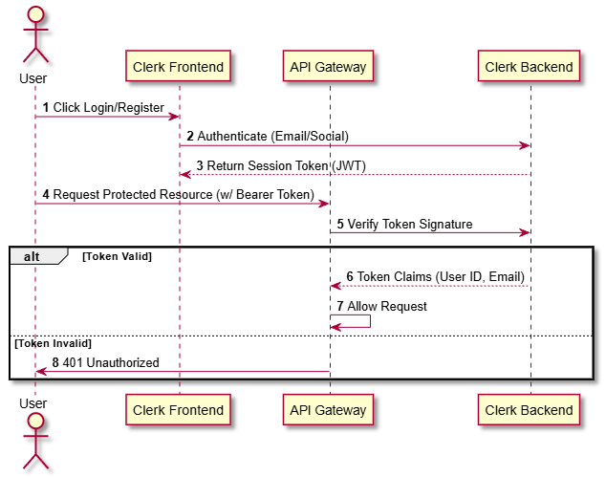

Activities Flow
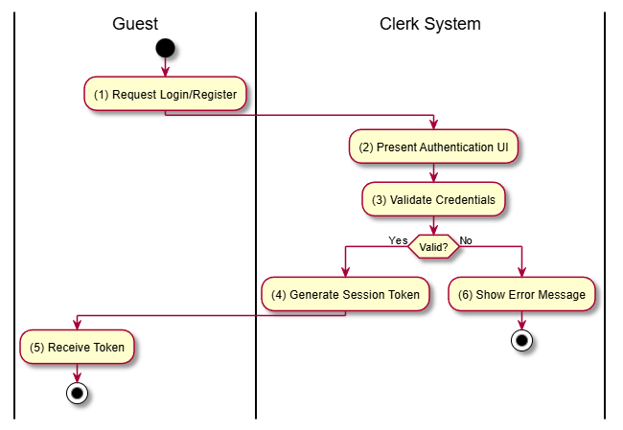

Business Rules

Activity | BR Code | Description
(1) | BR-01 | Authentication is handled entirely by Clerk (Third-party).
(5) | BR-02 | Tokens must be included in the Authorization header for all protected API calls (Section 6.1).

List Users

Use Case Description
Name | List Users
Description | Allows Administrators to view a list of all registered users in the system.
Actor | Admin
Trigger | GET /users
Pre-condition | Actor is authenticated and has ADMIN role.
Post-condition | List of users is returned.

Sequence Flow

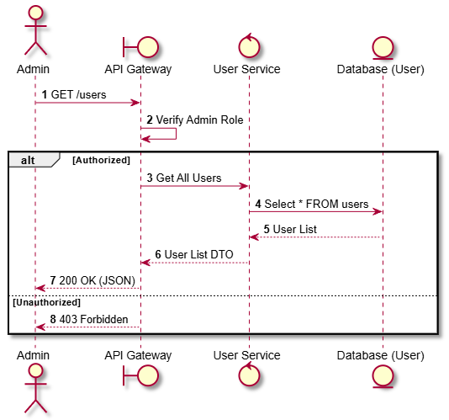

Activities Flow

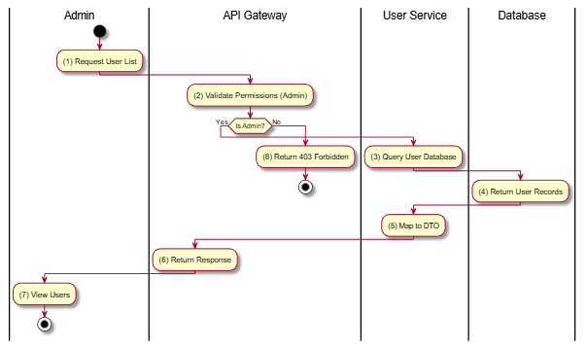

Business Rules
Activity | BR Code | Description
(2) | BR-1 | - Access is restricted to Admin role only (SRS Section 6.3).

Get User Profile

Use Case Description
Name | Get User Profile (Clerk Webhook Sync)
Description | Synchronizes user data from Clerk to the local User Service database via Webhook when a user registers or updates their profile in Clerk.
Actor | Member (via Clerk System)
Trigger | - Clerk Webhook Event (user.created, user.updated)
Pre-condition | - Valid Webhook Signature from Clerk.
Post-condition | - User record created or updated in postgres-user.

Sequence Flow
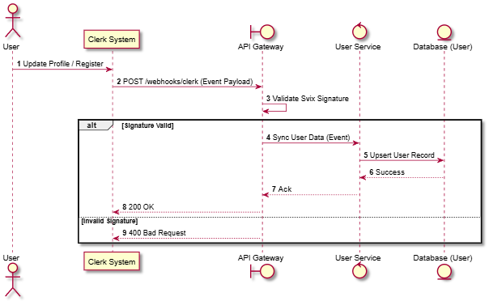

Activities Flow

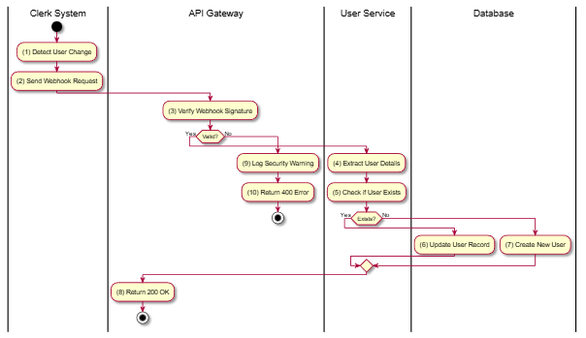

Business Rules
Activity | BR Code | Description
(3) | BR-1 | - Webhooks must be verified using the Svix secret to prevent spoofing.
(7) | BR-2 | - New accounts may need initialization of Loyalty Account (Bronze Tier).

Create Staff

Use Case Description
Name | Create Staff
Description | Allows Admins or Cinema Managers to create a new staff account with a specific position and assignment.
Actor | Admin, Cinema Manager
Trigger | POST /v1/staffs
Pre-condition | Admin/Manager logged in; Valid payload (email, position).
Post-condition | New Staff record created in DB.

Sequence Flow
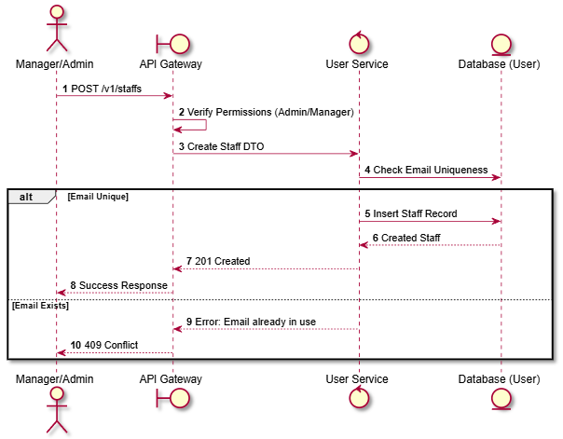

Activities Flow
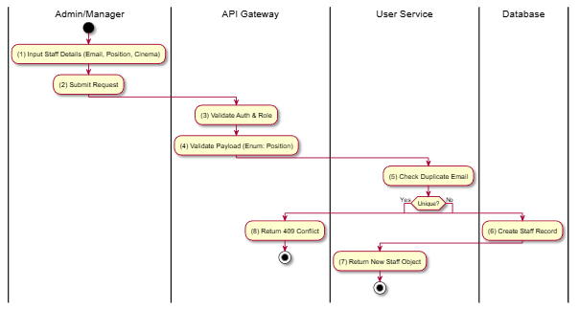

Business Rules
Activity | BR Code | Description
(4) | BR-1 | Position must be one of: TICKET_CLERK, CONCESSION_STAFF, USHER, PROJECTIONIST, CLEANER, SECURITY, etc.
(6) | BR-2 | Staff record links to User account (via Clerk ID possibly) or stands alone as internal record.

List Staff

Use Case Description
Name | List Staff
Description | Allows Admins or Cinema Managers to view a list of staff members, with filtering options for cinema location, position, and employment status.
Actor | Admin, Cinema Manager
Trigger | GET /v1/staffs
Pre-condition | User is authenticated with ADMIN or CINEMA_MANAGER role.
Post-condition | A filtered list of staff members is returned.

Sequence Flow
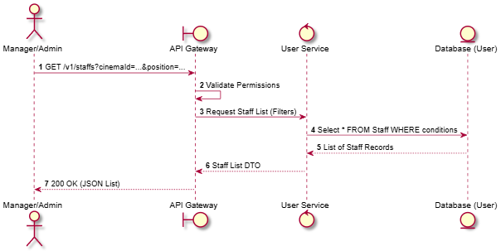

Activities Flow
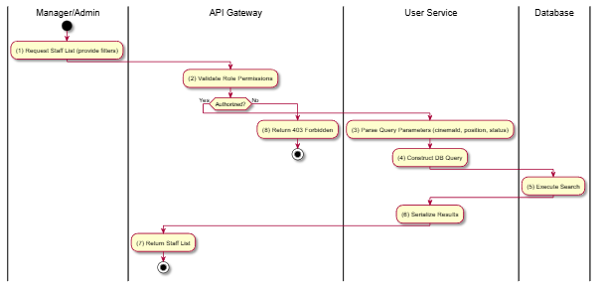

Business Rules
Activity | BR Code | Description
(2) | BR-1 | Query Parameters supported: cinemaId (Filter by location), position (Filter by StaffPosition enum), status (ACTIVE/INACTIVE).
(4) | BR-2 | Cinema Managers should typically only see staff assigned to their specific cinema (Implicit data scoping rule).

Get Staff Details

Use Case Description
Name | Get Staff Details
Description | Retrieves detailed information about a specific staff member by their unique ID.
Actor | Admin, Cinema Manager
Trigger | GET /v1/staffs/:id
Pre-condition | Staff ID exists; User is authenticated with appropriate privileges.
Post-condition | Detailed staff profile is returned.

Sequence Flow
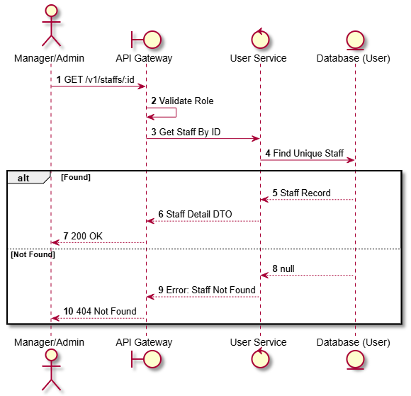

Activities Flow
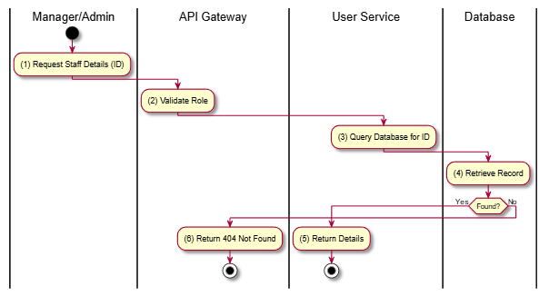

Business Rules
Activity | BR Code | Description
(1) | BR-1 | Standard CRUD operation. No complex business logic defined in SRS beyond access control.

Update Staff

Use Case Description
Name | Update Staff
Description | Updates the information of an existing staff member (e.g., position, status, assignment).
Actor | Admin, Cinema Manager
Trigger | PUT /v1/staffs/:id
Pre-condition | Staff ID exists; User authorized; Valid update payload.
Post-condition | Staff record is updated in the database.

Sequence Flow
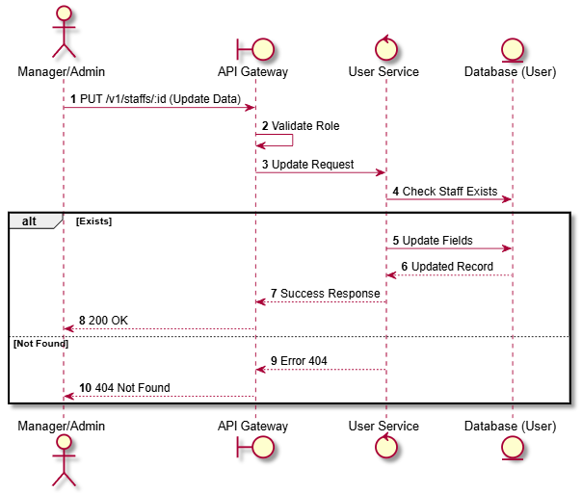

Activities Flow
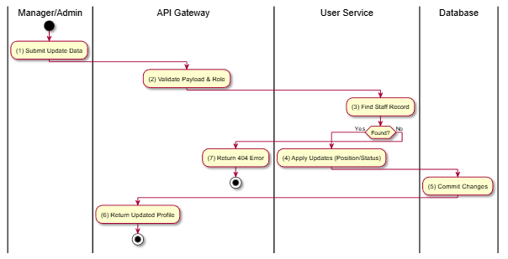

Business Rules
Activity | BR Code | Description
(4) | BR-1 | Updates to Position must be valid StaffPosition enum values.
(4) | BR-2 | Updates to Status must be valid StaffStatus (ACTIVE/INACTIVE).

Cinema Management

List All Cinemas

Use Case Description
Name | List All Cinemas
Description | Retrieves a list of all active cinema locations available in the system.
Actor | Guest, Member
Trigger | GET /v1/cinemas
Pre-condition | None (Public endpoint).
Post-condition | List of cinemas returned to user.

Sequence Flow
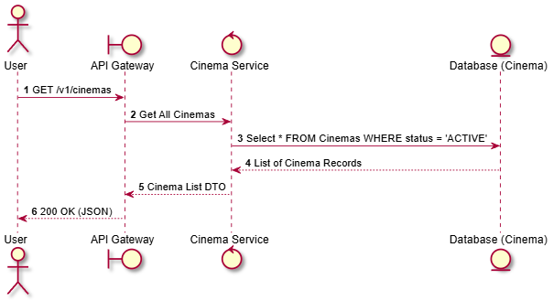

Activities Flow
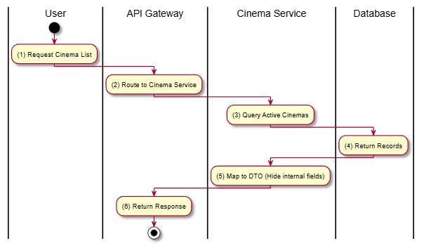

Business Rules
Activity | BR Code | Description
(3) | BR-1 | Only cinemas with CinemaStatus = ACTIVE should be visible to public users.

Create Cinema

Use Case Description
Name | Create Cinema
Description | Allows an Administrator to register a new cinema location in the system.
Actor | Admin
Trigger | POST /v1/cinemas/cinema
Pre-condition | Admin authenticated; Valid payload (Name, Address, City).
Post-condition | New cinema created in database; Status defaults to ACTIVE or MAINTENANCE.

Sequence Flow
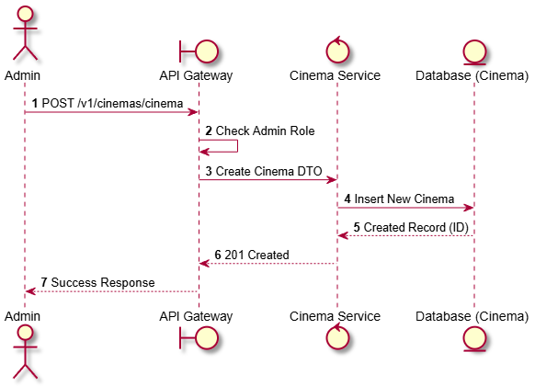

Activities Flow
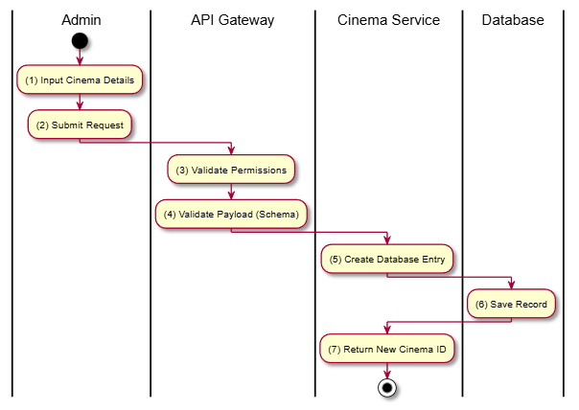

Business Rules
Activity | BR Code | Description
(1) | BR-1 | Required fields: Name, Address, City, District. Optional: Description, Image URLs.

Update Cinema

Use Case Description
Name | Update Cinema
Description | Modifies the details of an existing cinema (e.g., name, address, status).
Actor | Admin
Trigger | PATCH /v1/cinemas/cinema/:cinemaId
Pre-condition | Admin authenticated; Cinema ID exists.
Post-condition | Cinema record updated.

Sequence Flow
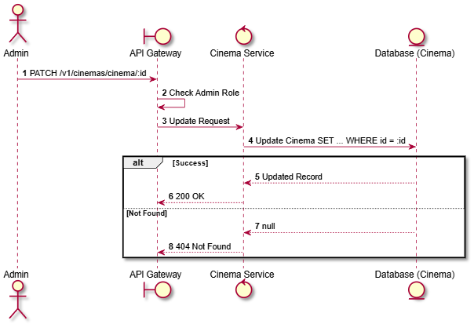

Activities Flow
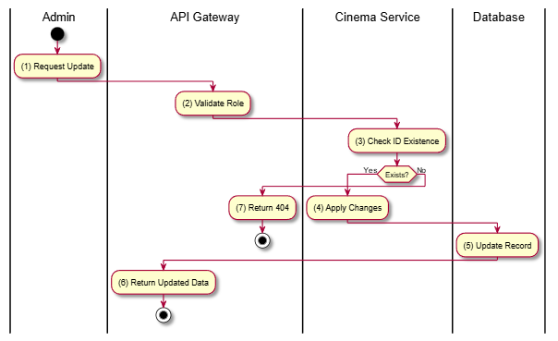

Business Rules
Activity | BR Code | Description
(4) | BR-1 | If status is changed to CLOSED or MAINTENANCE, it may impact future showtimes (though not explicitly enforced in this atomic op, it's a systemic implication).

Delete Cinema

Use Case Description
Name | Delete Cinema
Description | Soft-deletes or permanently removes a cinema from the system.
Actor | Admin
Trigger | DELETE /v1/cinemas/cinema/:cinemaId
Pre-condition | Admin authenticated; Cinema exists.
Post-condition | Cinema removed or marked deleted.

Sequence Flow
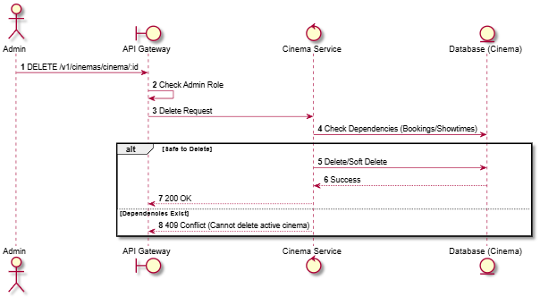

Activities Flow
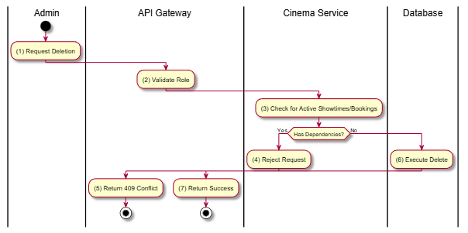

Business Rules
Activity | BR Code | Description
(3) | BR-1 | Typically, cinemas with past historical data (bookings) should be Soft Deleted (status = CLOSED/DELETED) rather than physically removed to preserve reporting integrity.

Get Cinema Detail

Use Case Description
Name | Get Cinema Detail
Description | Retrieves full details of a specific cinema, including amenities, address, and description.
Actor | Guest, Member
Trigger | GET /v1/cinemas/:id
Pre-condition | None.
Post-condition | Detailed cinema object returned.

Sequence Flow
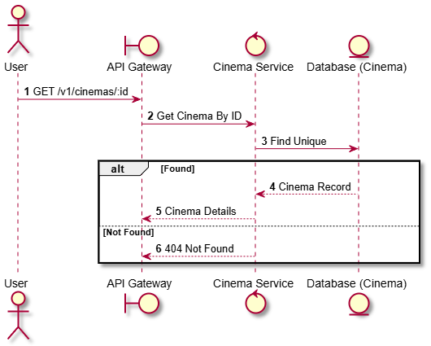

Activities Flow
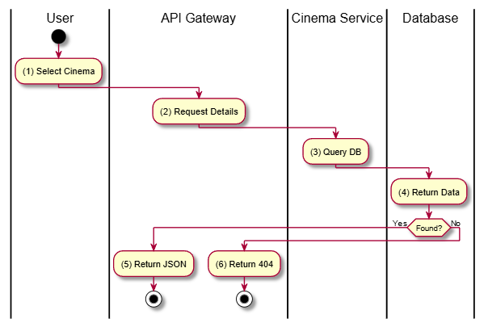

Business Rules
Activity | BR Code | Description
(1) | BR-1 | Standard Read Operation.

Search Cinemas Nearby

Use Case Description
Name | Search Cinemas Nearby
Description | Finds cinemas located within a certain radius of the user's provided coordinates (latitude/longitude).
Actor | Guest, Member
Trigger | GET /v1/cinemas/nearby
Pre-condition | User provides valid lat and lng query parameters.
Post-condition | List of cinemas sorted by distance returned.

Sequence Flow
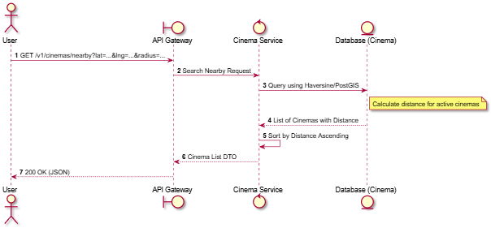

Activities Flow
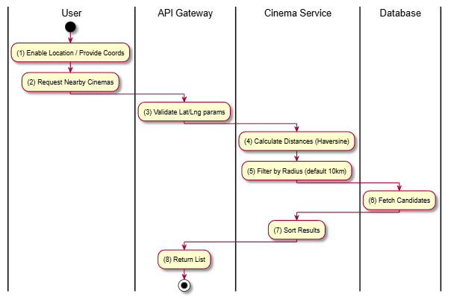

Business Rules
Activity | BR Code | Description
(5) | BR-1 | Default search radius is typically 10km or 20km if not specified.
(6) | BR-2 | Only ACTIVE cinemas are returned.

Search Cinemas by Query

Use Case Description
Name | Search Cinemas by Query
Description | Allows users to search for cinemas by name or address using a text string.
Actor | Guest, Member
Trigger | GET /v1/cinemas/search
Pre-condition | Query string provided (e.g., q=Galaxy).
Post-condition | List of matching cinemas returned.

Sequence Flow
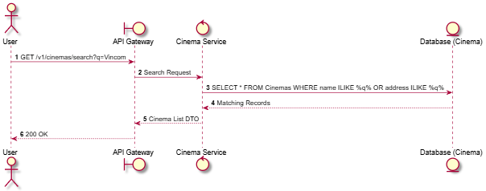

Activities Flow
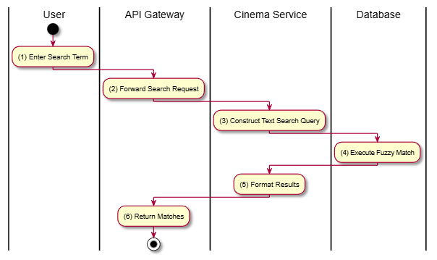

Business Rules
Activity | BR Code | Description
(3) | BR-1 | Search should be case-insensitive.

Hall Management

Get Hall by ID

Use Case Description
Name | Get Hall by ID
Description | Retrieves detailed information about a specific cinema hall, including its seat layout and type.
Actor | Member, Admin
Trigger | GET /v1/halls/hall/:hallId
Pre-condition | Hall ID exists; User is authenticated.
Post-condition | Hall details and seat matrix returned.

Sequence Flow
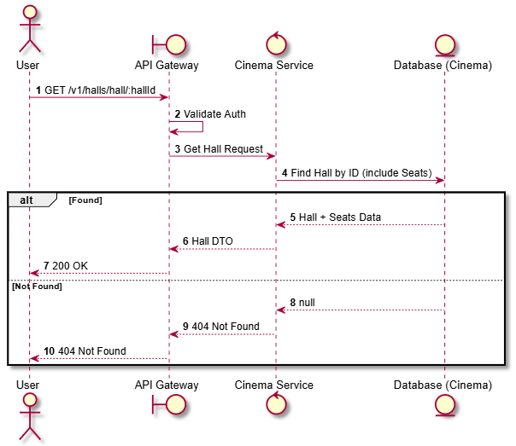

Activities Flow
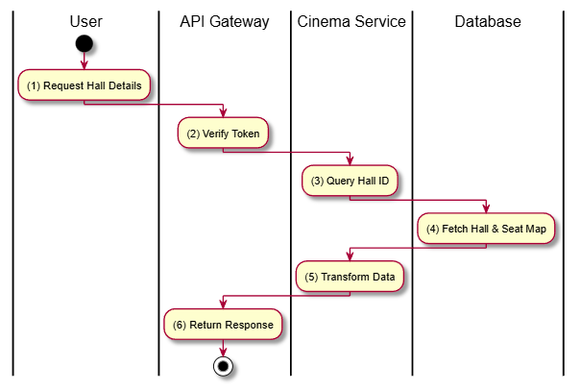

Business Rules
Activity | BR Code | Description
(4) | BR-1 | Returns full seat layout including row/col coordinates and types (VIP/Standard).

Get Halls of Cinema

Use Case Description
Name | Get Halls of Cinema
Description | Retrieves a list of all halls belonging to a specific cinema location.
Actor | Member, Admin
Trigger | GET /v1/halls/cinema/:cinemaId
Pre-condition | Cinema ID exists; User authenticated.
Post-condition | List of halls returned.

Sequence Flow
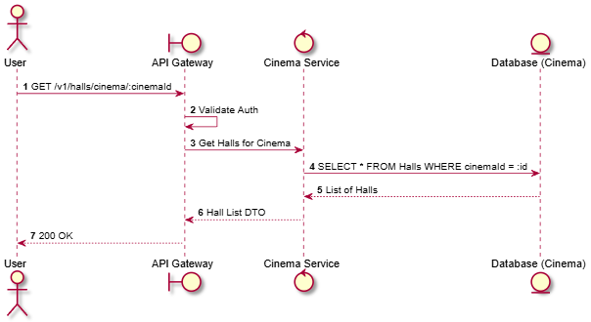

Activities Flow
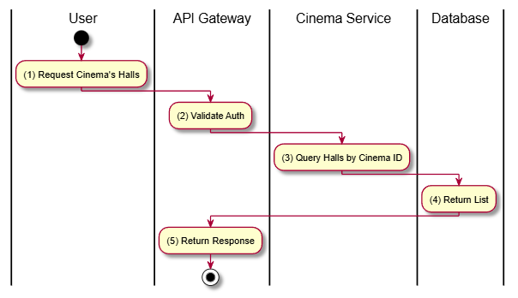

Business Rules
Activity | BR Code | Description
(3) | BR-1 | Should return halls regardless of status (Active/Maintenance) for Admins, but maybe filter for Members? (SRS implies general access, assumed all visible).

Create Hall

Use Case Description
Name | Create Hall
Description | Creates a new hall within a cinema, defining its name, type, and total seat capacity. Note: Seat layout is usually generated separately or initialized here.
Actor | Admin
Trigger | POST /v1/halls/hall
Pre-condition | Admin authenticated; Valid payload (CinemaId, Name, Type).
Post-condition | New Hall created.

Sequence Flow
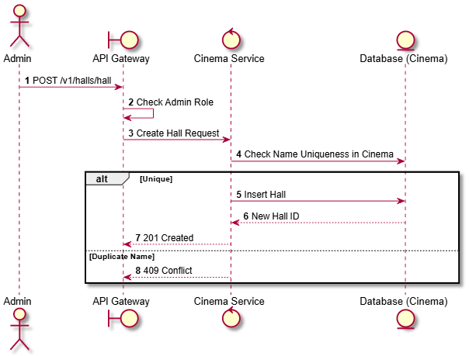

Activities Flow
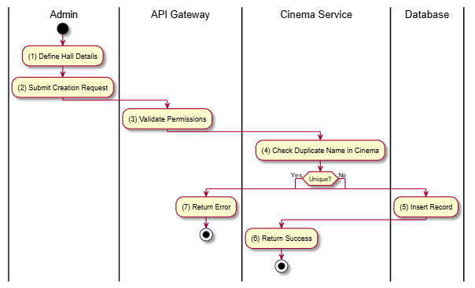

Business Rules
Activity | BR Code | Description
(4) | BR-1 | Hall names (e.g., "Hall 1") must be unique within a single Cinema.

Update Hall

Use Case Description
Name | Update Hall
Description | Updates hall details such as name, type (IMAX, standard), or operational status.
Actor | Admin
Trigger | PATCH /v1/halls/hall/:hallId
Pre-condition | Admin authenticated; Hall exists.
Post-condition | Hall record updated.

Sequence Flow
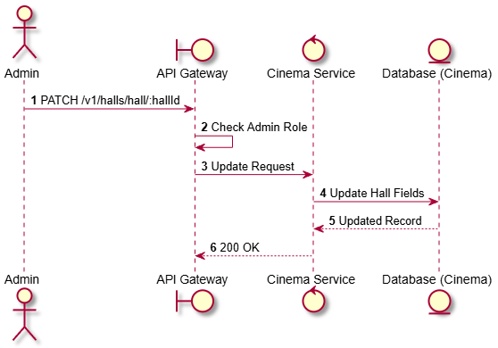

Activities Flow
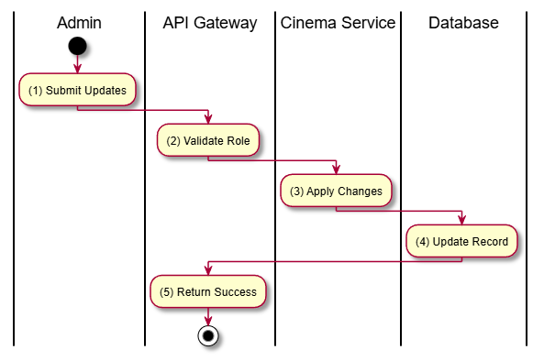

Business Rules
Activity | BR Code | Description
(3) | BR-1 | Status changes (e.g., to MAINTENANCE) must be handled carefully if future showtimes exist (Manual process implied).

Delete Hall

Use Case Description
Name | Delete Hall
Description | Removes a hall from the system.
Actor | Admin
Trigger | DELETE /v1/halls/hall/:hallId
Pre-condition | Admin authenticated; No active showtimes/bookings linked.
Post-condition | Hall deleted.

Sequence Flow
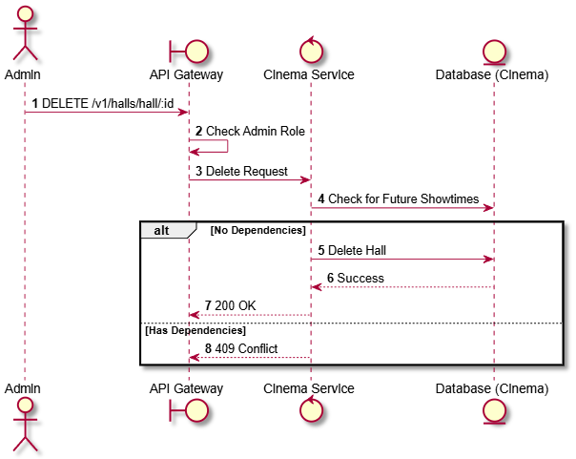

Activities Flow
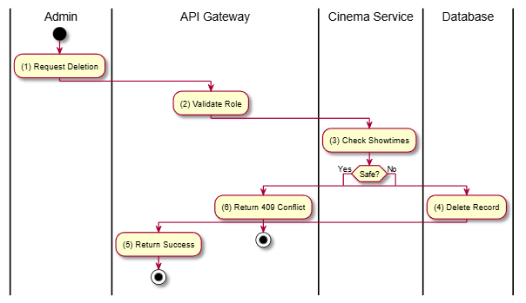

Business Rules
Activity | BR Code | Description
(3) | BR-1 | Halls with historical data should be soft-deleted.

Update Seat Status

Use Case Description
Name | Update Seat Status
Description | Allows modifying the status of a specific seat (e.g., mark as BROKEN or MAINTENANCE) to prevent booking.
Actor | Admin
Trigger | PATCH /v1/halls/seat/:seatId/status
Pre-condition | Admin authenticated.
Post-condition | Seat status updated.

Sequence Flow
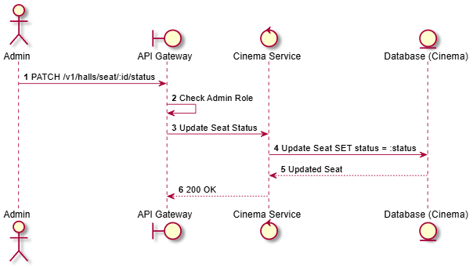

Activities Flow
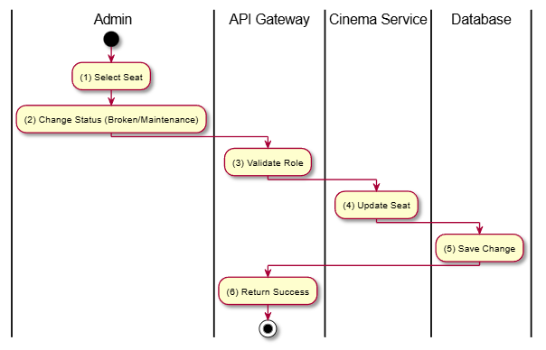

Business Rules
Activity | BR Code | Description
(4) | BR-1 | If a seat is marked BROKEN, it must be excluded from future booking availability calculations.

Ticket Pricing Management

Get Pricing for Hall

Use Case Description
Name | Get Pricing for Hall
Description | Retrieves the ticket pricing configuration for a specific hall, which includes pricing by seat type (Standard, VIP, etc.) and day type (Weekday, Weekend, Holiday).
Actor | Admin
Trigger | GET /v1/ticket-pricings/hall/:hallId
Pre-condition | Admin authenticated; Hall ID exists.
Post-condition | List of pricing rules for the hall is returned.

Sequence Flow
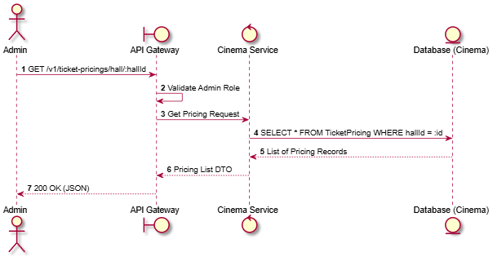

Activities Flow
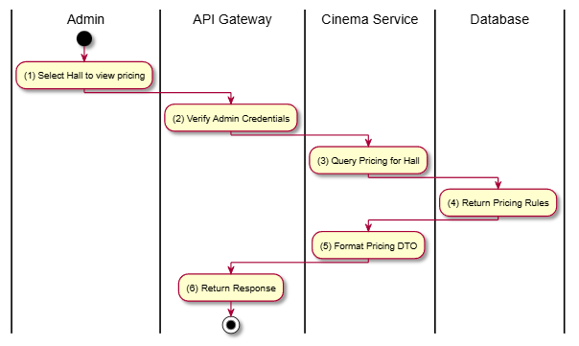

Business Rules
Activity | BR Code | Description
(4) | BR-1 | Pricing is defined by the combination of SeatType and DayType.

Update Ticket Pricing

Use Case Description
Name | Update Ticket Pricing
Description | Allows an Admin to update the price for a specific pricing rule (e.g., change the price of a VIP seat on Weekends).
Actor | Admin
Trigger | PATCH /v1/ticket-pricings/pricing/:pricingId
Pre-condition | Admin authenticated; Pricing ID exists; Valid price value provided.
Post-condition | Pricing record is updated.

Sequence Flow
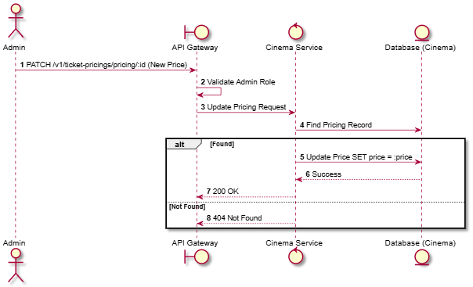

Activities Flow
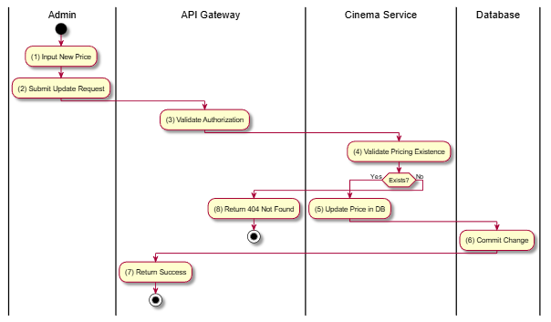

Business Rules
Activity | BR Code | Description
(5) | BR-1 | Prices must be positive numerical values.
(5) | BR-2 | Changes to pricing do not affect bookings already confirmed, only future ones.

Movie Catalog

List Movies

Use Case Description
Name | List Movies
Description | Retrieves a list of movies available in the catalog, supporting pagination, searching, and filtering by genre or age rating.
Actor | Guest, Member
Trigger | GET /v1/movies
Pre-condition | None.
Post-condition | List of movies returned.

Sequence Flow
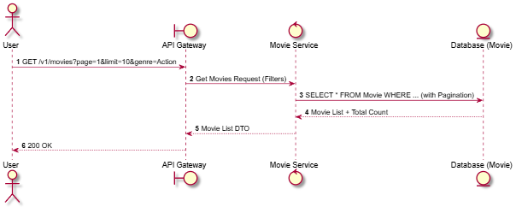

Activities Flow
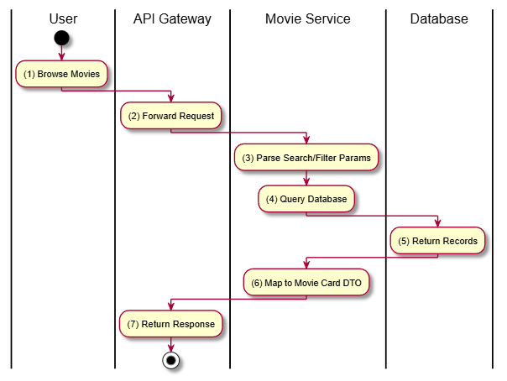

Business Rules
Activity | BR Code | Description
(3) | BR-1 | Supports filtering by genre, ageRating, and searching by title.
(6) | BR-2 | Returns basic info: Title, Poster, Age Rating, Duration.

Get Movie Details

Use Case Description
Name | Get Movie Details
Description | Retrieves comprehensive information about a specific movie, including its overview, cast, crew, and genres.
Actor | Guest, Member
Trigger | GET /v1/movies/:id
Pre-condition | Movie ID exists.
Post-condition | Detailed movie information returned.

Sequence Flow
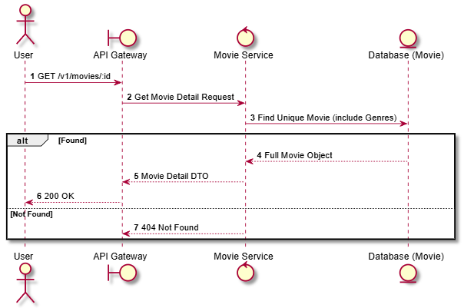

Activities Flow
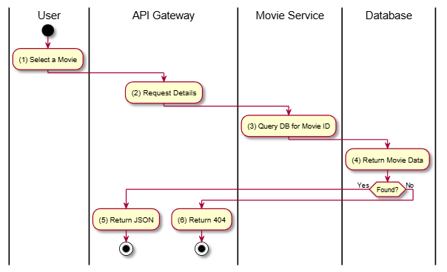

Business Rules
Activity | BR Code | Description
(4) | BR-1 | Includes Title, Overview, Release Date, Trailer URL, Poster, Backdrop, Runtime, and Age Rating (SRS 5.1).

Get Movie Releases

Use Case Description
Name | Get Movie Releases
Description | Retrieves the release dates and statuses for a specific movie in different regions or formats.
Actor | Guest, Member
Trigger | GET /v1/movies/:id/releases
Pre-condition | Movie ID exists.
Post-condition | List of releases returned.

Sequence Flow
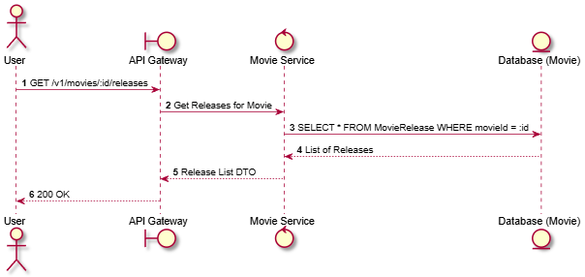

Activities Flow
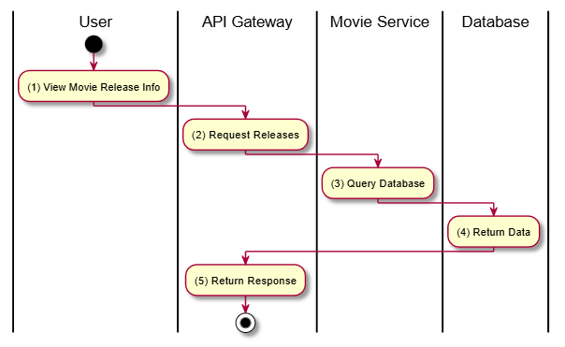

Business Rules
Activity | BR Code | Description
(3) | BR-1 | Movie releases define the "Showing" or "Upcoming" status of a movie.

Create Movie

Use Case Description
Name | Create Movie
Description | Allows an Administrator to add a new movie to the platform.
Actor | Admin
Trigger | POST /v1/movies
Pre-condition | Admin authenticated; Valid payload.
Post-condition | Movie created in database.

Sequence Flow
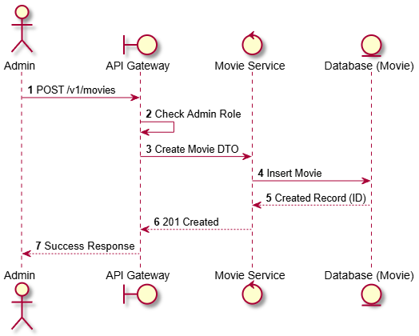

Activities Flow
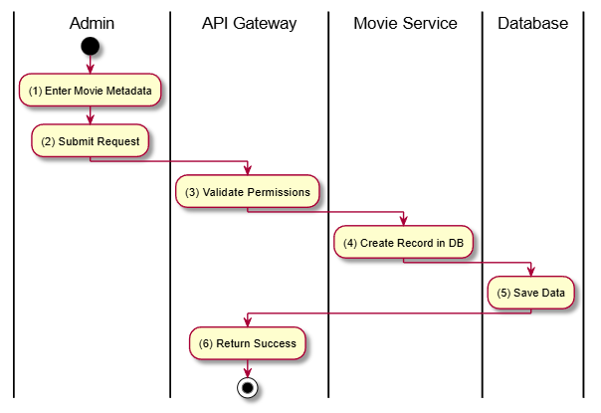

Business Rules
Activity | BR Code | Description
(1) | BR-1 | Required: Title, Overview, Poster URL, Backdrop URL, Trailer URL, Release Date, Runtime, Age Rating.

Update Movie

Use Case Description
Name | Update Movie
Description | Modifies the information of an existing movie.
Actor | Admin
Trigger | PUT /v1/movies/:id
Pre-condition | Admin authenticated; Movie ID exists.
Post-condition | Movie record updated.

Sequence Flow
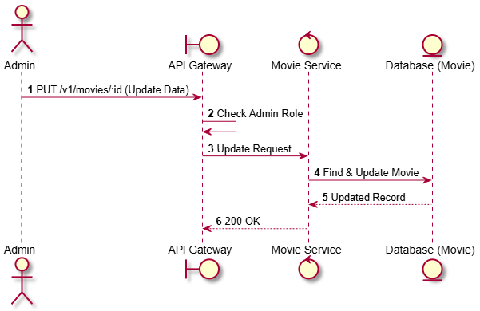

Activities Flow
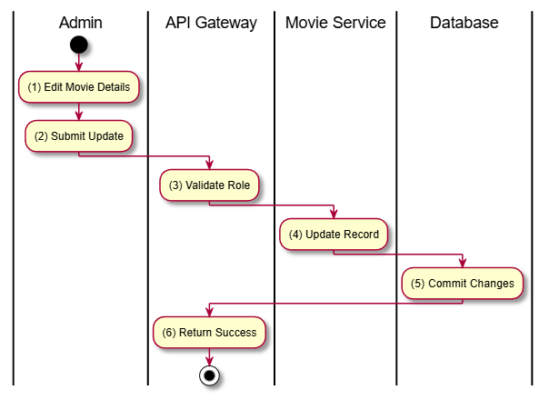

Business Rules
Activity | BR Code | Description
(4) | BR-1 | Can update title, overview, release date, runtime, poster, trailer, backdrop, age rating.
(4) | BR-2 | Updates to genres should also be handled (if included in payload).

Delete Movie

Use Case Description
Name | Delete Movie
Description | Removes a movie from the catalog.
Actor | Admin
Trigger | DELETE /v1/movies/:id
Pre-condition | Admin authenticated; No active showtimes linked.
Post-condition | Movie deleted.

Sequence Flow
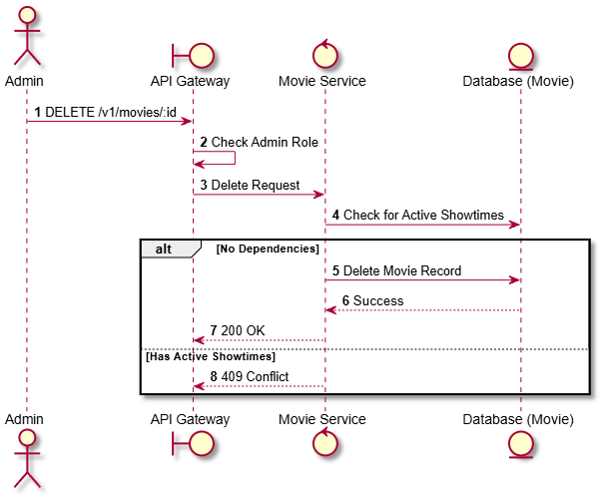

Activities Flow
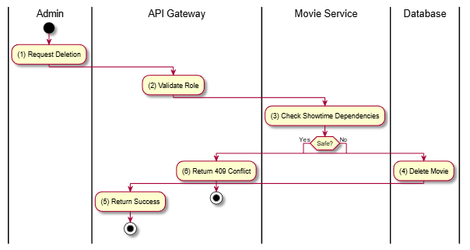

Business Rules
Activity | BR Code | Description
(3) | BR-1 | Supports filtering by genre, ageRating, and searching by title.
(6) | BR-2 | Returns basic info: Title, Poster, Age Rating, Duration.

Movie Releases

Create Movie Release

Use Case Description
Name | Create Movie Release
Description | Creates a new release entry for a movie, specifying the release date, end date, and format (e.g., 2D, 3D, IMAX).
Actor | Admin
Trigger | POST /v1/movie-releases
Pre-condition | Admin authenticated; Movie ID exists; Valid release dates.
Post-condition | Movie release record created.

Sequence Flow
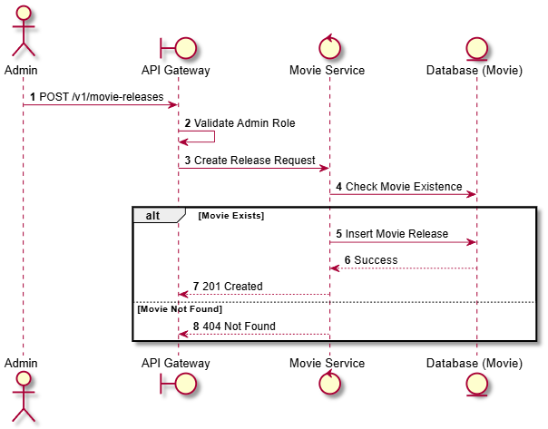

Activities Flow
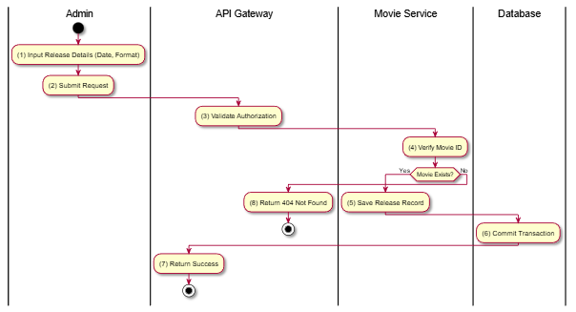

Business Rules
Activity | BR Code | Description
(1) | BR-1 | Format must be one of: TWO_D, THREE_D, IMAX, FOUR_DX (Movie Service Enums).
(1) | BR-2 | End date must be after the release date.

Update Movie Release

Use Case Description
Name | Update Movie Release
Description | Updates an existing movie release's schedule or format.
Actor | Admin
Trigger | PUT /v1/movie-releases/:id
Pre-condition | Admin authenticated; Release ID exists.
Post-condition | Movie release updated.

Sequence Flow
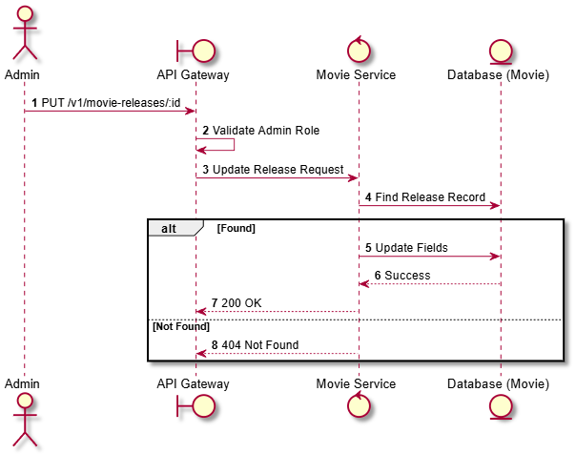

Activities Flow
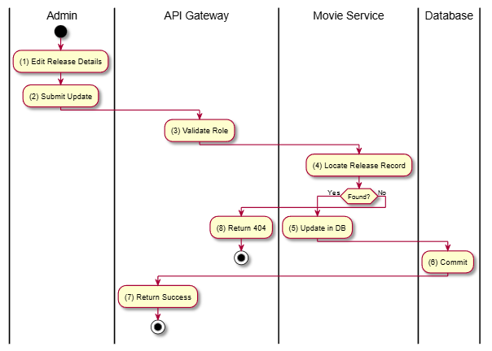

Business Rules
Activity | BR Code | Description
(5) | BR-1 | Updating a release format or date might affect scheduled showtimes (Manual reconciliation required).

Delete Movie Release

Use Case Description
Name | Delete Movie Release
Description | Deletes a movie release entry.
Actor | Admin
Trigger | DELETE /v1/movie-releases/:id
Pre-condition | Admin authenticated; Release exists.
Post-condition | Release record removed.

Sequence Flow
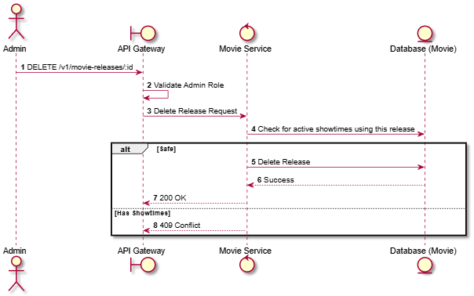

Activities Flow
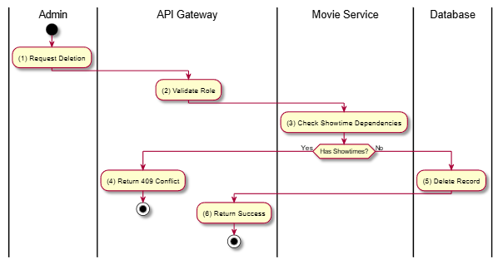

Business Rules
Activity | BR Code | Description
(3) | BR-1 | Deleting a release is prevented if it's currently linked to active showtimes.

Genre Management

List All Genres

Use Case Description
Name | List All Genres
Description | Retrieves a list of all movie genres available in the system.
Actor | Guest, Member
Trigger | GET /v1/genres
Pre-condition | None.
Post-condition | List of genres returned.

Sequence Flow
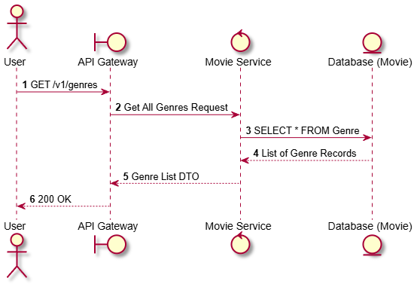

Activities Flow
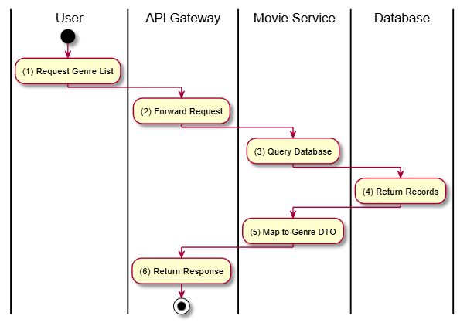

Business Rules
Activity | BR Code | Description
(3) | BR-1 | Returns all genres defined in the movie service database.

Get Genre by ID

Use Case Description
Name | Get Genre by ID
Description | Retrieves detailed information about a specific genre by its ID.
Actor | Guest, Member
Trigger | GET /v1/genres/:id
Pre-condition | Genre ID exists.
Post-condition | Genre details returned.

Sequence Flow


Activities Flow
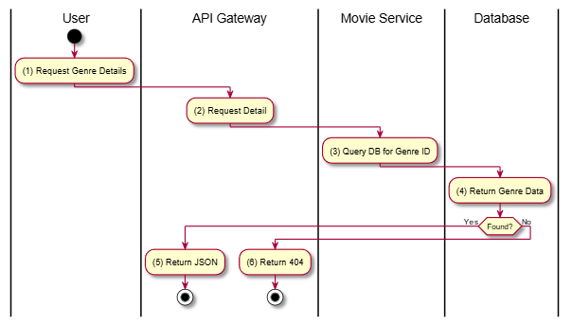

Business Rules
Activity | BR Code | Description
(1) | BR-1 | Standard read operation for a single genre.

Create Genre

Use Case Description
Name | Create Genre
Description | Allows an Administrator to add a new movie genre to the system.
Actor | Admin
Trigger | POST /v1/genres
Pre-condition | Admin authenticated; Valid payload (name).
Post-condition | New genre created in database.

Sequence Flow
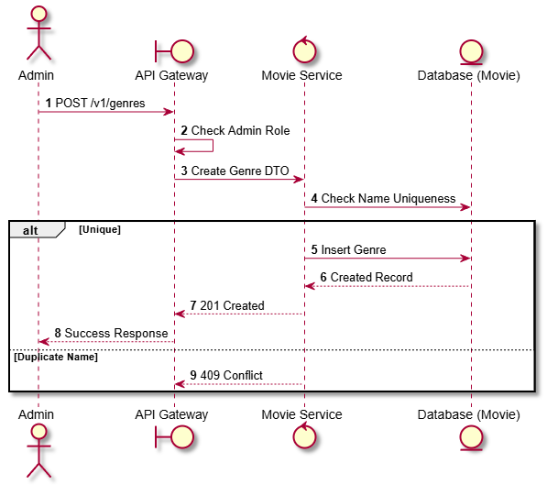

Activities Flow
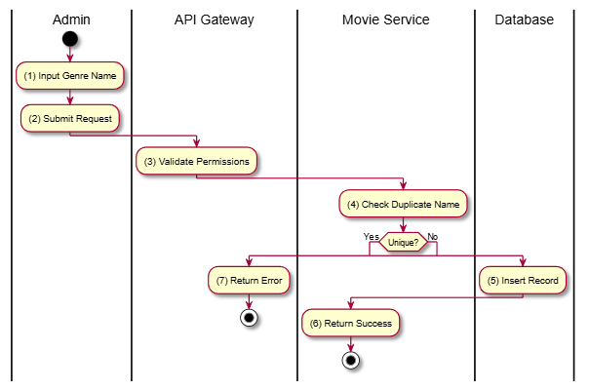

Business Rules
Activity | BR Code | Description
(4) | BR-1 | Genre names must be unique in the system.

Update Genre

Use Case Description
Name | Update Genre
Description | Modifies an existing movie genre's name.
Actor | Admin
Trigger | PUT /v1/genres/:id
Pre-condition | Admin authenticated; Genre ID exists.
Post-condition | Genre record updated.

Sequence Flow
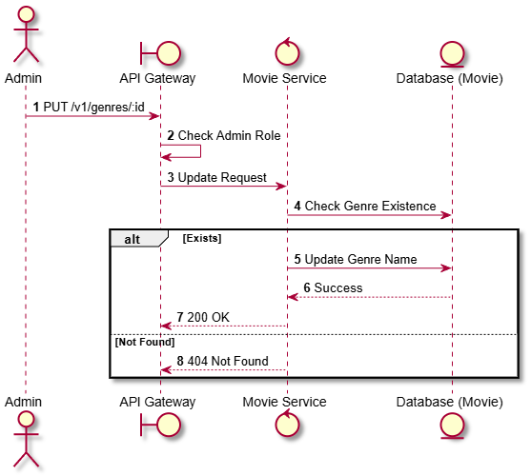

Activities Flow
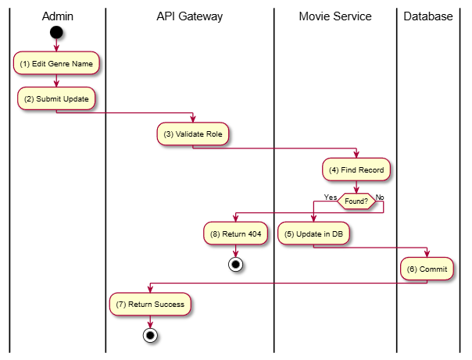

Business Rules
Activity | BR Code | Description
(5) | BR-1 | Updated genre name must not conflict with other existing genre names.

Delete Genre

Use Case Description
Name | Delete Genre
Description | Removes a movie genre from the system.
Actor | Admin
Trigger | DELETE /v1/genres/:id
Pre-condition | Admin authenticated; Genre ID exists.
Post-condition | Genre record removed.

Sequence Flow
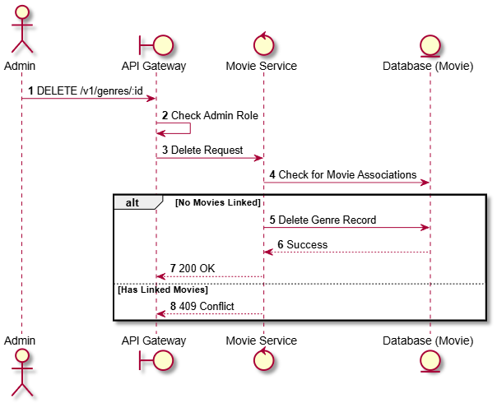

Activities Flow
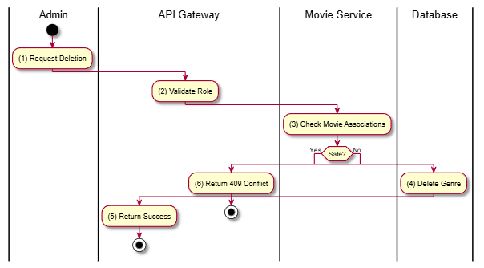

Business Rules
Activity | BR Code | Description
(3) | BR-1 | A genre cannot be deleted if there are movies currently associated with it.

Movie Reviews

List Reviews

Use Case Description
Name | List Reviews
Description | Retrieves a list of all reviews in the system, supporting administrative oversight.
Actor | Guest, Member
Trigger | GET /v1/reviews
Pre-condition | None.
Post-condition | List of all reviews returned.

Sequence Flow
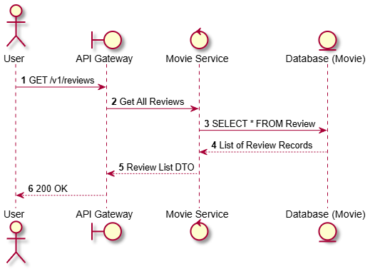

Activities Flow
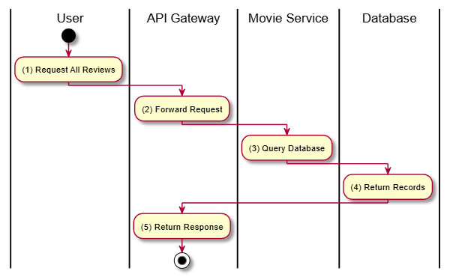

Business Rules
Activity | BR Code | Description
(1) | BR-1 | Typically used for general review feeds or admin moderation.
(1) | BR-2 | Ratings are on a scale of 1 to 5.

Get Movie Reviews

Use Case Description
Name | Get Movie Reviews
Description | Retrieves all reviews and ratings for a specific movie.
Actor | Guest, Member
Trigger | GET /v1/movies/:id/reviews
Pre-condition | Movie ID exists.
Post-condition | List of reviews for the movie returned.

Sequence Flow
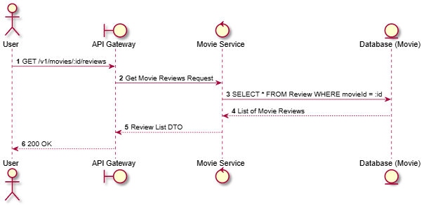

Activities Flow
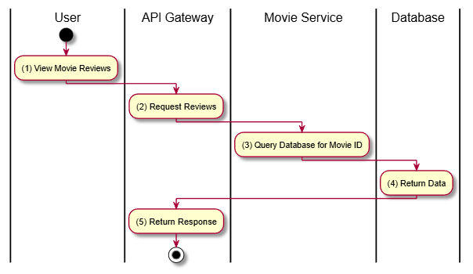

Business Rules
Activity | BR Code | Description
(3) | BR-1 | Reviews should include user names (or obfuscated IDs) and rating values.

Create Review

Use Case Description
Name | Create Review
Description | Allows a Member to submit a review and rating for a movie they have (presumably) seen.
Actor | Member
Trigger | POST /v1/movies/:id/reviews
Pre-condition | Member authenticated; Movie ID exists; Member has not reviewed this movie yet.
Post-condition | Review created; Average movie rating updated (if calculated on fly).

Sequence Flow
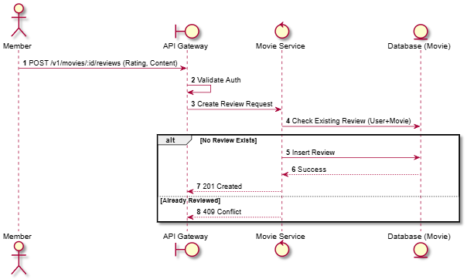

Activities Flow
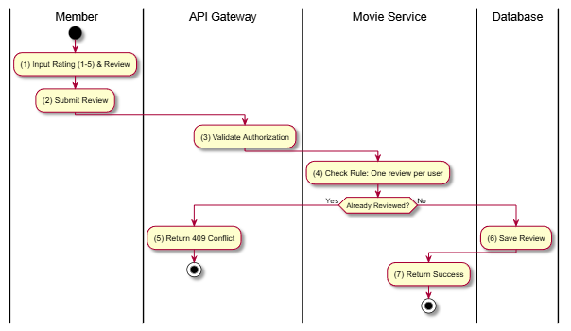

Business Rules
Activity | BR Code | Description
(4) | BR-1 | One user can only submit one review per movie.
(1) | BR-2 | Rating scale: 1 to 5.

Update Review

Use Case Description
Name | Update Review
Description | Allows a Member to modify their own review and rating for a movie.
Actor | Member
Trigger | PUT /v1/movies/:id/reviews/:reviewId
Pre-condition | Member authenticated; Review ID exists and belongs to the Member.
Post-condition | Review record updated.

Sequence Flow
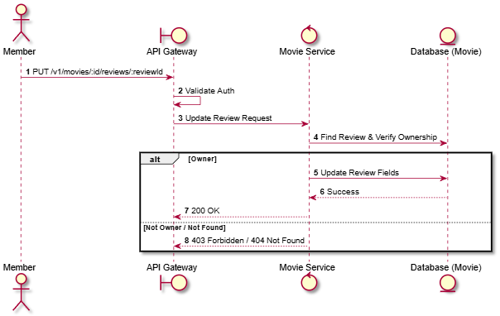

Activities Flow
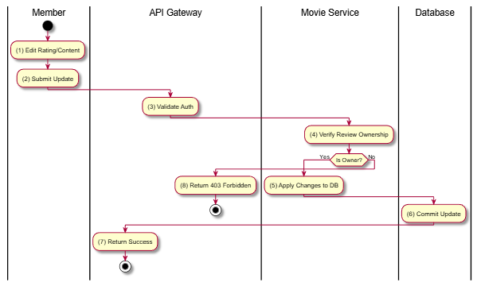

Business Rules
Activity | BR Code | Description
(4) | BR-1 | Users can only update reviews they created themselves.
(5) | BR-2 | New rating must be between 1 and 5.

Delete Review

Use Case Description
Name | Delete Review
Description | Allows an Administrator to delete a review (e.g., for moderation). Note: SRS also allows Members to delete their own, but trigger is usually Admin-focused in list.
Actor | Admin
Trigger | DELETE /v1/reviews/:id
Pre-condition | Admin authenticated; Review ID exists.
Post-condition | Review record removed.

Sequence Flow
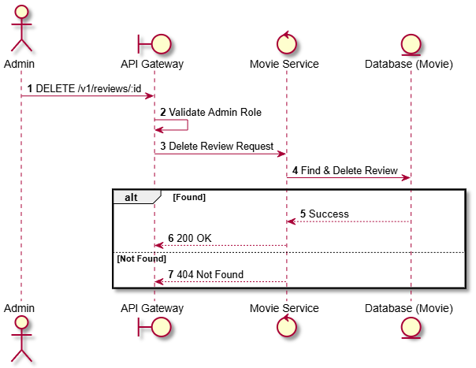

Activities Flow
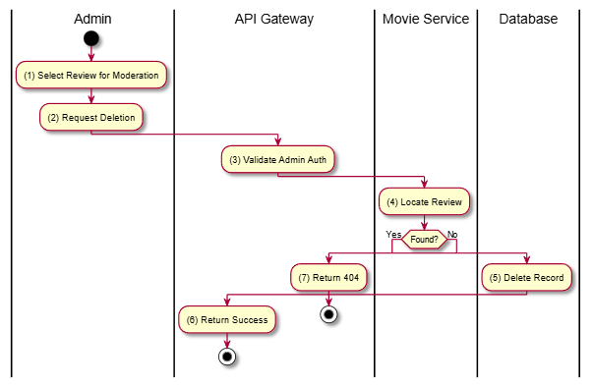

Business Rules
Activity | BR Code | Description
(5) | BR-1 | Deleted reviews should also trigger a recalculation of the movie's aggregate rating.

Showtime Scheduling

Get Showtime Seats

Use Case Description
Name | Get Showtime Seats
Description | Retrieves the current seat layout for a specific showtime, including real-time availability and held status for the requesting user.
Actor | Member
Trigger | GET /v1/showtimes/:id/seats
Pre-condition | Member is authenticated; Showtime ID exists.
Post-condition | Returns seat matrix with status (Available, Held, Booked, Broken).

Sequence Flow
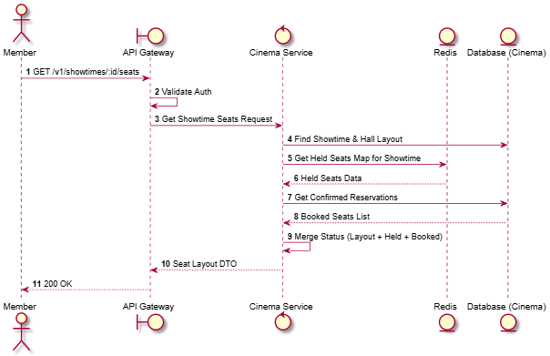

Activities Flow
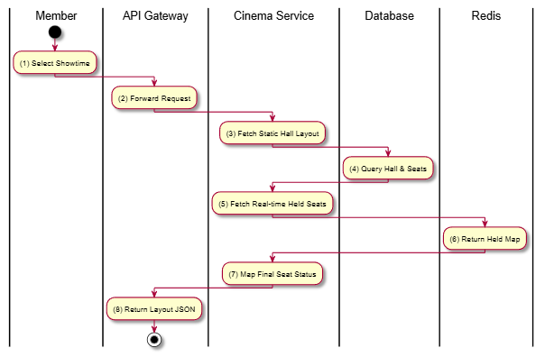

Business Rules
Activity | BR Code | Description
(5) | BR-1 | A seat cannot be held if it is already held by another user.
(7) | BR-2 | Seat types (VIP/Standard) determine the base price displayed on UI.

Get Session TTL

Use Case Description
Name | Get Session TTL
Description | Retrieves the remaining time (Time To Live) for the user's current seat-holding session for a showtime.
Actor | Member
Trigger | GET /v1/showtimes/showtime/:showtimeId/ttl
Pre-condition | Member has at least one seat held for this showtime.
Post-condition | Remaining seconds returned.

Sequence Flow
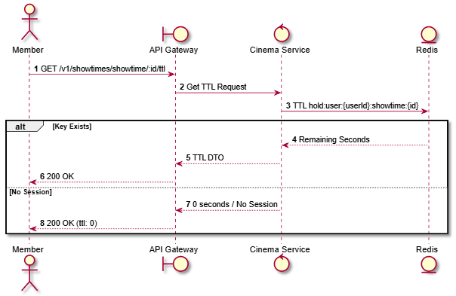

Activities Flow
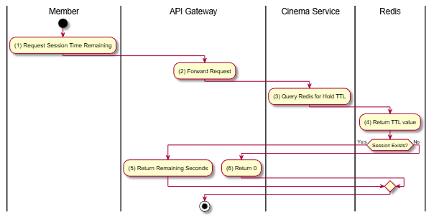

Business Rules
Activity | BR Code | Description
(3) | BR-1 | Seat hold duration (TTL): 10 minutes (600 seconds).

Create Showtime

Use Case Description
Name | Create Showtime
Description | Allows an Admin to schedule a single movie screening in a specific hall at a specific time.
Actor | Admin
Trigger | POST /v1/showtimes/showtime
Pre-condition | Admin authenticated; Movie, Hall, and Release IDs exist; No time overlap in the same hall.
Post-condition | New Showtime created.

Sequence Flow
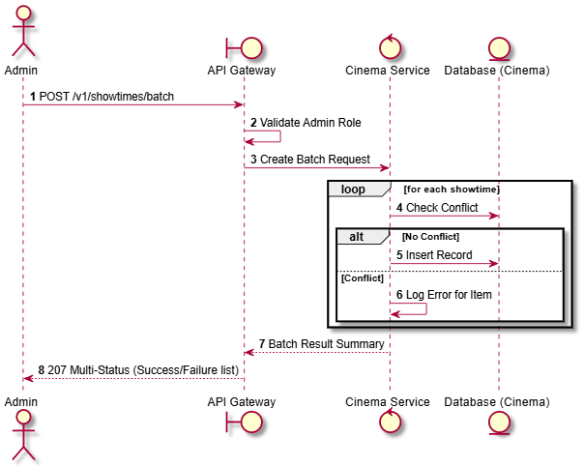

Activities Flow
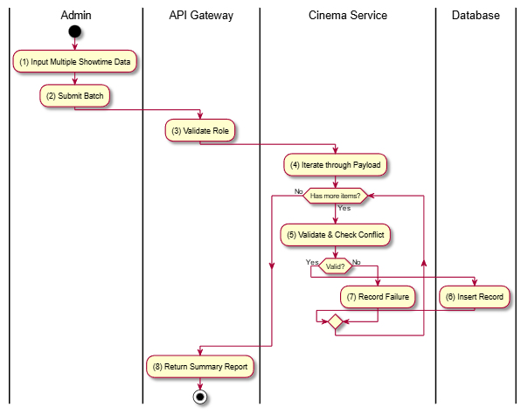

Business Rules
Activity | BR Code | Description
(5) | BR-1 | A hall cannot have two showtimes that overlap in time (including a buffer for cleaning).
(4) | BR-2 | Showtime status defaults to SCHEDULED or SELLING.

Update Showtime

Use Case Description
Name | Update Showtime
Description | Modifies an existing showtime's details (e.g., changing the hall, start time, or status).
Actor | Admin
Trigger | PATCH /v1/showtimes/showtime/:id
Pre-condition | Admin authenticated; Showtime exists; No bookings yet if changing time/hall.
Post-condition | Showtime record updated.

Sequence Flow
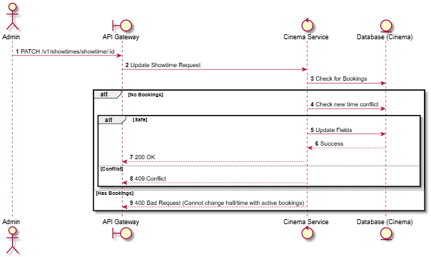

Activities Flow
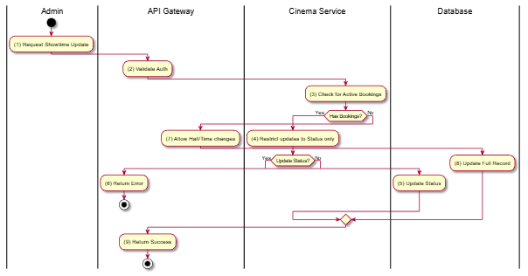

Business Rules
Activity | BR Code | Description
(3) | BR-1 | Changing Hall or Start Time is strictly prohibited if users have already booked tickets for that showtime.
(5) | BR-2 | Valid statuses: SCHEDULED, SELLING, SOLD_OUT, CANCELLED, COMPLETED.

Delete Showtime

Use Case Description
Name | Delete Showtime
Description | Removes a scheduled showtime from the system.
Actor | Admin
Trigger | DELETE /v1/showtimes/showtime/:id
Pre-condition | Admin authenticated; Showtime ID exists; No bookings associated with the showtime.
Post-condition | Showtime record deleted from database.

Sequence Flow
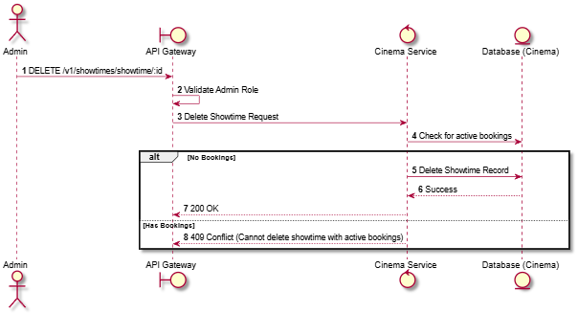

Activities Flow
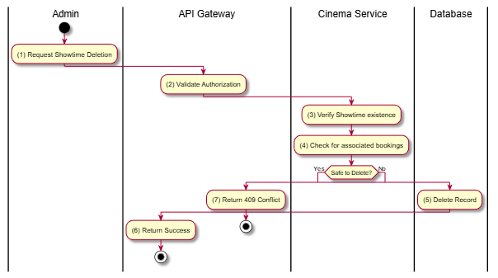

Business Rules
Activity | BR Code | Description
(4) | BR-1 | Showtimes with confirmed or pending bookings cannot be physically deleted. They should be cancelled instead.

Create Batch Showtimes

Use Case Description
Name | Create Batch Showtimes
Description | Allows an Admin to create multiple showtimes at once (e.g., for an entire week) using a template or list of times.
Actor | Admin
Trigger | POST /v1/showtimes/batch
Pre-condition | Admin authenticated; Valid list of showtime payloads.
Post-condition | Multiple showtimes created; Any conflicting entries are reported.

Sequence Flow


Activities Flow


Business Rules
Activity | BR Code | Description
(5) | BR-1 | Batch processing must handle partial successes (Atomic per record).
(5) | BR-2 | Conflict rules from ST-03 apply to each item.

Get Movie Showtimes at Cinema

Use Case Description
Name | Get Movie Showtimes at Cinema
Description | Retrieves all available showtimes for a specific movie at a specific cinema location.
Actor | Guest, Member
Trigger | GET /v1/cinemas/:cinemaId/movies/:movieId/showtimes
Pre-condition | Cinema ID and Movie ID exist.
Post-condition | List of showtimes (grouped by date/format) returned.

Sequence Flow
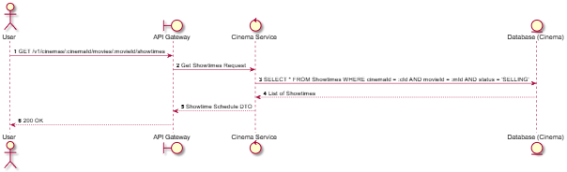

Activities Flow
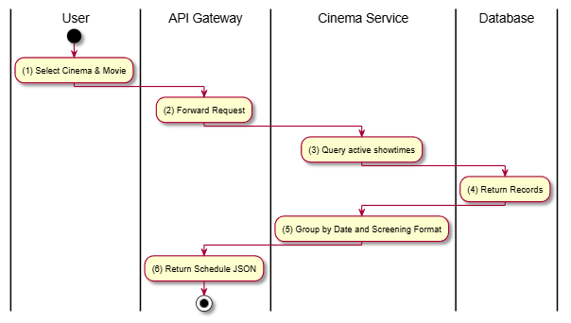

Business Rules
Activity | BR Code | Description
(3) | BR-1 | Only showtimes with status SELLING or SCHEDULED are returned to the public.
(5) | BR-2 | Results are categorized by format (2D, 3D, IMAX) for better user experience.

Admin Get Showtimes

Use Case Description
Name | Admin Get Showtimes
Description | Provides an administrative view of showtimes for a movie at a cinema, including internal status and capacity info.
Actor | Admin
Trigger | GET /v1/cinemas/:cinemaId/movies/:movieId/showtimes/admin
Pre-condition | Admin authenticated.
Post-condition | Detailed list of showtimes returned.

Sequence Flow
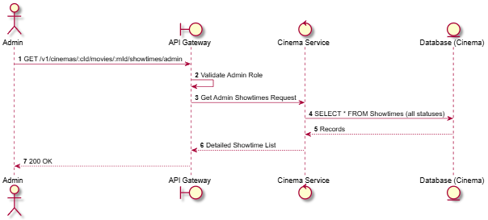

Activities Flow
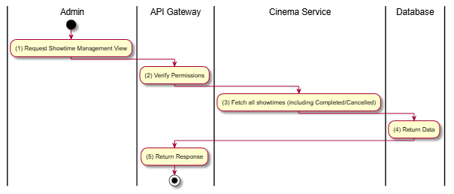

Business Rules
Activity | BR Code | Description
(3) | BR-1 | Unlike public views, this includes CANCELLED and COMPLETED showtimes for auditing.
(3) | BR-2 | Includes booking counts or seat occupancy percentages.

Get Movies at Cinema

Use Case Description
Name | Get Movies at Cinema
Description | Lists all movies that currently have scheduled showtimes at a specific cinema location.
Actor | Guest, Member
Trigger | GET /v1/cinemas/cinema/:cinemaId/movies
Pre-condition | Cinema ID exists.
Post-condition | List of movies with active showtimes returned.

Sequence Flow
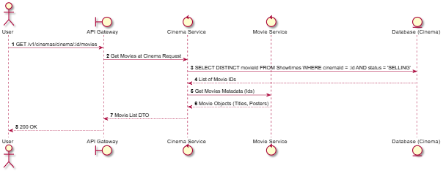

Activities Flow
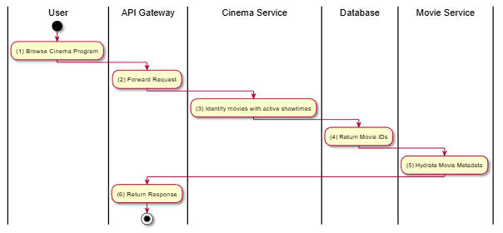

Business Rules
Activity | BR Code | Description
(3) | BR-1 | Only movies with at least one showtime in SELLING status are included.

Get All Movies with Showtimes

Use Case Description
Name | Get All Movies with Showtimes
Description | Aggregates all movies across the platform that currently have active showtimes, often used for a "Now Showing" landing page.
Actor | Guest, Member
Trigger | GET /v1/cinemas/movies/showtimes
Pre-condition | None.
Post-condition | Aggregated list of movies with their associated cinemas/times.

Sequence Flow
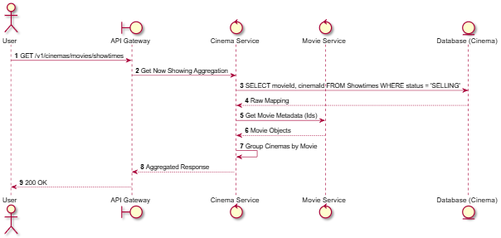

Activities Flow
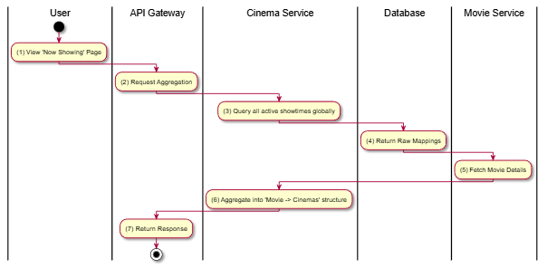

Business Rules
Activity | BR Code | Description
(3) | BR-1 | Filters out movies that have no available showtimes left for the day.
(6) | BR-2 | Typically sorted by movie popularity or release date.

User Booking Operations

Create Booking

Use Case Description
Name | Create Booking
Description | Initiates a new booking for a specific showtime and set of held seats.
Actor | Member
Trigger | POST /v1/bookings
Pre-condition | Member authenticated; Seats held in Redis; Showtime is active.
Post-condition | Booking created with status PENDING; Expiry timer started.

Sequence Flow
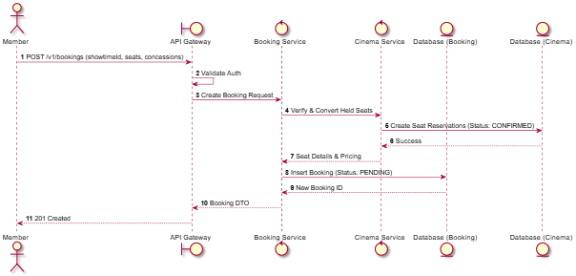

Activities Flow
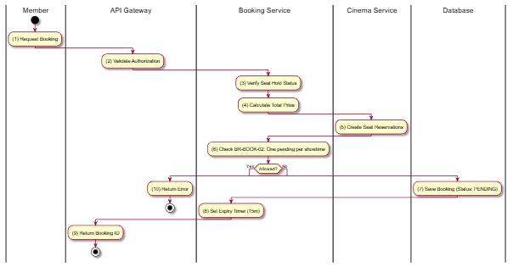

Business Rules
Activity | BR Code | Description
(8) | BR-1 | Booking expiry time: 15 minutes from creation.
(6) | BR-2 | Only one pending booking per user per showtime is allowed.
(4) | BR-3 | VAT rate: 10% on all transactions.

List User Bookings

Use Case Description
Name | List User Bookings
Description | Retrieves the booking history for the authenticated member.
Actor | Member
Trigger | GET /v1/bookings
Pre-condition | Member authenticated.
Post-condition | List of user's bookings returned.

Sequence Flow
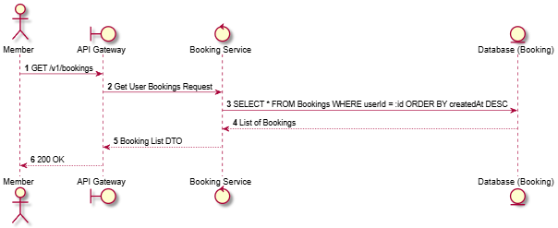

Activities Flow
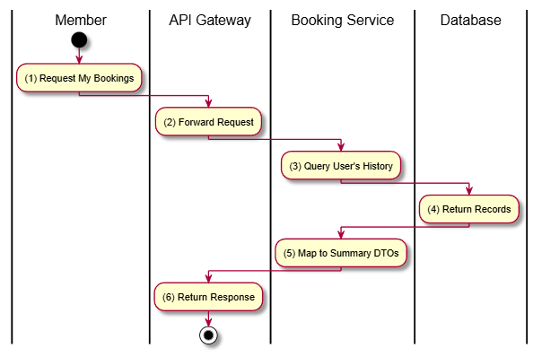

Business Rules
Activity | BR Code | Description
(3) | BR-1 | Only returns bookings belonging to the requesting user.

Get Booking Details

Use Case Description
Name | Get Booking Details
Description | Retrieves full details of a specific booking, including tickets, concessions, and payment status.
Actor | Member
Trigger | GET /v1/bookings/:id
Pre-condition | Member authenticated; Booking ID exists and belongs to the member.
Post-condition | Full booking object returned.

Sequence Flow
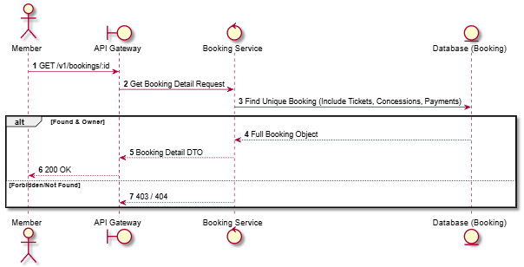

Activities Flow
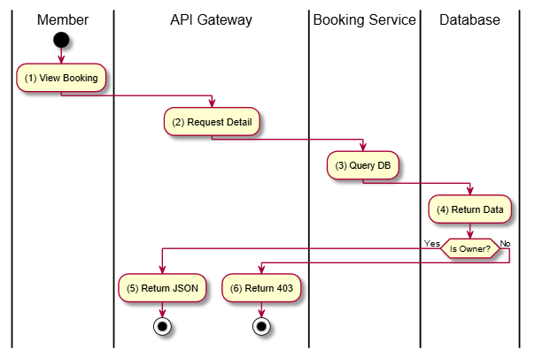

Business Rules
Activity | BR Code | Description
(3) | BR-1 | Includes QR code data for tickets if status is CONFIRMED.
(3) | BR-2 | Hydrates data for Bookings, Tickets, Payments, and BookingConcessions.

Get Booking Summary

Use Case Description
Name | Get Booking Summary
Description | Provides a lightweight summary of a booking, typically used for order confirmation screens before final payment.
Actor | Member
Trigger | GET /v1/bookings/:id/summary
Pre-condition | Booking exists.
Post-condition | Summary info returned.

Sequence Flow
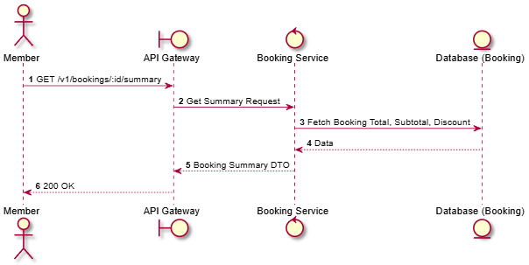

Activities Flow
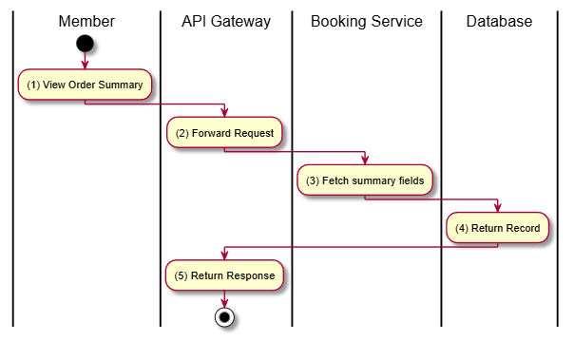

Business Rules
Activity | BR Code | Description
(3) | BR-1 | Filters out movies that have no available showtimes left for the day.

Cancel Booking

Use Case Description
Name | Cancel Booking
Description | Cancels a PENDING booking before payment or a CONFIRMED booking (without refund logic here, see BK-09 for refund).
Actor | Member
Trigger | POST /v1/bookings/:id/cancel
Pre-condition | Booking belongs to Member; Status is PENDING or CONFIRMED.
Post-condition | Booking status set to CANCELLED; Seats released.

Sequence Flow
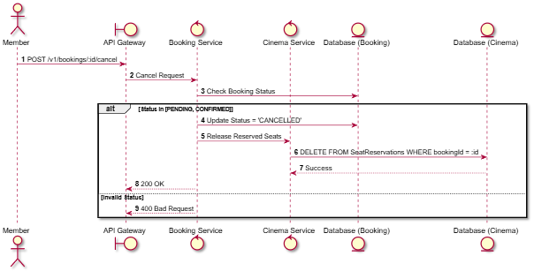

Activities Flow
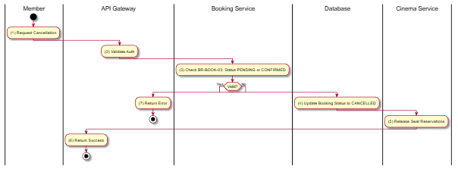

Business Rules
Activity | BR Code | Description
(3) | BR-1 | Bookings can only be cancelled when status is PENDING or CONFIRMED.
(5) | BR-2 | Seats are made available for other users immediately after cancellation.

Update Booking

Use Case Description
Name | Update Booking
Description | Allows updating booking details (e.g., adding concessions or applying a promotion) while in PENDING status.
Actor | Member
Trigger | PUT /v1/bookings/:id
Pre-condition | Booking belongs to Member; Status is PENDING.
Post-condition | Booking updated; Total price recalculated.

Sequence Flow
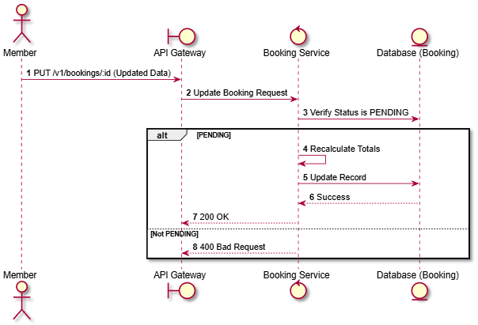

Activities Flow
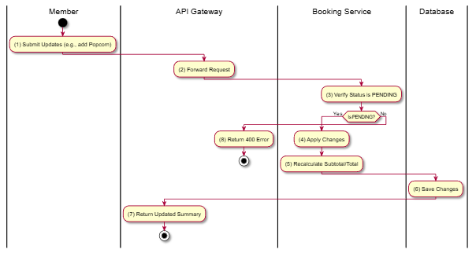

Business Rules
Activity | BR Code | Description
(3) | BR-1 | Bookings cannot be modified once they are CONFIRMED or PAID.
(5) | BR-2 | VAT (10%) must be recalculated based on new items.

Reschedule Booking

Use Case Description
Name | Reschedule Booking
Description | Allows a Member to change the showtime of an existing CONFIRMED booking, subject to limits and time constraints.
Actor | Member
Trigger | POST /v1/bookings/:id/reschedule
Pre-condition | Booking status is CONFIRMED; New showtime exists; At least 2 hours before original showtime.
Post-condition | Original booking cancelled; New booking created or updated; Reschedule count incremented.

Sequence Flow
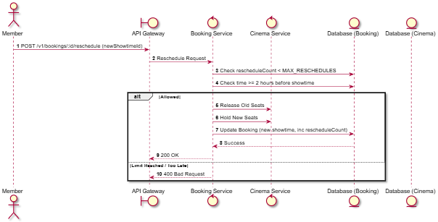

Activities Flow
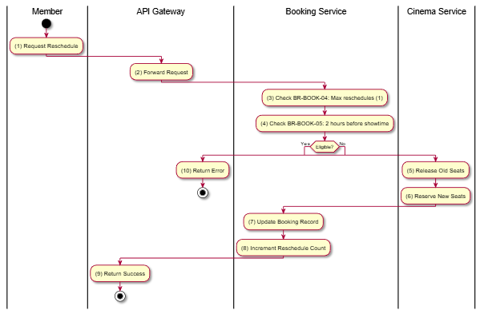

Business Rules
Activity | BR Code | Description
(3) | BR-1 | Maximum reschedules per booking: 1.
(4) | BR-2 | Rescheduling must be made at least 2 hours before showtime.
(7) | BR-3 | Total price may need adjustment if new showtime has different pricing.

Calculate Refund

Use Case Description
Name | Calculate Refund
Description | Calculates the potential refund amount for a booking cancellation based on business rules.
Actor | Member
Trigger | GET /v1/bookings/:id/refund-calculation
Pre-condition | Booking exists and is CONFIRMED.
Post-condition | Potential refund amount and breakdown returned.

Sequence Flow
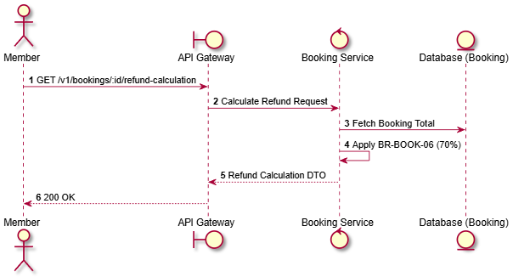

Activities Flow
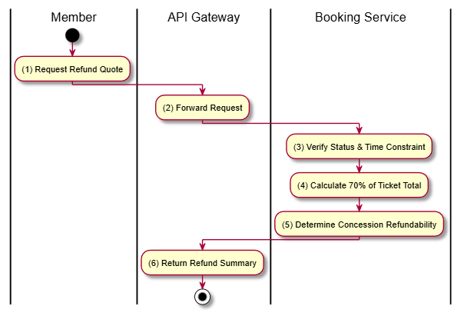

Business Rules
Activity | BR Code | Description
(4) | BR-1 | Refund percentage on ticket cancellation: 70%.
(3) | BR-2 | Refund eligibility requires cancellation at least 2 hours before showtime.

Cancel with Refund

Use Case Description
Name | Cancel with Refund
Description | Processes a cancellation and initiates a refund request in one operation.
Actor | Member
Trigger | POST /v1/bookings/:id/cancel-with-refund
Pre-condition | Member authenticated; Booking eligible for refund.
Post-condition | Booking status CANCELLED; Refund record created with status PENDING.

Sequence Flow
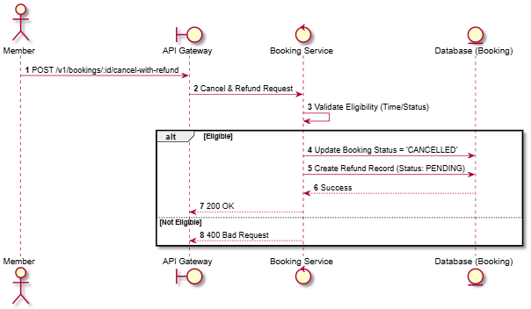

Activities Flow
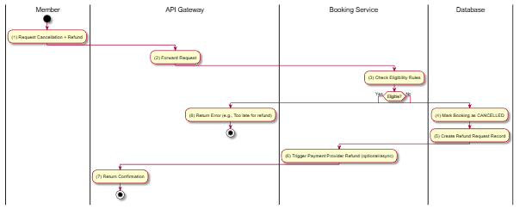

Business Rules
Activity | BR Code | Description
(3) | BR-1 | Cancellation must be made at least 2 hours before showtime.
(3) | BR-2 | Refund amount = 70% of ticket price.

Check User Booking at Showtime

Use Case Description
Name | Check User Booking at Showtime
Description | Checks if the user already has a pending or confirmed booking for a specific showtime.
Actor | Member
Trigger | GET /v1/bookings/showtime/:showtimeId/check
Pre-condition | Member authenticated.
Post-condition | Boolean status and booking ID (if exists) returned.

Sequence Flow
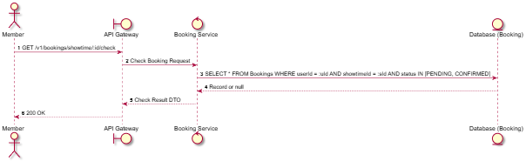

Activities Flow
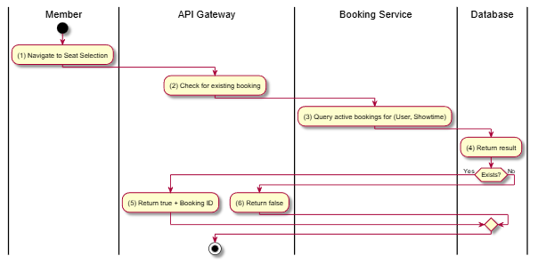

Business Rules
Activity | BR Code | Description
(3) | BR-1 | Prevents users from creating multiple active bookings for the same showtime.

Get Cancellation Policy

Use Case Description
Name | Get Cancellation Policy
Description | Returns the human-readable text of the platform's cancellation and refund policy.
Actor | Guest, Member
Trigger | GET /v1/bookings/cancellation-policy
Pre-condition | None.
Post-condition | Policy text returned.

Sequence Flow
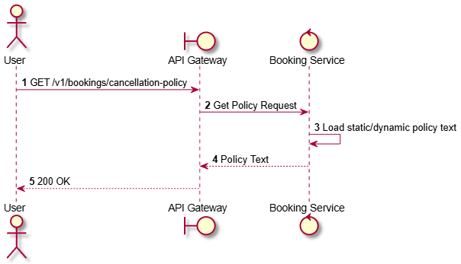

Activities Flow
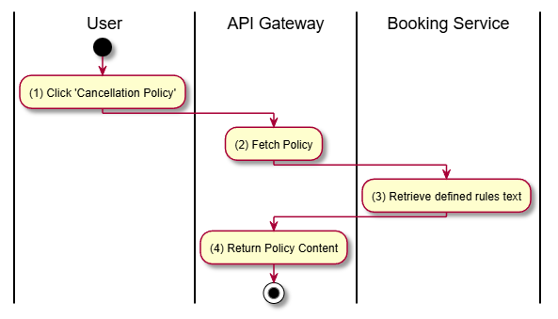

Business Rules
Activity | BR Code | Description
(3) | BR-1 | Must mention the 2-hour deadline.
(3) | BR-2 | Must mention the 70% refund rate.

Admin Booking Operations

Admin List All Bookings

Use Case Description
Name | Admin List All Bookings
Description | Allows Administrators to view a comprehensive list of all bookings across the platform with filtering and sorting capabilities.
Actor | Admin
Trigger | GET /v1/bookings/admin/all
Pre-condition | Admin authenticated with proper permissions.
Post-condition | Paginated list of all bookings returned.

Sequence Flow
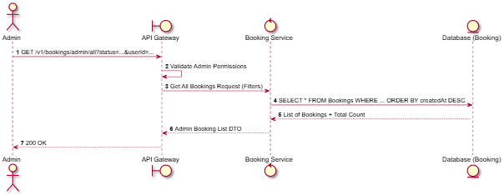

Activities Flow
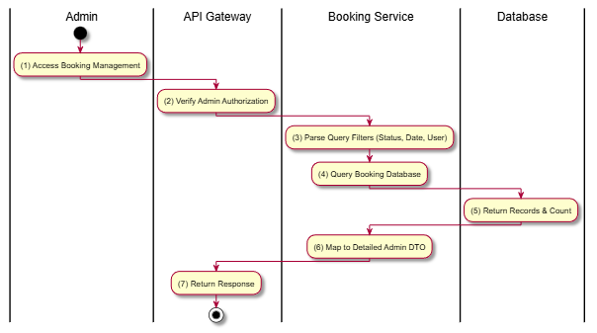

Business Rules
Activity | BR Code | Description
(2) | BR-1 | Restricted to Admin actor (SRS Section 2.1).
(6) | BR-2 | DTO includes sensitive user info and full transaction history not visible to members.

Find Bookings by Showtime

Use Case Description
Name | Find Bookings by Showtime
Description | Allows an Admin to view all bookings associated with a specific showtime.
Actor | Admin
Trigger | GET /v1/bookings/admin/showtime/:showtimeId
Pre-condition | Admin authenticated; Showtime ID exists.
Post-condition | List of bookings for the showtime returned.

Sequence Flow
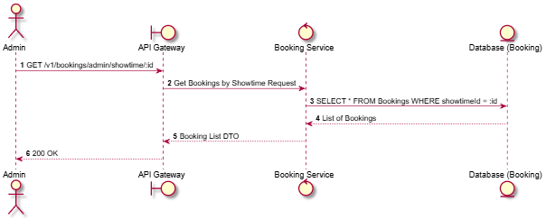

Activities Flow
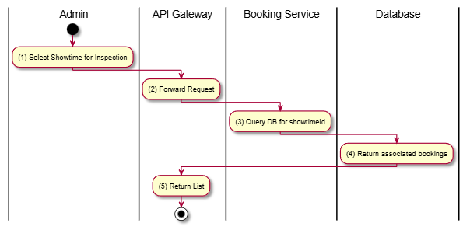

Business Rules
Activity | BR Code | Description
(3) | BR-1 | Useful for checking attendance or managing issues for a specific screening.

Find Bookings by Date Range

Use Case Description
Name | Find Bookings by Date Range
Description | Allows an Admin to filter bookings based on their creation date within a specified range.
Actor | Admin
Trigger | GET /v1/bookings/admin/date-range
Pre-condition | Admin authenticated; Valid start and end dates provided.
Post-condition | List of bookings within the date range returned.

Sequence Flow
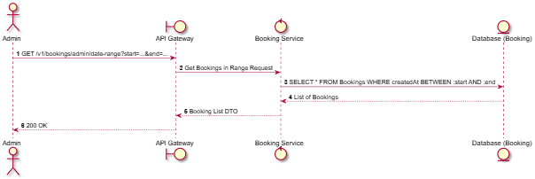

Activities Flow
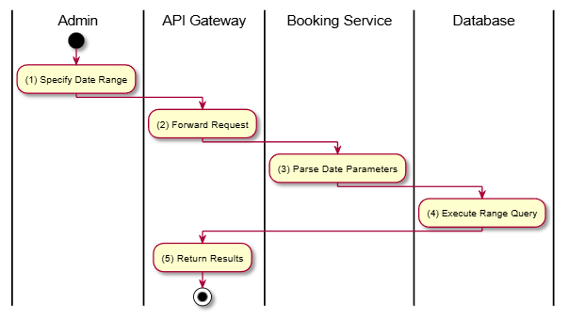

Business Rules
Activity | BR Code | Description
(3) | BR-1 | Dates must be in ISO 8601 format or compatible.

Update Booking Status

Use Case Description
Name | Update Booking Status
Description | Allows an Administrator to manually override the status of a booking (e.g., for troubleshooting or manual overrides).
Actor | Admin
Trigger | PUT /v1/bookings/admin/:id/status
Pre-condition | Admin authenticated; Booking exists; Target status is valid.
Post-condition | Booking status updated in database.

Sequence Flow
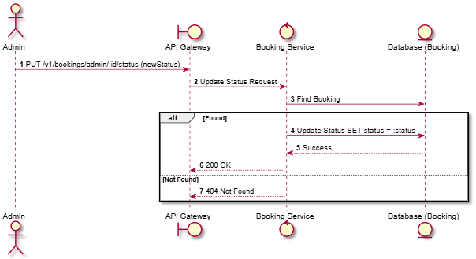

Activities Flow
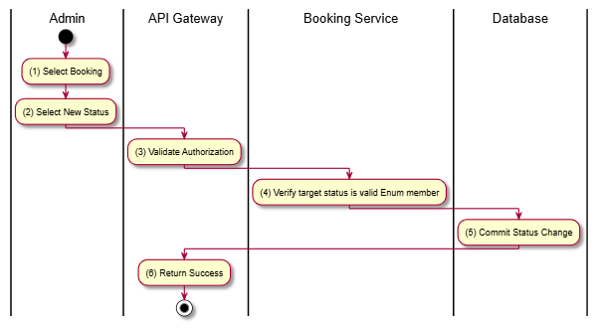

Business Rules
Activity | BR Code | Description
(4) | BR-1 | Target status must be a valid member of BookingStatus enum.
(5) | BR-2 | Changing status manually should be logged for auditing purposes.

Confirm Booking

Use Case Description
Name | Confirm Booking
Description | Manually marks a PENDING booking as CONFIRMED, typically used when payment is verified outside the automated system.
Actor | Admin
Trigger | POST /v1/bookings/admin/:id/confirm
Pre-condition | Admin authenticated; Booking status is PENDING.
Post-condition | Booking status set to CONFIRMED; Tickets generated.

Sequence Flow
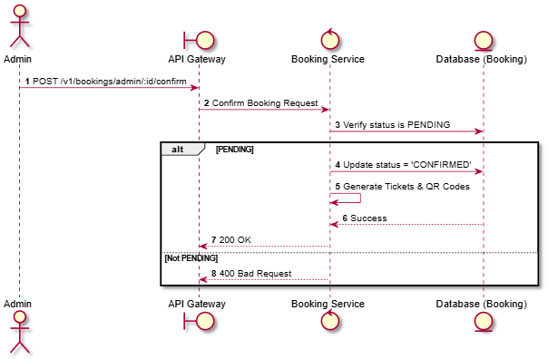

Activities Flow
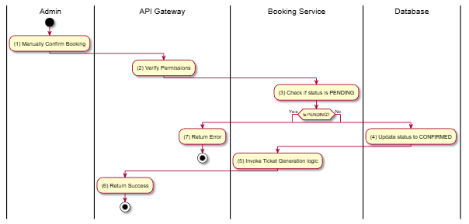

Business Rules
Activity | BR Code | Description
(4) | BR-1 | Confirming a booking manually bypasses the payment gateway IPN check.
(5) | BR-2 | Same ticket generation logic as automated flow (Section 3.7).

Complete Booking

Use Case Description
Name | Complete Booking
Description | Marks a CONFIRMED booking as COMPLETED. This usually happens automatically after the showtime ends or manually by an Admin.
Actor | Admin
Trigger | POST /v1/bookings/admin/:id/complete
Pre-condition | Admin authenticated; Booking status is CONFIRMED.
Post-condition | Booking status set to COMPLETED.

Sequence Flow
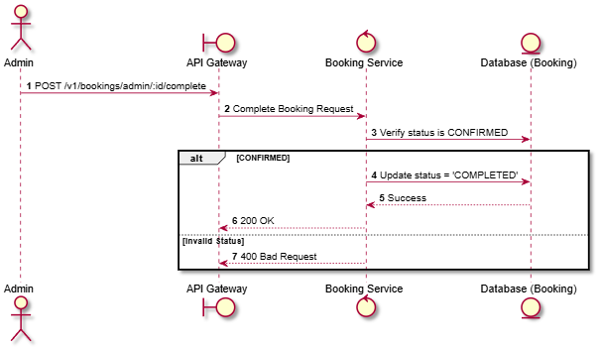

Activities Flow
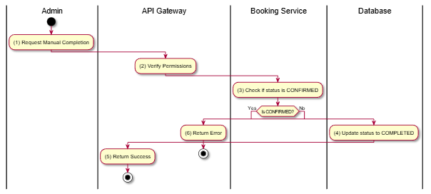

Business Rules
Activity | BR Code | Description
(4) | BR-1 | COMPLETED status indicates the service has been successfully rendered (user attended).

Expire Booking

Use Case Description
Name | Expire Booking
Description | Manually expires a PENDING booking that has exceeded its allowed payment time window.
Actor | Admin
Trigger | POST /v1/bookings/admin/:id/expire
Pre-condition | Admin authenticated; Booking status is PENDING.
Post-condition | Booking status set to EXPIRED; Seats released.

Sequence Flow
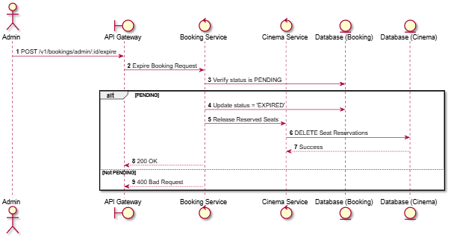

Activities Flow
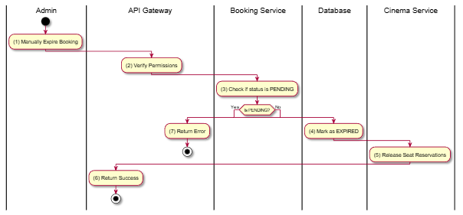

Business Rules
Activity | BR Code | Description
(3) | BR-1 | Bookings usually expire automatically after 15 minutes, but Admin can trigger this manually for cleanup.
(5) | BR-2 | Seats must be released immediately to make them available for others.

Get Booking Statistics

Use Case Description
Name | Get Booking Statistics
Description | Provides high-level statistics about bookings, such as total count by status, peak booking times, etc.
Actor | Admin
Trigger | GET /v1/bookings/admin/statistics
Pre-condition | Admin authenticated.
Post-condition | Statistical summary data returned.

Sequence Flow
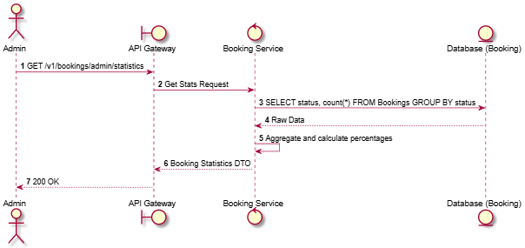

Activities Flow
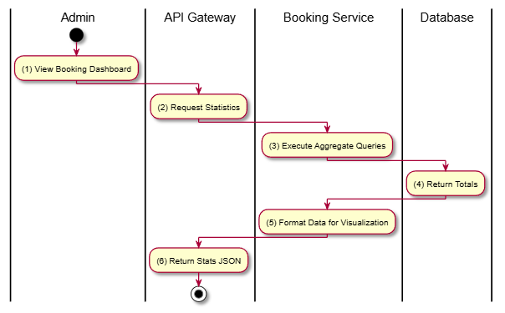

Business Rules
Activity | BR Code | Description
(3) | BR-1 | Statistics help in identifying system performance and booking trends.

Get Revenue Report

Use Case Description
Name | Get Revenue Report
Description | Generates a report of total revenue generated from bookings within a specific period, broken down by movie or cinema.
Actor | Admin
Trigger | GET /v1/bookings/admin/revenue-report
Pre-condition | Admin authenticated; Valid date range and grouping parameters.
Post-condition | Revenue report data returned.

Sequence Flow
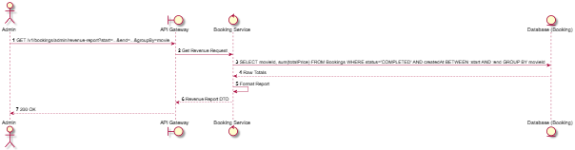

Activities Flow
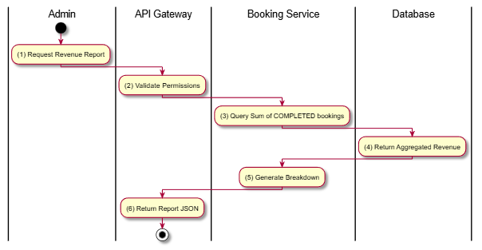

Business Rules
Activity | BR Code | Description
(3) | BR-1 | Only COMPLETED (and possibly CONFIRMED) bookings are counted towards revenue. CANCELLED or EXPIRED are excluded.
(3) | BR-2 | Reports should clearly distinguish between gross revenue and net revenue (minus 10% VAT).

Real-time Seat Selection

Hold Seat

Use Case Description
Name | Hold Seat
Description | Allows a member to temporarily lock a seat for 10 minutes while they complete their booking. This is a real-time operation using WebSockets and Redis.
Actor | Member
Trigger | WebSocket Event gateway.hold_seat
Pre-condition | Member authenticated; Showtime session active; Seat is currently 'Available'.
Post-condition | Seat status updated to 'Held' in Redis; Event broadcasted to other users.

Sequence Flow
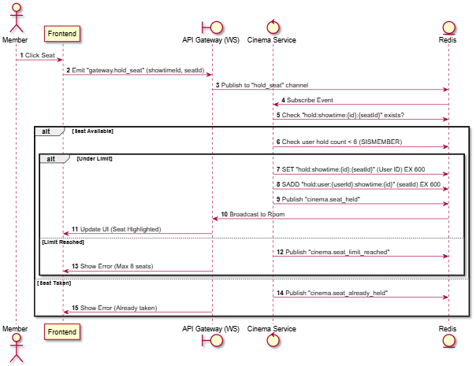

Activities Flow
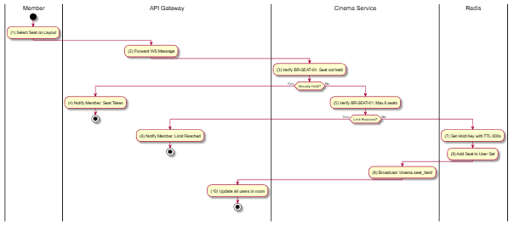

Business Rules
Activity | BR Code | Description
(5) | BR-1 | Maximum seats per user per showtime: 8 seats.
(7) | BR-2 | Seat hold duration (TTL): 10 minutes (600 seconds).
(3) | BR-3 | A seat cannot be held if it is already held by another user.

Release Seat

Use Case Description
Name | Release Seat
Description | Allows a member to manually release a seat they previously held.
Actor | Member
Trigger | WebSocket Event gateway.release_seat
Pre-condition | Member holds the seat.
Post-condition | Seat removed from Redis; Event broadcasted as 'Available'.

Sequence Flow
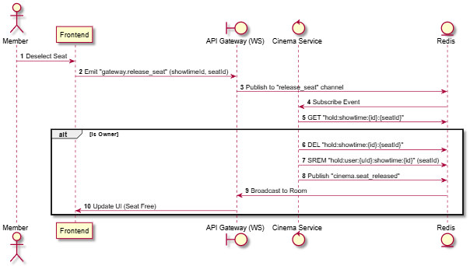

Activities Flow
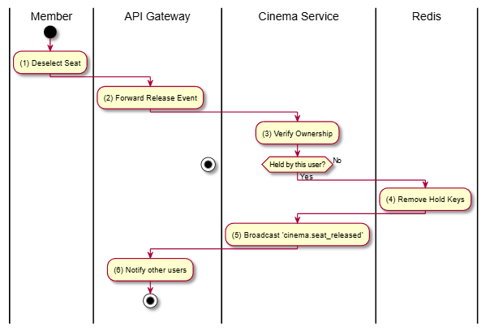

Business Rules
Activity | BR Code | Description
(3) | BR-1 | Users can only release seats they have personally held.

Confirm Seat Booked

Use Case Description
Name | Confirm Seat Booked
Description | Transitions a seat from 'Held' to 'Booked' status in the real-time layout once the booking is confirmed by the system.
Actor | System
Trigger | Redis Event booking.seat_booked
Pre-condition | Booking process successfully completed.
Post-condition | Seat status updated permanently for the duration of the showtime.

Sequence Flow
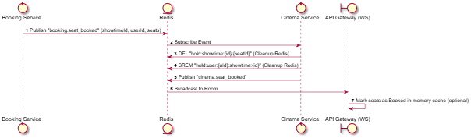

Activities Flow
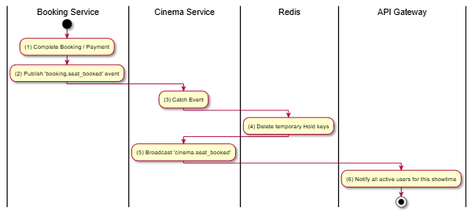

Business Rules
Activity | BR Code | Description
(4) | BR-1 | Real-time "Hold" state is temporary. Permanent "Booked" state is derived from Database (Postgres) but broadcasted via WebSocket for UX.

Clear Old Showtime Session

Use Case Description
Name | Clear Old Showtime Session
Description | Automatically releases all held seats from a previous showtime when a user navigates to a new showtime.
Actor | System
Trigger | Internal (Detect showtime change in client/gateway)
Pre-condition | User has held seats for a different showtime.
Post-condition | Previous showtime's seats released in Redis.

Sequence Flow
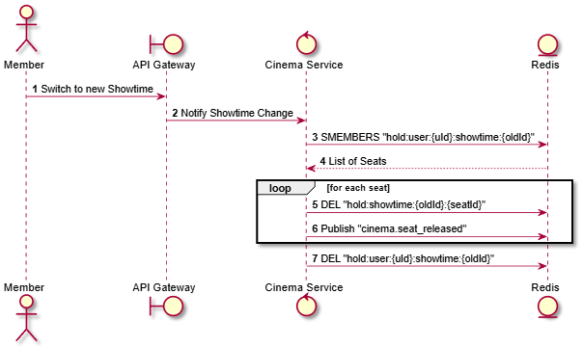

Activities Flow
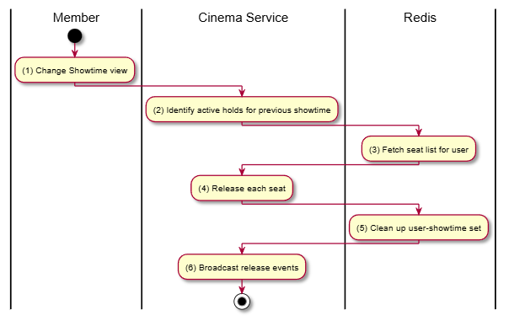

Business Rules
Activity | BR Code | Description
(2) | BR-1 | When a user selects a new showtime, all previously held seats from other showtimes are automatically released.

Get All Held Seats

Use Case Description
Name | Get All Held Seats
Description | Internal API call to retrieve all currently held seats for a showtime, typically used during initial layout load.
Actor | System
Trigger | Internal Service Call
Pre-condition | Showtime ID provided.
Post-condition | Map of seatId -> userId returned.

Sequence Flow
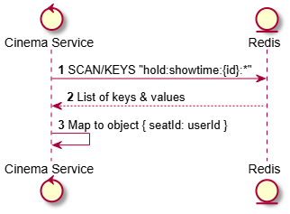

Activities Flow
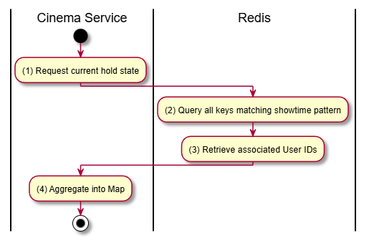

Business Rules
Activity | BR Code | Description
(2) | BR-1 | Efficient scanning of Redis is required to avoid blocking the main thread.

Get User Held Seats

Use Case Description
Name | Get User Held Seats
Description | Retrieves the specific list of seats currently held by the authenticated user for a given showtime.
Actor | System
Trigger | Internal Service Call
Pre-condition | User ID and Showtime ID provided.
Post-condition | List of seat IDs returned.

Sequence Flow
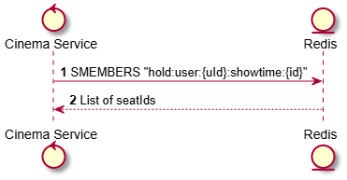

Activities Flow
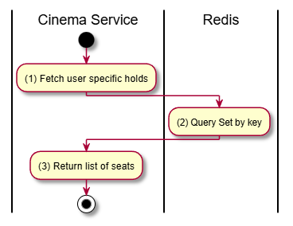

Business Rules
Activity | BR Code | Description
(2) | BR-1 | Used to highlight which seats are "Yours" vs "Others" on the UI.

Payment Transaction

Create Payment

Use Case Description
Name | Create Payment
Description | Initiates a payment transaction for a specific booking using a chosen payment gateway (e.g., VNPay).
Actor | Member
Trigger | POST /v1/payments/bookings/:bookingId
Pre-condition | Booking exists and status is PENDING; Member authenticated.
Post-condition | Payment record created (PENDING); Redirect URL generated for the member.

Sequence Flow
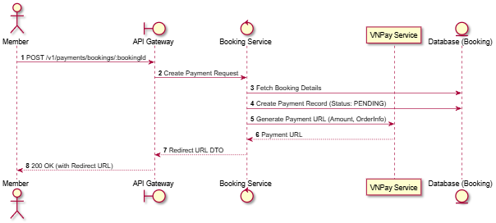

Activities Flow
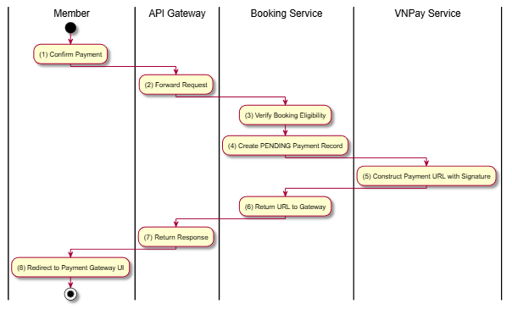

Business Rules
Activity | BR Code | Description
(3) | BR-1 | Payment must be initiated within 15 minutes of booking creation.
(5) | BR-2 | URL must include a secure hash (HMAC-SHA512) for integrity.

Get Payment Details

Use Case Description
Name | Get Payment Details
Description | Retrieves the status and transaction details of a specific payment.
Actor | Member
Trigger | GET /v1/payments/:id
Pre-condition | Member authenticated; Payment ID exists and belongs to the member.
Post-condition | Payment record details returned.

Sequence Flow
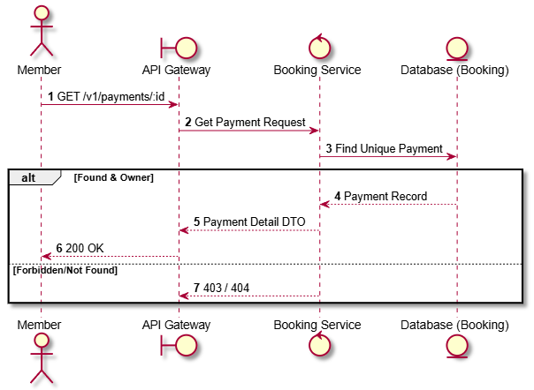

Activities Flow
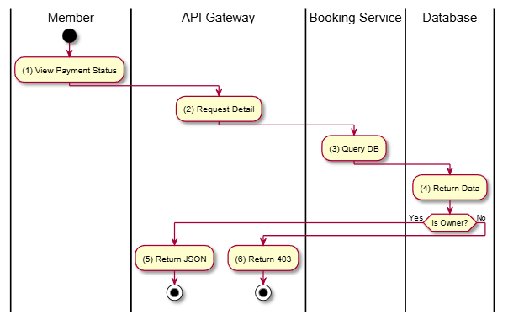

Business Rules
Activity | BR Code | Description
(3) | BR-1 | Only the member who initiated the payment can view its details.

Get Payments by Booking

Use Case Description
Name | Get Payments by Booking
Description | Lists all payment attempts associated with a specific booking.
Actor | Member
Trigger | GET /v1/payments/booking/:bookingId
Pre-condition | Member authenticated; Booking belongs to the member.
Post-condition | List of payment records returned.

Sequence Flow
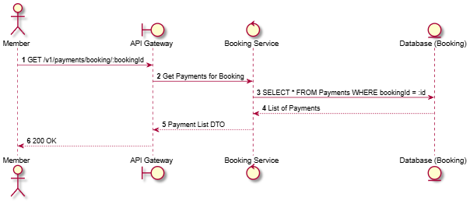

Activities Flow
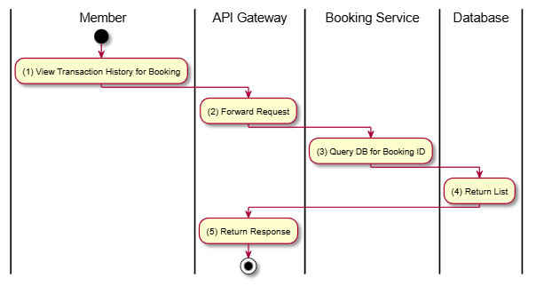

Business Rules
Activity | BR Code | Description
(3) | BR-1 | Useful for tracking failed attempts and final successful payment.
(3) | BR-2 | Only accessible to the booking owner.

VNPay IPN Webhook

Use Case Description
Name | VNPay IPN Webhook
Description | An asynchronous callback from VNPay to update the payment and booking status after a transaction is completed by the user.
Actor | System (VNPay)
Trigger | GET /v1/payments/vnpay/ipn
Pre-condition | Request includes valid VNPay parameters and signature.
Post-condition | Payment status updated; Booking status confirmed if successful; Tickets generated.

Sequence Flow
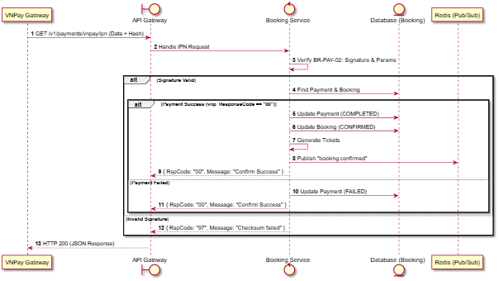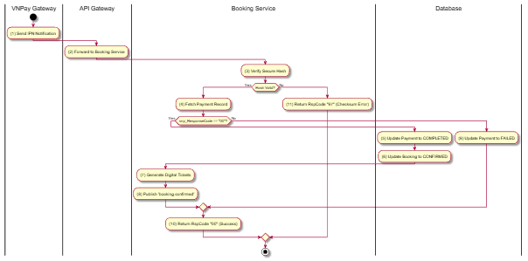

Activities Flow

Business Rules
Activity | BR Code | Description
(1) | BR-1 | VNPay IPN webhook is unauthenticated (public endpoint) but verified by hash.
(3) | BR-2 | VNPay IPN must return exact format: { RspCode: string, Message: string }.
(6) | BR-3 | Booking status transition: PENDING -> CONFIRMED.

VNPay Return URL

Use Case Description
Name | VNPay Return URL
Description | The browser redirect endpoint where users are sent after completing payment on the VNPay UI. It provides immediate feedback to the user.
Actor | Member
Trigger | GET /v1/payments/vnpay/return
Pre-condition | User redirected from VNPay.
Post-condition | User redirected to Frontend success or failure page.

Sequence Flow
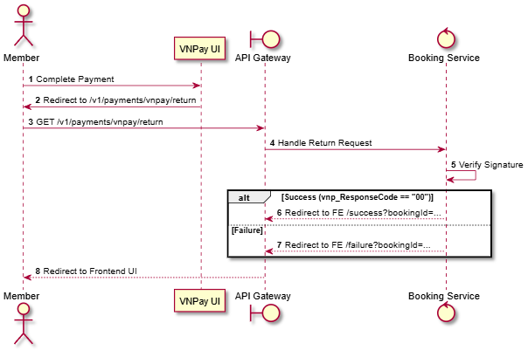

Activities Flow
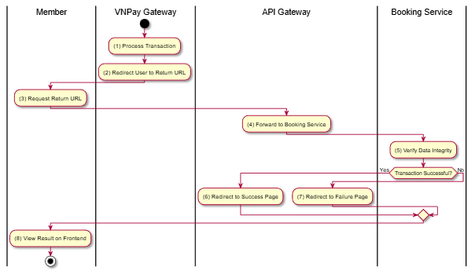

Business Rules
Activity | BR Code | Description
(5) | BR-1 | Immediate feedback only. Data consistency is guaranteed by PY-04 (IPN).
(6) | BR-2 | Success page should display booking summary and link to tickets.

Admin List All Payments

Use Case Description
Name | Admin List All Payments
Description | Allows Administrators to view a comprehensive list of all payment transactions in the system.
Actor | Admin
Trigger | GET /v1/payments/admin/all
Pre-condition | Admin authenticated.
Post-condition | Paginated list of all payments returned.

Sequence Flow
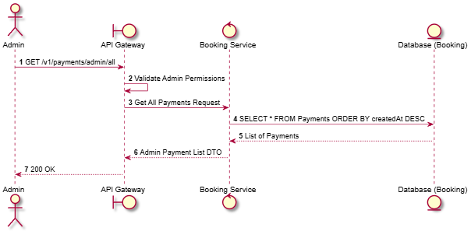

Activities Flow
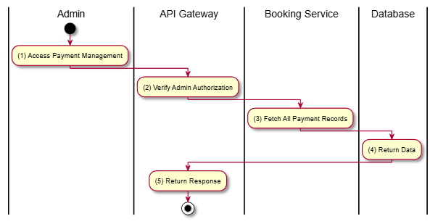

Business Rules
Activity | BR Code | Description
(2) | BR-1 | Access is restricted to Admin role.
(3) | BR-2 | Includes details like Transaction Reference, Gateway Response, and Amount.

Find Payments by Status

Use Case Description
Name | Find Payments by Status
Description | Allows an Admin to filter the payment list by status (e.g., PENDING, COMPLETED, FAILED).
Actor | Admin
Trigger | GET /v1/payments/admin/status/:status
Pre-condition | Admin authenticated; Status is a valid PaymentStatus.
Post-condition | List of matching payments returned.

Sequence Flow
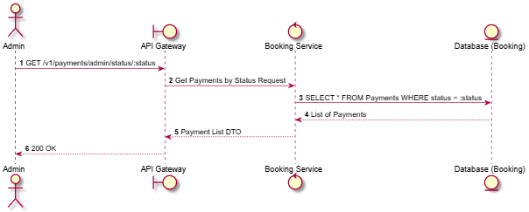

Activities Flow
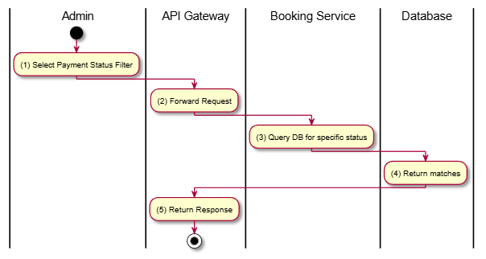

Business Rules
Activity | BR Code | Description
(3) | BR-1 | Valid values: PENDING, PROCESSING, COMPLETED, FAILED, REFUNDED.

Cancel Payment

Use Case Description
Name | Cancel Payment
Description | Allows an Admin to manually mark a PENDING or PROCESSING payment as FAILED/CANCELLED.
Actor | Admin
Trigger | PUT /v1/payments/admin/:id/cancel
Pre-condition | Admin authenticated; Payment exists.
Post-condition | Payment status updated.

Sequence Flow
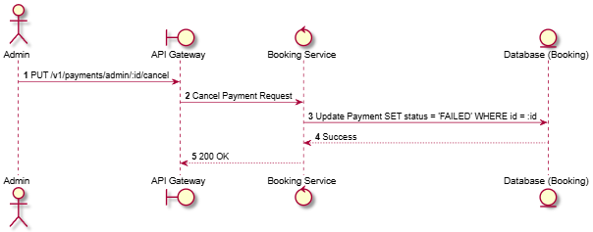

Activities Flow
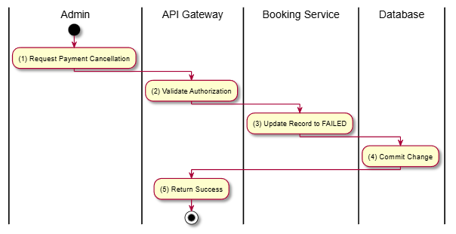

Business Rules
Activity | BR Code | Description
(3) | BR-1 | Does not trigger a refund at the gateway; only updates internal status.

Get Payment Statistics

Use Case Description
Name | Get Payment Statistics
Description | Provides a summary of payment transactions, such as success rate and distribution of payment methods.
Actor | Admin
Trigger | GET /v1/payments/admin/statistics
Pre-condition | Admin authenticated.
Post-condition | Statistical data returned.

Sequence Flow
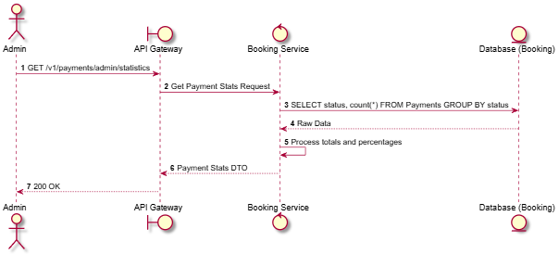

Activities Flow
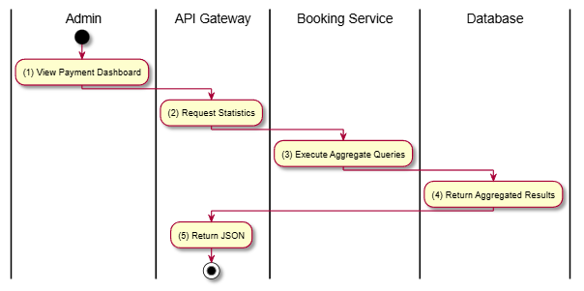

Business Rules
Activity | BR Code | Description
(3) | BR-1 | Statistics help monitor gateway stability and user preferences.

Ticket Management

Get Ticket Details

Use Case Description
Name | Get Ticket Details
Description | Retrieves full information about a specific digital ticket, including seat number, showtime details, and its current validity status.
Actor | Member
Trigger | GET /v1/tickets/:id
Pre-condition | Member authenticated; Ticket ID exists and belongs to the member.
Post-condition | Ticket details returned.

Sequence Flow
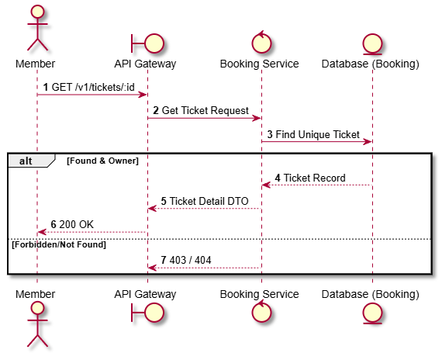

Activities Flow
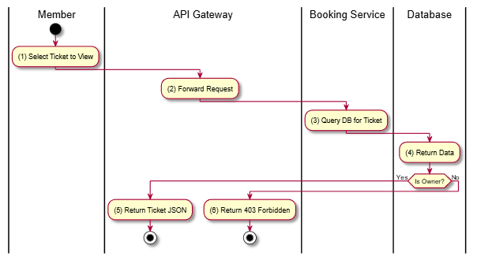

Business Rules
Activity | BR Code | Description
(3) | BR-1 | Ticket status must be one of the TicketStatus enum values.
(3) | BR-2 | Only the member who bought the ticket can view its detailed information.

Find Ticket by Code

Use Case Description
Name | Find Ticket by Code
Description | Allows a Member or Staff to retrieve ticket information using the unique alphanumeric ticket code (e.g., from a search or manual entry).
Actor | Member, Staff
Trigger | GET /v1/tickets/code/:ticketCode
Pre-condition | User authenticated; Ticket code exists.
Post-condition | Ticket information returned.

Sequence Flow
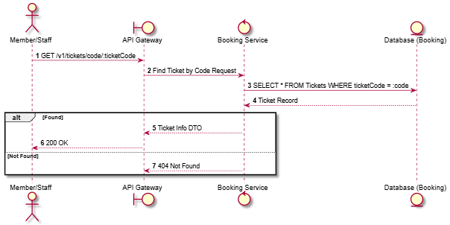

Activities Flow
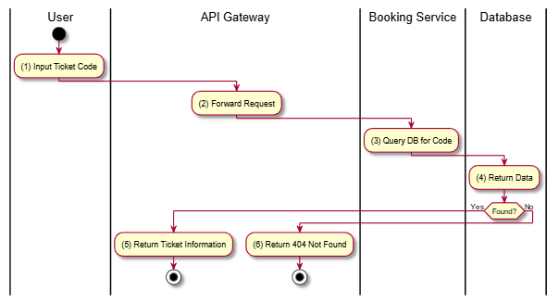

Business Rules
Activity | BR Code | Description
(3) | BR-1 | Codes are unique across the entire system.
(3) | BR-2 | Staff can see any ticket, while Members can only see their own tickets.

Validate Ticket

Use Case Description
Name | Validate Ticket
Description | Allows Staff to check the validity of a ticket (e.g., upon scanning QR code) without marking it as used.
Actor | Staff
Trigger | POST /v1/tickets/:id/validate
Pre-condition | Staff authenticated; Ticket ID exists.
Post-condition | Validation result (Valid/Invalid/Expired) returned.

Sequence Flow
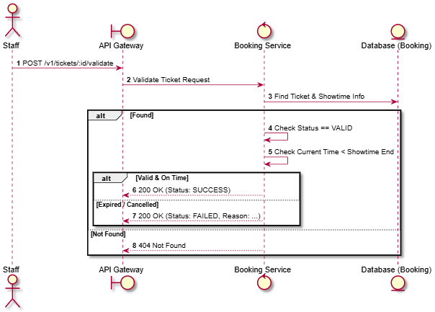

Activities Flow
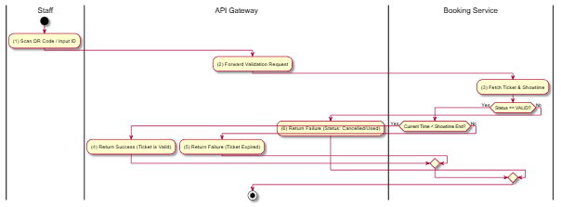

Business Rules
Activity | BR Code | Description
(3) | BR-1 | Valid states for validation: VALID.
(3) | BR-2 | Tickets cannot be validated after the movie showtime has ended.

Use Ticket (Mark Entry)

Use Case Description
Name | Use Ticket (Mark Entry)
Description | Marks a ticket as USED when the customer enters the cinema hall. This prevents the same ticket from being used twice.
Actor | Staff
Trigger | POST /v1/tickets/:id/use
Pre-condition | Staff authenticated; Ticket status is VALID.
Post-condition | Ticket status updated to USED.

Sequence Flow
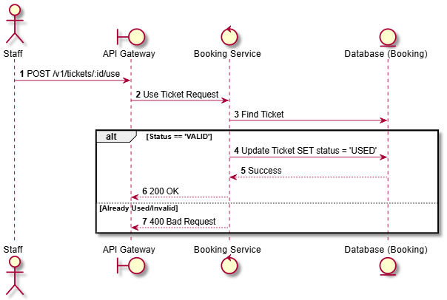

Activities Flow
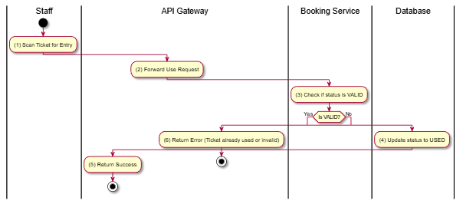

Business Rules
Activity | BR Code | Description
(3) | BR-1 | A ticket can only be transitioned to USED from VALID status.
(4) | BR-2 | The timestamp of usage should be recorded for auditing.

Generate QR Code

Use Case Description
Name | Generate QR Code
Description | Generates a base64-encoded QR code image containing the unique ticket ID or code for scanning.
Actor | Member
Trigger | GET /v1/tickets/:id/qr
Pre-condition | Ticket exists and belongs to the Member.
Post-condition | QR Code image (base64) returned.

Sequence Flow
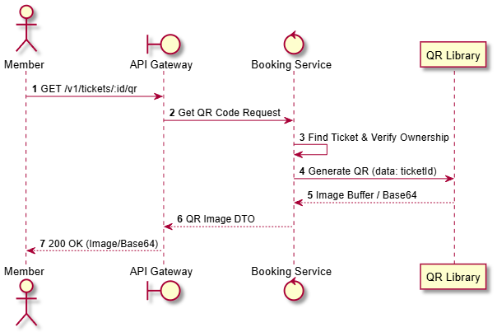

Activities Flow
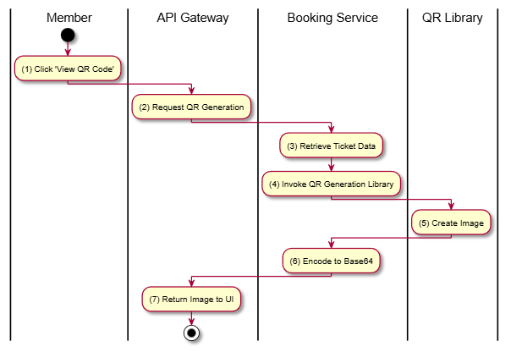

Business Rules
Activity | BR Code | Description
(4) | BR-1 | QR code typically contains the ticket's internal UUID or a specialized validation token.
(4) | BR-2 | QR Code Generation technology: qrcode v1.5.4.

Admin List All Tickets

Use Case Description
Name | Admin List All Tickets
Description | Allows Administrators to view a paginated list of all tickets issued in the system.
Actor | Admin
Trigger | GET /v1/tickets/admin/all
Pre-condition | Admin authenticated.
Post-condition | List of all tickets returned.

Sequence Flow
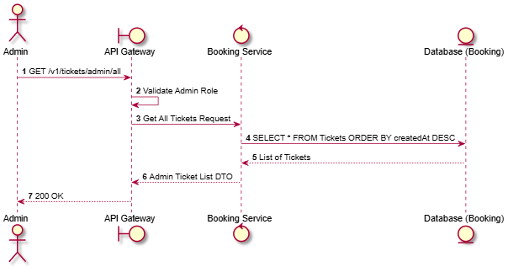

Activities Flow
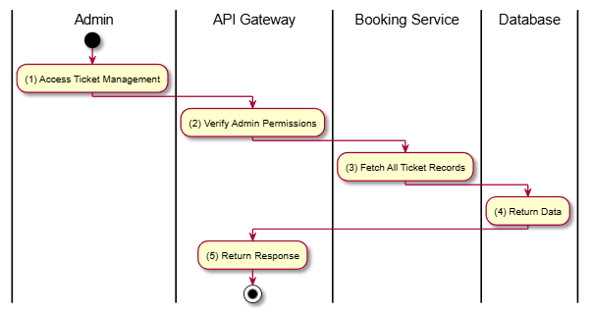

Business Rules
Activity | BR Code | Description
(2) | BR-1 | Restricted to Admin users.
(3) | BR-2 | Includes ticket status, seat info, and associated booking ID.

Find Tickets by Showtime

Use Case Description
Name | Find Tickets by Showtime
Description | Allows an Admin to view all tickets associated with a specific showtime.
Actor | Admin
Trigger | GET /v1/tickets/admin/showtime/:showtimeId
Pre-condition | Admin authenticated; Showtime ID exists.
Post-condition | List of tickets for the showtime returned.

Sequence Flow
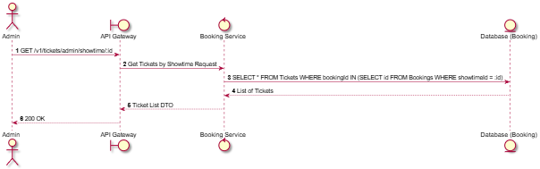

Activities Flow
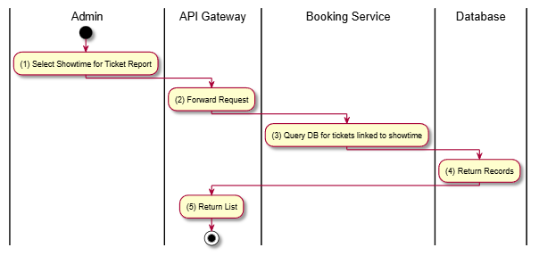

Business Rules
Activity | BR Code | Description
(3) | BR-1 | Useful for verifying seat occupancy for a specific screening.
(3) | BR-2 | Includes status of each ticket (VALID, USED, CANCELLED).

Find Tickets by Booking

Use Case Description
Name | Find Tickets by Booking
Description | Retrieves all tickets belonging to a specific booking ID.
Actor | Admin
Trigger | GET /v1/tickets/admin/booking/:bookingId
Pre-condition | Admin authenticated; Booking ID exists.
Post-condition | List of tickets for the booking returned.

Sequence Flow
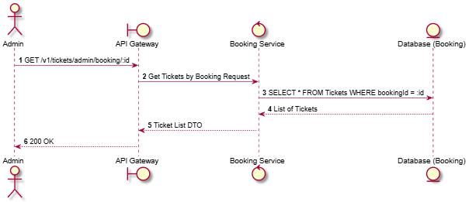

Activities Flow
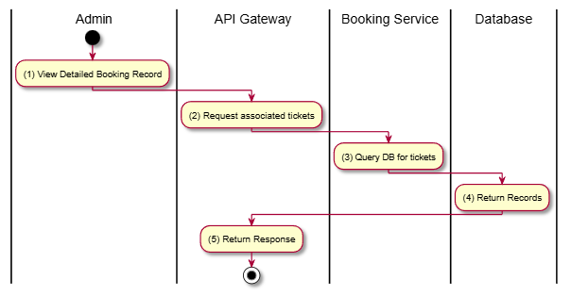

Business Rules
Activity | BR Code | Description
(3) | BR-1 | A single booking can contain multiple tickets (up to 8, as per BR-SEAT-01).

Bulk Validate Tickets

Use Case Description
Name | Bulk Validate Tickets
Description | Allows an Admin to validate a list of tickets simultaneously.
Actor | Admin
Trigger | POST /v1/tickets/admin/bulk-validate
Pre-condition | Admin authenticated; List of ticket IDs provided.
Post-condition | Validation report for all IDs returned.

Sequence Flow
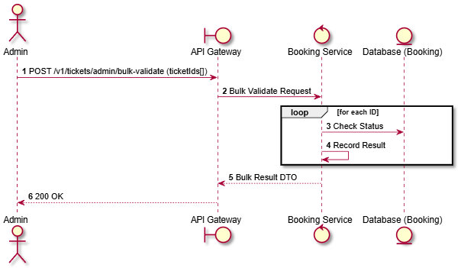

Activities Flow
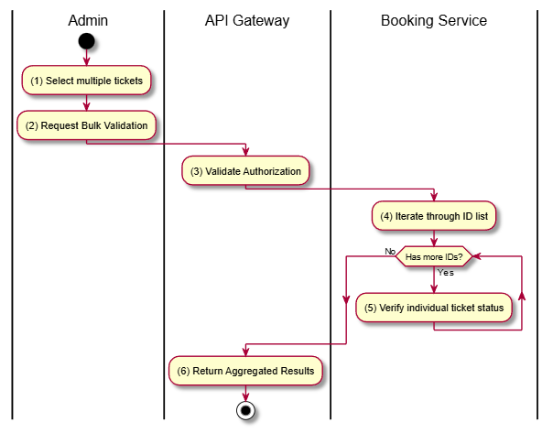

Business Rules
Activity | BR Code | Description
(4) | BR-1 | Typically used for mass entry processing or system-wide checks.

Cancel Ticket

Use Case Description
Name | Cancel Ticket
Description | Allows an Admin to manually cancel an individual ticket (without necessarily cancelling the entire booking).
Actor | Admin
Trigger | PUT /v1/tickets/admin/:id/cancel
Pre-condition | Admin authenticated; Ticket status is VALID.
Post-condition | Ticket status updated to CANCELLED.

Sequence Flow
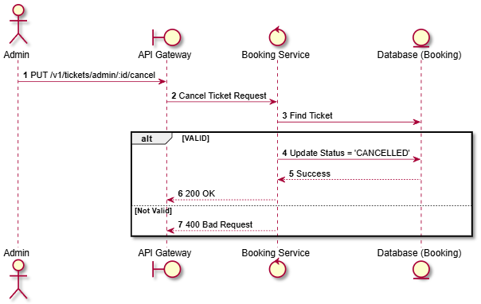

Activities Flow
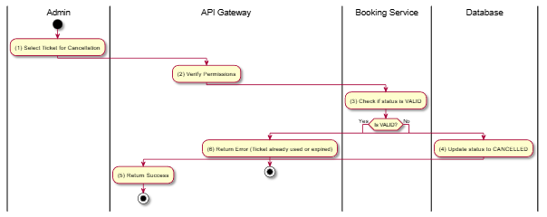

Business Rules
Activity | BR Code | Description
(4) | BR-1 | Transitioning a ticket to CANCELLED makes the corresponding seat available in the database (via cascading effects or manual trigger).

Refund Management

Create Refund Request

Use Case Description
Name | Create Refund Request
Description | Allows a Member to submit a formal request for a refund after cancelling a booking.
Actor | Member
Trigger | POST /v1/refunds
Pre-condition | Booking is CANCELLED; Payment status is COMPLETED; Request made within policy limits.
Post-condition | Refund record created with status PENDING.

Sequence Flow
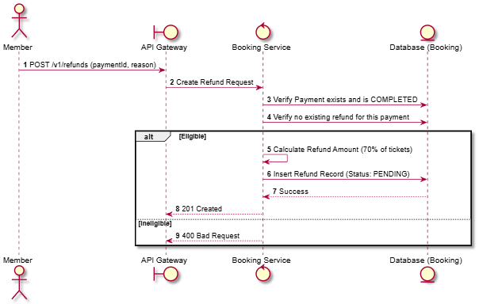

Activities Flow
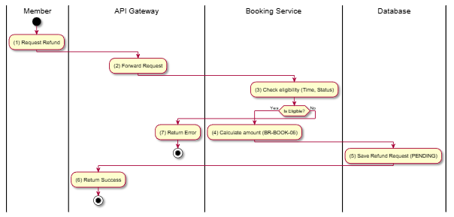

Business Rules
Activity | BR Code | Description
(3) | BR-1 | Cancellation must be made at least 2 hours before showtime to be eligible.
(4) | BR-2 | Refund percentage on ticket cancellation: 70%.

List Refunds

Use Case Description
Name | List Refunds
Description | Allows Administrators to view a list of all refund requests in the system.
Actor | Admin
Trigger | GET /v1/refunds
Pre-condition | Admin authenticated.
Post-condition | Paginated list of refund requests returned.

Sequence Flow
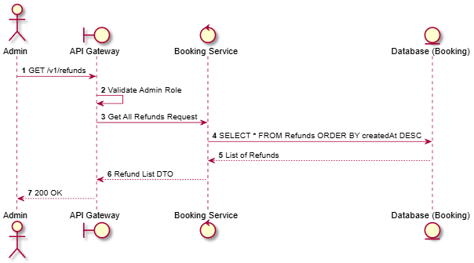

Activities Flow
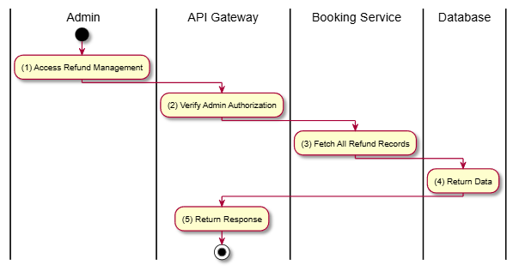

Business Rules
Activity | BR Code | Description
(2) | BR-1 | Restricted to Admin users.
(3) | BR-2 | DTO should include booking ID, user name, and requested amount.

Get Refund Details

Use Case Description
Name | Get Refund Details
Description | Retrieves full information about a specific refund request.
Actor | Admin
Trigger | GET /v1/refunds/:id
Pre-condition | Admin authenticated; Refund ID exists.
Post-condition | Refund details returned.

Sequence Flow
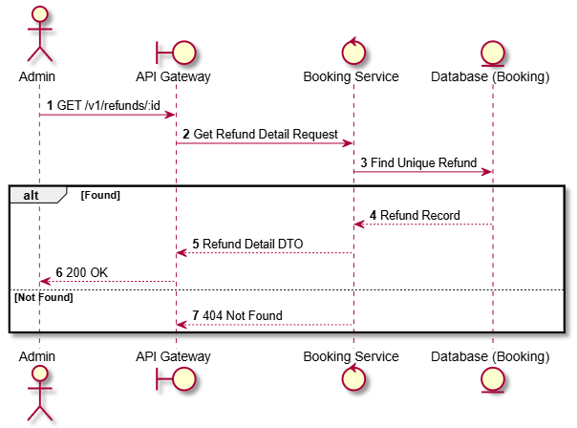

Activities Flow
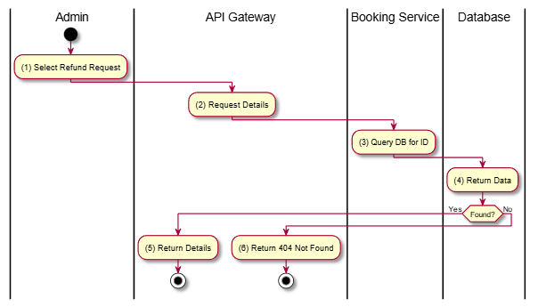

Business Rules
Activity | BR Code | Description
(1) | BR-1 | Standard administrative read operation.

Find Refunds by Payment

Use Case Description
Name | Find Refunds by Payment
Description | Retrieves the refund request(s) associated with a specific payment transaction.
Actor | Admin
Trigger | GET /v1/refunds/payment/:paymentId
Pre-condition | Admin authenticated; Payment ID exists.
Post-condition | List of associated refund records returned.

Sequence Flow
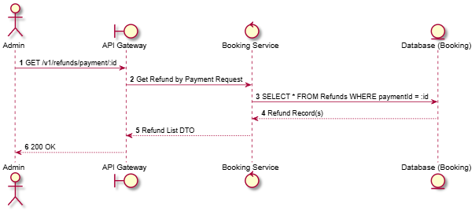

Activities Flow
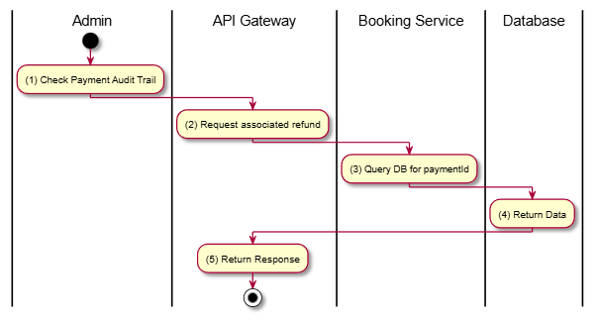

Business Rules
Activity | BR Code | Description
(3) | BR-1 | Typically, only one refund is allowed per payment.
(3) | BR-2 | Used to track whether a payment has already been reversed.

Process Refund

Use Case Description
Name | Process Refund
Description | Marks a refund request as PROCESSING while it is being handled by the finance department or gateway.
Actor | Admin
Trigger | PUT /v1/refunds/:id/process
Pre-condition | Admin authenticated; Refund status is PENDING.
Post-condition | Refund status updated to PROCESSING.

Sequence Flow
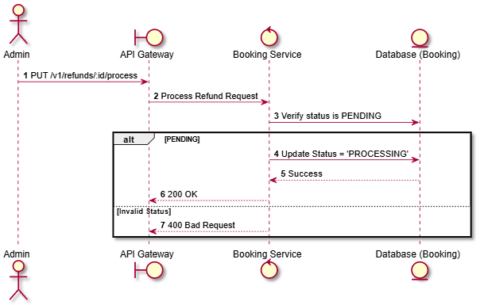

Activities Flow
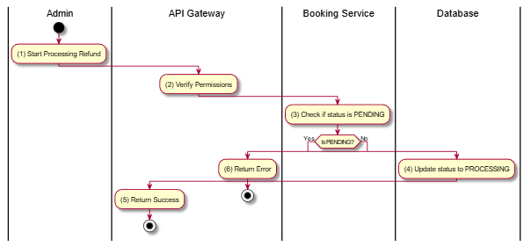

Business Rules
Activity | BR Code | Description
(4) | BR-1 | Valid values for RefundStatus: PENDING, PROCESSING, COMPLETED, FAILED.

Approve Refund

Use Case Description
Name | Approve Refund
Description | Formally approves a refund request and updates its status to COMPLETED.
Actor | Admin
Trigger | PUT /v1/refunds/:id/approve
Pre-condition | Admin authenticated; Refund status is PROCESSING.
Post-condition | Refund status set to COMPLETED; Payment status updated to REFUNDED.

Sequence Flow
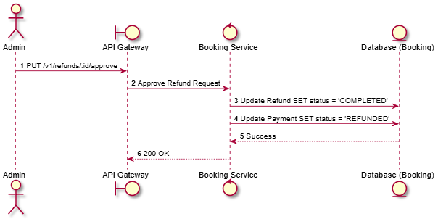

Activities Flow
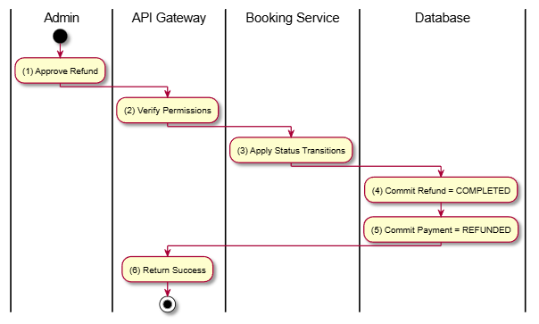

Business Rules
Activity | BR Code | Description
(4) | BR-1 | Approval assumes the money has been successfully sent back to the user's account.
(5) | BR-2 | Payment status synchronization is critical for financial reconciliation.

Reject Refund

Use Case Description
Name | Reject Refund
Description | Rejects a refund request (e.g., due to policy violation or invalid data) and updates its status to FAILED.
Actor | Admin
Trigger | PUT /v1/refunds/:id/reject
Pre-condition | Admin authenticated; Reason for rejection provided.
Post-condition | Refund status set to FAILED; Rejection reason logged.

Sequence Flow
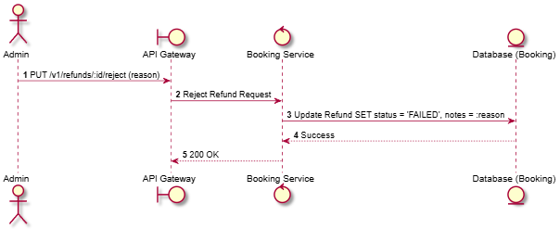

Activities Flow
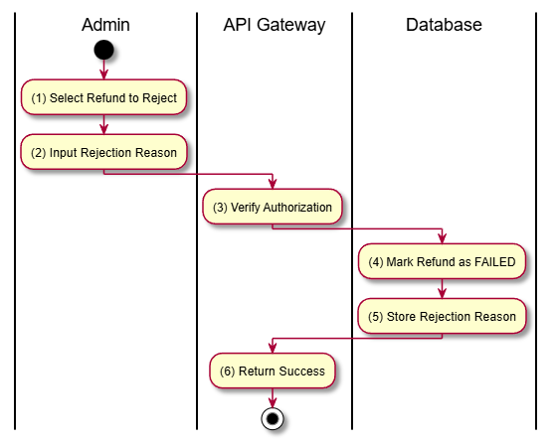

Business Rules
Activity | BR Code | Description
(2) | BR-1 | A reason must be provided for all rejected refunds to maintain audit quality.

Concessions FB

List Concessions

Use Case Description
Name | List Concessions
Description | Retrieves a list of all food and beverage items (concessions) available for purchase.
Actor | Guest, Member
Trigger | GET /v1/concessions
Pre-condition | None.
Post-condition | List of concession items returned.

Sequence Flow
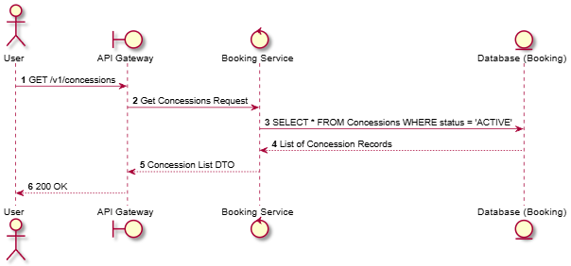

Activities Flow
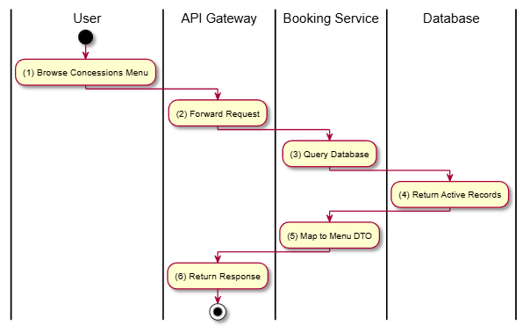

Business Rules
Activity | BR Code | Description
(4) | BR-1 | Categorized by ConcessionCategory (FOOD, DRINK, COMBO, MERCHANDISE).
(4) | BR-2 | Only items currently in stock or active are displayed to public users.

Get Concession Details

Use Case Description
Name | Get Concession Details
Description | Retrieves full information about a specific concession item, including description, ingredients, and nutritional info (if available).
Actor | Guest, Member
Trigger | GET /v1/concessions/:id
Pre-condition | Concession ID exists.
Post-condition | Detailed concession information returned.

Sequence Flow
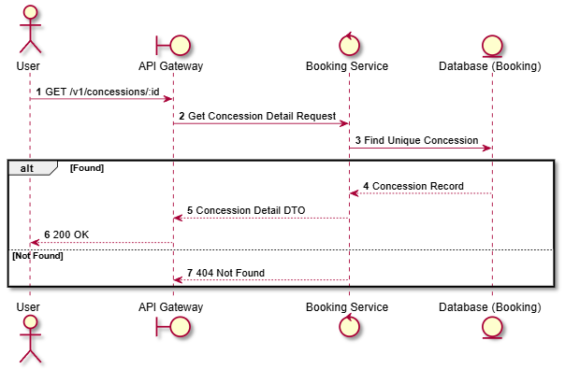

Activities Flow
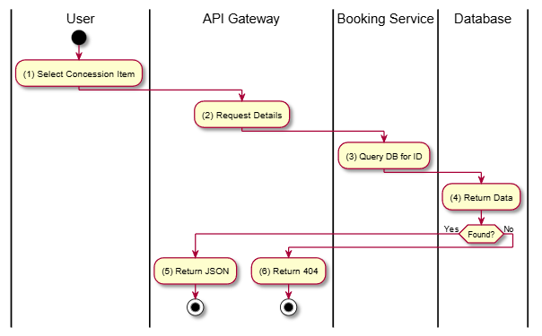

Business Rules
Activity | BR Code | Description
(1) | BR-1 | Standard read operation for a single concession item.

Create Concession

Use Case Description
Name | Create Concession
Description | Allows an Administrator to add a new food or beverage item to the catalog.
Actor | Admin
Trigger | POST /v1/concessions
Pre-condition | Admin authenticated; Valid payload (Name, Price, Category).
Post-condition | New concession record created.

Sequence Flow
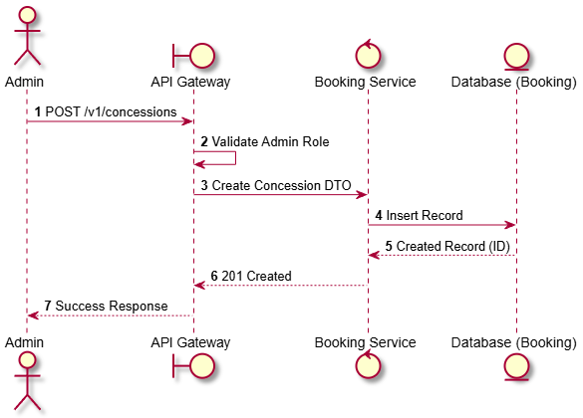

Activities Flow
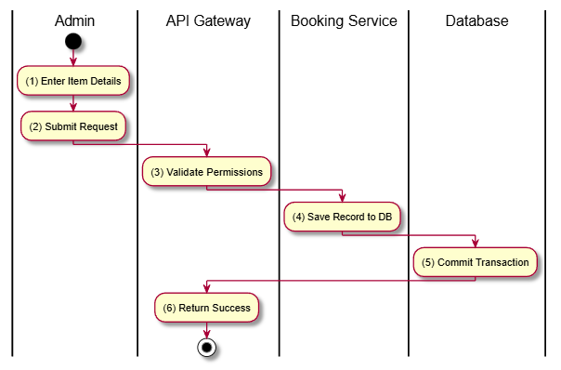

Business Rules
Activity | BR Code | Description
(1) | BR-1 | Required: Name, Price, Category. Optional: Description, Image URL.
(1) | BR-2 | Category must be a valid ConcessionCategory enum member.

Update Concession

Use Case Description
Name | Update Concession
Description | Modifies the information of an existing concession item.
Actor | Admin
Trigger | PUT /v1/concessions/:id
Pre-condition | Admin authenticated; Concession ID exists.
Post-condition | Concession record updated.

Sequence Flow
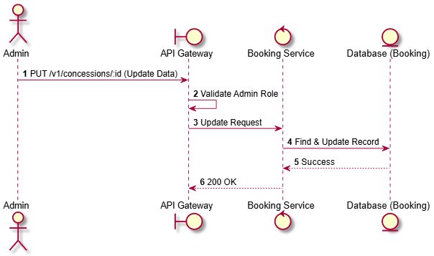

Activities Flow
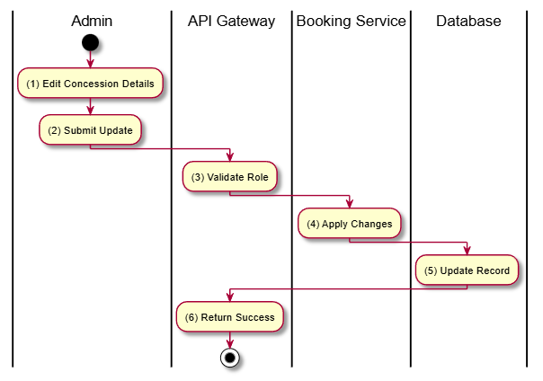

Business Rules
Activity | BR Code | Description
(4) | BR-1 | Can update price, name, category, or description.
(4) | BR-2 | Price updates only affect future transactions.

Delete Concession

Use Case Description
Name | Delete Concession
Description | Removes a concession item from the catalog or marks it as inactive.
Actor | Admin
Trigger | DELETE /v1/concessions/:id
Pre-condition | Admin authenticated; Concession exists.
Post-condition | Concession removed or status set to INACTIVE.

Sequence Flow
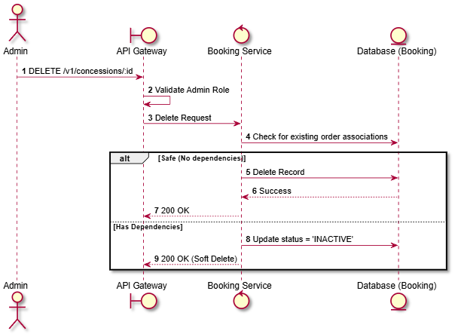

Activities Flow
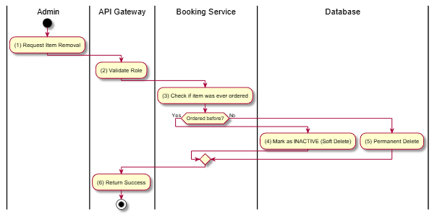

Business Rules
Activity | BR Code | Description
(3) | BR-1 | Items with transaction history should be soft-deleted to maintain data integrity for reporting.

Update Inventory

Use Case Description
Name | Update Inventory
Description | Allows an Administrator to update the available stock quantity for a concession item.
Actor | Admin
Trigger | PATCH /v1/concessions/:id/inventory
Pre-condition | Admin authenticated; Valid numeric quantity provided.
Post-condition | Stock level updated in database.

Sequence Flow
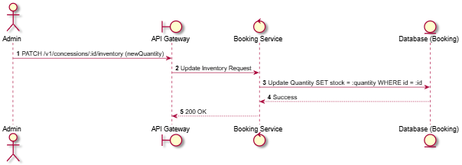

Activities Flow
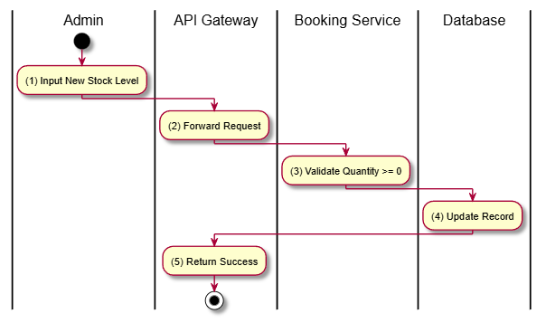

Business Rules
Activity | BR Code | Description
(3) | BR-1 | Inventory levels should decrement automatically when a booking is confirmed (if implemented in BK flow).
(3) | BR-2 | Stock quantity cannot be negative.

Promotions Discounts

List Promotions

Use Case Description
Name | List Promotions
Description | Retrieves a list of active promotions available to the user.
Actor | Guest, Member
Trigger | GET /v1/promotions
Pre-condition | None.
Post-condition | List of promotions returned.

Sequence Flow
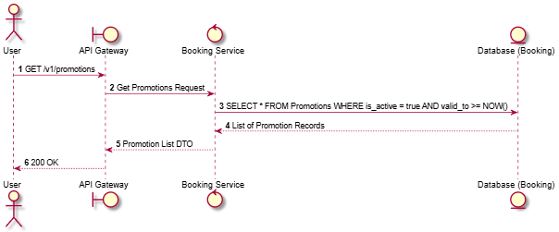

Activities Flow
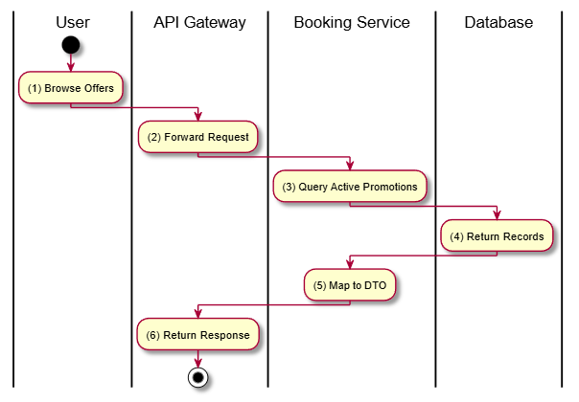

Business Rules
Activity | BR Code | Description
(3) | BR-1 | Promotion must be within valid date range (valid_from to valid_to).
(3) | BR-2 | Only promotions marked as is_active = true are displayed.
(3) | BR-3 | Supports various types: PERCENTAGE, FIXED_AMOUNT, etc.

Get Promotion Details

Use Case Description
Name | Get Promotion Details
Description | Retrieves full information about a specific promotion, including its terms and conditions.
Actor | Guest, Member
Trigger | GET /v1/promotions/:id
Pre-condition | Promotion ID exists.
Post-condition | Detailed promotion information returned.

Sequence Flow
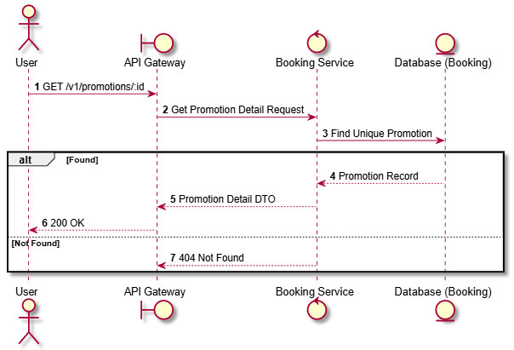

Activities Flow
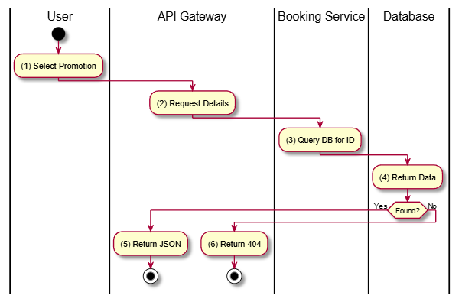

Business Rules
Activity | BR Code | Description
(1) | BR-1 | Standard read operation for a single promotion item.

Find Promotion by Code

Use Case Description
Name | Find Promotion by Code
Description | Retrieves promotion details using a unique alphanumeric code (e.g., "SUMMER20").
Actor | Member
Trigger | GET /v1/promotions/code/:code
Pre-condition | Member authenticated; Code exists.
Post-condition | Promotion details returned.

Sequence Flow
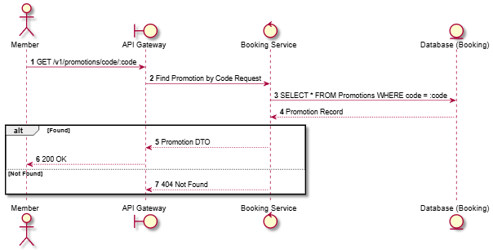

Activities Flow
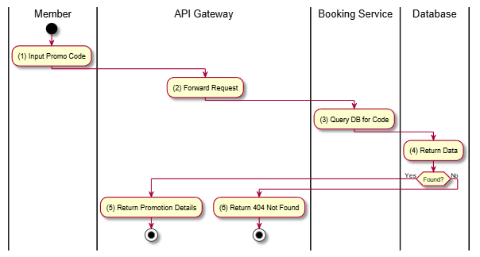

Business Rules
Activity | BR Code | Description
(3) | BR-1 | Code matching should be case-insensitive.
(3) | BR-2 | Even if found, the promotion must still be within its valid date range to be usable.

Validate Promotion Code

Use Case Description
Name | Validate Promotion Code
Description | Validates a promotion code against a specific booking subtotal to check if it's applicable.
Actor | Member
Trigger | POST /v1/promotions/validate/:code
Pre-condition | Member authenticated; Valid payload (subtotal).
Post-condition | Validation result (Applicable/Not Applicable) and potential discount returned.

Sequence Flow
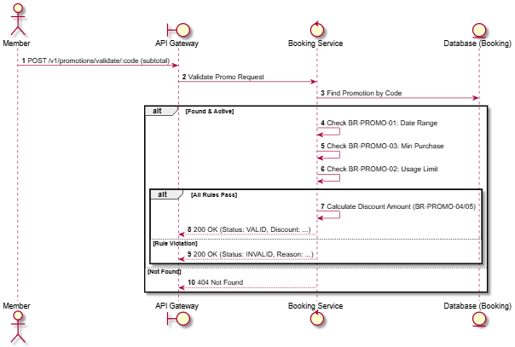

Activities Flow
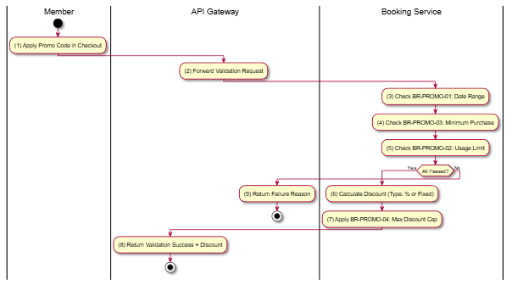

Business Rules
Activity | BR Code | Description
(3) | BR-1 | Promotion must be within valid date range.
(5) | BR-2 | Promotion usage limit is enforced per promotion.
(4) | BR-3 | Minimum purchase amount is validated before applying promotion.
(7) | BR-4 | For PERCENTAGE type promotions, max_discount cap is applied.
(6) | BR-5 | Discount cannot exceed the subtotal amount.

Create Promotion

Use Case Description
Name | Create Promotion
Description | Allows an Administrator to create a new promotional offer or discount code.
Actor | Admin
Trigger | POST /v1/promotions
Pre-condition | Admin authenticated; Valid payload (Code, Type, Value, Dates).
Post-condition | New promotion record created.

Sequence Flow
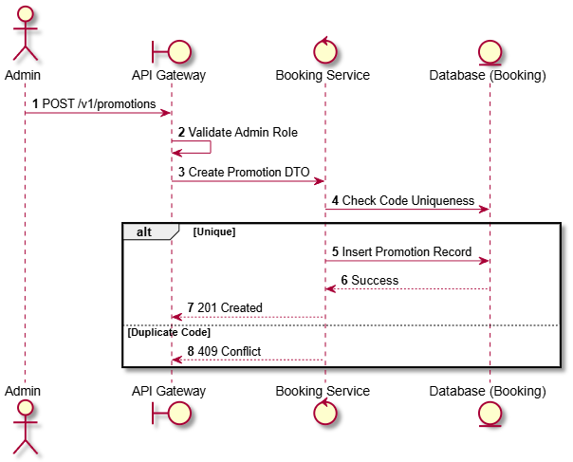

Activities Flow
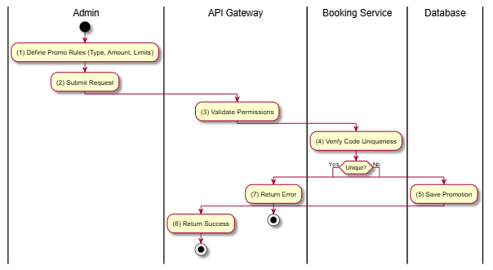

Business Rules
Activity | BR Code | Description
(1) | BR-1 | Required: Code, PromotionType, DiscountValue, ValidFrom, ValidTo.
(1) | BR-2 | PromotionType must be one of: PERCENTAGE, FIXED_AMOUNT, FREE_ITEM, POINTS.

Update Promotion

Use Case Description
Name | Update Promotion
Description | Modifies the terms or details of an existing promotion.
Actor | Admin
Trigger | PUT /v1/promotions/:id
Pre-condition | Admin authenticated; Promotion ID exists.
Post-condition | Promotion record updated.

Sequence Flow
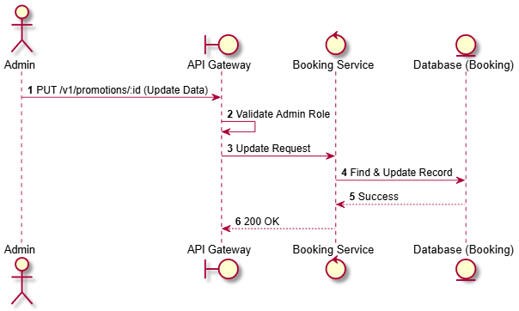

Activities Flow
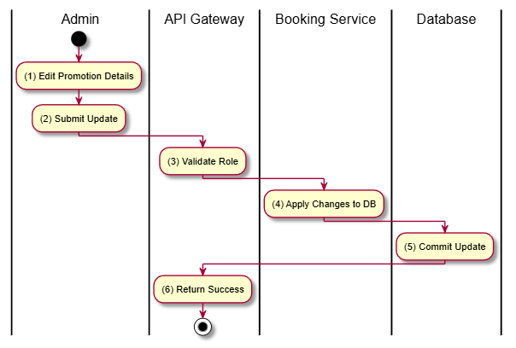

Business Rules
Activity | BR Code | Description
(4) | BR-1 | Can update dates, values, and limits.
(4) | BR-2 | Changing the code is generally discouraged but allowed if unique.

Delete Promotion

Use Case Description
Name | Delete Promotion
Description | Removes a promotion from the system.
Actor | Admin
Trigger | DELETE /v1/promotions/:id
Pre-condition | Admin authenticated; Promotion ID exists.
Post-condition | Promotion record removed or soft-deleted.

Sequence Flow
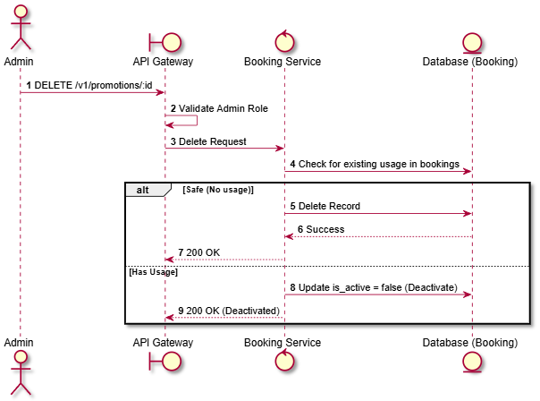

Activities Flow
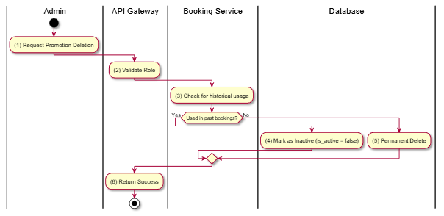

Business Rules
Activity | BR Code | Description
(3) | BR-1 | Promotions used in completed bookings should be soft-deleted to maintain audit integrity.

Toggle Promotion Active

Use Case Description
Name | Toggle Promotion Active
Description | Allows an Admin to quickly enable or disable a promotion without deleting it.
Actor | Admin
Trigger | PATCH /v1/promotions/:id/toggle-active
Pre-condition | Admin authenticated; Promotion ID exists.
Post-condition | is_active status flipped.

Sequence Flow
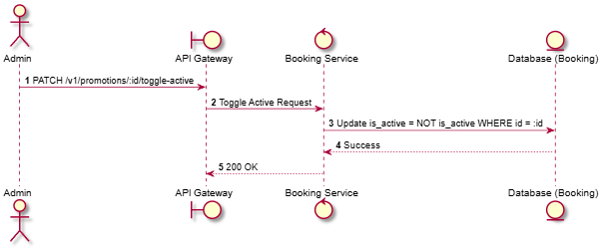

Activities Flow
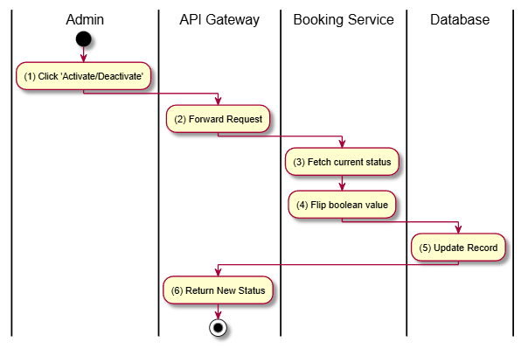

Business Rules
Activity | BR Code | Description
(3) | BR-1 | Deactivated promotions cannot be validated or used in checkout, even if the code is known.

Loyalty Points

Get Loyalty Balance

Use Case Description
Name | Get Loyalty Balance
Description | Retrieves the current loyalty points balance and membership tier for the authenticated member.
Actor | Member
Trigger | GET /v1/loyalty/balance
Pre-condition | Member authenticated.
Post-condition | Point balance and tier information returned.

Sequence Flow
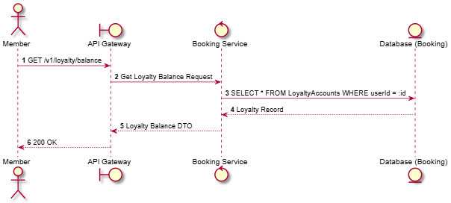

Activities Flow
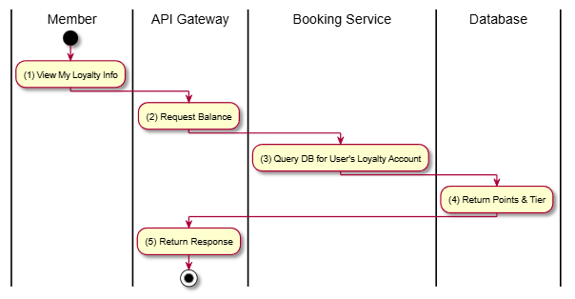

Business Rules
Activity | BR Code | Description
(4) | BR-1 | New loyalty accounts start at BRONZE tier.
(4) | BR-2 | Membership tiers: BRONZE, SILVER, GOLD, PLATINUM.

Get Transaction History

Use Case Description
Name | Get Transaction History
Description | Retrieves the history of point earnings and redemptions for the member.
Actor | Member
Trigger | GET /v1/loyalty/transactions
Pre-condition | Member authenticated.
Post-condition | List of loyalty transactions returned.

Sequence Flow
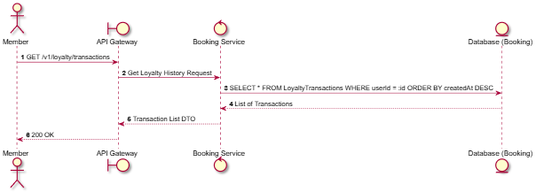

Activities Flow
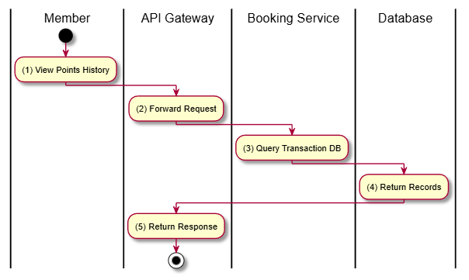

Business Rules
Activity | BR Code | Description
(3) | BR-1 | Types: EARN, REDEEM, EXPIRE.

Earn Points

Use Case Description
Name | Earn Points
Description | Automatically adds loyalty points to the user's account after a successful booking confirmation.
Actor | Member, System
Trigger | POST /v1/loyalty/earn (or internal event)
Pre-condition | Booking confirmed and paid.
Post-condition | Points balance increased; Transaction record created.

Sequence Flow
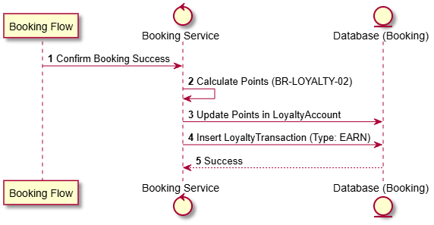

Activities Flow
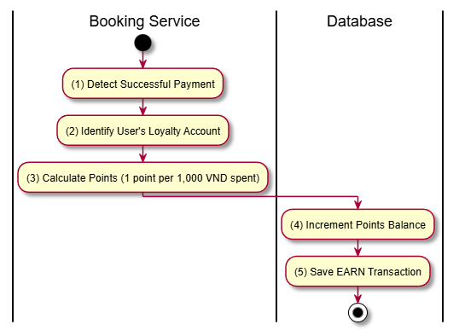

Business Rules
Activity | BR Code | Description
(3) | BR-1 | Point earning rate: 1 point per 1,000 VND spent.
(4) | BR-2 | Total spend used for calculation is typically the subtotal after discounts.

Redeem Points

Use Case Description
Name | Redeem Points
Description | Allows a member to use their accumulated loyalty points to pay for part or all of a booking.
Actor | Member
Trigger | POST /v1/loyalty/redeem
Pre-condition | Member has sufficient points; Booking is in PENDING status.
Post-condition | Points deducted; Booking total reduced; Transaction record created.

Sequence Flow
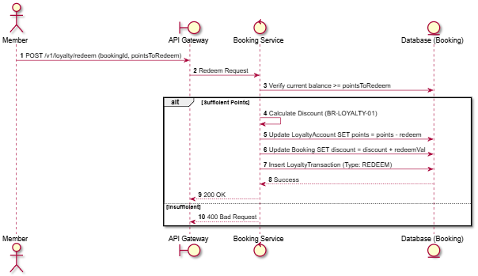

Activities Flow
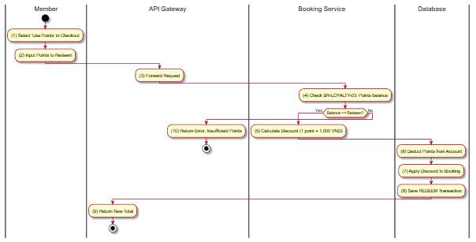

Business Rules
Activity | BR Code | Description
(5) | BR-1 | Point redemption rate: 1 point = 1,000 VND.
(4) | BR-2 | Users cannot redeem more points than their current balance.
(7) | BR-3 | Total discount cannot exceed the booking subtotal.

System Configuration

Get All Settings

Use Case Description
Name | Get All Settings
Description | Retrieves all system-wide configuration settings and key-value pairs.
Actor | Admin
Trigger | GET /v1/config
Pre-condition | Admin authenticated.
Post-condition | List of all settings returned.

Sequence Flow
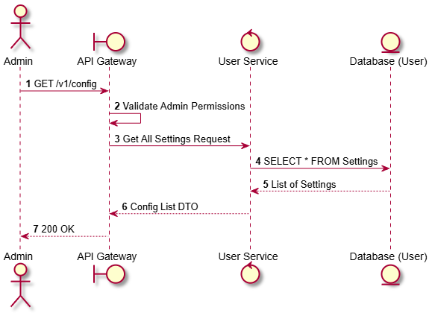

Activities Flow
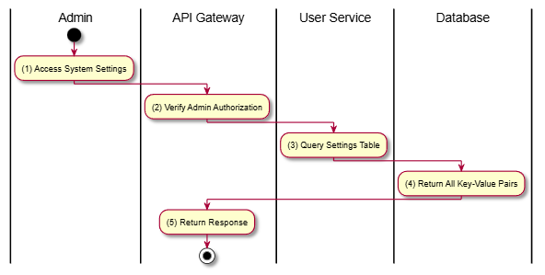

Business Rules
Activity | BR Code | Description
(2) | BR-1 | Settings include things like VAT rate, cancellation deadlines, etc. (SRS 5.1).
(2) | BR-2 | Only accessible to the Admin actor.

Update Setting

Use Case Description
Name | Update Setting
Description | Allows an Administrator to update the value of a specific system configuration setting.
Actor | Admin
Trigger | PUT /v1/config/:key
Pre-condition | Admin authenticated; Setting key exists.
Post-condition | Setting value updated in database.

Sequence Flow
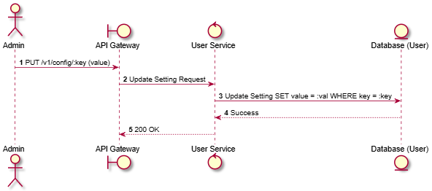

Activities Flow
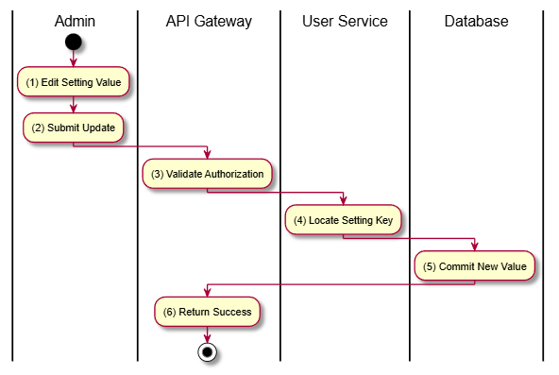

Business Rules
Activity | BR Code | Description
(5) | BR-1 | Changes to critical settings (like VAT) may have immediate system-wide financial impact.
(5) | BR-2 | Values are typically stored as strings and cast by the consuming service.

List Description


View Description


Non-functional Requirements

User Access and Security

Authentication and Authorization
- The system shall support secure authentication using email/password and third-party providers (e.g., Google).
- The system shall use JWT (JSON Web Token) for session management.
- Role-based access control (RBAC) shall be implemented to restrict access to admin and user functionalities.

Data Protection
- All sensitive user data (passwords, tokens) must be encrypted using industry standards (e.g., bcrypt, HTTPS).
- The system shall comply with data privacy regulations where applicable.

API Security
- All APIs must require authentication for protected resources.
- Rate limiting shall be applied to prevent abuse.
- Input validation must be enforced to prevent injection attacks.
Function | Guest | User | Admin | Super Admin
Authentication
Login / Register | X
Social Login | X
Logout |  | X | X | X
Profile Management
View Profile |  | X | X | X
Update Profile |  | X(*) | X(*) | X
Manage User Accounts |  |  | X | X
Movie Browsing
View Movies | X | X | X | X
Search Movies | X | X | X | X
View Movie Details | X | X | X | X
View Showtimes | X | X | X | X
Booking & Payment
Book Tickets |  | X
Select Seats |  | X
Make Payment |  | X
View Booking History |  | X
Cancel Booking |  | X(*)
Notifications
Receive Notifications |  | X | X | X
Manage Notifications |  | X | X | X
Movie Management
Create Movie |  |  | X | X
Update Movie |  |  | X | X
Delete Movie |  |  | X | X
Manage Showtimes |  |  | X | X
System Operations
Dashboard Analytics |  |  | X | X
Manage System Config |  |  |  | X
View Audit Logs |  |  | X | X
Manage Roles & Permissions |  |  |  | X

Performance Requirements

Response Time
- The system shall respond to user requests within:
- ≤ 2 seconds for standard operations (search, browse)
- ≤ 3 seconds for complex operations (booking, recommendations)

Throughput
- The system shall support at least 1,000 concurrent users
- 500 requests per second under normal load

Scalability
- The system shall scale horizontally using microservices or containerization.
- Load balancing shall be implemented for high availability.

Availability
- The system shall ensure 99.9% uptime.
- Failover mechanisms must be in place.

Implementation Requirements

Technology Stack
Statement:
- The system shall be implemented using modern web technologies.
Details:
- Backend: NestJS
- Database: PostgreSQL (Prisma ORM)
- Queue: BullMQ (Redis)
- Frontend: React / Next.js

Coding Standards
Statement:
- The system shall follow clean and maintainable coding practices.
Details:
- Follow SOLID principles
- Use layered architecture (Controller → Service → Repository)
- Code must be modular and reusable

Testing
Statement:
- The system shall ensure quality through testing.
Details:
- Unit tests for services
- Integration tests for modules
- E2E tests for APIs

Other Requirements

Archive Function
List | Actor | Condition
User | Admin | Record is marked with deletedAt or isBlocked. The user is prevented from logging in, but all related data (bookings, payments, notifications) is retained for auditing and history.
Booking | User / Admin | Bookings are never physically deleted. A status field (e.g., CANCELLED, COMPLETED) is used to represent lifecycle changes while preserving transaction history.
Movie | Admin | Movies are marked with deletedAt or isArchived. Archived movies are hidden from browsing and search but remain visible in historical bookings and reports.
Showtime | System / Admin | Showtimes are automatically archived when expired or manually when cancelled. Archived showtimes are no longer available for booking but remain for analytics and history.
SeatReservation | System | Seat reservations are not deleted. A status field (e.g., RESERVED, RELEASED, BOOKED) is used to manage seat lifecycle and prevent conflicts.
Payment | System / Admin | Payment records are never deleted. Status values (e.g., SUCCESS, FAILED, REFUNDED) are used to track lifecycle while ensuring financial audit integrity.
Notification | User / System | Notifications are archived using readAt or isDeleted flags. Archived notifications are hidden from active views but retained for tracking.
UserDevice | User / System | Devices are marked as inactive when logged out or expired. Archived devices are excluded from push notifications but kept for reactivation or tracking.

Security Audit Function
Enable Security Audit Function for "Admin" to track any modifications on user’s permissions.
- Logging: The system utilizes an AuctionAuditLog model to track sensitive administrative actions.
- Tracking: Every critical state change (e.g., overriding auction status, denying a bid, final approval) records the performedBy (User ID), action, previousStatus, newStatus, and a mandatory reason.
- Audit Trail: Admins can view a chronological timeline of modifications per auction via the getAuctionAuditLogs endpoint.

Movie Hub Sites
# | Site Name | Description
1 | Admin Site (Admin & Super Admin) | ❖ System & User Management: Central dashboard for managing user accounts, blocking/unblocking users, and assigning roles/permissions. ❖ Content & Operations Management: Admins manage movies, showtimes, and system configurations. They can view audit logs, monitor system activities, and oversee bookings and payments.
2 | Movie Management Site (Admin) | ❖ Movie & Showtime Operations: Allows Admins to create, update, archive, and manage movies and showtimes, including scheduling and availability. ❖ Content Control: Admins manage movie metadata (genre, duration, description, media assets) and ensure content accuracy.
3 | User Site (User & Guest) | ❖ Browsing & Booking: Users can browse movie listings, search/filter movies, view details, select showtimes, and book tickets. ❖ Account & History: Registered users can manage profiles, view booking history, receive notifications, and handle payments. Guests can only browse movies and view details.

Movie Hub Lists
# | List Code | List Name | Description
1 | List01 | Users | ❖ Primary identity storage including roles (User, Admin) and account status (active, blocked).
 | List02 | Movies | ❖ Master list of movies including title, genre, duration, rating, and archive status.
2 | List03 | Showtimes | ❖ Scheduling records linking movies to specific screening times, rooms, and availability.
3 | List04 | Bookings | ❖ Records of user ticket bookings including selected seats, showtime, and booking status.
4 | List05 | Payments | ❖ Financial transaction records for ticket purchases, including payment status and methods.
5 | List06 | Seat Reservations | ❖ Seat allocation records for each showtime to manage availability and prevent conflicts.
6 | List07 | Notifications | ❖ System-generated notifications for users (booking confirmations, reminders, updates).
7 | List08 | System Config | ❖ Key-value storage for global configurations such as pricing rules, booking limits, and system settings.

Custom Pages
● Home Page: Displays featured movies, trending movies, and quick access to booking.
● Movie Listing Page: Shows all available movies with search, filter, and sorting functionalities.
● Movie Detail Page: Provides detailed information about a selected movie, including showtimes and booking options.
● Booking Page: Allows users to select seats, confirm booking, and proceed to payment.
● User Profile Page: Enables users to manage personal information, view booking history, and update account settings.
● Admin Dashboard Page: Provides administrators with system overview, analytics, and management tools for users, movies, and showtimes.

Appendixes

Glossary
The list below contains all the necessary terms to interpret the document, including acronyms and abbreviations.
Term | Description
BR | Business Rule
CBR | Common Business Rule
DB | Notes Database
MSG | Message
UC | Use Case
N/A | Not Available or Not Applicable, used to indicate when information in a certain section could not be provided because it does not apply to this application.
UI | User Interface
SRS | Software Requirements Specification
TBD | To be determined or to be defined

Mapping to Notes Application
* There is no mapping between the migrated application and its source Notes application. *

Messages
This section describes the details of messages used in business rules e.g. error messages, confirmation messages, etc.
Message Code | Message Content | Button
MSG 1 | This field is mandatory. You must provide information in this field to proceed. | Ok
MSG 2 | Your username or password might be wrong. Please check and try again later. | Ok
MSG 3 | Sign in successful. | Ok
MSG 4 | Your information is not in the correct format. Please check again. | Ok
MSG 5 | Your entered email had been existed in the system. Please check again. | Ok
MSG 6 | Your entered phone number had been existed in the system. Please check again. | Ok
MSG 7 | Save data successful. | Ok
MSG 8 | The size of image is too large. You need to compress it to upload. | Ok
MSG 9 | Your action is failed due to constraints in the system. | Ok
MSG 10 | This username had been existed in the system. Please choose another username. | Ok
MSG 11 | Are you sure you want to delete this [item]? | Yes/No

Issues List
N/A

