

CAPSTONE PROJECT REPORT
Report 3 – Software Requirement Specification

– Hanoi, Jan 2024 –
Table of Contents
I. Record of Changes 3
II. Software Requirement Specification 4
1. Overall Requirements 4
1.1 Context Diagram 4
1.2 Main Workflows 5
1.3 User Requirements 7
1.4 System Functionalities 13
1.5 Entity Relationship Diagram 16
2. Use Case Specifications 17
2.1 Authentication & Onboarding 17
2.2 Server Management 20
2.3 Channel & Real-time Messaging 23
2.4 Voice Channel 25
2.5 Notification & Presence 26
2.6 User Profile 27
3. Functional Requirements 27
3.1 Feature Name1 28
3.2 User Authentication 28
3.3 System Administration 28
4. Non-Functional Requirements 30
4.1 External Interfaces 30
4.2 Quality Attributes 30
5. Requirement Appendix 32
5.1 Business Rules 32
5.2 System Messages 33
5.3 Other Requirements… 33

I. Record of Changes
Date | A/M/D | In charge | Change Description
*A - Added M - Modified D - Deleted

II. Software Requirement Specification

1. Overall Requirements

1.1 Context Diagram
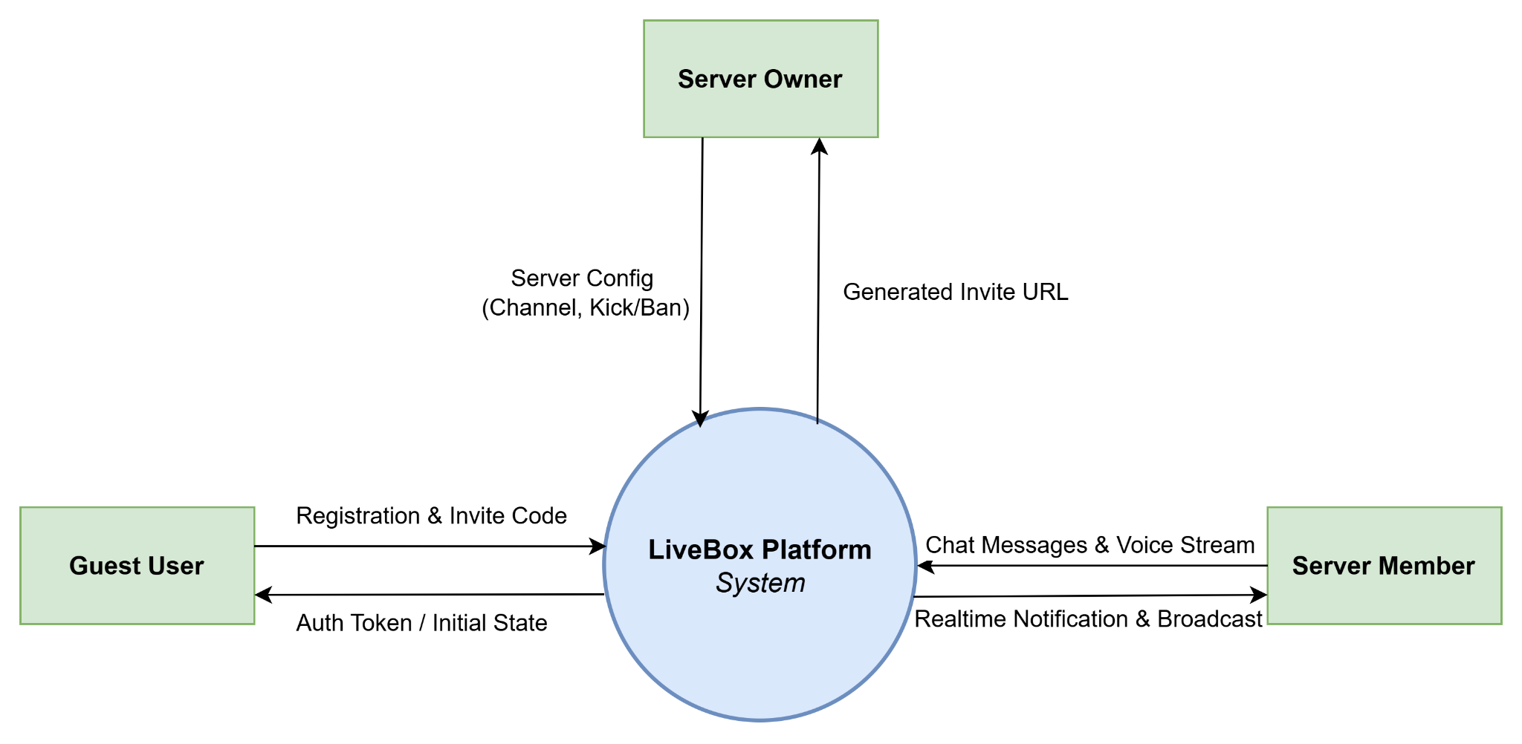
Figure 1.1.1: LiveBox Context Diagram

1.2 Main Workflows

1.2.1 Onboarding and Server Access Flow
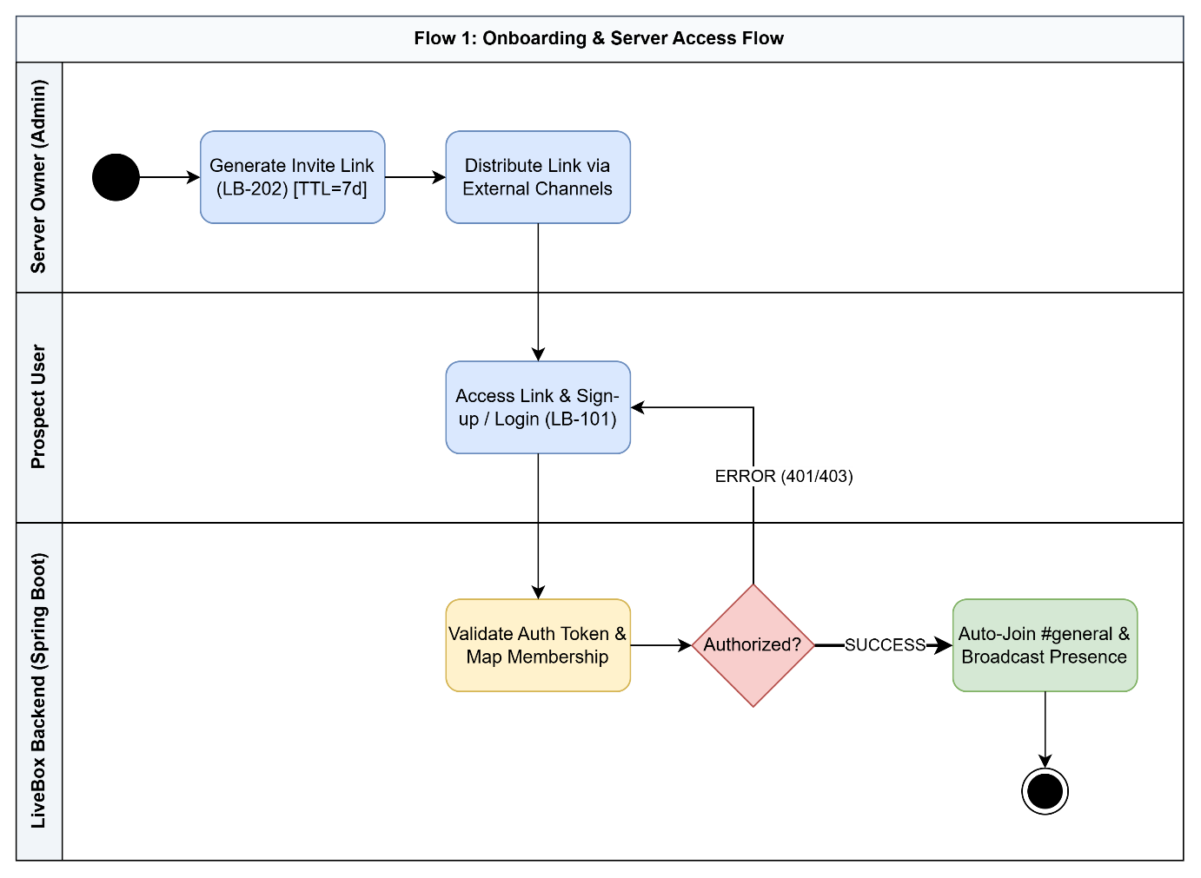
Figure 1.2.1: Onboarding and Server Access Flow

1.2.2 Messaging and Unread Badge
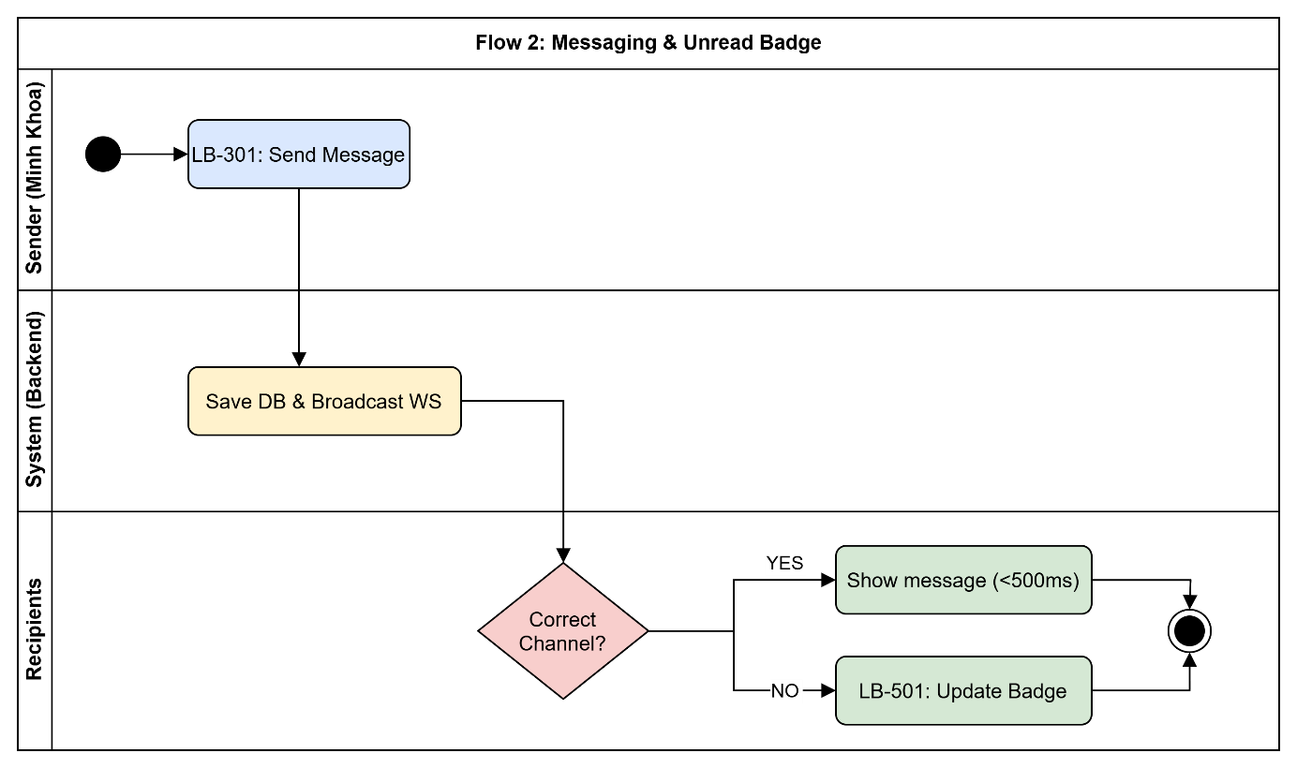
Figure 1.2.2: Messaging and Unread Badge

1.2.3 Voice Connection Setup
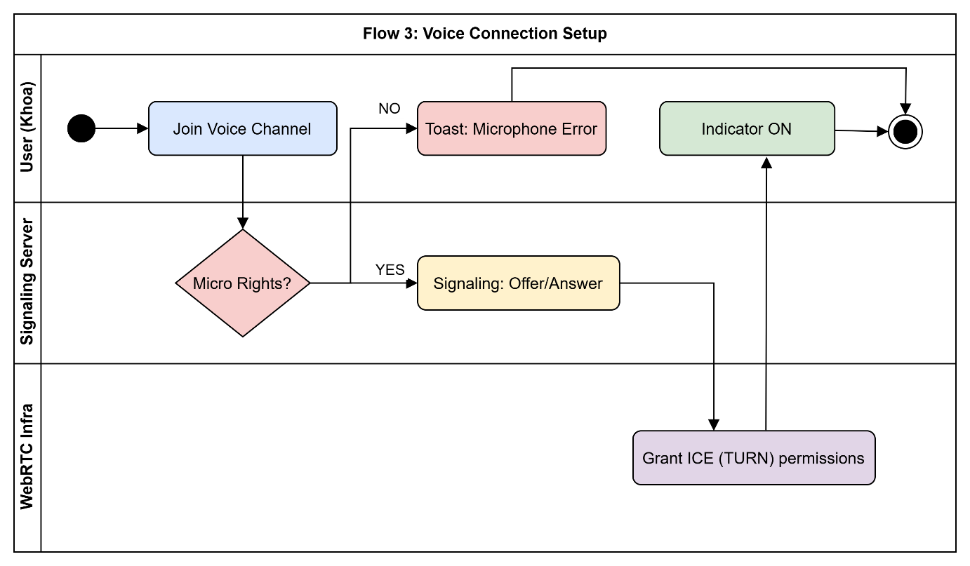
Figure 1.2.3: Voice Connection Setup Flow

1.3 User Requirements

1.3.1 Actors
Based on the Project Context, the LiveBox Real-time Chat Platform interacts directly with three primary System Actors:

No. | Actor | Description & System Expectations
1 | Server Owner (P01) | Description: The creator and administrator of a Server. They have full control over the Server's configuration, channels, and members.  Responsibilities: Create Server, create/delete channels, generate invite links, and perform kick/ban moderation actions.
2 | Active Member (P02) | Description: A regular user who has joined one or more Servers. They are the primary participants in the real-time communication platform.  Responsibilities: Send and receive real-time text messages, participate in WebRTC voice channels (max 20 users), and update their display name/avatar.
3 | Guest User (P03) | Description: A user who has received an invite link but has not yet registered, or a newly registered user who is just joining a Server for the first time.  Responsibilities: Register an account (in under 30 seconds), log in, and join their first Server using an invite code.

1.3.2 Use Cases (UC)

ID | Use Case | Feature | Actors | Use Case Description
UC-101 | New Account Registration | Authentication & Onboarding | Guest User | As a Guest User, I need a friction-less registration process so I can immediately start using the platform without unnecessary complexity.
UC-102 | Login and Session Persistence | Authentication & Onboarding | Server Owner, Active Member, Guest User | I want the system to maintain my session so I don't have to re-authenticate every time I open the application.
UC-103 | Secure Logout | Authentication & Onboarding | Server Owner, Active Member, Guest User | I need to securely log out so that my account is inaccessible on this device after I leave.
UC-201 | Server Creation | Server Management | Server Owner, Guest User | As a Server Owner, I need my own space to organize my community or work group.
UC-202 | Invite Members via Link | Server Management | Server Owner, Guest User | New members should be able to join quickly using an invite link, eliminating the need for manual, one-by-one additions.
UC-203 | Kick/Ban Member Moderation | Server Management | Server Owner, Guest User | I must have moderation tools (Kick/Ban) to maintain a healthy and safe communication environment for the community.
UC-204 | Leave Server | Server Management | Active Member | I want the server list (sidebar) to only display the servers I am currently active in, keeping my UI clutter-free.
UC-301 | Real-time Messaging (Send/Receive) | Channel & Real-time Messaging | Active Member | The conversation must feel natural and instantaneous, requiring no page reloads for message updates.
UC-302 | Create and Manage Text Channels | Channel & Real-time Messaging | Server Owner, Guest User | I need the ability to organize conversations into clear, topic-specific text channels.
UC-303 | View Member List and Online Status | Channel & Real-time Messaging | Active Member, Guest User | I need visibility into which members are online and active, facilitating immediate interaction.
UC-401 | Join and Leave Voice Channel | Voice Channel | Active Member | I need to be able to jump into a live meeting or chat directly without needing a separate meeting application.
UC-501 | Unread Message Notification (Badging) | Notification & Presence | Active Member | I must be notified of unread messages so I don't miss important communication, even when active in a different channel.
UC-601 | Update Personal Profile (Avatar & Display Name) | User Profile | Active Member | I need to update my profile information so other members can easily identify me within the server.
…

1.3.3 Use Case Diagrams

1.3.3.1 UCs for Server Owner (P01)
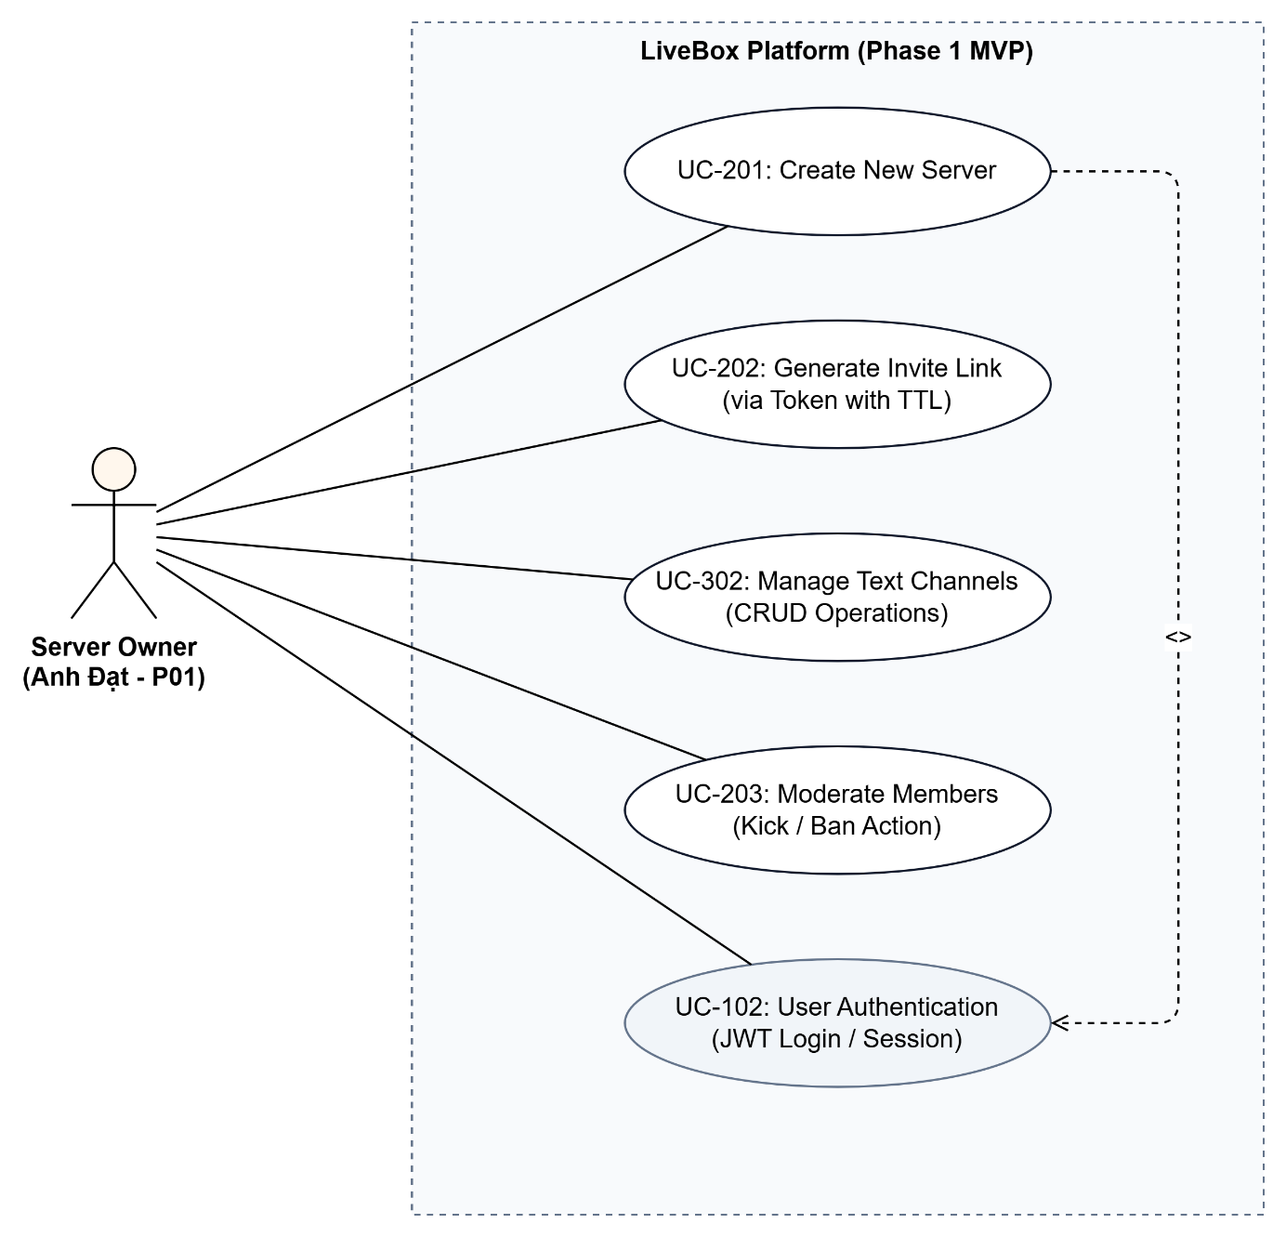
Figure 1.3.1: Use Case Diagram for Server Owner (P01)

1.3.3.2 UCs for Active Member (P02)
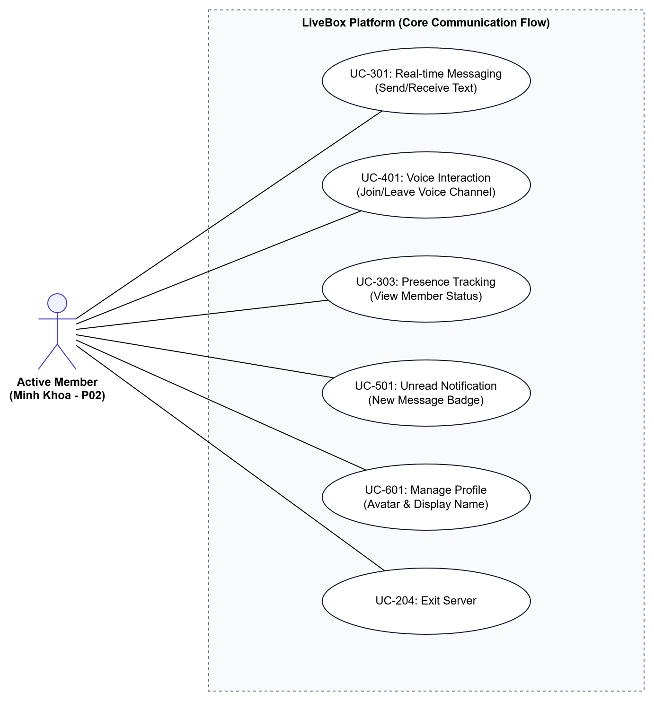
Figure 1.3.2: Use Case Diagram for Active Member (P02)

1.3.3.3 UCs for Guest User (P03)
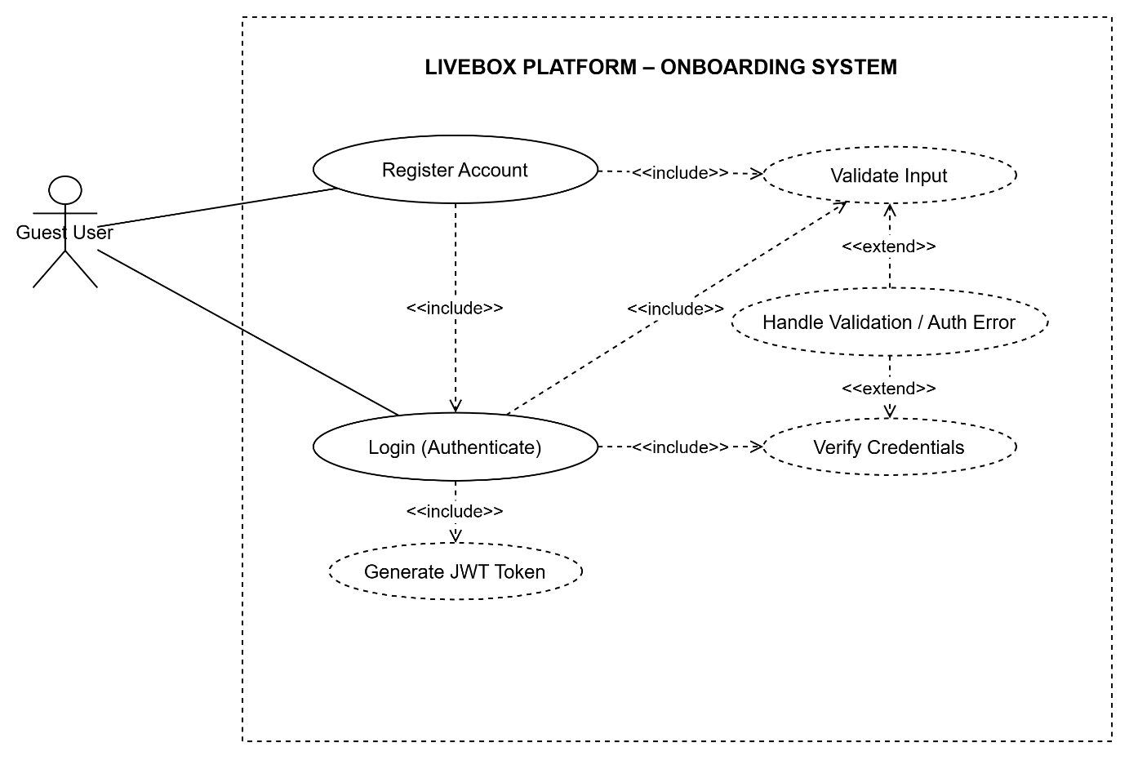
Figure 1.3.3: Use Case Diagram for Guest User (P03)

1.4 System Functionalities

1.4.1 Screens Flow

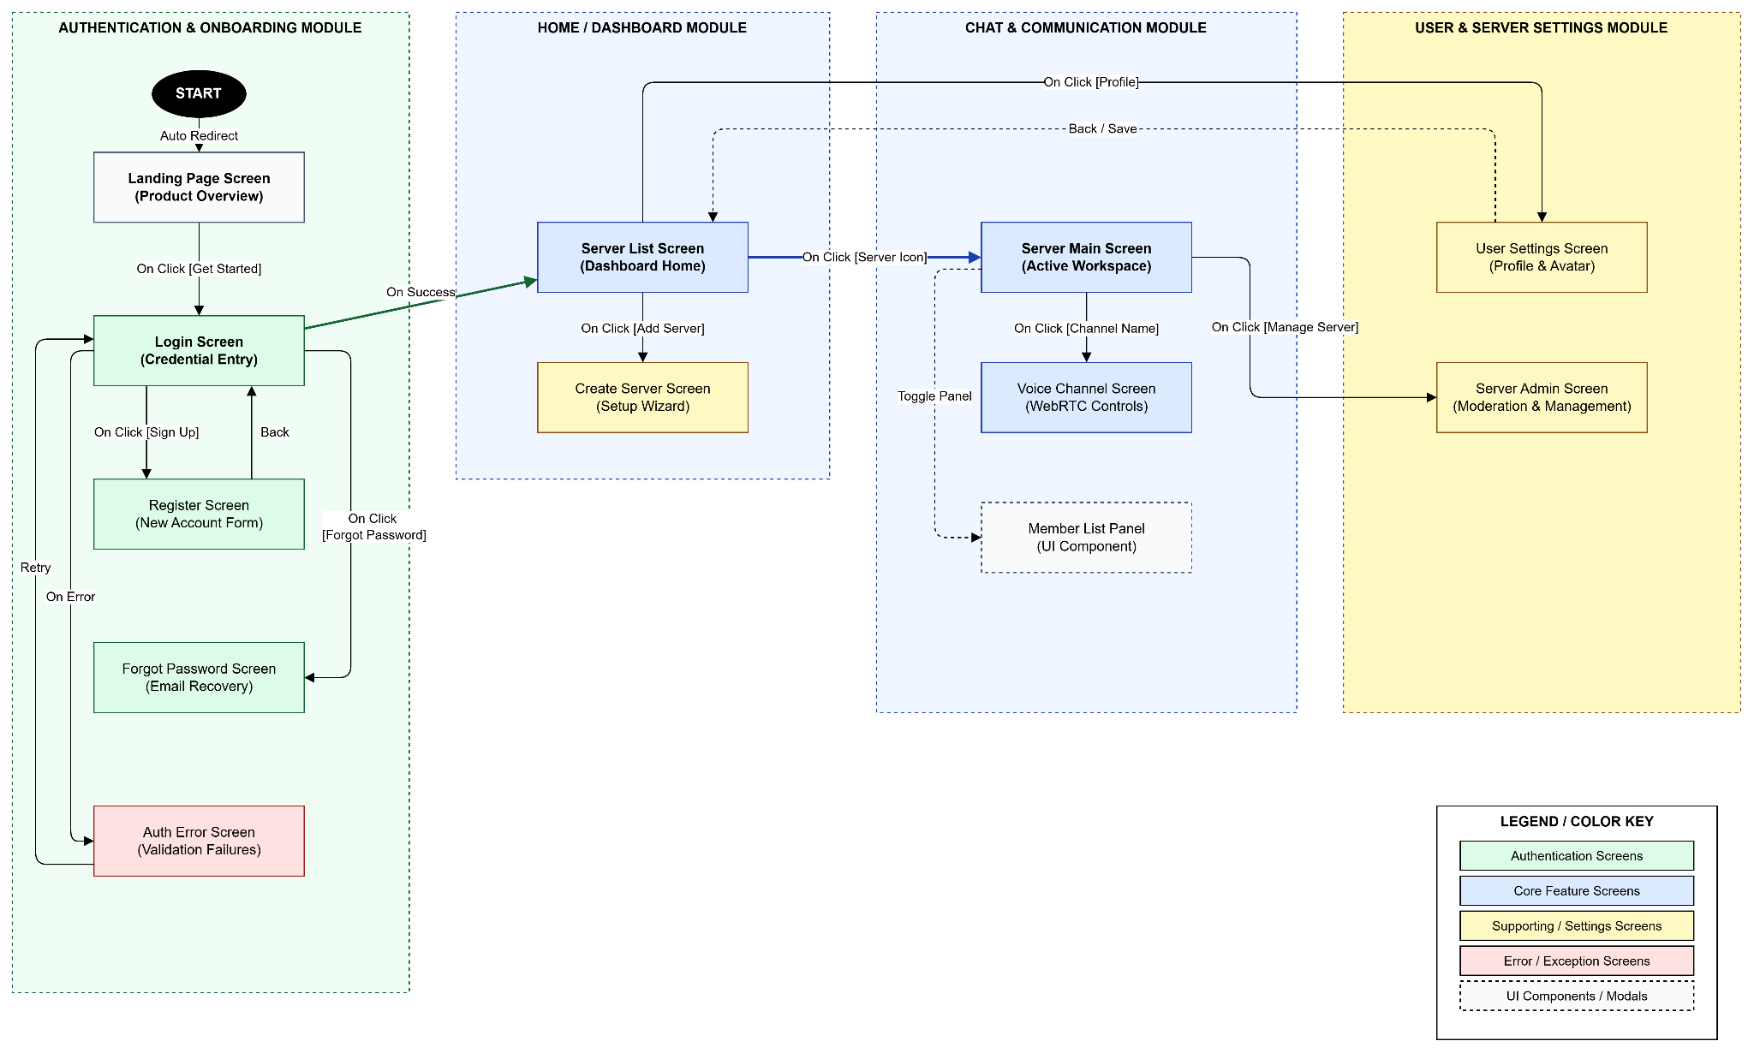Figure 1.4.1: LiveBox Screen Flow Diagram (S01 - S07)

1.4.2 Screen Authorization
Screen / Component | Guest User (P03) | Active Member (P02) | Server Owner (P01) | Key Features / Notes
Landing Page Screen (S01) | X |  |  | Initial access point.
Register Screen (S02) | X |  |  | Account creation.
Login Screen (S03) | X |  |  | JWT & Token flow.
Forgot Password Screen | X |  |  | Recovery flow.
Auth Error Screen | X | X | X | Error display.
Server List (S04) |  | X | X | Dashboard view.
Create Server (S04.c) |  | X | X | Initiates UC-201.
Server Main Screen (S05) |  | X | X | Messaging view.
Voice Overlay (S05.a) |  | X | X | WebRTC control.
Member Panel |  | X | X | Real-time presence.
User Settings (S06) |  | X | X | Profile update.
Server Admin (S07) |  |  | X | Owner-only tools.

1.4.3 Non-UI Functions

# | Feature | System Function | Description
1 | Authentication & Session Management | JWT Access & Refresh Token Service | Handles stateless authentication (G16) by issuing an Access Token (1h) and a Refresh Token (7 days). It manages token generation, signing, and automatic renewal via a background interceptor to ensure a seamless session (LB-102).
2 | Authentication & Session Management | Token Revocation Service (C04) | Manages the blacklisting (deletion from DB) of Refresh Tokens upon secure logout (LB-103) to prevent unauthorized session reuse and ensure absolute security (BG-05).
3 | Channel & Real-time Messaging | WebSocket Message Broadcasting | Utilizing Spring Boot and STOMP (G14) to broadcast chat messages to all connected clients in a Channel (G02) with a targeted latency of < 500ms (BG-02, LB-301).
4 | Channel & Real-time Messaging | Presence Tracking Service | Monitors the real-time status (Online/Offline - G13) of users via WebSocket heartbeat connections and broadcasts status changes to the Server’s Member List (LB-303).
5 | Server Management | Invite Link Generator with TTL | Generates secure, unique Invite Links (G07) with an embedded TTL of 7 days (C06). A background cron job periodically invalidates expired codes in the PostgreSQL database (LB-202).
6 | Voice Interaction | WebRTC Signaling Server | Orchestrates the initial handshake and exchange of ICE candidates/SDP offers between peers to establish P2P WebRTC (G15) voice connections without external applications (LB-401).
7 | Notification & Presence | Unread Message Counter Logic | A background service that tracks read receipts in the PostgreSQL database (C03) to accurately calculate and push Unread Badges (G10) to the channel sidebar via WebSocket (LB-501).
8 | Infrastructure & Performance | Connection Pool Management | Optimizes database interaction by managing a pool of PostgreSQL connections to support up to 500 concurrent users per instance during Phase 1 (C01).

1.5 Entity Relationship Diagram
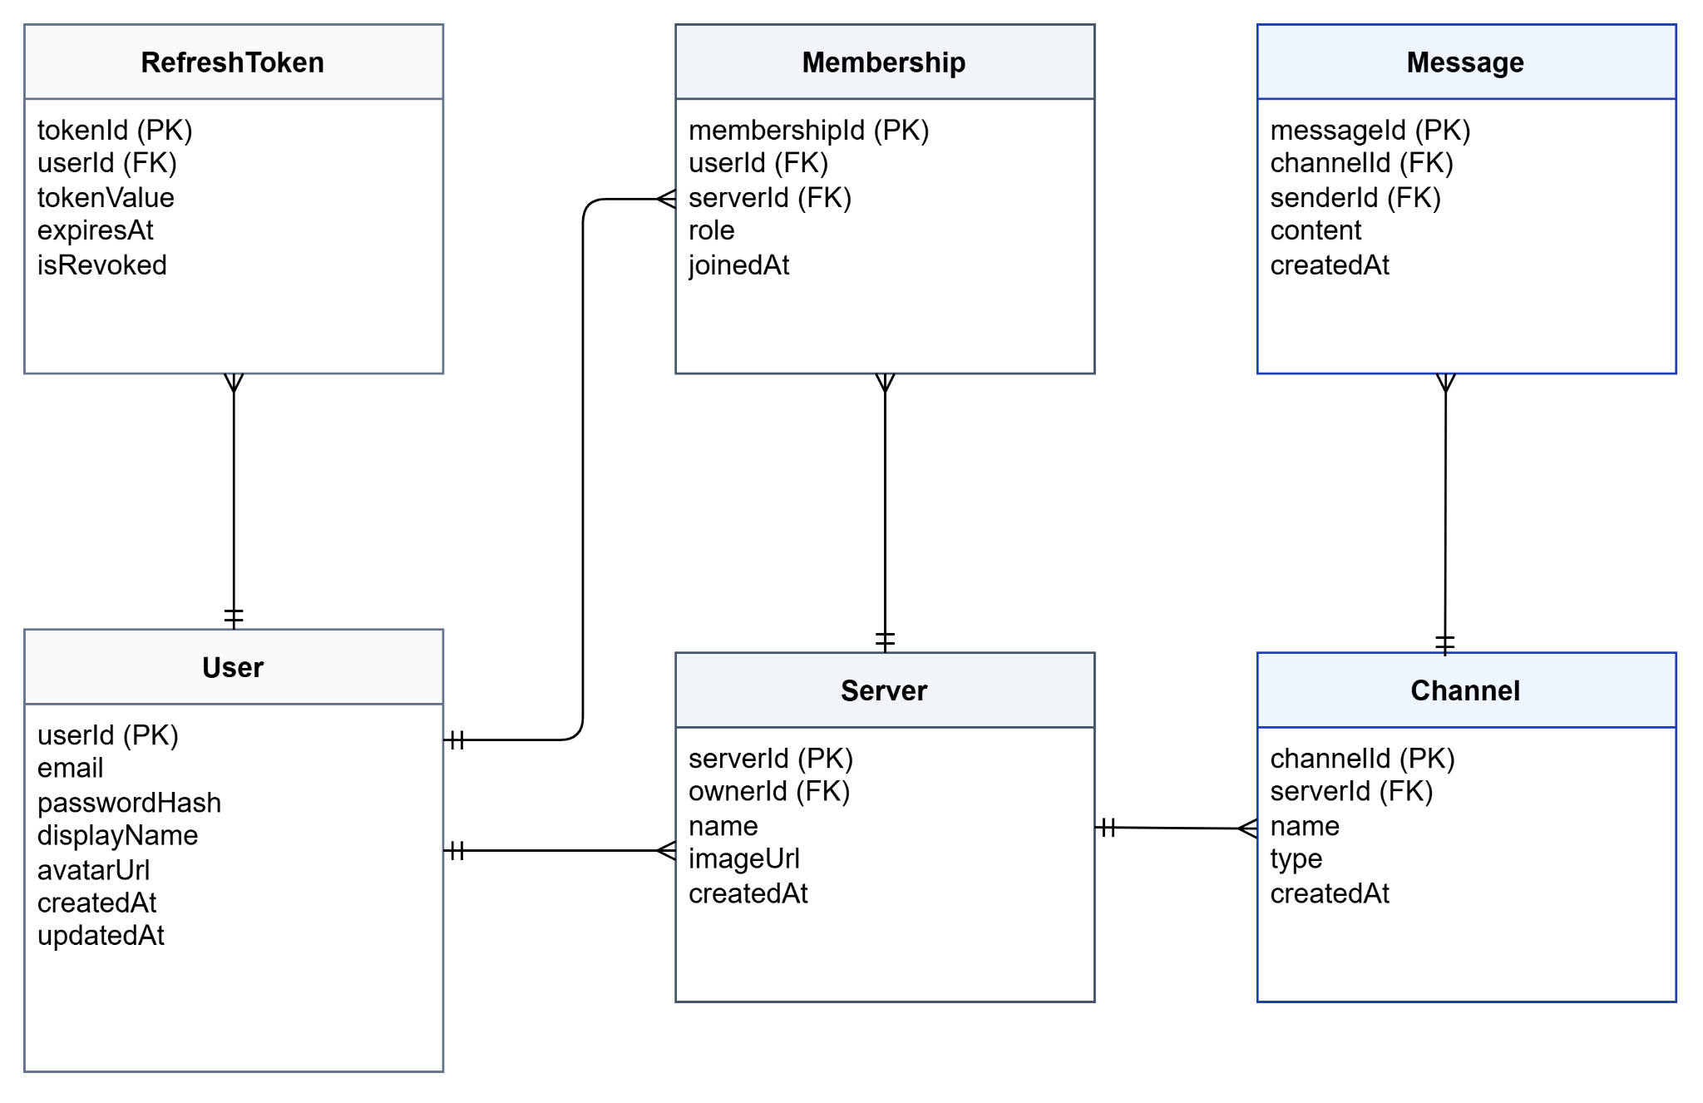Figure 1.5.1: Entity Relationship Diagram (ERD)
Entities Description
# | Entity | Description
1 | User | The core entity representing a registered account, secured by password hashing, for system authentication.
2 | Server | The root container for communication, managed by an Owner, hosting multiple Channels and Memberships.
3 | Channel | A specific communication space within a Server, categorized as either real-time WebSocket (Text) or WebRTC (Voice).
4 | Message | A persistent record of text content exchanged in a Text Channel, optimized for performant lazy-loading.
5 | Membership | An associative entity resolving the M:N User-Server relationship, crucial for implementing Server-level RBAC (Owner/Member).
6 | ReadReceipt | A tracking entity used to determine the last read message by a user in a Channel, enabling accurate Unread Badge calculation.
7 | RefreshToken | A long-lived token stored in the database (C04) to manage session persistence and secure JWT Access Token rotation.
8 | InviteCode | A temporary, secure code with a 7-day TTL (C06) used to facilitate new Member onboarding to a specific Server.

2. Use Case Specifications

2.1 Authentication & Onboarding

UC-101: New Account Registration
Primary Actors | Guest User (P03 - Lan Anh) | Secondary Actors | None
Description | As a Guest User, I want a single-screen, friction-less registration process (email + password only) so that I can onboard and start using the platform immediately, achieving the BG-01 goal of registration in ≤ 30 seconds. (Related Story: LB-101)
Preconditions | The user must not have an existing account on LiveBox.
Postconditions | - A new User Account is successfully created in the PostgreSQL database.  - The system redirects the user to the primary Server view.  - The user is automatically logged in with a valid JWT Access Token.
Normal Sequence/Flow | - The user selects the "Register" option.  - The system displays the New Account Registration screen (single-screen flow).  - The user provides a valid Email and Password.  - The user clicks the "Sign Up" button.  - System validates the input (e.g., email format, password strength).  - The system hashes the password and persists the new account details in the database.  - System issues a new JWT Access Token (1h TTL) and a Refresh Token (7 days TTL), storing the Refresh Token in the database (C04).  - System logs in the user and redirects to the primary Server view.
Alternative Sequences/Flows | AF 5.1: Invalid Input  If the email format is invalid or the password does not meet criteria, the system displays an inline error message (e.g., MSG02) next to the corresponding field. The user must correct the input before proceeding.  AF 5.2: Existing Email  If the provided email is already registered, the system displays a clear error message (e.g., "Email already in use") and prompts the user to log in or reset the password.

UC-102: Login and Session Persistence
Primary Actors | Server Owner (P01), Active Member (P02), Guest User (P03) | Secondary Actors | None
Description | As a returning LiveBox User, I want the system to securely handle session persistence using JWT and Refresh Tokens, so that I don't have to re-authenticate every time I open the application, supporting the BG-05 requirement for secure access. (Related Story: LB-102)
Preconditions | - User account has been successfully created and verified.  - User has valid login credentials (email and password) or a valid Refresh Token.
Postconditions | - The user is successfully authenticated and logged into the system.  - The system issues a valid JWT Access Token (1h) and Refresh Token (7 days).
Normal Sequence/Flow | A. Initial Login via Credentials  - The user accesses the LiveBox application.  - The system presents the Login Screen.  - The user enters Email and Password.  - The user clicks the "Log In" button.  - The system validates credentials against the PostgreSQL database.  - If valid, the system generates and returns a JWT Access Token (1h) and a Refresh Token (7 days), storing the Refresh Token in the database (C04).  - System redirects the user to the primary Server view.  B. Session Persistence (Token Refresh Flow)  - The user opens the application and the local Access Token is expired (T > 1 hour).  - The client application attempts to exchange the stored Refresh Token for a new Access Token.  - System validates the Refresh Token against the database (C04).  - If valid, the system issues a new JWT Access Token and redirects the user to the Server view without re-prompting for credentials.
Alternative Sequences/Flows | AF 5.1: Invalid Credentials (Authentication Failure)  If the Email or Password is incorrect, the system displays the error message: "Invalid email or password. Please try again." (MSG05).  AF 5.2: Token Revocation Failure (Security Check)  If the Refresh Token is invalid or has been revoked (e.g., due to secure logout), the system rejects the token request and forces the user back to the Login Screen for explicit re-authentication.

UC-103: Secure Logout
Primary Actors | Server Owner (P01), Active Member (P02), Guest User (P03) | Secondary Actors | None
Description | As a LiveBox User, I want a secure logout mechanism (LB-103) that revokes my Refresh Token (C04) and closes the WebSocket connection (G14) so that my session is fully terminated and unauthorized access is prevented (BG-05).
Preconditions | User is successfully logged in and has an active JWT Access Token and a valid Refresh Token persisted in the database (C04).
Postconditions | - The user's active session is destroyed.  - The Refresh Token is revoked (deleted from DB).  - The system redirects the user to the Login Screen.
Normal Sequence/Flow | - The user clicks the "Logout" button.  - Client application sends a request to the backend with the Refresh Token.  - System validates the token, revokes the Refresh Token (C04) by deleting it from the PostgreSQL database (C03).  - System closes the active WebSocket connection (G14).  - System returns a successful logout response and clears the Access Token from the client.  - Client redirects the user to the Login Screen.
Alternative Sequences/Flows | AF 3.1: Token Validation Failure  If the Refresh Token is already expired or invalid, the system still proceeds to clear local tokens and redirect to the Login Screen, ensuring a clean session termination and security integrity.

2.2 Server Management

UC-201: Server Creation
Primary Actors | Server Owner (P01) | Secondary Actors | Guest User (P03)
Description | As a Server Owner (Anh Đạt - P01), I want to create a new Server (G01) with a custom name and avatar so that I can organize my community or work group (LB-201) and centralize our communication tools (BG-03).
Preconditions | User must be authenticated and logged in.
Postconditions | - A new Server record is created in the database.  - The creator is assigned the Server Owner role (G05).  - A default #general Text Channel (G03) is created.
Normal Sequence/Flow | - User clicks "Create New Server".  - System displays the Server Creation screen.  - User inputs Server Name and optionally uploads a Server Avatar.  - User clicks "Confirm".  - System validates inputs (Name length, Avatar file size/type C05).  - System persists the new Server and assigns Owner role (G05).  - System automatically creates a default Text Channel (G03) named #general.  - System redirects the user to the new Server's #general Channel view.
Alternative Sequences/Flows | AF 5.1: Invalid Avatar File  If the uploaded file exceeds the 2MB limit (C05) or is not PNG/JPG, the system displays an error message (MSG10) and blocks creation until a compliant file is provided.

UC-202: Invite Members via Link
Primary Actors | Server Owner (P01) | Secondary Actors | Guest User (P03)
Description | As a Server Owner, I need to generate a revocable Invite Link (G07) with a 7-day TTL (C06) so that new Guest Users (Lan Anh - P03) can onboard and join the Server quickly (BG-01, LB-202).
Preconditions | User is logged in and is the Server Owner (P01) of the selected Server.
Postconditions | - A new Invite Link (G07) is generated with a 7-day TTL (C06).  - Invited user is added as a Member (G06) to the Server.
Normal Sequence/Flow | - Generation: Server Owner selects "Generate Invite Link" from Server Settings.  - System generates a unique URL (/invite/{code}).  - System persists the code with a TTL of 7 days (C06).  - Usage: Guest User (P03) uses the link.  - System validates the link (existence and TTL).  - System adds the user as a Member (G06).  - System redirects the Member to the Server's default #general Text Channel view.
Alternative Sequences/Flows | AF 5.1: Expired/Invalid Link  If the Invite Link has expired (TTL > 7 days - C06) or is invalid, the system displays an error message (e.g., "Invite link is expired or invalid") and prevents the user from joining the Server.

UC-203: Kick/Ban Member Moderation
Primary Actors | Server Owner (P01) | Secondary Actors | Active Member (P02), Guest User (P03)
Description | As a Server Owner (Anh Đạt - P01), I must have immediate moderation control (Kick/Ban - G08/G09) to remove or permanently block users, maintaining a secure and professional environment (BG-05, LB-203).
Preconditions | The user performing the action is the Server Owner (P01). The target user is an Active Member (G06) of the Server.
Postconditions | The target user is immediately removed from the Server. If Ban (G09) is used, the user cannot rejoin the Server.
Normal Sequence/Flow (Kick - G08) | - Server Owner selects a Member from the Member List.  - Owner selects the "Kick Member" option.  - System prompts for confirmation.  - Owner confirms.  - System immediately terminates the Member's WebSocket session and removes them from ServerMembership.  - System displays a success notification.
Alternative Sequences/Flows | AF 2.1: Ban Member (G09)  If the Owner selects "Ban Member," the system performs the normal flow steps, AND persists the Member's User ID in a BanList table. The system then rejects any future join attempt by this user for the Server, even with a valid Invite Link (G07).

UC-204: Leave Server
Primary Actors | Active Member (P02) | Secondary Actors | None
Description | As an Active Member (Minh Khoa - P02), I want to autonomously leave a Server (LB-204) so that my server list remains relevant and clutter-free.
Preconditions | User is an Active Member (G06) of the Server. User is not the Server Owner (G05).
Postconditions | The user is removed from the Server's membership list. The Server is no longer displayed in the user's sidebar.
Normal Sequence/Flow | - Active Member selects the Server in the sidebar.  - Member accesses the Server context menu and selects "Leave Server".  - System prompts for confirmation.  - Member confirms.  - System removes the Member's record from the ServerMembership table.  - System closes the Member's WebSocket connection to that Server.  - System navigates the user to the most recently active or default Server.
Alternative Sequences/Flows | AF 2.1: Owner Cannot Leave  If the user is the Server Owner (P01 - G05), the system blocks the action and displays an error message (e.g., "Error: Ownership transfer required before leaving this Server").

2.3 Channel & Real-time Messaging

UC-301: Real-time Messaging (Send/Receive)
Primary Actors | Active Member (P02) | Secondary Actors | None
Description | As an Active Member (Minh Khoa - P02), I want my text messages to be sent and received instantly (LB-301) via WebSocket (G14) with a delivery latency of ≤ 500ms (BG-02), guaranteeing an instantaneous conversation flow.
Preconditions | User is logged in, has joined a Server, and is currently viewing an active Text Channel (G03).
Postconditions | - A new message record is created in the database.  - The message is broadcast via WebSocket (G14) to all active Members in the Channel within 500ms (BG-02).
Normal Sequence/Flow | - Active Member (P02) types a message in the Text Channel (G03) input field.  - Member sends the message (e.g., presses Enter).  - Client sends the message payload to the backend via WebSocket/STOMP (G14).  - System validates the message and persists the message to the PostgreSQL database (C03).  - System immediately broadcasts the message payload to all connected Members of that Channel via WebSocket (G14).  - All clients render the new message, maintaining the chronological order.
Alternative Sequences/Flows | AF 4.1: Network Interruption  If the client's WebSocket connection drops during transmission, the client attempts auto-reconnection. If persistence fails (C03), the system displays a transient error (e.g., "Failed to send. Check connection.") and attempts to resend the payload.

UC-302: Create and Manage Text Channels
Primary Actors | Server Owner (P01) | Secondary Actors | None
Description | As a Server Owner (Anh Đạt - P01), I need dedicated administrative capability (Owner only) to create, rename, and delete Text Channels (G03) (LB-302) to organize conversations by topic and meet the goal of tool centralization (BG-03).
Preconditions | User must be the Server Owner (P01) of the selected Server.
Postconditions | A new Channel record is created, or an existing Channel is modified/deleted. All Members' UIs are updated in realtime.
Normal Sequence/Flow (Create Channel) | - Server Owner selects "Add Channel" option.  - Owner specifies Channel Type (Text/Voice - G02).  - Owner inputs the channel name (e.g., #dev-team).  - System validates the input and persists the new Channel record.  - System broadcasts a realtime CHANNEL_UPDATE event to all connected Members (G06).  - All clients instantly refresh the Channel list in the sidebar.
Alternative Sequences/Flows | AF 5.1: Permission Denied  If an Active Member (P02) attempts to access the "Add Channel" or "Edit Channel" functions, the system blocks access and displays a "Permission Denied" message.

UC-303: View Member List and Online Status
Primary Actors | Active Member (P02) | Secondary Actors | Guest User (P03)
Description | As a Member (Minh Khoa - P02), I need visibility into the Member List and the Online/Offline status (G13) (LB-303) so that I know who is available for immediate interaction (BG-04).
Preconditions | User is logged in and has joined a Server.
Postconditions | The right-hand sidebar displays an accurate, realtime-updated list of all Members, segregated by their connection status (Online/Offline - G13).
Normal Sequence/Flow (Presence Update) | - User views a Channel. The right-hand panel displays the Member List.  - When a Member establishes or closes a WebSocket connection (G14), the system broadcasts a PRESENCE_UPDATE event.  - The client receives the update and instantly changes the status indicator (green dot for Online, gray for Offline - G13) next to the affected Member's Display Name (G12).
Alternative Sequences/Flows | AF 3.1: Offline Status  If a Member's WebSocket connection is terminated or inactive for > 5 minutes, their status is automatically set to Offline (G13) until a new connection is established.

2.4 Voice Channel

UC-401: Join and Leave Voice Channel
Primary Actors | Active Member (P02) | Secondary Actors | None
Description | As an Active Member (Minh Khoa - P02), I want to join a Voice Channel (G04) with a single click (LB-401) using WebRTC (G15) so that I can immediately jump into a live voice meeting without requiring a separate application (BG-03).
Preconditions | User is logged in. The Voice Channel's concurrent user limit (20 people - C02) must not be exceeded.
Postconditions | - The user's audio stream is established via WebRTC (G15).  - The user is listed in the active Voice Channel participant list.  - The Speaking Indicator (G11) functions correctly.
Normal Sequence/Flow (Join Voice) | - Active Member clicks on a Voice Channel (G04) name in the sidebar.  - Client initiates the WebRTC P2P connection handshake (G15).  - System verifies concurrent user limit (C02: max 20 users).  - Upon successful connection, the user's avatar moves to the Voice Channel list.  - When the user's mic activity is detected, the Speaking Indicator (G11) is activated for all participants.
Alternative Sequences/Flows | AF 3.1: Capacity Constraint  If the Voice Channel already has 20 users (C02), the system rejects the connection attempt and displays an error message (e.g., "Voice Channel is full. Max 20 users allowed.").  AF 5.1: Leaving Channel  User clicks the "Disconnect" button or switches to a Text Channel. The system cleanly terminates the WebRTC session (G15) and removes the user from the active Voice Channel list.

2.5 Notification & Presence

UC-501: Unread Message Notification (Badging)
Primary Actors | Active Member (P02) | Secondary Actors | None
Description | As an Active Member (Minh Khoa - P02), I must see an accurate Unread Badge (G10) on a Channel (G02) whenever a new message is sent (LB-501), ensuring I don't miss important communication (BG-04).
Preconditions | User is logged in and is currently active in a Channel different from the one receiving the new message.
Postconditions | The corresponding Channel in the sidebar displays an updated Unread Badge (G10) count. The Badge is cleared upon user viewing the Channel.
Normal Sequence/Flow (Receive & Update) | - User is viewing Channel #B. A new message is received for Channel #A.  - System (Backend) increments the Unread count for Channel #A associated with the user's profile.  - The client receives the update and displays the numerical Unread Badge (G10) next to Channel #A in the sidebar.  - When the user clicks on Channel #A, the client sends a MARK_AS_READ request to the backend.  - System resets the Unread count to zero, and the client removes the Badge (G10) from the UI.
Alternative Sequences/Flows | AF 5.1: Multiple Unread  If multiple messages are received for a Channel while the user is away, the Unread Badge (G10) counter must accurately reflect the total count of all unread messages.

2.6 User Profile

UC-601: Update Personal Profile (Avatar & Display Name)
Primary Actors | Active Member (P02) | Secondary Actors | None
Description | As an Active Member (Minh Khoa - P02), I need to update my Display Name (G12) and Avatar (LB-601) so that other Members can easily identify me and my presence is professional (BG-03).
Preconditions | User is logged in.
Postconditions | The user's Display Name (G12) and/or Avatar is updated. Changes are reflected in all Servers in realtime.
Normal Sequence/Flow | - Active Member accesses the User Profile settings.  - User modifies the Display Name (G12) (1–50 characters).  - User optionally uploads a new Avatar (PNG/JPG ≤ 2MB - C05).  - User clicks "Save Changes".  - System validates inputs (Display Name length, Avatar file size/type C05).  - System persists the updated details.  - System broadcasts a PROFILE_UPDATE event to all relevant WebSocket connections to update the UI in realtime.
Alternative Sequences/Flows | AF 5.1: Validation Failure  If the Display Name exceeds 50 characters (G12) or the Avatar file size exceeds 2MB (C05), the system displays an inline error message (MSG10) and prevents saving.

3. Functional Requirements
[Provide descriptions about the system’s functions/screens. The functions/screens are grouped by the system features, and even sub-features if needed. For the screens, you need to provide the screen layouts (mock-up screens) and relevant specifications if needed]

3.1 Feature Name1

3.1.1 SubFeature Name1.1

3.1.1.1 Screen/Function Name1
[Content #1: UI layout (Mockup screen prototype)]
[Content #2: brief descriptions of the screen/function, mapped to the relevant use cases]
[Content #3: provide further descriptions for the screen’s components/fields using table format below]
Field Name | Description
Field Name1 | Field description: data type min/max length or value, initial data, etc.
Field Name2 | …
Field Group-Name1
Field Name3 | …
Field Name4 | …
Field Group-Name2
… | …

3.1.1.2 Screen/Function Name2
…

3.1.2 SubFeature Name1.2
…

3.2 User Authentication

3.2.1 User Register
…

3.2.2 User Login
…

3.2.3 Password Reset
…

3.3 System Administration

3.3.1 Master Data

3.3.1.1 Setting List
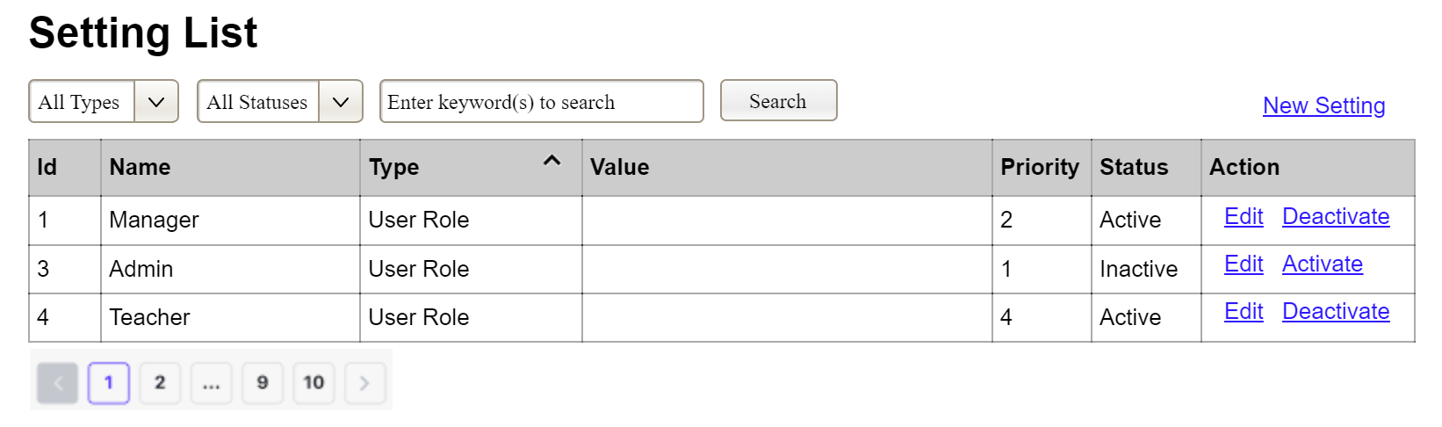
(1)
(2)
(3)
This screen allows the Administrator to:
- View Setting List: view list of current master data.
- Filter Setting List: filter master data by data types, statuses
- Search Settings: enter keyword(s) to search master data by their names or values
- Sort Setting List: sort mater data list (ascending, descending) by clicking column headers
On the screen, s/he can also
- Activate/Deactivate Setting: change status of a specific inactive/active master data
- Choose to go to the Setting Details screens for adding new or updating an existing master data by clicking the New Setting or Edit link.
Field Description
Field Name | Description
(1) | Initial values: all the active setting names with null or blank type  Hover the mouse to show the field name: “Setting Type”
(2) | Initial values: All Statuses, Active, Inactive (default value “All Status”)  Hover the mouse to show the field name: “Setting Status”
(3) | The change-status action is Activate or Deactivate depending on the current status of the relevant setting (Inactive or Active, respectively).

3.3.1.2 Setting Details
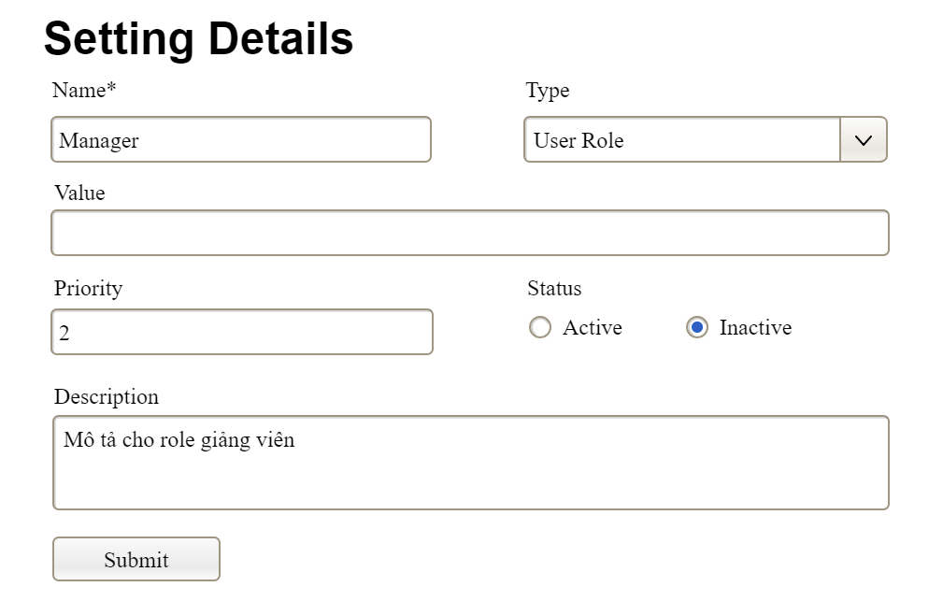

This screen allows the Administrator to:
- Add New Setting: add new master data.
- Update Setting Details: update details of a specific master data
Field Description
Field Name | Description
Name | Data type: non-digit string, max length of 20 characters
Type | Initial data values: all active setting names (with null or blank type)
Value | Data type: any string, max length of 100 characters
Priority | Data type: a positive integer
Description | Data type: any string, max length of 200 characters

3.3.2 User Management

3.3.2.1 User List
…

3.3.2.2 User Details
…

4. Non-Functional Requirements

4.1 External Interfaces

Interface Category | Interface Type | Description & Technical Specifications
User Interface (UI) | Web-based UI | A responsive web interface built with ReactJS and TypeScript. It must provide a unified workspace containing the server sidebar, channel list, messaging area, and member list.
Application Programming Interface (API) | RESTful API | Communicates via HTTP/HTTPS using JSON as the primary data exchange format. Used for management operations such as User Registration, Server Creation, and Profile Updates.
Real-time Communication | WebSocket / STOMP | Persistent full-duplex communication protocol used for instant messaging, unread notifications, and presence tracking (online/offline status).
Media Interface | WebRTC | Peer-to-peer (P2P) signaling for voice channels. Requires integration with STUN/TURN servers (e.g., Cloudflare or Metered.ca) to facilitate NAT traversal.
Persistence Layer | PostgreSQL | Interface for structured data storage, supporting ACID compliance for users, servers, channels, and message history.

4.2 Quality Attributes

4.2.1 Usability
- Onboarding Efficiency (BG-01): A new user (e.g., Lan Anh) must be able to complete the registration flow and join their first server via an invite link in ≤ 30 seconds.
- Task Completion Time: Key communication tasks, such as switching between two text channels or initiating a voice call, must be completed in ≤ 2 clicks from the main dashboard.
- Learning Curve: Users familiar with standard messaging platforms (e.g., Zalo, Messenger) shall require zero formal training to send their first message or join a voice room.
- UI Consistency: All interfaces must adhere to a centralized Design System (Colors, Typography, Components) as defined in the project wireframes to ensure a cohesive user experience.

4.2.2 Performance
- Messaging Latency (BG-02): The 95th-percentile end-to-end latency for broadcasting a message via WebSocket (from sender transmission to recipient display) must be < 500ms.
- Concurrency: The Phase 1 MVP system must support a minimum of 500 concurrent users on a single Spring Boot instance without performance degradation.
- Voice Capacity: Each voice channel must maintain stable WebRTC performance for up to 20 simultaneous participants.
- Initial Page Load: The core application bundle must load and render the login/landing page in ≤ 2 seconds under standard 4G/Broadband conditions.

4.2.3 Security
- Authentication (BG-05): All protected API endpoints must require a valid JWT Access Token. The system must implement JWT Refresh Token rotation with a 7-day validity period.
- Access Control: 100% of server-specific resources (channels, member lists) must be restricted to authenticated members of that specific server.
- Session Management: The system must provide a secure logout function that immediately revokes the Refresh Token in the database and terminates the WebSocket connection.
- Data Integrity: All data in transit must be encrypted using TLS 1.2 or higher (HTTPS/WSS).

4.2.4 Reliability & Availability
- Uptime Target: The system shall maintain an availability of 99.5% during the Phase 1 demonstration period.
- Fault Tolerance: In the event of a WebSocket disconnection, the ReactJS client must implement an exponential backoff reconnection logic to restore real-time functionality without requiring a manual page refresh.
- Data Persistence: 100% of sent messages and server configurations must be stored in the PostgreSQL database with no data loss during standard operation.

4.2.5 Scalability
- Vertical Scaling: The Spring Boot backend and PostgreSQL database must be capable of vertical scaling (increasing CPU/RAM) on cloud providers (e.g., Render, Railway) to handle sudden spikes in user activity.
- Database Growth: The schema must support a growth trajectory of up to 10,000 users and 1,000,000 messages before requiring horizontal sharding or partitioning.

4.2.6 Maintainability
- Deployment (Vibe Coding): The system must utilize a CI/CD pipeline (automated via GitHub Actions or cloud-native tools) to ensure new updates can be deployed to production in < 10 minutes.
- Monitoring & Logging: The backend must implement centralized logging (e.g., SLF4J/Logback) to track 100% of critical errors and authentication failures for rapid debugging.
- Code Documentation: The codebase must maintain a minimum of 80% documentation coverage for core API services to facilitate future Phase 2 development.

4.2.7 Compatibility
- Browser Support: The system must be fully functional on the latest stable versions of Google Chrome, Mozilla Firefox, and Microsoft Edge.
- Responsive Design: The web application must remain usable on screen widths ranging from 1024px (Tablet/Small Laptop) to 1920px+ (Desktop).

5. Requirement Appendix
[Provide business rules, common requirements, or other extra requirements information here]

5.1 Business Rules
[Provide common business rules that you must follow. The information can be provided in the table format as the sample below]

ID | Rule Definition
BR-01 | All users must be authenticated via a valid JWT Access Token before accessing protected system features.
BR-02 | A Guest User shall not be permitted to view server content or send messages until an account is created and a server is joined via an invite link.
BR-03 | Only a Server Owner is authorized to delete a server, manage its administrative settings, or create/delete channels.
BR-04 | A server must always have exactly one Owner; the Owner cannot leave the server unless the ownership is transferred or the server is deleted.
BR-05 | Server invite links must include a Time-To-Live (TTL) constraint and shall automatically expire after 7 days.
BR-06 | A user who has been "Banned" from a server is permanently prohibited from re-joining that server via any invite link until the ban is manually lifted by the Owner.
BR-07 | Text messages must be broadcast to all online members of a specific channel within a maximum latency of 500ms.
BR-08 | Passwords must consist of a minimum of 8 characters and shall be stored only in a secure, hashed format.
BR-09 | User-uploaded files for avatars or server icons are restricted to a maximum size of 2MB and must be in PNG or JPG format.
BR-10 | Unread message badges shall be updated in real-time and must disappear immediately once the user enters the respective channel.

5.2 System Messages

# | Message code | Message Type | Context | Content
1 | MSG01 | Validation Error | Mandatory field left blank | "The {field_name} is required. Please fill in the missing information."
2 | MSG02 | Validation Error | Password length constraint | "Password is too short. It must contain at least 8 characters."
3 | MSG03 | Validation Error | Email format is incorrect | "Please enter a valid email address (e.g., name@example.com)."
4 | MSG04 | Inline | Email already exists in database | "This email is already registered. Please log in or use a different email."
5 | MSG05 | Toast Message | Login failed due to credentials | "Invalid email or password. Please try again."
6 | MSG06 | Toast Message | Server created successfully | "Server '{server_name}' has been created successfully."
7 | MSG07 | Modal | Confirm server deletion | "Are you sure you want to delete this server? All data and messages will be permanently lost."
8 | MSG08 | Inline | Invite link has expired | "This invite link has expired or is no longer valid."
9 | MSG09 | Toast Message | Member kicked from server | "User has been successfully removed from the server."
10 | MSG10 | Validation Error | File upload exceeds 2MB limit | "File size exceeds the 2MB limit. Please upload a smaller image."
11 | MSG11 | Toast Message | Profile update successful | "Your profile has been updated successfully."
12 | MSG12 | Toast Message | System error / Connection lost | "Connection lost. Attempting to reconnect..."

5.3 Other Requirements…

