**Group of 2 students:**

**Roll No: 13BCE105 and 13BCE109**

**Open CMS (Wordpress)**

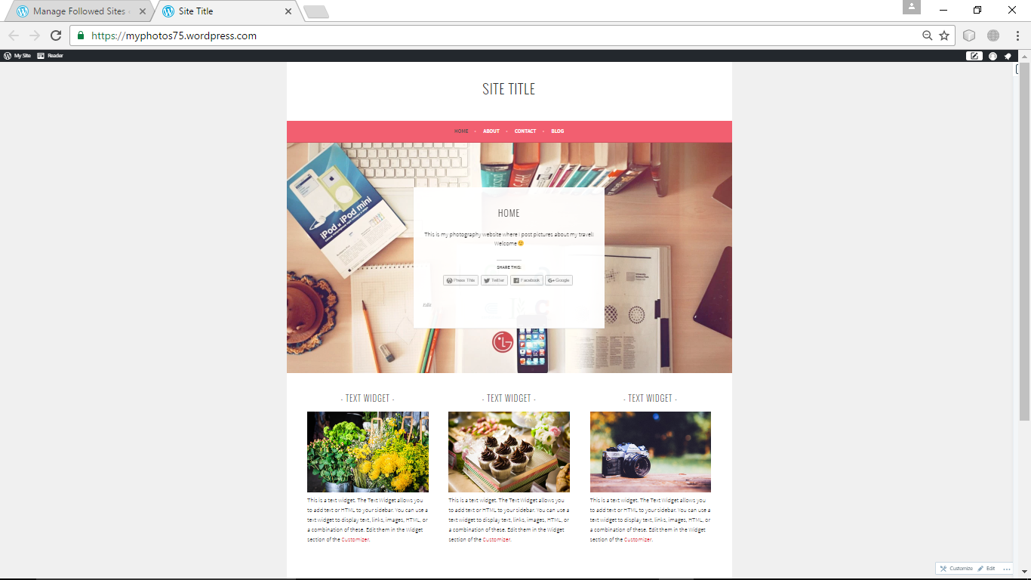

**Home page**

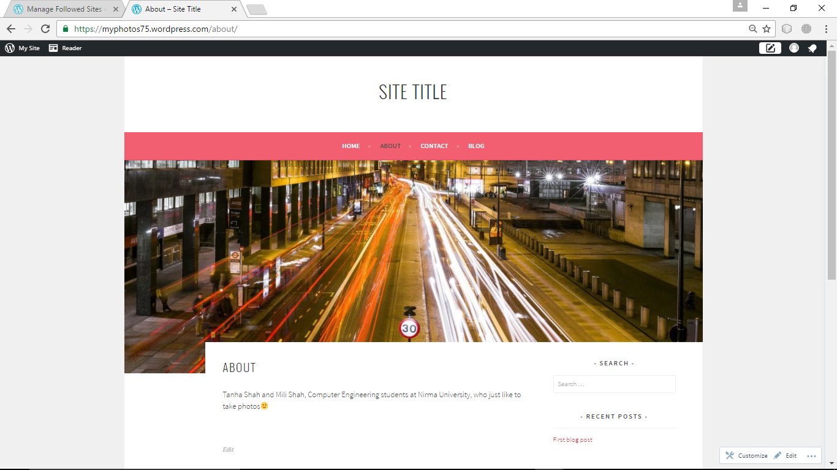**About page**

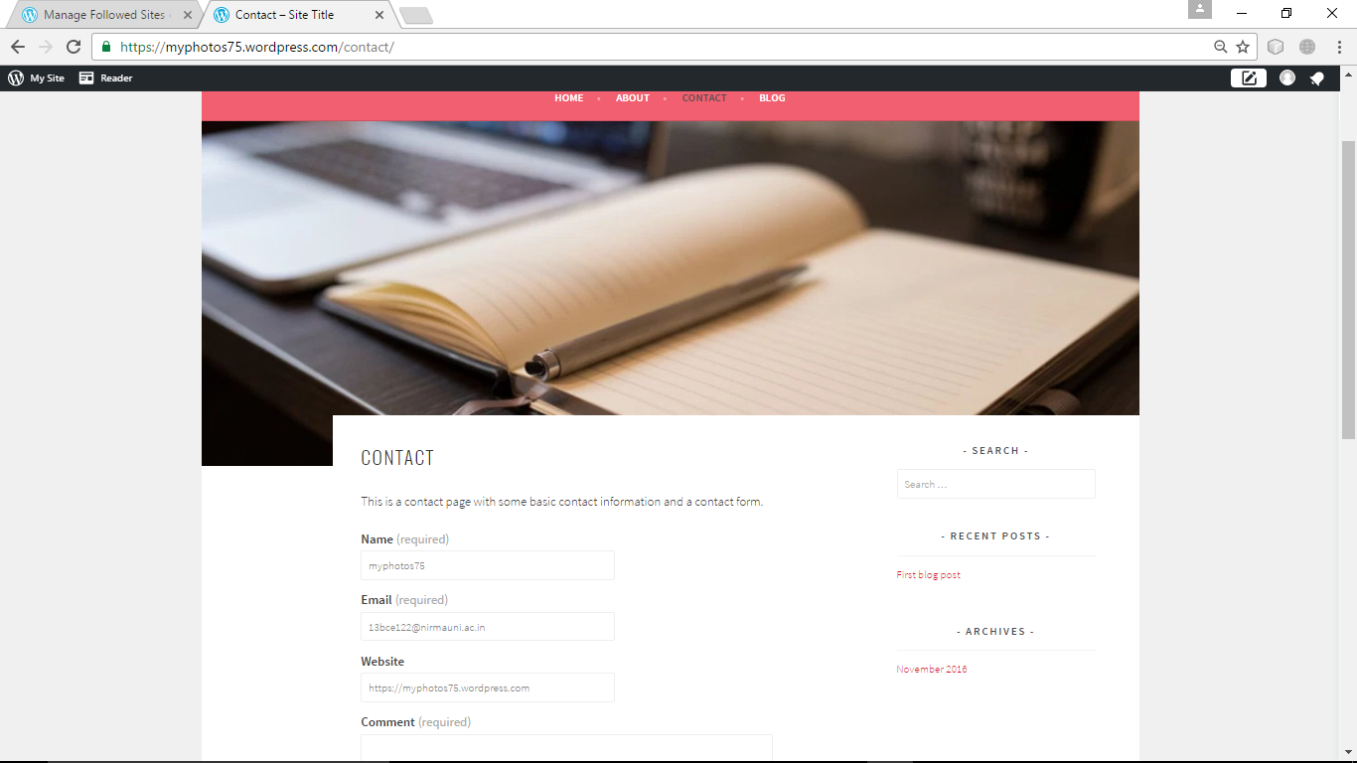

**Contact page**

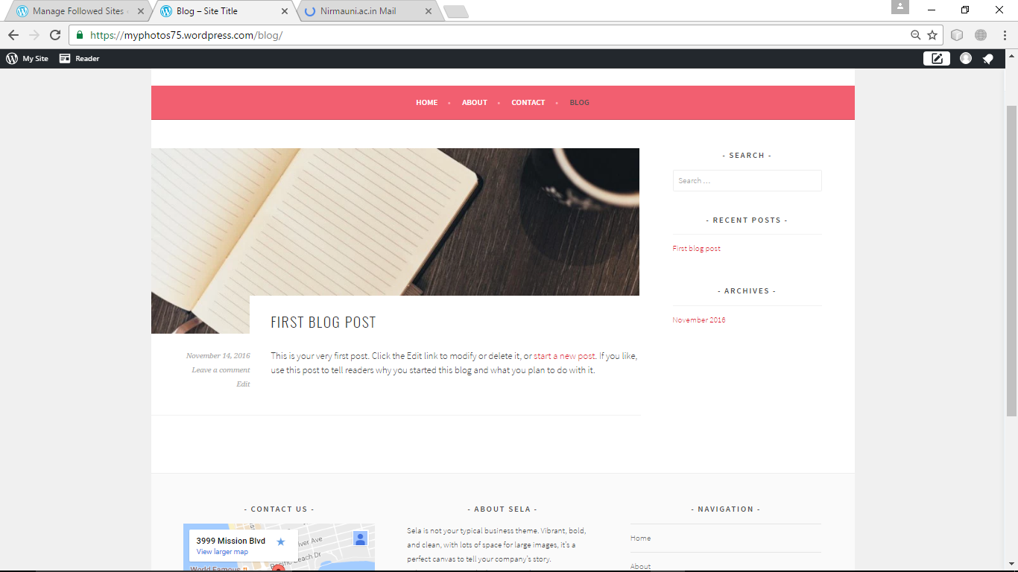

**Blog**