BMS INSTITUTE OF TECHNOLOGY AND MANAGEMENT
Autonomous Institute under VTU, Belagavi, Karnataka – 590 018
Yelahanka, Bengaluru, Karnataka – 560 119
DEPARTMENT OF INFORMATION SCIENCE AND ENGINEERING
Data Flow Diagrams
Data Flow Diagrams
Level 0 (Context) and Level 1
Project: ARES – Conflict Escalation Early-Warning System
Major Project – Information Science and Engineering (2022 Scheme)
Prepared by
Ms. Shirin S Hegde 1BY23IS198 — Data Engineering & Integration Lead
Ms. Sreshta Karthikeyan 1BY23IS215 — AI/ML Model Developer
Ms. Tanya Deep 1BY23IS231 — System Development & Visualization Lead

Under the Guidance of
Prof. Sneha Sureddy, Assistant Professor, Dept. of ISE
February 2026

1. Purpose
This document defines the movement of data through ARES at increasing levels of detail, following standard DFD conventions (external entity, process, data store, data flow).

2. DFD Level 0 — Context Diagram
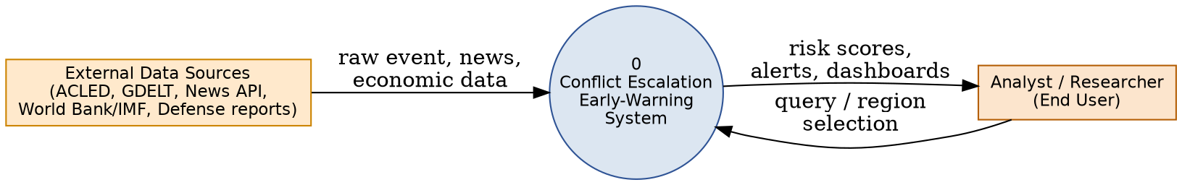
At the context level, ARES is treated as a single process (0) that receives raw event, news, and economic data from external sources, and returns risk scores, alerts, and dashboards to the Analyst/Researcher, who may also submit region/query selections back into the system.

3. DFD Level 1 — Process Decomposition
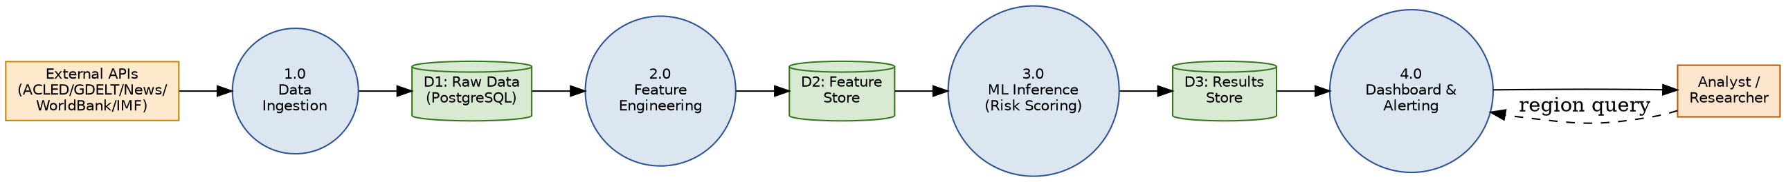
Process | Description | Input | Output
1.0 Data Ingestion | Asynchronous fetch from external APIs | External API responses | D1: Raw Data
2.0 Feature Engineering | Computes rolling escalation indicators | D1: Raw Data | D2: Feature Store
3.0 ML Inference | Runs trained model to compute risk score | D2: Feature Store | D3: Results Store
4.0 Dashboard & Alerting | Serves results and handles user queries | D3: Results Store, user query | Dashboard views, alerts

4. DFD Level 2 (Process 2.0 — Feature Engineering, Expanded)
Process 2.0 expands into: 2.1 compute event acceleration (rolling 7-day event count delta), 2.2 compute sentiment volatility (standard-deviation shift in news tone), 2.3 compute protest-to-violence ratio, 2.4 compute economic stress gradient (quarter-over-quarter inflation/GDP/unemployment delta). Each sub-process reads from D1 (Raw Data) filtered by Region_Key and time window, and writes its computed indicator to D2 (Feature Store).
Sub-process | Formula / Logic | Data Store Written
2.1 Event Acceleration | (events_last_7d − events_prior_7d) / events_prior_7d | features.event_acceleration
2.2 Sentiment Volatility | Std. deviation of daily tone score over rolling window | features.sentiment_volatility
2.3 Protest-to-Violence Ratio | protest_events / (protest_events + violent_events) | features.protest_ratio
2.4 Economic Stress Gradient | QoQ delta of inflation, GDP growth, unemployment | economic_indicators (derived)

