BMS INSTITUTE OF TECHNOLOGY AND MANAGEMENT
Autonomous Institute under VTU, Belagavi, Karnataka – 590 018
Yelahanka, Bengaluru, Karnataka – 560 119
DEPARTMENT OF INFORMATION SCIENCE AND ENGINEERING
Final Project Report
Project Report
ARES: Conflict Escalation Early-Warning System
Project: ARES – Conflict Escalation Early-Warning System
Major Project – Information Science and Engineering (2022 Scheme)
Prepared by
Ms. Shirin S Hegde 1BY23IS198 — Data Engineering & Integration Lead
Ms. Sreshta Karthikeyan 1BY23IS215 — AI/ML Model Developer
Ms. Tanya Deep 1BY23IS231 — System Development & Visualization Lead

Under the Guidance of
Prof. Sneha Sureddy, Assistant Professor, Dept. of ISE
Major Project Phase — 2022 Scheme — 2025-26

Chapter 1: Introduction

1.1 Background
Armed conflicts and geopolitical crises rarely emerge without warning. Escalation is typically preceded by a measurable build-up of political tension, economic stress, hostile media narratives, and shifting diplomatic behaviour. Despite the growing availability of open-source political event data, news feeds, and economic indicators, most existing conflict-monitoring tools remain reactive — cataloguing violence only after it has occurred, rather than forecasting the conditions that precede it.

1.2 Problem Statement
There is no accessible, explainable, open-source system that fuses political-event, narrative, economic, and diplomatic signals into a single, interpretable early-warning score at the regional level. ARES addresses this gap. For a full boundary definition of what "conflict escalation" means in this project's scope, see Chapter 3 (Requirement Analysis) and the companion Problem Statement Document.

1.3 Objectives
- Develop an early-warning system capable of detecting conflict escalation before the outbreak of violence.
- Integrate and analyze multi-source open data related to political events, media narratives, and economic indicators.
- Identify and model leading indicators that signal transitions from stability to escalation.
- Forecast short-term escalation risk using machine learning and deep learning techniques.
- Provide interpretable, source-traceable outputs that explain the causes and drivers behind each risk score.

1.4 Scope of the Project
In scope: automated ingestion of open-source conflict, news, economic, and diplomatic data; feature engineering for escalation indicators; a machine-learning risk-scoring pipeline; an interactive dashboard with drill-down and source-evidence views; and historical backtesting for validation. Real-time (sub-minute) streaming, classified data sources, and autonomous decision-making are explicitly out of scope.

1.5 Organization of the Report
Chapter 2 reviews related literature. Chapter 3 analyzes requirements. Chapter 4 presents the system design and architecture. Chapter 5 describes the implementation methodology. Chapter 6 covers the testing strategy. Chapter 7 presents results (to be completed as implementation progresses). Chapter 8 concludes and outlines future scope.

Chapter 2: Literature Survey

2.1 Conflict Forecasting & Political Violence
Early-warning research has progressed from statistical forecasting toward ensemble and deep-learning approaches. Hegre et al.'s ViEWS system established an ensemble machine-learning framework for global political-violence prediction using UCDP and PRIO data, later extended to long-range forecasting through 2050. Subsequent work applied logistic regression and machine learning to subnational, grid-based conflict prediction, and compared random forests against logistic regression for class-imbalanced civil-war onset — a methodological concern directly relevant to ARES given how rare true escalation events are relative to stable periods.
Bayesian spatio-temporal models (Brandt et al.) and random-forest approaches on ICEWS data (Ward et al.) demonstrated that political-event datasets carry predictive signal, while Raleigh et al.'s introduction of the ACLED dataset itself remains a foundational data source this project directly reuses.

2.2 Deep Learning & Graph-Based Event Forecasting
More recent work has moved toward graph neural networks and temporal knowledge graphs to capture relational structure between actors, locations, and events (Ma et al.; Trivedi et al.; Rossi et al.'s Temporal Graph Networks; Pareja et al.'s EvolveGCN). Campedelli et al. applied LSTM and graph models to predict terrorist attack targets, and Hossain et al. used attention networks on GDELT to detect early geopolitical precursor signals — directly analogous to ARES's event-acceleration and narrative-shift features, though these approaches generally trade interpretability for predictive power, a tension this project resolves by defaulting to simpler, explainable models first (see Chapter 4 and the Model Selection & Evaluation Plan).

2.3 Climate–Conflict Interaction
A separate body of research (Mach et al. in Nature; Hsiang, Burke & Miguel in Science; Burke, Hsiang & Miguel on temperature-economy effects) establishes climate and economic stress as measurable risk factors for conflict, motivating ARES's inclusion of macroeconomic indicators (inflation, GDP growth, unemployment) as a first-class feature category alongside event and narrative data.

2.4 Time-Series Forecasting Methods
For the short-term forecasting component, relevant modeling approaches include Temporal Fusion Transformers for interpretable multi-horizon forecasting (Lim et al.), transformer-based multivariate time-series representation learning (Zerveas et al.), and DeepAR's probabilistic autoregressive forecasting (Salinas et al.) — candidate techniques for ARES's time-series module if the simpler statistical baseline proves insufficient during backtesting.

2.5 Causal & Interpretable Machine Learning
Given ARES's explainability requirement (NFR-03), causal representation learning (Schölkopf et al.) and heterogeneous causal-effect estimation (Athey & Imbens) inform the project's approach to surfacing which factors drive a given risk score, rather than presenting an unexplained black-box output.

2.6 Research Gap
Across this literature, two consistent gaps emerge: first, most systems predict isolated conflict events rather than continuously tracking escalation trends across multiple fused data sources in near-real time; second, there is a lack of integrated, explainable platforms that combine event, narrative, economic, and diplomatic signals with an interactive visualization layer accessible to non-specialist analysts. ARES is scoped specifically to address both gaps.

2.7 Comparative Positioning Against Existing Systems
System | Approach | Explainability | Data Fusion | Gap ARES Addresses
ViEWS (Hegre et al.) | Ensemble ML on UCDP/PRIO, country/PRIO-grid level | Limited — model-level, not per-alert | Conflict + structural covariates | No integrated news/economic real-time fusion or interactive drill-down UI
ICEWS-based RF models (Ward et al.) | Random forest on event data | Low — feature importances only, not surfaced per-prediction | Event data primarily | No source-level evidence trail per prediction
GDELT-based attention models (Hossain et al.) | Attention networks on news/event streams | Low — attention weights rarely user-facing | News/event only | No economic/diplomatic fusion; not designed for analyst-facing use
ARES (this project) | Layered: explainable baseline first, complex models only if proven | High — mandatory per-score factor breakdown + source link (NFR-03) | Event + news + economic + diplomatic, fused via Region_Key | Combines fusion breadth with mandatory explainability and an analyst-facing dashboard

Chapter 3: Requirement Analysis
Full functional and non-functional requirements are specified in the companion Software Requirements Specification (SRS), following IEEE 830-1998 format. A summary of key functional requirement categories is given below; see the SRS for the complete, numbered requirement set (FR-01 through FR-14, NFR-01 through NFR-10).
- Scheduled, asynchronous multi-source data ingestion (event, news, economic, diplomatic)
- Region-linked feature engineering (event acceleration, sentiment volatility, protest ratio, economic stress gradient)
- Interpretable ML-based risk scoring with mandatory source traceability
- Interactive dashboard with drill-down, trend visualization, and explainability panel
- Historical backtesting capability for model validation

Chapter 4: System Design

ARES is implemented as a modular monolith — a single deployable application with clearly separated internal modules (ingestion, storage, features, model, api, frontend) — chosen for faster development, easier debugging, and zero DevOps overhead relative to a microservices approach, appropriate for a two-semester student timeline.
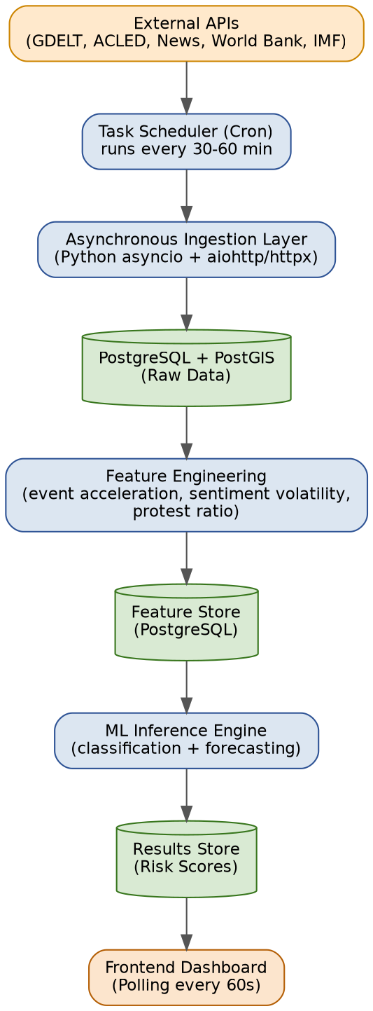

PostgreSQL with the PostGIS spatial extension stores all data, linked across sources via a common Region_Key rather than raw coordinates or event IDs. Full schema and ER diagram are provided in the companion System Architecture Document and Use Case & ER Diagram document.
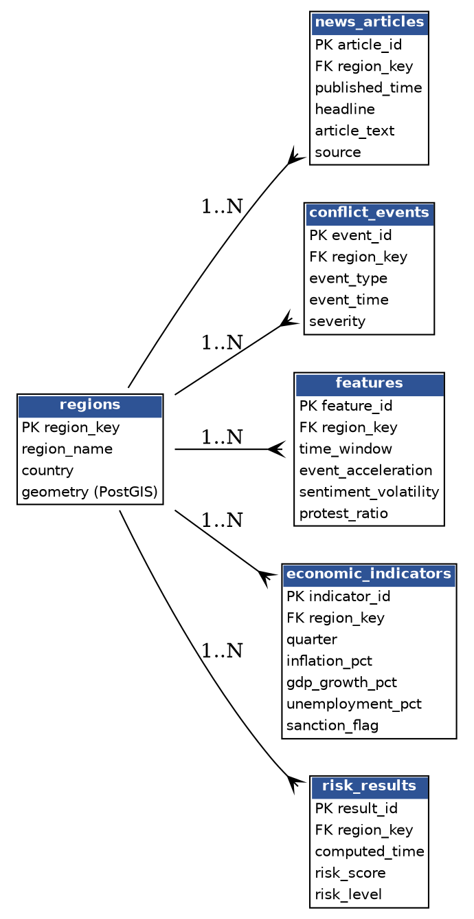

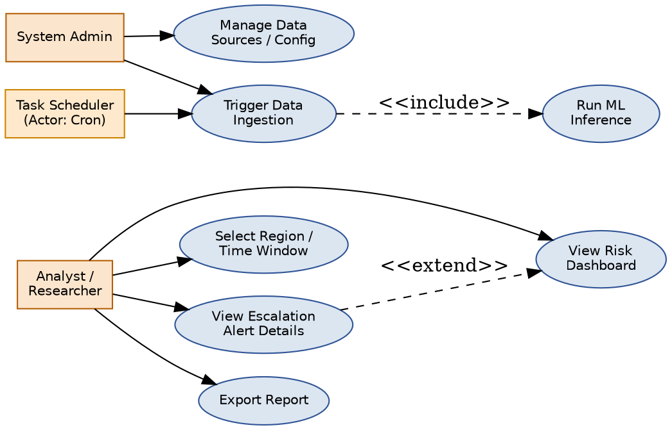

4.4 Module-Level Technical Design

Implemented with Python asyncio and httpx/aiohttp. A single ingest_cycle() coroutine fans out to per-source coroutines (fetch_acled, fetch_gdelt, fetch_news, fetch_econ) via asyncio.gather, so a slow or failing source cannot block the others (NFR-02). Each fetcher applies exponential backoff (base 2s, max 3 retries) on HTTP 429/5xx responses before logging a failure and continuing. Raw responses are hashed and compared against the local cache table before any write, so a re-run within the TTL window performs zero redundant API calls.

A thin data-access layer over PostgreSQL/PostGIS using SQLAlchemy Core (not full ORM, to keep query plans transparent for a small, well-understood schema). All fact tables carry a composite index on (region_key, event_time/published_time) since every query pattern in the system — feature computation, dashboard drill-down, evidence feed — filters by region and a time window.

Computes the four rolling indicators defined in SRS Section 3.4 (event acceleration, sentiment volatility, protest ratio, economic stress gradient) as a scheduled batch job over all Region_Keys with new raw data since the last run, rather than recomputing the full history — bounding the job's runtime to the size of the incremental update, not the full dataset.

Loads the trained classifier and the fine-tuned sentiment model into memory once at process startup (Section 5.2 of the System Architecture Document). Exposes a single score_region(region_key, time_window) function used both by the scheduled hourly batch and by the on-demand endpoint triggered from a drill-down request, so there is exactly one code path computing a risk score — eliminating a class of bugs where batch and on-demand scores could silently drift apart.

A lightweight REST layer (see SRS Section 3.5 for the full endpoint table) that translates HTTP requests into storage/model module calls and serializes results to JSON. Kept deliberately thin — no business logic lives in this layer — so that ingestion, feature, and model logic remain independently testable without spinning up the web server.

Polls the API layer every 60 seconds (Section 6.1 of the System Architecture Document) and renders the dashboard views specified in the UI/UX Wireframes document: the main overview (traffic-light cards, heatmap, trend chart, explainability panel) and the region drill-down (contributing factors, escalation timeline, source evidence feed).

5.5 Technology Choices and Alternatives Considered
Decision | Chosen | Alternative(s) Considered | Why Rejected
Architecture style | Modular monolith | Microservices | Adds service-discovery/orchestration overhead disproportionate to a 3-person, 2-semester project
Database | PostgreSQL + PostGIS | MongoDB | Weak relational joins and poor temporal aggregation for this analytics-heavy, time-series workload
Vector store | None (feature-based ML) | Pinecone/Weaviate for semantic search | No large-scale embedding retrieval requirement in the current scope
Task queue | Cron | Celery + Redis broker | Unnecessary complexity at this scale; a simple scheduled job meets the 30-60 min ingestion cadence
Real-time updates | 60s polling | WebSockets | Sub-second real-time alerts are not a requirement; polling is simpler and more reliable to debug
Caching | DB timestamp cache + in-memory LRU | Redis | Operational overhead not justified for a single-user/low-traffic academic deployment

Chapter 5: Implementation Methodology

The team follows a phased, milestone-driven approach aligned to the VI–VII semester review schedule (Review 0 through Review 3), with work distributed by module ownership as detailed in the companion Module Distribution Sheet and Gantt Chart/Timeline.

Data is ingested asynchronously (Python asyncio/aiohttp) from ACLED, GDELT, NewsAPI, and World Bank/IMF sources on a 30–60 minute schedule, cleaned and deduplicated, assigned a Region_Key, and persisted to PostgreSQL. Full preprocessing rules are in the companion Dataset Documentation.

Rolling-window features (event acceleration, sentiment volatility, protest-to-violence ratio, economic stress gradient) are computed per region and fed into a layered modeling approach: simple, explainable models (Random Forest, statistical baselines) are used first, with more complex models (transformer-based NLP, LSTM/temporal models) adopted only where backtesting shows a clear, reproducible improvement. Full detail is in the companion Model Selection & Evaluation Plan.

Per the companion Ethical & Bias Considerations document, the system is implemented strictly as a decision-support tool: no autonomous action is taken on any output, de-escalation markers are included as explicit negative-weight inputs to avoid one-directional alerting, and every risk score is required to carry a traceable source link.

5.6 Representative Algorithm Pseudocode

for region in regions_with_new_data:
events_now = query_events(region, window=7d, end=now)
events_prior = query_events(region, window=7d, end=now-7d)
event_accel = (len(events_now) - len(events_prior)) / max(len(events_prior), 1)
tones = query_article_tones(region, window=14d)
sentiment_vol = stddev(tones)
protests, violent = split_by_type(events_now_30d)
protest_ratio = len(protests) / max(len(protests) + len(violent), 1)
econ = latest_economic_indicators(region)
econ_stress = weighted_sum(econ.inflation_delta, -econ.gdp_delta, econ.unemployment_delta, econ.sanction_flag)
save_features(region, event_accel, sentiment_vol, protest_ratio, econ_stress)

for case in historical_cases:
cutoff = case.escalation_peak_date - lookback_window
data = load_data(region=case.region, end_date=cutoff)
scores = run_model(data)
flag_date = first_date_where(scores.tier == 'Red' or scores.tier == 'Amber')
lead_time = case.escalation_peak_date - flag_date
record_result(case.id, flag_date, lead_time, scores)
report_metrics(recall, precision, false_positive_rate, mean_lead_time)

Chapter 6: Testing Strategy
Testing follows the companion Test Plan document, covering unit tests (feature formulas, region-key matching, API parsers), integration tests (end-to-end ingestion-to-dashboard flow), model validation (historical backtesting), and usability testing of the dashboard. The full test-case set is provided in the companion Test Case Sheets spreadsheet, organized into Ingestion, Feature & Model, and Dashboard test suites.

6.1 Sample Test Case Walkthrough
To illustrate the testing approach concretely (full set in the companion Test Case Sheets), consider TC-09 — validating that the model flags a known historical escalation case within the backtest window:
- Restrict ingested data to the period ending at a defined cutoff date, strictly before the documented escalation peak.
- Run the full pipeline (features → model → risk tiering) as it would run in production, using only pre-cutoff data.
- Record the date on which the region first crosses into the Amber or Red tier.
- Compute lead time as (actual escalation peak date − first-flag date); a positive value indicates a successful early warning.
- Repeat across multiple historical cases to compute aggregate recall, precision, and false-positive rate against the NFR-04/NFR-05 targets.
This is the same procedure specified in UC-03 (SRS Section 4.1) and the pseudocode in Section 5.6.2 above — the test plan, requirements, and implementation are intentionally kept in lockstep so that a reviewer can trace one artifact to the others.

Chapter 7: Results and Discussion
[TO BE COMPLETED FOLLOWING IMPLEMENTATION] This chapter is a placeholder to be filled in once the ingestion pipeline, feature engineering, model training, and backtesting are complete. It should report: (a) the historical case(s) used for backtesting and why they were chosen, (b) the achieved recall, precision, and false-positive rate against the targets defined in the Model Selection & Evaluation Plan (recall ≥ 75%, FPR < 15%), (c) the measured detection lead time ahead of the documented escalation peak, (d) screenshots of the working dashboard, and (e) any deviations from the planned design and why they were made.
Suggested structure once populated: 7.1 Backtest Case Selection · 7.2 Model Performance Metrics · 7.3 Detection Lead-Time Analysis · 7.4 Dashboard Walkthrough (Screenshots) · 7.5 Deviations from Design and Justification.

Chapter 8: Conclusion and Future Scope

[TO BE FINALIZED] ARES demonstrates the feasibility of fusing open-source event, narrative, economic, and diplomatic data into an interpretable, explainable conflict-escalation early-warning system, built entirely on free and open-source tooling within an academic timeline. Update this section with a concrete summary of what was actually achieved once Chapter 7 is complete.

- Extending coverage to lower open-source-density regions with adjusted confidence reporting.
- Upgrading the time-series component to Temporal Fusion Transformer or DeepAR-style probabilistic forecasting if backtesting shows the statistical baseline is insufficient.
- Adding a graph neural network layer to model actor-to-actor relational escalation dynamics, as explored by Ma et al. and Rossi et al. in the literature survey.
- A public research/education-only deployment with appropriate misuse safeguards, subject to renewed ethical review.

References
- Hegre, H. et al. (2019). ViEWS: A political violence early-warning system. Journal of Peace Research, 56(2), 155-174.
- Hegre, H. et al. (2019). Predicting armed conflict 2010-2050. International Studies Quarterly.
- Hegre, H. et al. (2018). Forecasting civil conflict along subnational lines. Journal of Peace Research.
- Brandt, P. et al. (2016). Forecasting political conflict in space and time. Journal of Conflict Resolution.
- Ward, M. et al. (2013). Predicting political instability using machine learning. International Studies Review.
- Muchlinski, D., Siroky, D., He, J., & Kocher, M. (2016). Comparing random forest with logistic regression for predicting class-imbalanced civil war onset data. Political Analysis, 24(1), 87-103.
- Raleigh, C., Linke, A., Hegre, H., & Karlsen, J. (2010). Introducing ACLED: An armed conflict location and event dataset. Journal of Peace Research, 47(5), 651-660.
- Leetaru, K., & Schrodt, P. (2013). GDELT: Global database of events, language, and tone. ISA Conference.
- Boschee, E. et al. (2015). ICEWS event data system. Data Science Conference.
- Ma, Y. et al. (2023). Event forecasting with graph neural networks. AI Conference.
- Trivedi, R. et al. (2017). Event prediction using temporal knowledge graphs. ML Conference.
- Rossi, E. et al. (2020). Temporal graph networks for deep learning on dynamic graphs. arXiv:2006.10637.
- Pareja, A. et al. (2020). EvolveGCN: Evolving graph convolutional networks for dynamic graphs. AAAI 2020.
- Campedelli, G. et al. (2021). Learning future terrorist targets through temporal meta-graphs. AI Conference.
- Hossain, T. et al. (2023). Identifying precursors to geopolitical events. AI Conference.
- Mach, K. J. et al. (2019). Climate as a risk factor for armed conflict. Nature, 571, 193-197.
- Hsiang, S. M., Burke, M., & Miguel, E. (2013). Quantifying the influence of climate on human conflict. Science, 341(6151).
- Burke, M., Hsiang, S. M., & Miguel, E. (2015). Global non-linear effect of temperature on economic production. Nature, 527, 235-239.
- Lim, B., Arik, S. O., Loeff, N., & Pfister, T. (2021). Temporal fusion transformers for interpretable multi-horizon time series forecasting. International Journal of Forecasting, 37(4), 1748-1764.
- Salinas, D., Flunkert, V., Gasthaus, J., & Januschowski, T. (2020). DeepAR: Probabilistic forecasting with autoregressive recurrent networks. International Journal of Forecasting, 36(3), 1181-1191.
- Schölkopf, B. et al. (2021). Toward causal representation learning. Proceedings of the IEEE, 109(5), 612-634.
- Athey, S., & Imbens, G. (2022). Machine learning methods for estimating heterogeneous causal effects. Journal of Economic Perspectives, 36(3), 31-54.

