BMS INSTITUTE OF TECHNOLOGY AND MANAGEMENT
Autonomous Institute under VTU, Belagavi, Karnataka – 590 018
Yelahanka, Bengaluru, Karnataka – 560 119
DEPARTMENT OF INFORMATION SCIENCE AND ENGINEERING
Software Requirements Specification
Software Requirements Specification (SRS)
IEEE 830-1998 Format — ARES Conflict Escalation Early-Warning System
Project: ARES – Conflict Escalation Early-Warning System
Major Project – Information Science and Engineering (2022 Scheme)
Prepared by
Ms. Shirin S Hegde 1BY23IS198 — Data Engineering & Integration Lead
Ms. Sreshta Karthikeyan 1BY23IS215 — AI/ML Model Developer
Ms. Tanya Deep 1BY23IS231 — System Development & Visualization Lead

Under the Guidance of
Prof. Sneha Sureddy, Assistant Professor, Dept. of ISE
Version 1.0 — February 2026

1. Introduction

1.1 Purpose
This Software Requirements Specification (SRS) describes the functional and non-functional requirements of ARES, a Conflict Escalation Early-Warning System, for the VI–VII semester Major Project (2022 Scheme), Department of Information Science and Engineering, BMSIT&M. It is intended for the development team, project guide, and evaluation panel.

1.2 Scope
ARES ingests open-source political event, news/media, and economic data; computes region-level escalation features; runs machine-learning inference to produce an interpretable 0–100 risk score; and presents results through an interactive dashboard with source-level explainability. The system is a decision-support tool — it does not take autonomous action.

1.3 Definitions, Acronyms, and Abbreviations
Term | Definition
ARES | Conflict Escalation Early-Warning System (project codename)
ACLED | Armed Conflict Location & Event Data Project — conflict event dataset
GDELT | Global Database of Events, Language, and Tone — global news/event dataset
Region_Key | Common identifier used to link all data sources to a geographic region
Risk Score | 0–100 output representing modeled escalation risk for a region/time window
PostGIS | Spatial database extension for PostgreSQL
MVP | Minimum Viable Product

1.4 References
- IEEE Std 830-1998, IEEE Recommended Practice for Software Requirements Specifications
- Hegre et al. (2019), "ViEWS: A Political Violence Early-Warning System", Journal of Peace Research
- Raleigh et al. (2010), "Introducing ACLED", Journal of Peace Research
- ARES System Architecture & Design Document (companion document)
- ARES Dataset Documentation (companion document)

1.5 Overview
Section 2 gives an overall product description. Section 3 lists specific functional and non-functional requirements. Section 4 lists external interface requirements. Section 5 covers system attributes such as reliability and maintainability.

2. Overall Description

2.1 Product Perspective
ARES is a new, standalone academic system implemented as a modular monolith. It is not a replacement for existing conflict databases (ACLED, GDELT) but a downstream analytical layer that fuses them into actionable, explainable risk indicators.
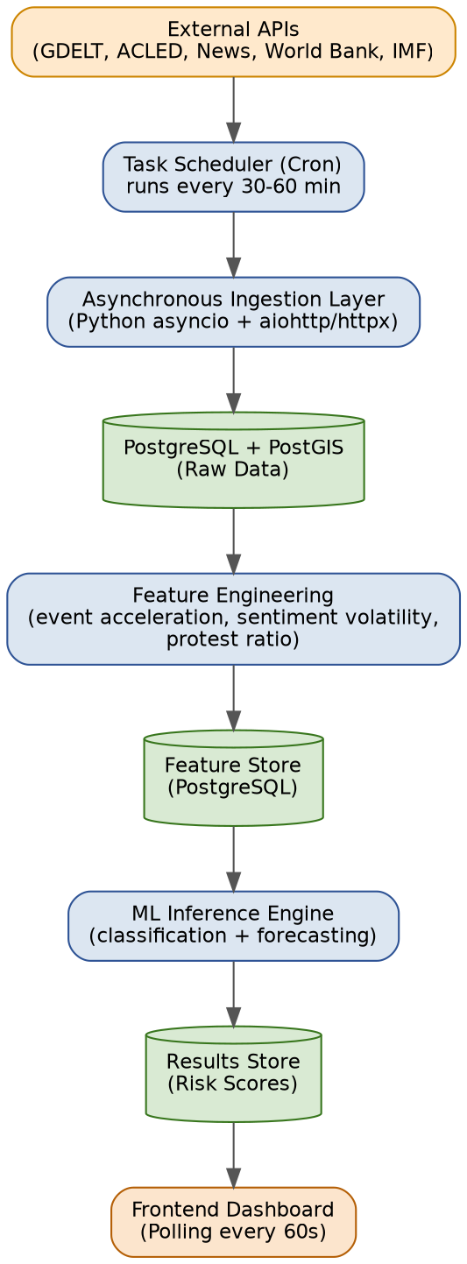

2.2 Product Functions (Summary)
- Scheduled, asynchronous ingestion of multi-source open data (event, news, economic, diplomatic).
- Feature engineering: event acceleration, sentiment volatility, protest-to-violence ratio, economic stress gradient.
- ML-based risk scoring per region per time window, with explainable factor breakdown.
- Interactive dashboard: traffic-light region view, drill-down, trend charts, source evidence links.
- Historical backtesting module for model validation against known escalation events.

2.3 User Classes and Characteristics
User Class | Description | Technical Level
Analyst / Researcher | Views dashboard, drills into regions, reviews evidence | Low–Medium
Project Evaluator | Reviews backtest results and technical documentation | Medium
System Administrator (dev team) | Configures data sources, triggers ingestion, maintains DB | High

2.4 Operating Environment
- Backend: Python 3.9+, containerized via Docker for consistent deployment
- Database: PostgreSQL with PostGIS extension
- Frontend: browser-based dashboard, polling-based updates (60s interval)
- Deployment target: single-host/local demo environment for academic evaluation

2.5 Design and Implementation Constraints
- Zero-budget constraint: only free/open-source tools and academic-licensed datasets.
- No classified, dark-web, or non-public data sources permitted.
- Must remain explainable — no "black box" outputs without a traceable source.
- Single-host modular monolith; no microservices/service-mesh complexity.

2.6 Assumptions and Dependencies
- Continued free-tier availability of GDELT (BigQuery), ACLED academic access, and World Bank/IMF APIs.
- Open-source data density is assumed sufficient for regions selected for MVP validation.
- Team retains access to a machine capable of running PostgreSQL/PostGIS and Python ML libraries locally.

3. Specific Requirements

3.1 Functional Requirements
ID | Requirement | Priority
FR-01 | The system shall ingest event data from ACLED/GDELT/ICEWS on a scheduled basis (every 30–60 minutes) without manual intervention. | Must
FR-02 | The system shall ingest news/media data and compute a tone/sentiment score per article. | Must
FR-03 | The system shall ingest quarterly economic indicators (inflation, GDP growth, unemployment, sanctions) per country. | Must
FR-04 | The system shall link all ingested records to a common Region_Key for cross-source aggregation. | Must
FR-05 | The system shall compute rolling-window features: event acceleration, sentiment volatility, protest-to-violence ratio. | Must
FR-06 | The system shall compute an interpretable 0–100 risk score per region per time window using the trained ML model. | Must
FR-07 | The system shall display a traffic-light (Green/Amber/Red) risk indicator per region on the dashboard. | Must
FR-08 | The system shall allow a user to drill into a region and view its contributing risk factors. | Must
FR-09 | The system shall provide a "View Source" action linking each alert to the underlying article/event record. | Must
FR-10 | The system shall support historical backtesting: restricting ingestion to a past date range and evaluating detection lead time. | Must
FR-11 | The system shall display a 90-day risk-score trend line per region. | Should
FR-12 | The system shall allow export of a region's risk report (PDF/CSV). | Should
FR-13 | The system shall send an alert notification when a region's risk score crosses a configurable threshold. | Could
FR-14 | The system shall support a "what-if" sandbox to adjust input parameters and observe predicted risk change. | Won't (MVP)

3.2 Non-Functional Requirements
ID | Category | Requirement
NFR-01 | Performance | The dashboard shall load within 3 seconds under normal conditions.
NFR-02 | Availability | The system shall remain functional using last-cached data if external APIs or internet connectivity are unavailable.
NFR-03 | Explainability | Every risk score shall be accompanied by a factor breakdown and a traceable source link; no unexplained scores shall be surfaced.
NFR-04 | Accuracy | The model shall achieve a recall of at least 75% for historical "high-impact" escalation events in backtesting.
NFR-05 | False Alarm Control | The false positive rate for high-risk alerts shall remain below 15% in backtesting.
NFR-06 | Security | API keys and credentials shall be stored via environment variables (.env) and excluded from version control.
NFR-07 | Data Privacy | Personally identifiable information incidentally captured from social/news sources shall be anonymized before storage.
NFR-08 | Maintainability | The system shall be organized as clearly separated internal modules (ingestion, storage, features, model, API, frontend).
NFR-09 | Portability | The system shall be containerized (Docker) to ensure consistent environment reproduction for demo and evaluation.
NFR-10 | Usability | A first-time analyst user shall be able to identify the highest-risk region within 10 seconds of opening the dashboard.

3.3 External Interface Requirements

A browser-based dashboard providing: a global region overview (traffic-light cards), an interactive risk heatmap, region drill-down views, trend charts, and an explainability panel. See the UI/UX Wireframes document for detailed mockups.

None beyond a standard host machine (CPU-based; no specialized hardware required for the MVP model set).

External System | Interface Type | Purpose
ACLED API | REST / academic data export | Conflict event records
GDELT (BigQuery) | SQL query interface | News tone & global event mentions
NewsAPI | REST | Headline and article metadata
World Bank / IMF APIs | REST | Quarterly economic indicators
PostgreSQL + PostGIS | SQL / DB driver | Persistent storage for all ingested and derived data

HTTPS for all external API calls; internal frontend-backend communication via polling REST endpoints (60-second interval).

4. System Features (Traceability to Use Cases)
See the companion Use Case & ER Diagram document for the full use-case model. Primary actors are the Analyst/Researcher, the System Administrator, and the automated Task Scheduler.
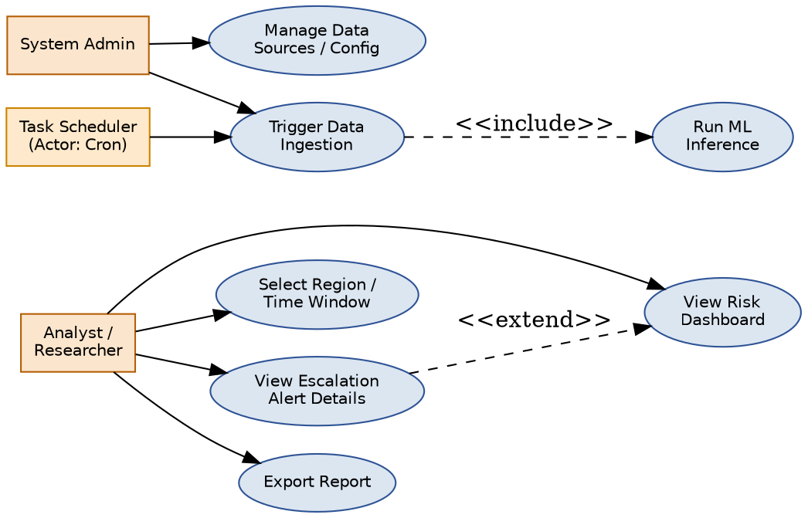

5. Other Non-Functional Attributes

Scheduled ingestion jobs shall log failures and retry with backoff; a single API failure shall not block ingestion from other sources.

See the companion Ethical & Bias Considerations document for detailed requirements on source-credibility weighting, de-escalation markers, and human-in-the-loop verification, which are binding constraints on system design.

High-fidelity raw data is retained on a rolling 90-day window; aggregated features and historical risk scores are retained for the life of the project for backtesting reproducibility.

6. Appendix
Appendix A — Full data dictionary: see companion Data Dictionary document.
Appendix B — Model selection and evaluation metrics: see companion Model Selection & Evaluation Plan document.

