BMS INSTITUTE OF TECHNOLOGY AND MANAGEMENT
Autonomous Institute under VTU, Belagavi, Karnataka – 590 018
Yelahanka, Bengaluru, Karnataka – 560 119
DEPARTMENT OF INFORMATION SCIENCE AND ENGINEERING
System Architecture Document
System Architecture Document
High-Level Design — Data Pipeline, ML Model, Alerting, Dashboard
Project: ARES – Conflict Escalation Early-Warning System
Major Project – Information Science and Engineering (2022 Scheme)
Prepared by
Ms. Shirin S Hegde 1BY23IS198 — Data Engineering & Integration Lead
Ms. Sreshta Karthikeyan 1BY23IS215 — AI/ML Model Developer
Ms. Tanya Deep 1BY23IS231 — System Development & Visualization Lead

Under the Guidance of
Prof. Sneha Sureddy, Assistant Professor, Dept. of ISE
February 2026

1. Architecture Overview
ARES is implemented as a Modular Monolith: all components run as a single deployable application, but are logically separated into independent internal modules. This was chosen over microservices for faster development, easier debugging, and zero DevOps overhead — appropriate for a student project timeline.
- /ingestion — API data collection
- /storage — Database access layer
- /features — Feature engineering
- /model — ML training & inference
- /api — Backend endpoints
- /frontend — Dashboard & visualization

2. High-Level Data Flow
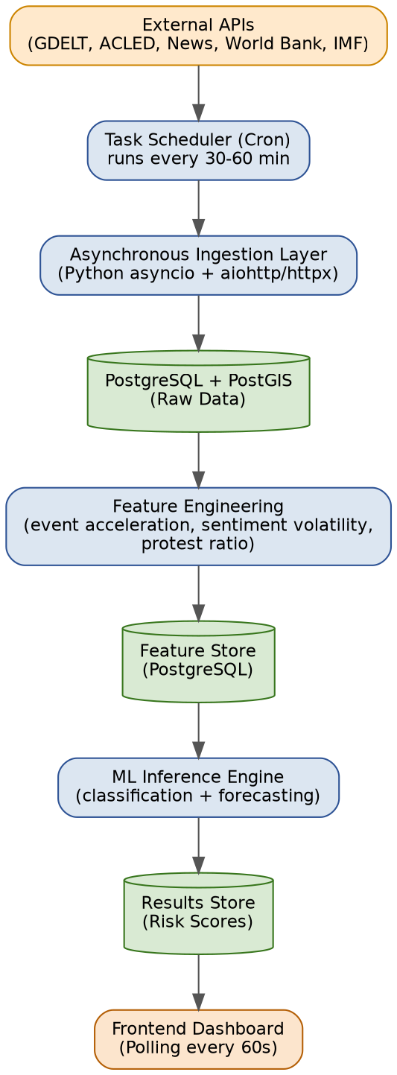
External APIs → Task Scheduler (Cron) → Asynchronous Ingestion Layer → PostgreSQL (Raw Data) → Feature Engineering → Feature Store (PostgreSQL) → ML Inference → Results Store → Frontend Dashboard.
A vector database is deliberately not used: the project relies on feature-based ML rather than semantic search, and no large-scale embedding retrieval is required, so a vector store would add unnecessary complexity for this scope.

3. Concurrency & API Handling
Ingestion uses asynchronous Python (asyncio with aiohttp/httpx) so multiple external APIs are fetched in parallel without blocking. Cron jobs trigger ingestion every 30–60 minutes; Celery-based task queuing is not required at this scale.

4. Data Persistence

Chosen for structured relational data, native geographic support, time-series-friendly querying, and industry-standard status. MongoDB was considered and rejected due to weak relational joins and poor temporal aggregation for this analytics-heavy workload.

All data sources are linked using a common Region_Key rather than raw coordinates or event IDs, enabling clean aggregation and avoiding noisy event-to-event joins. See the Use Case & ER Diagram document for the full entity-relationship model.

A hybrid cache is used: (1) database-level caching of API responses with timestamps, queried only when stale; (2) a short-TTL (5–15 min) in-memory LRU cache. Redis was considered and rejected as unnecessary operational complexity for a single-user/low-traffic academic system.

5. ML / AI Pipeline

Stored in PostgreSQL, per region and time window: event frequency, event acceleration, sentiment volatility, protest-to-violence ratio, diplomatic silence duration.

Models are loaded in-memory at server startup for low-latency inference and simple deployment; separate ML microservices are unnecessary for a single-model system.

A hybrid strategy is used: scheduled hourly baseline updates, plus on-demand inference when a user triggers region-specific analysis — balancing performance and responsiveness.

6. Frontend & Visualization

The frontend polls for updates every 60 seconds. This is simpler and more reliable than WebSockets, which are unnecessary since sub-second real-time alerts are not a requirement for this system.

Client-side rendering via MapLibre/Plotly Mapbox for interactive heatmaps with zoom/pan support and lower server load. Only aggregated geographic data is sent to the frontend.

7. DevSecOps & Deployment

Docker is used to ensure environment consistency, simplify demo/deployment, and reflect professional best practice; a single-container deployment is sufficient for this scope.

API keys are stored in a .env file, excluded from version control via .gitignore, and accessed via environment variables at runtime.

GitHub Actions for linting, unit tests, and build verification is optional but recommended for project polish.

8. Architecture Summary
The system is implemented as a modular monolith using Python, with asynchronous data ingestion, PostgreSQL with PostGIS for spatial and temporal storage, and a scheduled machine-learning inference pipeline. Feature engineering and model inference are tightly integrated, and results are served through a lightweight dashboard. The architecture prioritizes simplicity, explainability, and scalability within a student-friendly scope.

