BMS INSTITUTE OF TECHNOLOGY AND MANAGEMENT
Autonomous Institute under VTU, Belagavi, Karnataka – 590 018
Yelahanka, Bengaluru, Karnataka – 560 119
DEPARTMENT OF INFORMATION SCIENCE AND ENGINEERING
Use Case and ER Diagrams
Use Case Diagram & Entity-Relationship Diagram
Project: ARES – Conflict Escalation Early-Warning System
Major Project – Information Science and Engineering (2022 Scheme)
Prepared by
Ms. Shirin S Hegde 1BY23IS198 — Data Engineering & Integration Lead
Ms. Sreshta Karthikeyan 1BY23IS215 — AI/ML Model Developer
Ms. Tanya Deep 1BY23IS231 — System Development & Visualization Lead

Under the Guidance of
Prof. Sneha Sureddy, Assistant Professor, Dept. of ISE
February 2026

1. Use Case Diagram
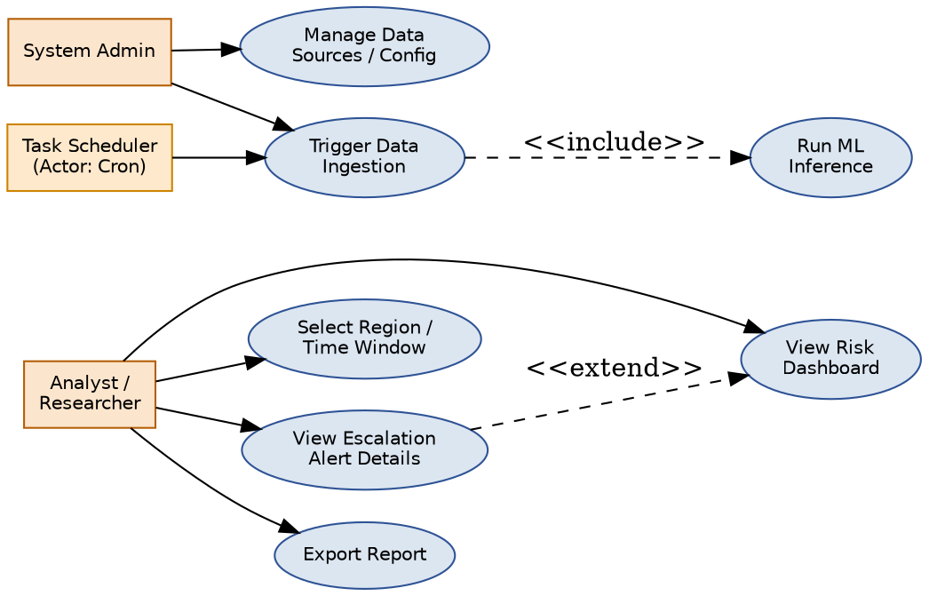
Use Case | Actor(s) | Description
View Risk Dashboard | Analyst/Researcher | View global traffic-light risk overview
Select Region/Time Window | Analyst/Researcher | Filter dashboard by region and date range
View Escalation Alert Details | Analyst/Researcher | Drill into a region's contributing factors and evidence
Export Report | Analyst/Researcher | Export a region's risk report as PDF/CSV
Trigger Data Ingestion | System Admin, Task Scheduler | Manually or automatically start an ingestion cycle
Run ML Inference | System Admin (included by ingestion) | Recompute risk scores after new data lands
Manage Data Sources / Config | System Admin | Add/modify API credentials and source configuration

2. Entity-Relationship Diagram
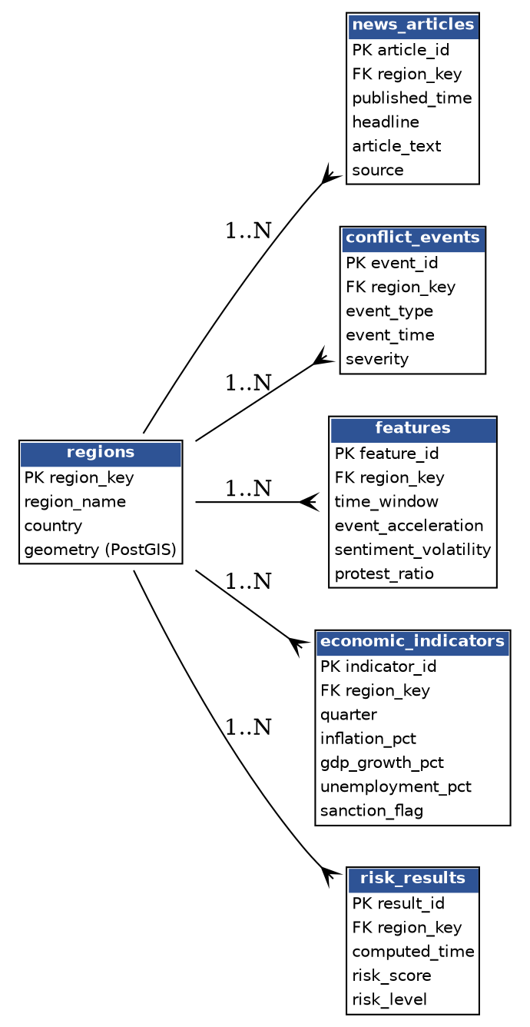
All fact tables (news_articles, conflict_events, features, economic_indicators, risk_results) are linked to the central regions table via the Region_Key foreign key, enabling consistent cross-source aggregation without noisy event-to-event joins. Full column-level definitions are provided in the companion Data Dictionary document.

