**Visual Search Experiment**

PSY310: Lab in Psychology

9th August 2024

Tanisha Patel

AU2220163

**GitHub link**:

**Introduction**

A visual search task aids in studying the various underlying processes of attention and its allocation by presenting the participant with an item set and asking them to correctly identify the target stimuli among multiple distractors.

Attentional processes can be studied across various parameters. One is by relating search time with efficiency. With an increased amount of distractors and differences in search time, the researcher can imply whether the attention was required to analyze each item individually (serial attention) or was automatic (parallel processing). Second, is through feature vs. conjunction search. In such a task, the target is unique by only one characteristic/feature, which may require automatic processing or, it differs on some level while maintaining similar features with the distractors requiring focused attention. The visual search is also helpful in studying the pop-out effect which suggests that certain visual properties automatically guide attention and attentional bottlenecks that indicate our attentional limitations. Efficient and inefficient are also determined by analyzing the search time. Efficient searches would require focused attention while compromising the time taken whereas inefficient searches would be quick but may compromise accuracy.

Studying attention through visual search has multiple real-life applications such as in education where the study material can be made such that it enhances grasping of concepts with better visual depictions, font, diagrams, and the overall page layout. It may also be used in the medical sector, where experts are meant to examine CT scans, X-rays, and MRIs. In the defense sector as well, it would help in efficiently locating the enemy target.

**Method**

***Participant***

The experiment included four participants’ responses, twenty-year-old females, and third-year students at Ahmedabad University.

***Materials and Procedure***

The visual search experiment was carried out on PsychoPy, on a laptop with a display resolution of 1920 x 1080 pixels, a 14’’ monitor, and a refresh rate of 59.93 Hz. Firstly, a white color cross-shaped fixation with size 0.1 x 0.1 units (from exp settings), anchored to the center was presented on the screen from the start that lasted till the end of the experiment along with a target stimulus, ‘T’ and distractors, ‘L’, both white. The positioning and orientation of the target and distractors were random. Also, the trials were categorized into two set sizes, one with five items and the other with ten. The participants responded with a mouse click upon correctly identifying the target stimulus among the distractors. Each participant completed 200 trials. Thereafter, the mean RT (reaction time) of all the 800 trials in total was calculated and the RTs of the two set sizes were compared.

**Results**

The mean RT for the four participants for 800 trials was calculated to be 1.4315s. The mean RT for the set size of five items was 1.3212s and for ten items was 1.5473s. For participant-1, the mean RT was 1.3069s, and the mean RT for set sizes five and ten were 1.1840s and 1.419s respectively. For participant-2, the mean RT was 1.3251ss, and the mean RT for set sizes five and ten were 1.2144s and 1.4247s respectively. For participant-3, the mean RT was 1.6401s and the mean RT for set sizes five and ten were 1.5213s and 1.7985s respectively. For participant-4, the mean RT was 1.4124s, and the mean RT for set sizes five and ten were 1.3206s and 1.5205s respectively. The slope of the graph is 0.0452.

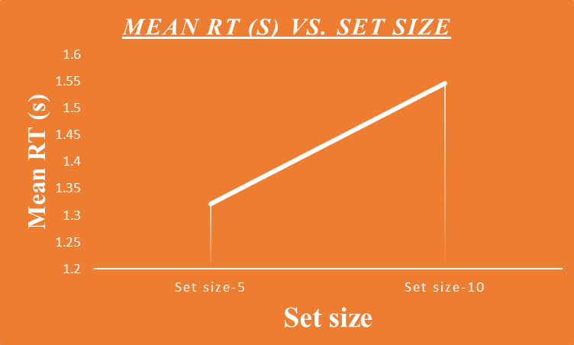

*Figure 1*

**Discussion**

The above graph has a positive slope for RT, suggesting that more attention is required for the participants to analyze items as the set size increases, also indicating the serial nature of attention, i.e., each item must be individually analyzed to identify the features of the target stimuli rather than employing parallel processing. Further research can focus on the speed-accuracy tradeoff that participants indulge in, to develop a deeper understanding of visual search.

**References**

*Palmer, J., & Davis, E. (2004). Visual search and attention: An overview. Spatial Vision, 17(4), 249–255.* [*https://doi.org/10.1163/1568568041920168*](https://doi.org/10.1163/1568568041920168)

*Chapman, A. F., & Störmer, V. S. (2022). Feature similarity is non-linearly related to attentional selection: Evidence from visual search and sustained attention tasks. Journal of Vision, 22(8), 4. https://doi.org/10.1167/jov.22.8.4*