**LAB NO:04**

**OBJECTIVE:** To become familiar with RMI callback mechanism.

* **TASK:**Develop the RMI Callback application of Payroll and PayrollMessage services for calculating the earnings.

CLIENT :

* REMOTE INTERFACE:

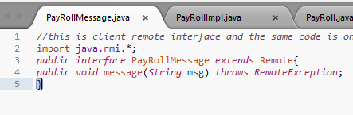

REMOTE OBJECT CLASS:

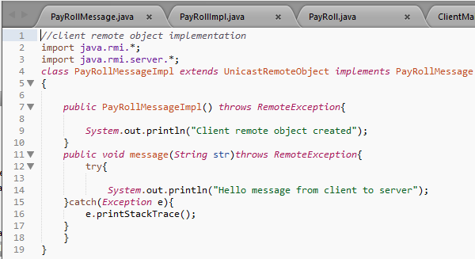

CLIENT MAIN CLASS:

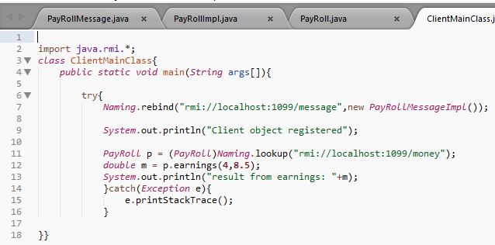

SERVER:

REMOTE INTERFACE:

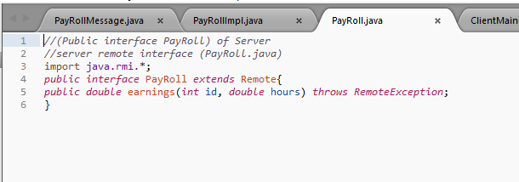

REMOTE OBJECT CLASS:

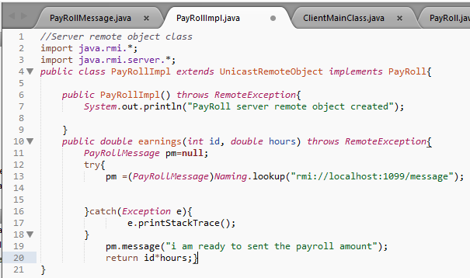

SERVER MAIN CLASS:

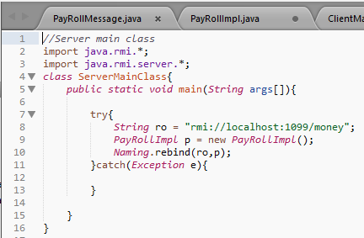

OUTPUT:

SERVER:

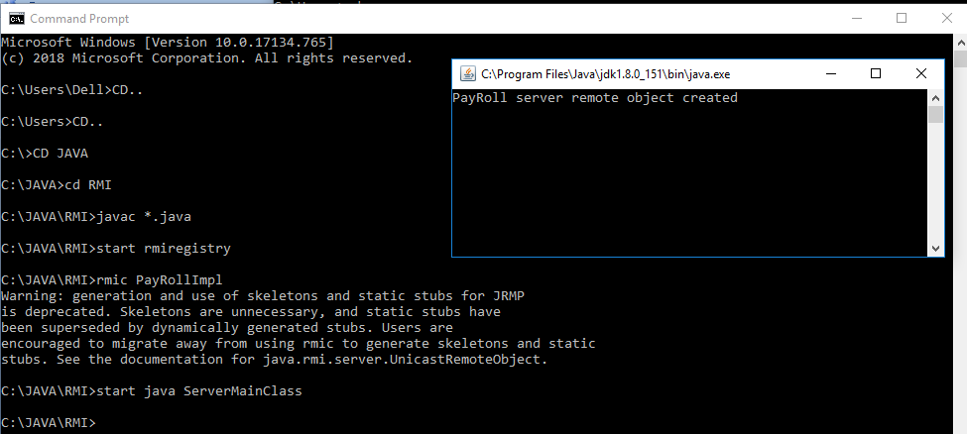

CLIENT:

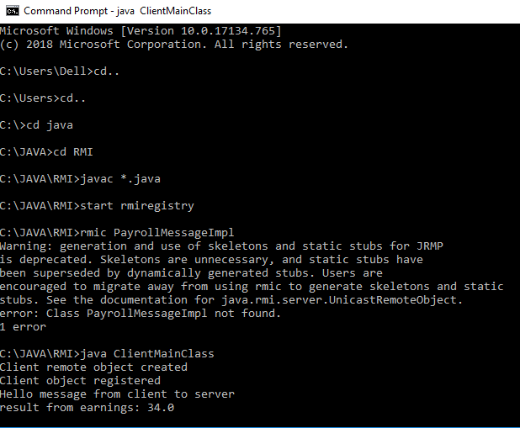

* **(Optional Task):** Develop an RMI application for chatting between client and server , the chatting should stop when both of them say “bye”

REMOTE INTERFACE:

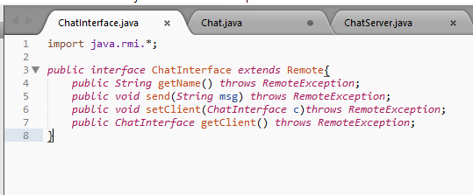

REMOTE OBJECT CLASS:

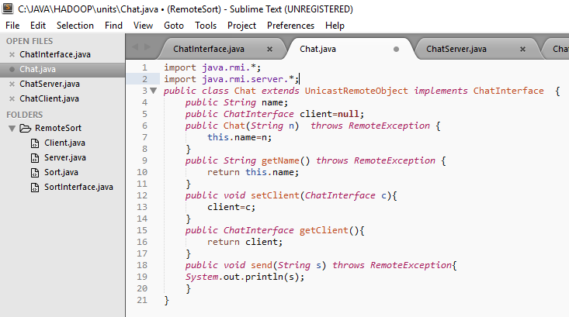

SERVER MAIN CLASS:

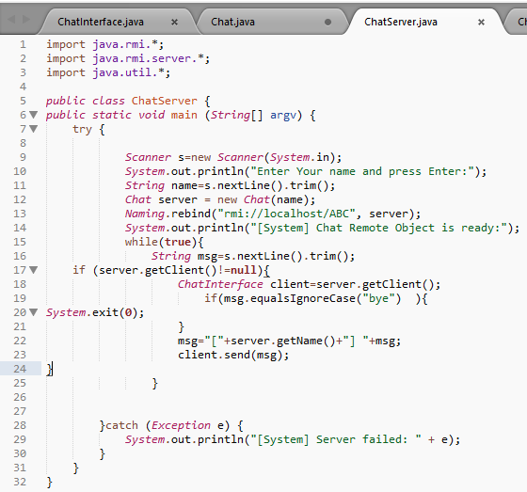

CLIENT MAIN CLASS:

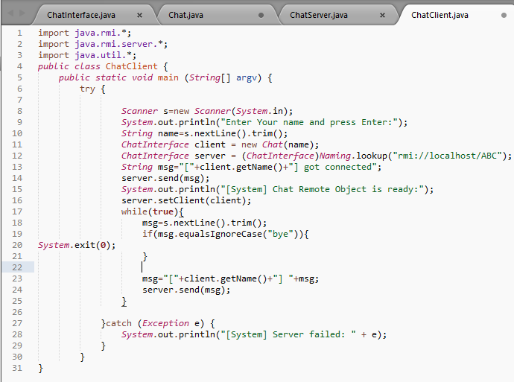

OUTPUT:

The following output shows the chatting between client and server on inputting bye the client/server will terminate .

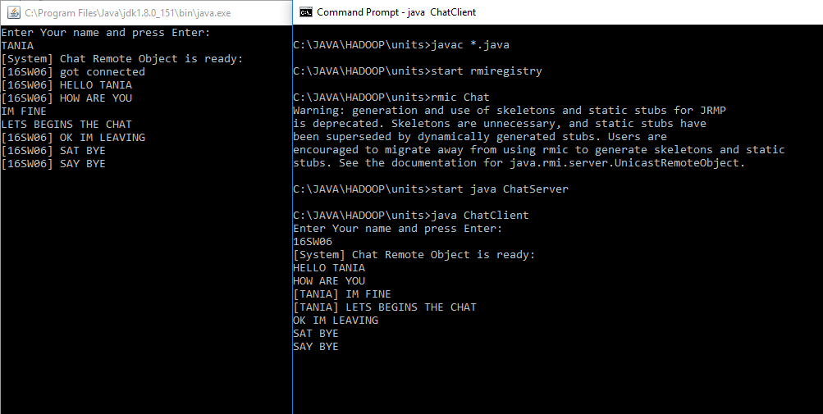

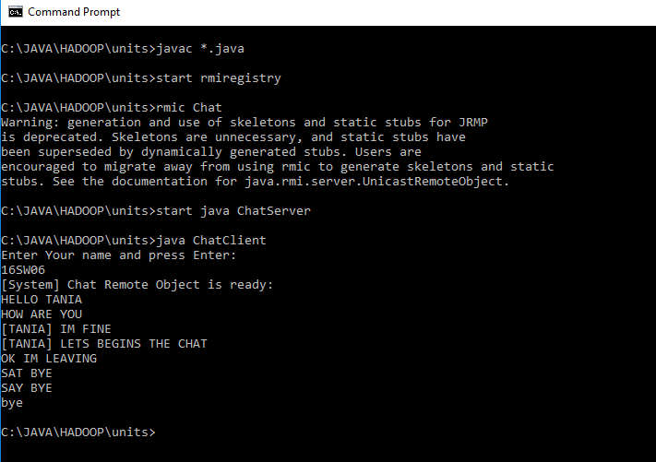

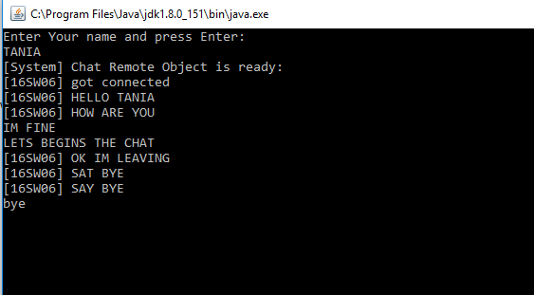

On bye from client side the cmd window will shut down