**LAB NO:3**

**OBJECTIVE: Generate stubs and skeletons using RMI in java and run client and server.**

**CLIENT:**

* HelloInterface.java(interface)
* HelloClient.java(client main class)

**SERVER:**

* Hello.java(Remote Object Class)
* HelloServer.java(server main class)
* HelloInterface.java(interface)

**CLASSTASK: Send message from server to client using RMI**

HelloInterface.java

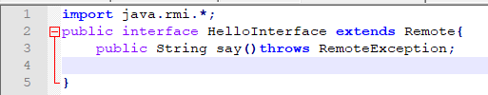

HelloClient.java

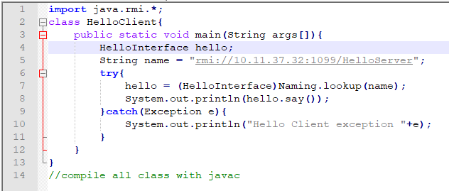

Server Main class

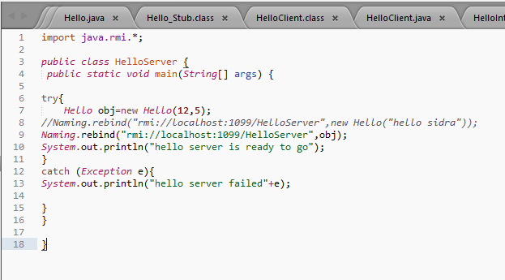

Remote interface

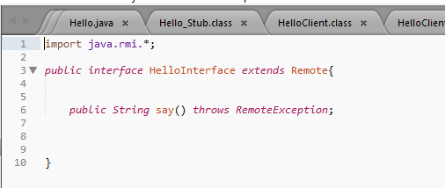

Remote object class:

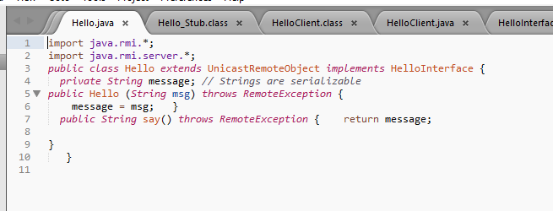

OUTPUT:

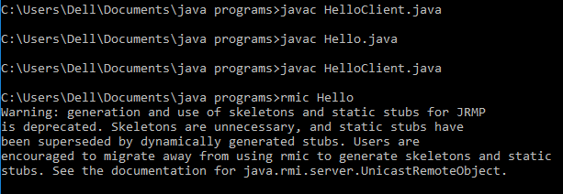



**TASK:Create an RMI program in which server performs the basic arithmetic operations.**

**Remote Interface:**

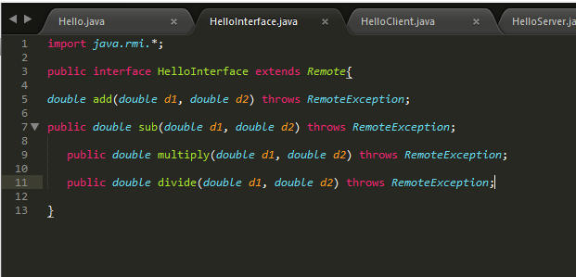

**Remote Object class**

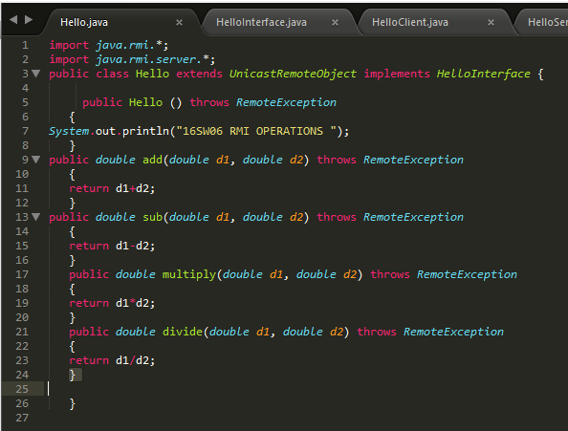

**Client Main class**

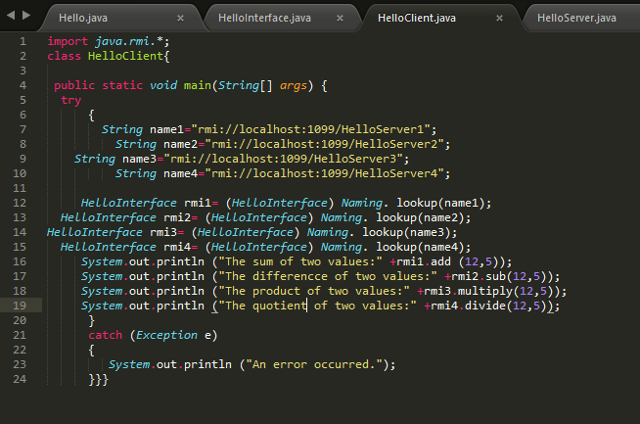

**Server Main class**

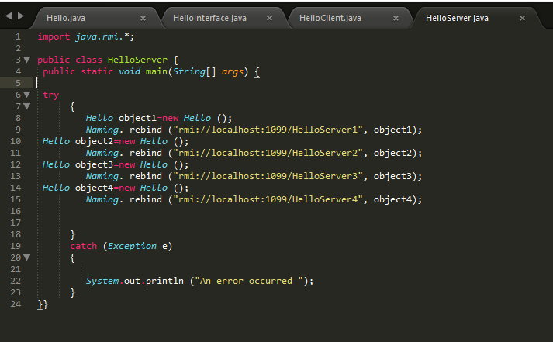

**OUTPUT:**

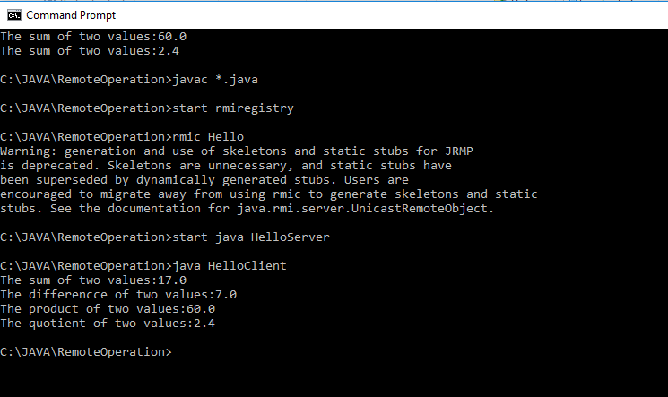

**Server:**

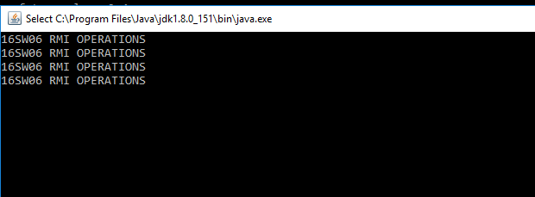

**TASK:Create an RMI program in which server sorts the number in ascending order.**

**Remote Interface:**

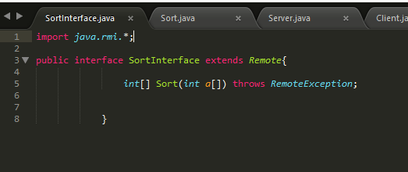

**Remote Object class:**

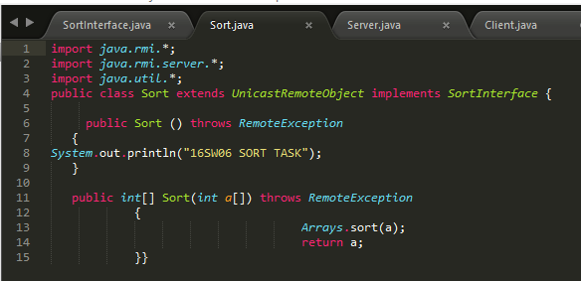

**Server Main class:**

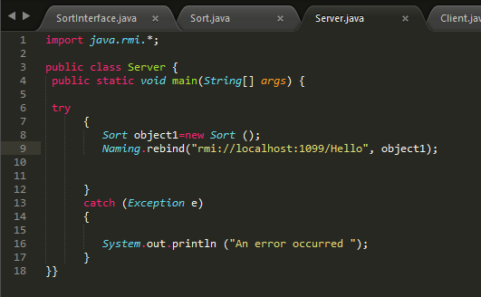

**Client Main class:**

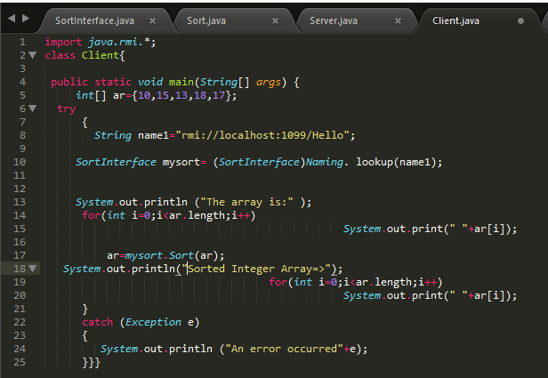

**OUTPUT:**

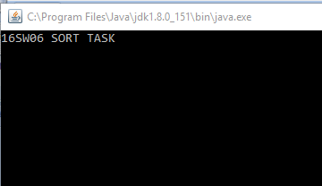

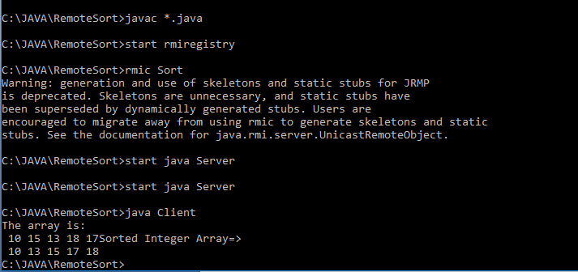

**(OPTIONAL TASK) Write an RMI program to implement the Map/Reduce concept of Hadoop on the server program. In other words the client program asks user to provide multiple sentences and send to server, server sends back the word counts.**

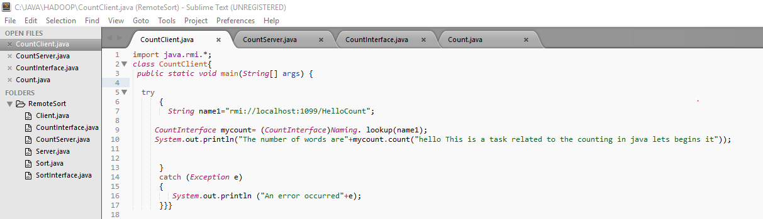

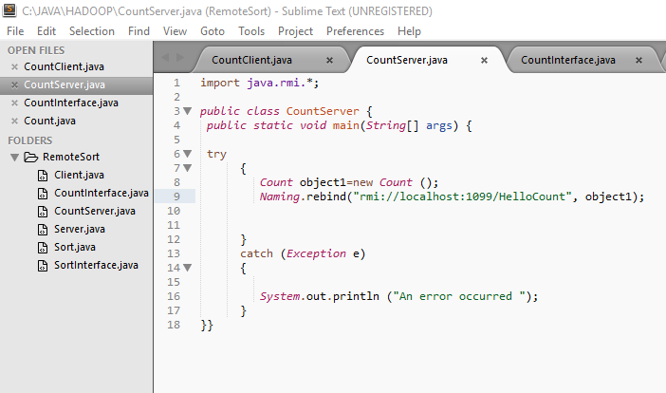

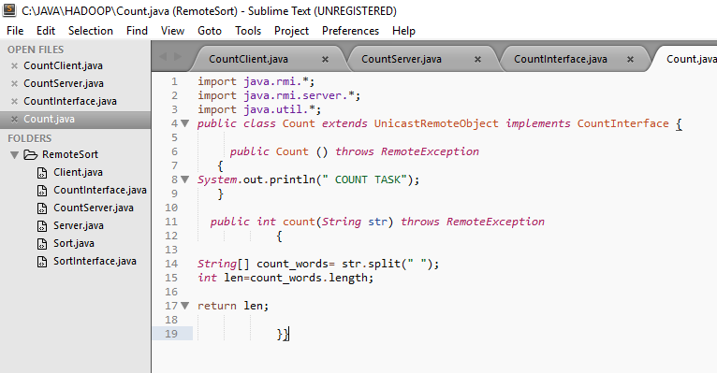

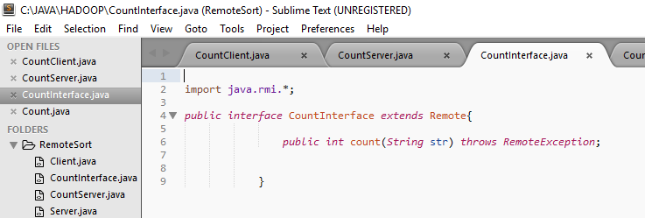

**OUTPUT:**

